|  |  |
| --- | --- |
| logo ngan.png | MINISTRY OF EDUCATION AND TRAINING |

|  |
| --- |
| **FPT UNIVERSITY** |
| Capstone Project Document |
| Build a Web Application  for Multi-Hotels Booking |
|  |
| |  |  | | --- | --- | | **Group 2** | | | **Group Members** | Nguyễn Phú An – Team Member – 60519  Bùi Minh Đức – Team Member – 60324  Nguyễn Hiếu Triệu Vỹ – Team Leader – SE60793 | | **Supervisor** | Lâm Hữu Khánh Phương | | **Ext Supervisor** | N/A | | **Capstone Project Code** | MHB | |
| Hồ Chí Minh City, December 2013 - |

|  |
| --- |
| *This page is intentionally left blank* |

*Acknowledgement*

After more than three months of intensive researching, working, and having fun, we have finally reached the fundamental objectives of the project *Multi-Hotel Booking*. Apart from our own efforts, the completion of this project depends largely on the encouragement and guidelines of many others. We would like to dedicate this page to expressing our gratitude to the people who have been instrumental in our project.

Firstly and most importantly, we would like to show our greatest respect to Mr. Lâm Hữu Khánh Phương, our supervisor, whose tremendous support and surprising yet innovative ideas contributed a great deal to the completion of our project. Without his encouragement and guidance, this project would probably not have materialized. More than that, we really appreciate the fact that he put us under no pressure whatsoever and always let us having fun while we were working on this project.

Secondly, we would like to thank our fellow men in Group 11, who were also working on a similar project. We will never forget the moments when we were so drawn into arguments that led to nowhere that we even thought we would ended up failing to finish our projects. It was an extraordinarily interesting experience having worked together.

Finally, we would like to express our deepest gratitude to our parents and our lecturers for always being there for us. We appreciate that they did a lot to gear us up for all the things we might encounter in our lives. We would not be who we are today if it weren’t for them.

Group 2  
*Nguyễn Phú An,  
Bùi Minh Đức,  
Nguyễn Hiếu Triệu Vỹ*

*This page is intentionally left blank*

# Table of contents

Table of contents 3

Table of figures 10

Terminology 11

1. Introduction 12

2. Software Project Management Plan (SPMP) 15

2.1. Problem Definition 15

2.1.1. Name of this Capstone Project 15

2.1.2. Problem Abstract 15

2.1.3. Project Overview 15

2.1.3.1. The Current System 15

2.1.3.2. The Proposed System 16

2.1.3.3. Boundaries of the System 17

2.1.3.4. Development Environment 17

2.2. Project organization 17

2.2.1. Software Process Model 17

2.2.2. Roles and Responsibilities 18

2.2.3. Tools and Techniques 18

2.3. Project management plan 19

2.3.1. Tasks 19

2.3.1.1. Task 1: Initiating 19

2.3.1.2. Task 2: Planning 19

2.3.1.3. Task 3: Specifying requirements 19

2.3.1.4. Task 4: Designing database 19

2.3.1.5. Task 5: Creating Software Design Description 20

2.3.1.6. Task 6: Implementing 20

2.3.1.7. Task 7: Performing Testing 20

2.3.1.8. Task 8: Writing User’s Manual 21

2.3.1.9. Task 9: Deploying the Website 21

2.3.2. Task sheet 21

2.4. Coding Convention 26

3. Software Requirement Specifications (SRS) 27

3.1. User Requirement Specification 27

3.1.1. Guest Requirements 27

3.1.2. Logged User Requirements 27

3.1.3. Traveler Requirements 27

3.1.4. System Admin Requirements 27

3.1.5. Hotel Owner Requirements 28

3.2. System Requirement Specification (Specific Requirements) 28

3.2.1. External Interface Requirements 28

3.2.1.1. User Interfaces 28

3.2.1.2. Hardware Interfaces 28

3.2.1.3. Software Interfaces 28

3.2.2. Main flow overviews 29

3.2.2.1. Flow 1: Traveler makes a reservation for a room 29

3.2.2.2. Flow 2: Hotel owner opens a hotel in the system 29

3.2.3. System Features 30

3.2.3.1. Overall Use Case Diagram 30

3.2.3.2. « Guest, Traveler » Search hotels 31

3.2.3.3. « Guest, Traveler » Check room prices and availability 34

3.2.3.4. « Guest, Traveler » Book rooms 36

3.2.3.5. « Guest, Traveler » Request a refund 42

3.2.3.6. « Traveler » Review a hotel 44

3.2.3.7. « Traveler » Rate a hotel 45

3.2.3.8. « Hotel Owner » Create a hotel 46

3.2.3.9. « Hotel Owner » Edit a hotel 49

3.2.3.10. « Hotel Owner » Delete a hotel 52

3.2.3.11. « Hotel Owner » Add a room type 54

3.2.3.12. « Hotel Owner » Edit a room type 57

3.2.3.13. « Hotel Owner » Delete a room type 59

3.2.3.14. « Hotel Owner » View price calendar 60

3.2.3.15. « Hotel Owner » Add a price 63

3.2.3.16. « Hotel Owner » Edit a price 66

3.2.3.17. « Hotel Owner » Delete a price 68

3.2.3.18. « Hotel Owner » Drag and drop a price bar 70

3.2.3.19. « Hotel Owner » Resize a price bar 72

3.2.3.20. « Hotel Owner » Approve a booking 73

3.2.3.21. « Hotel Owner » Accept/Reject a refund request 75

3.2.3.22. « Hotel Owner » View bookings by day 77

3.2.3.23. « Hotel Owner » Install a Facebook app 79

3.2.3.24. « System Admin » Approve hotel opening request 81

3.2.3.25. « System Admin » Get hotel infor from BMT 82

3.2.3.26. « System Admin » Get prices from BMT 84

3.2.4. Software System Attributes 86

3.2.4.1. Reliability 86

3.2.4.2. Availability 86

3.2.4.3. Security 86

3.2.4.4. Maintainability 86

3.2.4.5. Portability 86

3.2.4.6. Performance 86

3.3. Entity Relationship Diagram 86

4. Software Design Description (SDD) 88

4.1. Design Overview 88

4.2. System Architectural Design 88

4.3. Component Diagram 89

4.4. Detailed Designs 89

4.4.1. Entity Classes 89

4.4.1.1. Hotel Class 91

4.4.1.2. Feature Class 91

4.4.1.3. Image Class 91

4.4.1.4. Provider Class 92

4.4.1.5. Province Class 92

4.4.1.6. RoomType Class 92

4.4.1.7. Price Class 93

4.4.1.8. DailyStatus Class 93

4.4.1.9. UserProfile Class 93

4.4.1.10. Booking Class 94

4.4.1.11. Refund Class 94

4.4.1.12. Role Class 94

4.4.1.13. BookingItem Class 94

4.4.1.14. Review Class 95

4.4.1.15. Rating Class 95

4.4.1.16. RatingCriterion Class 95

4.4.2. Repository Classes 95

4.4.2.1. Class diagram 95

4.4.2.2. IHotelRepository Interface 96

4.4.2.3. IFeatureRepository Interface 98

4.4.2.4. IPriceRepository Interface 99

4.4.2.5. IRoomTypeRepository Interface 100

4.4.2.6. IReviewRepository Interface 100

4.4.2.7. IUserProfileRepository Interface 102

4.4.2.8. IBookingRepository Interface 102

4.4.2.9. IRefundRepository Interface 104

4.4.3. Data Synchronization Classes 105

4.4.3.1. Class diagram 105

4.4.3.2. IHotelSyncher Interface 105

4.4.3.3. IPriceSyncher 106

4.4.3.4. IBookingSyncher Interface 106

4.4.4. Business Logic Classes 107

4.4.4.1. Class diagram 107

4.4.4.2. ISender Interface 107

4.4.4.3. IBookingList Interface 108

4.4.4.4. IPlaceSuggestion Interface 109

4.4.4.5. IFacebookCommuter Interface 109

4.5. Behavioral Diagrams 110

4.5.1. State Machine Diagram: Booking Status Transition 110

4.5.2. State Machine Diagram: Refund Request Status Transition 110

4.5.3. Sequence Diagram: Search Hotels 111

4.5.4. Sequence Diagram: Add Rooms to Booking List 112

4.5.5. Sequence Diagram: Book Rooms and Pay 113

4.5.6. Sequence Diagram: Request a Refund 114

4.5.8. Sequence Diagram: Create a Hotel 115

4.5.9. Sequence Diagram: Edit a Hotel 116

4.5.10. Sequence Diagram: Add a Price 117

4.5.11. Sequence Diagram: Approve a Booking 118

4.5.12. Sequence Diagram: Approve a Refund Request 119

4.5.13. Sequence Diagram: Get Hotel Information from BMT 120

4.5.14. Sequence Diagram: Get Prices from BMT 121

4.5.15. Sequence Diagram: Install Facebook tab 122

4.6. User Interface Design 123

4.6.1. Home Page 123

4.6.2. Search Hotels Page 123

4.6.3. Hotel Details Page 125

4.6.4. Booking Details Page 125

4.6.5. Booking Success Page 126

4.6.6. Dashboard Page 127

4.6.7. Hotel Management Page 128

4.6.8. Approve Booking Page 129

4.6.9. Prices Monitor Page 129

4.7. Database Design 130

4.7.1. Logical database design 130

4.7.1.1. Booking Relation 132

4.7.1.2. BookingItem Relation 132

4.7.1.3. DailyStatus Relation 132

4.7.1.4. Feature Relation 132

4.7.1.5. Hotel Relation 133

4.7.1.6. HotelFeature Relation 133

4.7.1.7. Image Relation 134

4.7.1.8. Price Relation 134

4.7.1.9. Provider Relation 134

4.7.1.10. Province Relation 135

4.7.1.11. Rating Relation 135

4.7.1.12. RatingCriterion Relation 135

4.7.1.13. Refund Relation 135

4.7.1.14. Review Relation 136

4.7.1.15. RoomType Relation 136

4.7.1.16. UserProfile Relation 136

4.7.1.17. Role Relation 137

4.7.1.18. UserRole Relation 137

4.7.2. Physical database design 137

5. Software Test Document 139

5.1. Introduction 139

5.1.1. System Overview 139

5.1.2. Test Approach 139

5.2. Test Plan 139

5.2.1. Features to be tested 140

5.2.2. Features not to be tested 140

5.3. System Test Cases 141

5.3.1. Log in 141

5.3.2. View Dashboard 142

5.3.3. Create a hotel 143

5.3.4. Approve hotel opening request 144

5.3.5. Monitor prices 144

5.3.6. Synchronize with external data provider 146

5.3.7. Search hotels 147

5.3.8. Search available rooms in a hotel 149

5.3.9. Book rooms 151

5.3.10. Request a refund 154

5.3.11. Rate a hotel 155

5.3.12. Write a review 155

5.3.13. Approve booking 156

5.3.14. Install Facebook tab 157

5.4. Checklists 159

5.4.1. Checklist of Validation 159

5.4.2. Submission Checklist 159

6. Software User’s Manual 161

6.1. Installation Guide 161

6.1.1. Prerequisites 161

6.1.2. Installation procedures 161

6.2. User’s Guide 167

6.2.1. Guides for Guests and Travelers 167

6.2.1.1. Log in to the system 167

6.2.1.2. Log out of the system 167

6.2.1.3. Register an account with Traveler role 168

6.2.1.4. Search for hotels 169

6.2.1.5. View hotel details, rate, and comment 171

6.2.1.6. Book rooms and pay 172

6.2.2. Guides for Hotel Owners and System Admins 174

6.2.2.1. View the dashboard page 174

6.2.2.2. Create a hotel 175

6.2.2.3. Delete a hotel under your management 177

6.2.2.4. Add a room type 177

6.2.2.5. Delete a room type 178

6.2.2.6. Monitor prices 179

6.2.2.7. Add a price 179

6.2.2.8. Resize, drap and drop a price 180

6.2.2.9. Approve a booking 181

6.2.2.10. Approve hotel opening request 182

6.2.2.11. Install a Facebook Tab 182

6.2.2.12. Synchronize the external provider (BMT) 183

Appendix 185

Reference 185

# Table of figures

Figure 1. An overview of the MHB system 16

Figure 2. The waterfall software lifecycle model 18

Figure 3. Traveler makes a reservation for a room 29

Figure 4. Hotel owner opens a hotel in the system 30

Figure 5. Model-View-Controller Architecture 88

Figure 6. Home page 123

Figure 7. Search Hotel page 124

Figure 8. Hotel Details page 125

Figure 9. Booking Details page 126

Figure 10. Dashboard page 127

Figure 11. Approve Booking page 129

Figure 12. Booking list screen 181

Diagram 1. Actor overview diagram 27

Diagram 2. Use case diagram 30

Diagram 3. Entity relationship diagram 87

Diagram 4. Component Diagram 89

Diagram 5. Entity class diagram 90

Diagram 6. State machine diagram: Booking status transition 110

Diagram 7. State machine diagram: Refund request status transition 110

Diagram 8. Sequence diagram: Search Hotels 111

Diagram 9. Sequence diagram: Add rooms to booking list 112

Diagram 10. Sequence diagram: Book rooms and pay 113

Diagram 11. Sequence diagram: Request a refund 114

Diagram 12. Sequence diagram: Create a hotel 115

Diagram 13. Sequence diagram: Edit a hotel 116

Diagram 14. Sequence diagram: Add a price 117

Diagram 15. Sequence diagram: Approve a booking 118

Diagram 16. Sequence diagram: Approve a refund request 119

Diagram 17. Sequence diagram: Get hotel information from BMT 120

Diagram 18. Sequence diagram: Get prices from BMT 121

Diagram 19. Sequence diagram: Install Facebook tab 122

Diagram 20. Logical database design 131

Diagram 21. Physical database design 138

# Terminology

|  |  |  |
| --- | --- | --- |
| No. | Terminology | Explanation |
| 1. | Traveler | A person who needs to book rooms in hotels at their destination |
| 2. | Hotel Owner | A person in charge of managing their hotels |
| 3. | Hotel Data Provider | A system that provides hotel data including hotel information, room availability, and price changes |
| 4. | Local Hotel | A hotel opened by a hotel owner |
| 5. | External Hotel | A hotel provided by an external hotel data provider |
| 6. | BMT Hotel Data Provider | A specific hotel data provider that provides hotel data for our system |
| 7. | Hotel Opening Request | A request sent by a hotel owner to the system admin to ask to open their hotel in the MHB system |
| 8. | Hotel Information Portal | The part of the MHB system that allows travelers to interact with |
| 9. | Online Travel Agent | The name used to call a system that operates online to provide information about travelling. The MHB system itself can be considered an online travel agent. |

# Introduction

|  |  |  |  |  |  |
| --- | --- | --- | --- | --- | --- |
| **Project Title:** | | *Build a web application for multi-hotels booking* | | | |
| **Start Date:** | | Sep 9, 2013 | | **Finished Date:** | Dec 9, 2013 |
| **Scenario Problems:** | | The idea of a hotel information portal has been being adopted by many large travel agents around the world. Before working on this project, our team conducted a small research about hotel management and room booking processes in a number of large system. Here are the major findings during the research:  **FTS Hotel Management System**  This system allows hotel owners to manage a chain of hotels. Daily tasks are automated, including front-desk service, guest management, room booking, room allocation, room service monitoring, billing, payment, and statistics. We find it really useful for monitoring a small number of hotels.  **TripAdvisor Travel Agent**  This system acts as an intermediate travel agent that collects hotel data from different hotel information portals to allow comparing prices of similar hotels, to help travelers get the best price when they book rooms. Moreover, TripAdvisor offers trusted advice from real travelers. We find this system reliable because it adopts the perspective of a travelers, not the hotels.  **Ivivu Hotel Information Portal**  This system allow travelers to easily search for, compare, and book rooms that best suit their needs. Travelers can also take part in promotion campaigns organized. We find it reliable because it requires direct contacts between the travelers and the hotel owners, so the bookings are always guaranteed. However, this feature itself is a weakness because it does not automate the booking process.  From the findings above, we decided to develop a hotel information system that operates a little bit differently. The features of the system under development are listed in the Project Objectives section below. | | | |
| **Project Objectives:** | | The project aims to develop a web-based application that   * Mainly assists a wide range of people, including, but not limited to, visitors, travelers, and businesspeople, in searching, comparing, and making reservations for the most appropriate hotels at their destination. * Helps hotel owners (especially owners of small and non-luxury hotels, who cannot afford to open their own landing page) to sell their rooms by provides them with tools to manage their hotels at basic level and allowing their hotels to operate on the website. * Connects to hotel data providers, who in turn work with their hotel partners, to acquire necessary information about hotels, room types, prices, and reservations. | | | |
| **Scope Definition:** | | Following the descriptions of the project objectives, the scope of the project is constrained to the following statements:   * The users of the application should interact with the application itself through a friendly and attractive user interface. * *For travelers* (and other similar users), the application should provide fundamental functions such as searching for hotels, making reservations, pay for rooms booked, review and rate hotels, and cancel bookings. * *For hotel owners,* MHB *is not* a hotel management system, that is, it does not provide hotel owners with an intensive tool to help monitor their hotel or allocate rooms. MHB *is* a hotel information portal. It only provides basic means to manage basic information about the hotel itself, its room types, and price changes over days. * *For system administrators*, the application should allow them to monitor fundamental information about members, hotels, and data exchanges between the MHB system and external hotel data provider. * *For hotel data providers,* MHB *does not* interact directly with hotel owners for information about their hotels. Instead, it should feed on information from a set of web services provided by one or more providers. It is the hotel data providers’ responsibility to gather and process data about hotels. | | | |
| **Main Project Success Criteria:** | | The system must meet all written specifications, be thoroughly tested and completed on time. Also, this project must be compatible with the current working process and model of FPT University. | | | |
| **Approaches:** | | * Adopt the perspective of a traveler during the whole development process, in order to develop a web-based application that promotes usability and interactivity as much as possible. * Negotiate with web service providers to use their services, then agree upon how the application communicates with the web services, what information should be retained and what should be eliminated. * Try to provide hotel owners with a customized tool for monitoring their hotels that resembles the organization of a typical hotel as much as possible, so that they can easily adapt to the managing model of MHB without radical changes. * Conduct research on how to determine the most appropriate price based on the prices of the same product in the market, what refund scheme should be applied, and what promotion campaigns are suited to the core businesses of the application. * Conduct research on how to utilize information of hotels in other system such as creating a Facebook app that is tailored for each hotel or selling this information to some other hotel information systems. | | | |
| **References for this section:** | | <http://www.fts.com.vn/FTS/phan-mem-quan-ly-khach-san-fts-hotel.html>  <http://www.tripadvisor.com/PressCenter-c6-About_Us.html>  <http://www.ivivu.com/gioi-thieu-42-vi.html> | | | |
|  | | | | | |
| **Functions:** | | | | | |
| **Group Functions** | | **Summary** | | | |
| **Functions for travellers** | | * Allow travelers and other similar users to view, search for, and filter hotels based on criteria that suit their needs; * Allow travelers and other similar users to rate by different criteria and write reviews for a hotel; * Allow travelers and other similar users to book rooms in a hotel, purchase via the Internet, get notifications via email or SMS message, and, if no constraints are violated, cancel their reservation; | | | |
| **Functions for hotel owners** | | * Allow hotel owners to open their hotels in the MHB system by sending a hotel opening request; * Allow hotel owners to get notifications about new bookings and refund requests made the travelers; * Allow hotel owners to manage fundamental information about hotels, rooms, reviews from customers, and room reservations; * Allow hotel owners to monitor daily price changes and daily number of available rooms if the prices of their rooms vary with time; * Allow hotel owners to install a customized Facebook application that has functions similar to those of the website for their own hotel; | | | |
| **Functions for system admins** | | * Allow system admins to manage all relevant information about the system; * Allow system admins to grant access rights to other users of the system; * Allow system admins to decide which hotels should be active and which should be deactivated in the system; * Allow system admins to collect and synchronize between the data provided by hotel data provider and local data. | | | |
|  | | | | | |
| **Roles and Responsibility:** | | | | | |
| **No** | **Full name** | | **Role** | **Position** | **Contact** |
| **1.** | Lâm Hữu Khánh Phương | | Supervisor | Lecturer | [PhuongLHK@fpt.edu.vn](mailto:PhuongLHK@fpt.edu.vn) |
| **2.** | Nguyễn Hiếu Triệu Vỹ | | Developer, Tester | Team Leader | [VyNHTSE60793@fpt.edu.vn](mailto:VyNHTSE60793@fpt.edu.vn) |
| **3.** | Bùi Minh Đức | | Developer, Tester | Member | [DucBM60324@fpt.edu.vn](mailto:DucBM60324@fpt.edu.vn) |
| **4.** | Nguyễn Phú An | | Developer, Tester | Member | [AnNP60519@fpt.edu.vn](mailto:AnNP60519@fpt.edu.vn) |
|  | | | | | |
| **Project Authorization:** | | | | | |
| **Approved by** | | | **Role** | | **Date** |
| Lâm Hữu Khánh Phương | | | Supervisor | |  |
|  | | | | | |
| **Comments:** | |  | | | |

# Software Project Management Plan (SPMP)



## Problem Definition



### Name of this Capstone Project

|  |  |
| --- | --- |
| **Official name** | Build a web application for multi-hotels booking. |
| **Vietnamese name** | Xây dựng cổng thông tin cung cấp dịch vụ đặt phòng khách sạn. |
| **Abbreviation** | MHB |

### Problem Abstract

The idea of the project is to develop a web-based application that mainly assists a wide range of people in searching, comparing, and making reservations, and pay online for the most appropriate hotels at their destination. It helps hotel owners to sell their rooms by providing them with basic tools to monitor their hotels and allowing their hotels to be operating on the Internet. It also communicates with hotel data providers for reliable data of hotels.

### Project Overview



#### The Current System

The idea of developing a hotel information portal by gathering information from various hotels is itself not a new one. Before we start to explore the proposed system, we will go through a number of room booking processes available in the market.

**Traditional booking process**

Many hotels, even big ones, still adopts a traditional booking process on their own landing website:

1. Travelers browse and search for rooms available on the landing website;
2. If they find a room that suits their need, they will make a request to the hotel, either via telephone or by using an integrated booking function on the website;
3. They must either pay manually for the room using master card or transferring money with banking services, or, if the hotel does not require the traveler to pay in advance, wait for the hotel owner to approve of their request;
4. The hotel owner approves the request by allocating the appropriate rooms for the traveler;
5. The traveler goes to the hotel, pay by cash if the reservation was not paid, and checks in.

This process is really a nuisance since travelers have no ways to search for, compare, or filter similar hotels in the same region without manually browsing the internet. Moreover, all hotel management tasks must be performed manually by hotel owners.

**Ivivu.com booking process**

1. Travelers search for, compare, and filter similar hotels at their destination to find the most appropriate hotel for their needs;
2. Travelers send a form to request for the rooms they need, including their personal information;
3. Ivivu.com contacts the hotel to check the availability of the rooms requested;
4. Ivivu.com directly contacts the traveler to confirm the booking and collects additional information;

This booking process is good because provides machenisms for travelers to find the most suitable process but they do not automate the room availability monitoring tasks.

**Booking processes in international hotel portals**

Other international hotel information portals such as hotels.com, booking.com do automate the whole processes of room booking and hotel management, but they do not have much support for hotels in Vietnam, especially non-luxury hotels.

#### The Proposed System

By working on this project, we will develop a new hotel information portal that assists hotels in Vietnam to be closer to their customers. The system allegedly has the features specified bellows:

**Gather hotel data from different sources**

The system will collect data for hotels, room availability, and prices from at least two sources. Firstly, it allows hotel owners to open their hotel in the system. The hotel owners can optionally install a Facebook tab for the Facebook pages of their hotels. Secondly, the system communicates with external hotel data providers (BMT system in this case), in order to acquire data about hotels, room availability, and prices.

**Support monitoring room availability and prices**

The MHB system is integrated with a simple tool to help monitoring the availability of each room type and the changes of prices over days. This approach is appropriate because in the physical hotel, the number of rooms available every day are not always the same, and prices for the rooms do not always remain at the same.

**Automate the booking process**

To help travelers easily search for, book, and pay for the rooms they want, the MHB system also includes a hotel information portal. The booking process should be simplified, so that after the travelers booked the rooms, they can be ensured that the bookings will be notified to the hotel and the rooms will be allocated, without any troublesome contact between the hotel and them.

Below is an overview of the MHB system. Note that we assume that a hotel owner either work with one of the hotel data providers or the MHB system. We do not resolve information conflict if the hotel owner work with both (and the hotel will be regarded as two different hotels).



Figure . An overview of the MHB system

Here we want to note that, there is another group in this Capstone Project Semester who were working on system that functions as Hotel Data Provider. We will consume their services.

#### Boundaries of the System

There is no legacy system for the product to be built on. The product will be developed from scratch, independent of any current system.

As said previously, the system under development *is not* a hotel management system. It does not provide mechanisms to manage each specific room in the hotel, the daily allocations of these rooms, or other additional services. MHB *i*s a hotel information portal. It focuses mainly on providing up-to-date and accurate information about hotels, room types, price changes, and gives hotel owners opportunities to boost sales.

The final product of this Capstone Project includes

* An information portal that helps travelers book rooms;
* A management module for hotel owners and system admins;
* An integration module that connects to an external hotel data provider;
* A Facebook application customizable for each hotel;
* All the documents involved in the development process.

#### Development Environment

Below is the list of hardware and software requirements needed for the development environment of the project.

**Hardware requirements**

* Personal computers for developing with the minimum configuration: 2 Gb of RAM, 100Gb of hard disk, Core 2 Duo 2.0 Ghz;
* A server computer for testing with the minimum configuration: 4 Gb of RAM, 100Gb of hard disk, Core 2 Duo 2.0 Ghz;
* All computers must be connected to the internet.

**Software requirements**

* Operating system: Windows 7 or above;
* Web Server: IIS Express 8;
* Framework: .NET Framework 4.5;
* IDE: Visual Studio 2012;
* DBMS: SQL Server 2008 R2;
* Source Control: Team Foundation Server 2012.

## Project organization



### Software Process Model

The waterfall software lifecycle model will be used to guide the development of the system. The waterfall model includes five major phases as in the figure below, enforcing moving to the next phase only after completion of the previous phase.

Requirement Specifications

System and Software Designs

Implementation and Unit Testing

Integration and System Testing

Operation and Maintenance

Figure . The waterfall software lifecycle model

### Roles and Responsibilities

|  |  |  |  |
| --- | --- | --- | --- |
| No | Full name | Role in group | Responsibilities |
| 1 | Lâm Hữu Khánh Phương | Supervisor | * Give advice on business and technical problems; * Review and approve of project documents and product deliverables; * Assess the performance of team members. |
| 2 | Nguyễn Hiếu Triệu Vỹ | Team Leader,  Developer,  Tester | * Create project management plan and distribute tasks to the other members; * Monitor the development process and review the deliverables; * Work on system architecture and detailed designs; * Implement; * Prepare documents; * Perform unit testing; * Deploy the final product. |
| 3 | Nguyễn Phú An | Developer, Tester | * Research on organizations of hotels and pricing model; * Design user interfaces; * Work on detailed designs; * Implement; * Prepare documents; * Perform unit testing, system testing, and integration test. |
| 4 | Bùi Minh Đức | Developer, Tester | * Research on connecting with hotel data providers; * Design user interfaces; * Work on detailed designs; * Implement; * Perform unit testing, system testing, and integration test. |

### Tools and Techniques

The tools that will be used to develop the system includes:

* *Developing tools:* Microsoft Visual Studio 2012; Team Foundation Server 2012; Microsoft SQL Server 2008 RC;
* *Modelling tools:* Visual Paradigm 10.2 Community Edition;
* *Document tools:* Microsoft Office 2013.

## Project management plan



### Tasks

Below are all the major tasks that need to be performed sequentially during the development of the system.



#### Task 1: Initiating

|  |  |
| --- | --- |
| ***Task name*** | Initiating |
| ***Descriptions*** | Perform research on organizations of hotels and pricing model; decide upon the technology that will be used to develop the system. |
| ***Deliverables*** | Report 1 – Project Introduction |
| ***Resources needed*** | All team members; 6 days |
| ***Dependencies and constraints*** | N/A |
| ***Risks*** | Team members did not know each other in advance and have little background in terms of hotels; the chosen technology is new to all members. |

#### Task 2: Planning

|  |  |
| --- | --- |
| ***Task name*** | Planning |
| ***Descriptions*** | Create the project management plan; break the system into modules and assign tasks to each member. |
| ***Deliverables*** | Report 2 – Software Project Management Plan |
| ***Resources needed*** | All team members; 6 days |
| ***Dependencies and constraints*** | Task 1 has finished |
| ***Risks*** | Team leader has no experience in managing software projects; all members are still not acquainted with the new technology. |

#### Task 3: Specifying requirements

|  |  |
| --- | --- |
| ***Task name*** | Specifying requirements |
| ***Descriptions*** | Discuss and agree upon the software requirements, what is to be developed and what is not; generate detailed descriptions of all the functions to be developed. |
| ***Deliverables*** | Report 3 – Software Requirement Specification |
| ***Resources needed*** | All team members; 12 days |
| ***Dependencies and constraints*** | Task 2 has finished |
| ***Risks*** | Many aspects of the problem are still unclear to team members; little experience of working in a hotel management project. |

#### Task 4: Designing database

|  |  |
| --- | --- |
| ***Task name*** | Designing database |
| ***Descriptions*** | Design the database based on the requirements collected, through three major steps: Conceptual, Logical, and Physical Design |
| ***Deliverables*** | ERD and the physical database with sample data |
| ***Resources needed*** | All team members; 4 days |
| ***Dependencies and constraints*** | Task 3 has finished |
| ***Risks*** | Some of the requirements specified are not clear and cannot be translated into corresponding entities; little experience in organizing data. |

#### Task 5: Creating Software Design Description

|  |  |
| --- | --- |
| ***Task name*** | Creating Software Design Description |
| ***Descriptions*** | Agree upon the system architecture; Wwork on the detailed design of each module; decide which techniques are appropriate to which modules; design the user interfaces for users to interact with, using HTML5, CSS and JavaScript. |
| ***Deliverables*** | Report 4 – Software Design Description |
| ***Resources needed*** | All team members; 12 days |
| ***Dependencies and constraints*** | Task 4 has finished |
| ***Risks*** | Some functions are difficult to find an appropriate methods to implement; initial development environment setup is also difficult. |

#### Task 6: Implementing

|  |  |
| --- | --- |
| ***Task name*** | Implementing |
| ***Descriptions*** | Each team member implement all the functions that he or she was assigned and regularly check in the code to the Team Foundation Server; regularly validate that the implementation is consistent with the system and detailed designs. |
| ***Deliverables*** | The implemented website |
| ***Resources needed*** | All team members; 24 days |
| ***Dependencies and constraints*** | Task 5 has finished |
| ***Risks*** | Some design documents contain errors; implementation is not always consistent with the system and detailed designs. |

#### Task 7: Performing Testing

|  |  |
| --- | --- |
| ***Task name*** | Performing Unit Testing |
| ***Descriptions*** | Create and perform appropriate test cases for all main functions; record the test results for later reference; fix all the bugs found during the testing sessions. |
| ***Deliverables*** | Report 5 – Software Test Documentation |
| ***Resources needed*** | All team members; 12 days |
| ***Dependencies and constraints*** | Task 6 has finished |
| ***Risks*** | Lack of test cases for some non-critical functions; not enough time to intensively test all the functions. |

#### Task 8: Writing User’s Manual

|  |  |
| --- | --- |
| ***Task name*** | Writing User’s Manual |
| ***Descriptions*** | Writing a user’s manual to instruct the users, including guest, travelers, hotel owners, and system administrators, how to use the system. |
| ***Deliverables*** | Report 6 – User’s Manual |
| ***Resources needed*** | All team members; 6 days |
| ***Dependencies and constraints*** | Task 7 has finished |
| ***Risks*** | Some of the functions are not consistent with the user requirements, causing the user’s manual to be inconsistent with the user requirements. |

#### Task 9: Deploying the Website

|  |  |
| --- | --- |
| ***Task name*** | Deploying the Website |
| ***Descriptions*** | Perform acceptance testing and deploy the website to a host on the Internet |
| ***Deliverables*** | The complete website |
| ***Resources needed*** | All team members; all days left |
| ***Dependencies and constraints*** | Task 8 has finished |
| ***Risks*** | Little experience of deploying a website to a real host |

### Task sheet

Refer to the next page for the detailed task sheet of the project plan.

|  |  |  |  |  |  |
| --- | --- | --- | --- | --- | --- |
| Task Name | Length | Start | Finish | Predecessor | Resources |
| 1. Initiating | **6 days** | **Mon, 9-9-2013** | **Sat, 14-9-2013** |  |  |
| * 1. Identify key stakeholders | 1 day | 9-9-2013 | 9-9-2013 |  | VyNHT, AnNP, DucBM |
| * 1. Research & discuss about business and technology | 2 days | 10-9-2013 | 11-9-2013 | 1.1 | VyNHT, AnNP, DucBM |
| * 1. Research on similar existing system | 2 days | 12-9-2013 | 13-9-2013 |  | VyNHT, AnNP, DucBM |
| * 1. Hold project kick-off meeting | 0.5 days | 14-9-2013 | 14-9-2013 | 1.2, 1.3 | VyNHT, AnNP, DucBM |
| * 1. Report 1 – Project Introduction | 0.5 days | 14-9-2013 | 14-9-2013 | 1.4 | VyNHT, AnNP, DucBM |
| 1. Planning | **6 days** | **Mon, 16-9-2013** | **Sat, 21-9-2013** |  |  |
| * 1. Hold team planning meeting | 0.5 days | 16-9-2013 | 16-9-2013 | 1.5 | VyNHT, AnNP, DucBM |
| * 1. Prepare problem abstract, proposed solution, coding convention | 0.5 days | 16-9-2013 | 16-9-2013 | 2.1 | AnNP |
| * 1. Prepare major tasks for the whole team | 1 days | 17-9-2013 | 17-9-2013 | 2.1 | DucBM |
| * 1. Prepare management plan and determine task resources, durations, and dependencies | 2 days | 18-9-2013 | 19-9-2013 | 2.1 | VyNHT |
| * 1. Configure Team Foundation Server | 1 days | 20-9-2013 | 20-9-2013 | 2.4 | VyNHT |
| * 1. Report 2 – Project Management Plan | 1 days | 21-9-2013 | 21-9-2013 | 2.1-2.5 | VyNHT, AnNP, DucBM |
| 1. Specifying requirements | **12 days** | **Mon, 23-9-2013** | **Sat, 5-10-2013** |  |  |
| * 1. Identify users and users’ requirements | 3 days | 23-9-2013 | 25-9-2013 | 2.6 | VyNHT |
| * 1. Define system requirements | 1 days | 26-9-2013 | 26-9-2013 | 3.1 | AnNP |
| * 1. Define non-functional requirements | 1 days | 26-9-2013 | 26-9-2013 | 3.1 | DucBM |
| * 1. Determine main flows | 3 days | 26-9-2013 | 28-9-2013 | 3.1 | VyNHT |
| * 1. Specify functional requirements for viewing, searching hotels, filtering hotels | 3 days | 29-9-2013 | 1-10-2013 |  | VyNHT |
| * 1. Specify functional requirements for booking rooms, paying online, refunding | 3 days | 2-10-2013 | 4-10-2013 |  | AnNP |
| * 1. Specify functional requirements for managing hotels, hotel services, user reviews, Facebook tab | 3 days | 2-10-2013 | 4-10-2013 |  | VyNHT |
| * 1. Specify functional requirements for room types, pricing model and bookings | 3 days | 2-10-2013 | 4-10-2013 |  | DucBM |
| * 1. Specify functional requirements for connecting with external hotel provider | 3 days | 2-10-2013 | 4-10-2013 |  | DucBM |
| * 1. Specify functional requirements for statistics | 3 days | 2-10-2013 | 4-10-2013 |  | AnNP |
| * 1. Report 3 – Software Requirement Specification | 1 days | 5-10-2013 | 5-10-2013 | 3.1-3.10 | VyNHT, AnNP, DucBM |
| 1. Designing database | **4 days** | **Mon, 7-10-2013** | **Thu, 10-10-2013** |  |  |
| * 1. Discuss on conceptual data model | 0.5 days | 7-10-2013 | 7-10-2013 | 3.11 | VyNHT, AnNP, DucBM |
| * 1. Creating ERD | 0.5 days | 8-10-2013 | 8-10-2013 | 4.1 | VyNHT |
| * 1. Validate ERD against software requirements | 1 days | 9-10-2013 | 9-10-2013 | 4.2 | AnNP, DucBM |
| * 1. Create logical model and physical database | 1 days | 10-10-2013 | 10-10-2013 | 4.3 | VyNHT |
| 1. Creating Software Design Description | **12 days** | **Mon, 7-10-2013** | **Sat, 19-10-2013** |  |  |
| * 1. Discuss on system architecture | 0.5 days | 7-10-2013 | 7-10-2013 | 3.11 | VyNHT, AnNP, DucBM |
| * 1. Configure development environment | 0.5 days | 8-10-2013 | 8-10-2013 |  | VyNHT |
| * 1. Design a master customer layout | 4 days | 7-10-2013 | 10-10-2013 | 3.11 | AnNP |
| * 1. Design a master admin layout | 4 days | 7-10-2013 | 10-10-2013 | 3.11 | DucBM |
| * 1. Design pages for logging in, registering | 1 days | 11-10-2013 | 11-10-2013 |  | VyNHT |
| * 1. Design pages for viewing, searching hotels, filtering hotels | 2 days | 12-10-2013 | 13-10-2013 |  | VyNHT |
| * 1. Design pages for booking rooms, paying online, refunding | 3 days | 11-10-2013 | 13-10-2013 |  | AnNP |
| * 1. Design pages for managing hotels, hotel services, user reviews, installing Facebook tabs | 5 days | 11-10-2013 | 15-10-2013 |  | VyNHT |
| * 1. Design pages for room types, pricing model and bookings | 5 days | 11-10-2013 | 15-10-2013 |  | DucBM |
| * 1. Design pages for connecting with external hotel provider | 1 days | 16-10-2013 | 16-10-2013 |  | DucBM |
| * 1. Design pages for statistics | 1 days | 16-10-2013 | 16-10-2013 |  | VyNHT |
| * 1. Create main sequence diagrams for viewing, searching hotels, filtering hotels | 2 days | 17-10-2013 | 18-10-2013 |  | VyNHT |
| * 1. Create main sequence diagrams booking rooms, paying online, refunding | 2 days | 17-10-2013 | 18-10-2013 |  | AnNP |
| * 1. Create main sequence diagrams managing hotels, room types, hotel services, user reviews | 2 days | 17-10-2013 | 18-10-2013 |  | VyNHT |
| * 1. Create main sequence diagrams pricing model and bookings | 2 days | 17-10-2013 | 18-10-2013 |  | DucBM |
| * 1. Create main sequence diagrams connecting with external hotel providers and Facebook | 1 days | 17-10-2013 | 17-10-2013 |  | DucBM, VyNHT |
| * 1. Draw entity class diagram | 1 day | 19-10-2013 | 19-10-2013 |  | AnNP |
| * 1. Draw model class diagram | 1 day | 19-10-2013 | 19-10-2013 |  | VyNHT |
| * 1. Compose class description | 1 day | 18-10-2013 | 18-10-2013 |  | VyNHT |
| * 1. Compose physical database description | 1 day | 19-10-2013 | 19-10-2013 |  | DucBM |
| * 1. Report 4 – Software Design Description | 1 day | 19-10-2013 | 19-10-2013 |  | VyNHT, AnNP, DucBM |
| 1. Implementing | **24 days** | **Mon, 21-10-2013** | **Sat, 16-11-2013** |  |  |
| * 1. Log in, log out, register | 1 day | 21-10-2013 | 21-10-2013 | 5.5 | VyNHT |
| * 1. View hotels | 2 days | 22-10-2013 | 23-10-2013 | 5.6 | VyNHT |
| * 1. Search and filter hotels | 3 days | 24-10-2013 | 26-10-2013 | 5.6 | VyNHT |
| * 1. View, search, filter room types | 3 days | 21-10-2013 | 23-10-2013 | 5.7 | AnNP |
| * 1. Book rooms, pay online, notify users via email and phone | 3 days | 24-10-2013 | 27-10-2013 | 5.7 | AnNP |
| * 1. View history of bookings | 1 day | 28-10-2013 | 28-10-2013 | 5.3 | AnNP |
| * 1. Refund a booking | 1 day | 29-10-2013 | 29-10-2013 | 5.3 | AnNP |
| * 1. Manage all hotels and their features, images, reviews, and bookings | 6 days | 27-10-2013 | 3-11-2013 | 5.8 | VyNHT |
| * 1. Manage rooms, room prices, refund requests by hotel | 6 days | 21-10-2013 | 27-10-2013 | 5.9 | DucBM |
| * 1. Manage statistics | 2 days | 30-10-2013 | 1-11-2013 | 5.11 | AnNP |
| * 1. Connect to external data provider | 4 days | 28-10-2013 | 1-11-2013 | 5.10 | DucBM |
| * 1. Connect a hotel to Facebook | 2 day | 28-10-2013 | 29-11-2013 | 5.10 | VyNHT |
| * 1. Authorizing between hotel owners and system admins | 2 days | 30-10-2013 | 1-11-2013 |  | VyNHT |
| * 1. Integrate all implemented functions | 15 days | 2-11-2013 | 16-11-2013 |  | VyNHT, AnNP, DucBM |
| 1. Performing Testing | **12 days** | **Mon, 4-11-2013** | **Sat, 16-11-2013** |  |  |
| * 1. Write appropriate unit test cases for the functions each member implemented | 3 days | 4-11-2013 | 6-11-2013 | 6.14 | VyNHT, AnNP, DucBM |
| * 1. Perform unit testing and record the results | 2 days | 7-11-2013 | 8-11-2013 | 7.1 | VyNHT, AnNP, DucBM |
| * 1. Fix the bugs discovered during unit testing | 3 days | 9-11-2013 | 11-11-2013 | 7.2 | VyNHT, AnNP, DucBM |
| * 1. Complete code review checklists | 1 day | 12-11-2013 | 12-11-2013 | 7.3 | VyNHT, AnNP, DucBM |
| * 1. Report 5 – Software Test Documentation | 1 day | 13-11-2013 | 13-11-2013 | 7.4 | VyNHT, AnNP, DucBM |
| * 1. Perform integration test and fix the bugs discovered | 2 days | 14-11-2013 | 16-11-2013 | 7.5 | VyNHT, AnNP, DucBM |
| 1. Writing Users’ Manual | **6 days** | **Mon, 18-11-2013** | **Sat, 23-11-2013** |  |  |
| * 1. Write users’ manual for all the functions that each member implemented | 4 days | 18-11-2013 | 21-11-2013 | 7.5 | VyNHT, AnNP, DucBM |
| * 1. Check if the users’ manual and software requirements are consistent | 2 days | 22-11-2013 | 23-11-2013 | 8.1 | VyNHT, AnNP, DucBM |
| 1. Deploying the Website | **6 days** | **Mon, 25-11-2013** | **Sat, 30-11-2013** |  |  |
| * 1. Add more data to the database | 2 day | 25-11-2013 | 26-11-2013 |  | VyNHT, AnNP, DucBM |
| * 1. Deploy the website the a real host | 1 day | 27-11-2013 | 27-11-2013 | 7.6 | VyNHT, AnNP, DucBM |
| * 1. Test the website on the real host | 3 days | 28-11-2013 | 30-11-2013 |  | VyNHT, AnNP, DucBM |
| 1. Finalizing and closing | **6 days** | **Mon, 2-12-2013** | **Sat, 7-12-2013** |  |  |
| * 1. Prepare final project report | 3 days | 2-12-2013 | 4-12-2013 |  | VyNHT, AnNP, DucBM |
| * 1. Prepare final project presentation | 2 days | 5-12-2013 | 6-12-2013 |  | VyNHT, AnNP, DucBM |
| * 1. Final team meeting | 1 day | 7-12-2013 | 7-12-2013 |  | VyNHT, AnNP, DucBM |
| * 1. Close the project | 0 days | 7-12-2013 | 7-12-2013 |  | VyNHT, AnNP, DucBM |

## Coding Convention

The implantation of the system must strictly follow all the standard coding and naming convention specified by Microsoft, which can be found at <http://msdn.microsoft.com/en-us/library/ff926074.aspx>.



# Software Requirement Specifications (SRS)



## User Requirement Specification

The system should allow 4 types of actors, namely Guest, Traveler, Hotel Owner, and System Admin, and an abstract actor named Logged User, to interact with. Each of these types of user is granted a set of functions as specified below.

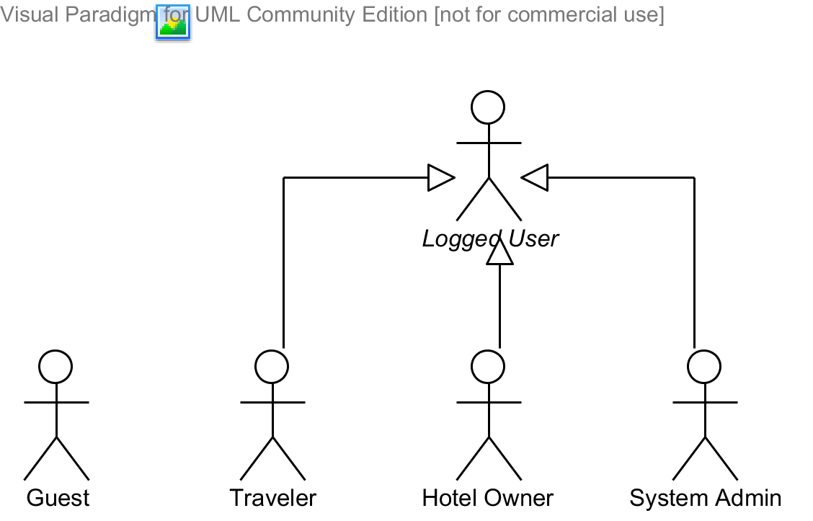

Diagram . Actor overview diagram



### Guest Requirements

A guest is an unauthenticated user of the website. He or she can:

* Log in with his authorized account or via a Facebook account;
* Register a new account;
* View, search for, and filter hotels by a number of criteria that suit his or her needs;
* View details of an arbitrary hotel;
* Book one or more rooms in a hotel and make payments for via online payment services;
* Receive notifications of booking via email and SMS;
* Cancel a booking if it satisfies the terms and regulations of the hotel.

### Logged User Requirements

A logged user is an authenticated user of the website (e.g., a user who logged on to the system with a valid username and password). He or she can:

* Log out;
* Change his or her own password;
* View and update his or her own account details.

Note that that this actor is an abstract one and does not represent a real actor in practice.

### Traveler Requirements

A traveler is a logged user (see 3.1.2. Logged User Requirement) and is given all the functions of a logged user. In addition, he or she is granted all the functions of a guest (see 3.1.1. Logged User Requirement) except for the Log in and Register functions. A traveler also has his or her own set of functions:

* View a list of his or her past bookings;
* Leave reviews to share his or her opion and experience about the hotel;
* Rate hotels by multiple criteria;

### System Admin Requirements

A system admin is a logged user (see 3.1.2. Logged User Requirement) and is given all the functions of a logged user. In addition, a system admin also has his or her own set of functions:

* Create hotel owners and another system admin;
* Manage all the hotels (both local and external) in the system;
* Approve of hotel opening requests by hotel owners;
* Connect to external hotel data providers to synchronizing hotel information.

### Hotel Owner Requirements

A hotel owner is a user who can to manage all relevant information about hotels under their management. A hotel owner is a logged user (see 3.1.2. Logged User Requirement) and is given all the functions of a logged user. Specifically, a hotel owner can:

* Manage information on hotels, including managing reviews on the hotels, hotel features, images, and room types;
* Monitor daily price changes of a rooms and daily available quantities of a rooms;
* Manage all bookings and refunding requests from customers;
* Install Facebook tabs on the Facebook fan pages of their hotels.

## System Requirement Specification (Specific Requirements)



### External Interface Requirements



#### User Interfaces

The MHB website should adopt an attractive and user-friendly interface so that the users of the system can get a good experience browsing the site.

The pages should be well linked together to promote seamless navigation between them. The instructions should be specific and suggestive, so that the users will not be confused about what to do next.

Client postbacks should be limited wherever possible, in order to boost performance and ease of use.

Vietnamese should be the official language of the website as its target customers are mainly Vietnamese people. Vietnam Dong should be the official currency. Moreover, all other localizable information, such as date and time, should be Vietnamese-styled.

#### Hardware Interfaces

The MHB website can be reached by personal computers that support Internet connection and web browsers. In order to get the best experience, the following conditions should be satisfied:

* 50 Kbps Internet connection or faster;
* 1 gigahertz (GHz) processor or faster;
* 512 megabytes (MB) RAM or more;

#### Software Interfaces

The software listed below is needed for the system to operate normally:

|  |  |  |  |
| --- | --- | --- | --- |
| **Software Name** | **Version** | **Cost** | **Provider** |
| Web Browser   * Internet Explorer * Google Chrome * Mozilla Firefox * Safari * Opera | 7.0 or higher | Free  Free  Free  Free  Free | Microsoft  Google  Mozilla  Apple  Opera |
| SQL Server Express | 10.0 | Free | Microsoft |
| .NET Framework | 4.5 | Free | Microsoft |
| IIS Express | 8 | Free | Microsoft |

### Main flow overviews

There are two main flows in the system as specified below.



#### Flow 1: Traveler makes a reservation for a room



Figure . Traveler makes a reservation for a room

The flow *Traveler makes a reservation for a room* include the followings steps:

1. The traveler searches for and filters hotels and room types by criteria that suit his or her needs;
2. The traveler chooses a room type, the number of rooms needed, check-in and check-out dates, and other relevant information;
3. The traveler provides necessary information and pay for the room via an online payment service;
4. The traveler receives a booking code that he or she can use when checking in the hotel and get notifications via email and SMS;
5. *If the hotel is a local one (that is, it is managed by a hotel owner)*, a notification will be sent to the hotel owner.

* The hotel owner verifies that they will allocate this room for the traveler by approving the booking request.

*If the hotel is provided by an external hotel data provider*, a notification will be sent to the hotel provider.

* The hotel provider is responsible for notifying the hotel owner of the booking request.

#### Flow 2: Hotel owner opens a hotel in the system

The flow *Hotel owner opens a hotel in the system* include the followings steps:

1. The hotel owner completes basic information of their hotel and makes a request to the system admin;
2. The hotel opening request is notified to the system admins;
3. The system admin check the validity of the hotel and approves of the hotel opening request;
4. The hotel owner continues to add images, room types, features for their hotel;
5. The hotel owner specifies prices and daily available statuses for each room. Until this step, their hotel is searchable, filterable, and can be booked on the MHB website;
6. The hotel owner installs a Facebook application for the Facebook page of their hotel (If there is no Facebook page for the hotel, the hotel owner must manually create one on Facebook).



Figure . Hotel owner opens a hotel in the system

### System Features



#### Overall Use Case Diagram

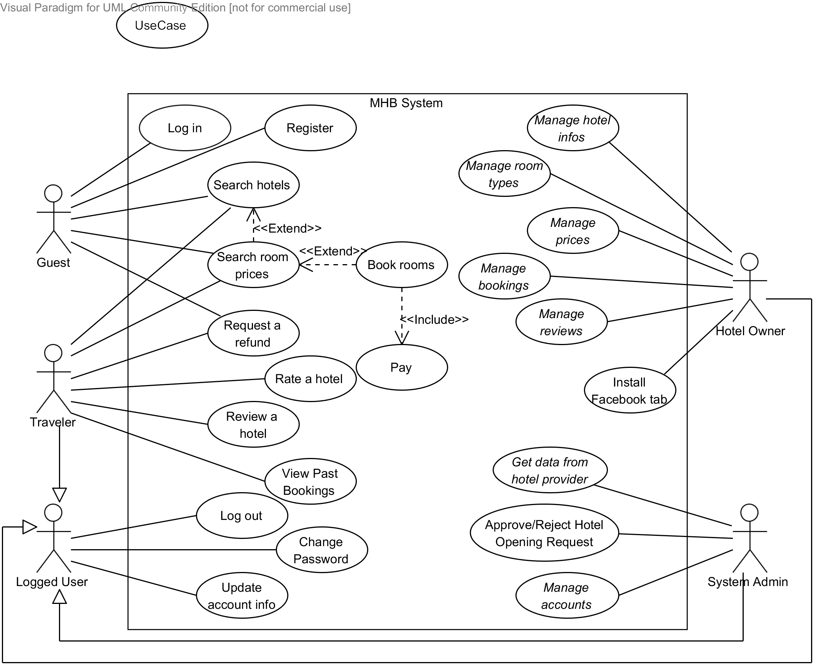

Diagram . Use case diagram

Note that only important and business-related use cases are described in details in the section below.

#### « Guest, Traveler » Search hotels

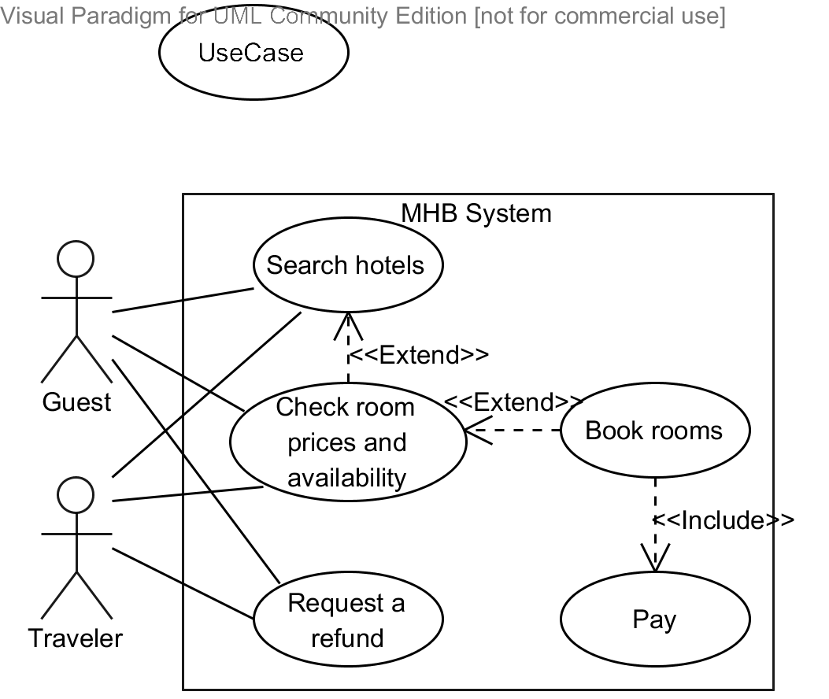

|  |  |  |  |  |
| --- | --- | --- | --- | --- |
| **SEARCH HOTELS – SPECIFICATION** | | | | |
| **Use-case No.** | UC001 | **Use-case Version** | | 1.0 |
| **Use-case Name** | Search Hotels | | | |
| **Author** | Nguyễn Hiếu Triệu Vỹ | | | |
| **Date** | 10/10/2013 | **Priority** | High | |
| **Actor:**  Guest, Traveler  **Summary:**  This use case allows a guest or a traveler to search for and filter hotels and their room types by criteria such as destination, check-in date, check-out date, star quality, user rating average points…  **Goal:**  To search for hotels that best suit the needs of the user so that he or she can continues to selects the most appropriate room type.  **Triggers:**  The user clicks on the button “Tìm ngay” on the home page or the search page.  **Preconditions:**  The home page or the search page is being displayed.  **Post Conditions:**  *On success:* A list of matched hotels is displayed to the user.  *On failure:* An error message is displayed. The content of the error message will be specified in the Exception Scenario section based on the type of failure.  **Main Success Scenario:**   |  |  |  | | --- | --- | --- | | **Step** | **User Action** | **System Response** | | 1. | Enters a searching query in the “Điểm đến” textbox. |  | | 2. |  | [See Exception No. 8]  Displays a drop down list containing three sections:   * A list of all hotels that have name or address containing the searching query string (all strings should be converted to unsigned strings before searching). Only a maximum of 4 hotels in the results are visible to the user. * A list of places that are retrieved from Google Geocoding service (including hidden latitude and longitude). Only a maximum of 5 places in the results are visible to the user. | | 3. | Selects a hotel or a place in the result drop down list. |  | | 4. | Specifies check-in and check-out dates. |  | | 5. | Clicks on the button “Tìm ngay”.  [See Exception No. 1, 2, 3, 4, 5, 6] |  | |  |  | [See Exception No. 7]  *If the user selected a hotel name*, redirects the user to the hotel detail page with rooms that match the searching dates already displaying.  [See Use case UC002]  *If the user selected a place name*, displays a list of all matched hotels. The list should be divided into a maximum of 10 hotels each page. Each item in the result list should include the following information:   * Basic information of a hotel such as name, address, star, check-in time, check-out time, description, introduction,... * Distance from the center of the searching place; * User rating average point; * Number of reviews for the hotel; * Last booking date for the hotel; * A room that has the lowest prices between the check-in and check-out dates; * Links to the hotel detail page;   In addition, a google map will display the location of all the hotels found. | | 6. | [See Alternative No. 1, 2, 3, 4] |  |   **Alternative Scenario:**   |  |  |  |  | | --- | --- | --- | --- | | **No** | **Step** | **User Action** | **System Response** | | 1. | 1. | Chooses filtering critiria, including:   * Provinces that the hotels locate in; * Star quality (from 1 star to 5 stars); * User rating average (from 1 to 5 points); * Distance from the center of the searching place |  | | 2. |  | Displays a filtered list of all the hotels that match the searching and sorting criteria | | 2. | 1. | Selects sorting criteria among “Gần điểm đến nhất”, “Tiêu chuẩn (giảm dần)”, “Tiêu chuẩn (tăng dần)”, “Đánh giá (giảm dần)”, “Đánh giá (tăng dần)”, “Giá phòng (giảm dần)”, “Giá phòng (tăng dần)” |  | | 2. |  | Displays a sorted list of all the hotels that match the searching and filtering criteria. | | 3. | 1. | Clicks on the page number in the list of found hotels. |  | | 2. |  | Display a list of all the hotels in the selected page number that match the searching and filtering criteria. | | 3. | 1. | Clicks on the icon that represent a hotel on the google map. |  | | 2. |  | Displays detailed information of that hotel on the Google map. | | 4. | 1. | Change the searching radius in the “Bán kính tìm” dropdown list |  | | 2. |  | Display a list of hotels that locates in the radius of the destination and satisfies all the other searching, sorting and filtering conditions. |   **Exceptions:**   |  |  |  | | --- | --- | --- | | **No** | **User Action** | **System Response** | | 1. | Leaves the destination textbox empty. | Prompts the message “Vui lòng chọn một địa điểm đến để tiếp tục.” | | 2. | Leaves the check-in date textbox or the check-out date textbox empty. | Prompts the message “Vui lòng chọn ngày nhận phòng và ngày trả phòng để tiếp tục.” | | 3. | Enters a value of check-in date greater than the value of check-out date or vice versa. | Prompts the message “Ngày đặt phòng không được lớn hơn ngày trả phòng.” | | 4. | Enters the check-in and check-out dates, but the check-out date is more than 30 days greater than the check-in days. | Prompts the message “Ngày trả phòng không được lớn hơn ngày đặt phòng quá 30 ngày.” | | 5. | Enters the check-in and check-out dates, one or both of these dates are less than the system current date. | Prompts the message “Bạn chỉ có thể tìm phòng kể từ ngày hôm nay trở đi.” | | 6. | Enters dates in an invalid date format. | Prompts the message “Ngày tháng không hợp lệ” | | 7. | Specifies searching and filtering criteria that match no hotels in the system. | Prompts the message “Không tìm thấy khách sạn nào thỏa mãn yêu cầu tìm kiếm của bạn. Bạn có thể giảm số ngày hoặc thay đổi các tiêu chí lọc dữ liệu để thu được nhiều kết quả hơn.” | | 8. | Enters a query string that does not match any hotels or places. | Prompts the message “Không tìm thấy kết quả nào.” |   **Relationships:**  “Check room prices and availability” use case  **Business Rules:**   |  |  | | --- | --- | | **No** | **Business Rule Description** | | 1. | MHB only allows user to search for hotels by check-in and check-out dates if the duration between check-in and check-out dates is less than 30 days. This is due to the fact that very few travelers stay in a hotel for more than 30 days. If the traveler really want to do so, they need to directly contact the hotel owner. | | 2. | Values of the dropdown list “Sắp xếp theo” include “Gần điểm đến nhất”, “Tiêu chuẩn (giảm dần)”, “Tiêu chuẩn (tăng dần)”, “Đánh giá (giảm dần)”, “Đánh giá (tăng dần)”, “Giá phòng (giảm dần)”, “Giá phòng (tăng dần)” | | 3. | Values of the dropdown list “Bán kính tìm” include “1 km”, “2 km”, “5 km”, “10 km”, “15 km”, “20 km”. | | | | | |

#### « Guest, Traveler » Check room prices and availability



|  |  |  |  |  |
| --- | --- | --- | --- | --- |
| **CHECK ROOM PRICES AND AVAILABILITY– SPECIFICATION** | | | | |
| **Use-case No.** | UC002 | **Use-case Version** | | 1.0 |
| **Use-case Name** | Check room prices and availability | | | |
| **Author** | Nguyễn Hiếu Triệu Vỹ | | | |
| **Date** | 14/10/2013 | **Priority** | High | |
| **Actor:**  Guest, Traveler  **Summary:**  This use case allows a guest or a traveler view detailed information of a hotel and search for prices of available room types given check-in date and check-out date.  **Goal:**  To view room detailed description and search for prices of available room types.  **Triggers:**  The user clicks on a link that leads to the hotel details page.  **Preconditions:**  The home page, search page, or hotel list page is being displayed.  **Post Conditions:**  *On success:* The detailed information of the selected hotel is shown to the user. A list of available room types and their prices are displayed accordingly.  *On failure:* An error message is displayed. Please refer to the Exception Scenario section the see what the content of the error message is.  **Main Success Scenario:**   |  |  |  | | --- | --- | --- | | **Step** | **User Action** | **System Response** | | 1. | Clicks on a link that leads to the hotel details page. |  | | 2. |  | [See Exception No. 1]  Displays all basic information of the selected hotel, including the following information:   * Basic information of the selected hotel such as name, address, star, check-in time, check-out time, description, introduction, and hotel features. * All reviews from travelers. * Rating average point; * A list of all room types in the hotel. Each room type should include basic information of a room, including name, description, capacity, maximum allowed extra children, maximum allowed extma adults, price of the room on the current system date. | | 3. | Specifies check-in and check-out dates. |  | | 5. | Clicks on the button “Kiểm tra giá”.  [See Exception No. 2, 3, 4, 5, 6, 7] |  | |  |  | [See Exception No. 7]  Displays a list of all matched room types. Each item in the result list should include the following information:   * Basic information of a room type such as name, description, capacity, max allowed extra children, max allowed extra adults,... * Information about prices of this room for the given period including base price, plus extra amount for extra children and adults. If there are more than one prices in this period, displays them all as a grid; * A select box that allows the user to select the number of rooms they want to book (with a max value of 10 rooms) and a button named “Đặt phòng”. |   **Alternative Scenario:**  N/A  **Exceptions:**   |  |  |  | | --- | --- | --- | | **No** | **User Action** | **System Response** | | 1. | Selects a hotels but the hotel cannot be found in the system, was marked as deactivated or was deleted. | Redirects to 404 file not found page. | | 2. | Leaves the check-in date textbox or the check-out date textbox empty. | Prompts the message “Vui lòng chọn ngày nhận phòng và ngày trả phòng để tiếp tục.” | | 3. | Enters a value of check-in date greater than the value of check-out date or vice versa. | Prompts the message “Ngày đặt phòng không được lớn hơn ngày trả phòng.” | | 4. | Enters the check-in and check-out dates, but the check-out date is more than 30 days greater than the check-in days. | Prompts the message “Ngày trả phòng không được lớn hơn ngày đặt phòng quá 30 ngày.” | | 5. | Enters the check-in and check-out dates, one or both of these dates are less than the system current date. | Prompts the message “Bạn chỉ có thể tìm phòng kể từ ngày hôn nay trở đi.” | | 6. | Enters dates in an invalid date format. | Prompts the message “Ngày tháng không hợp lệ” | | 7. | Specifies check-in and check-out dates that match no room types in the hotel. | Prompts the message “Không tìm thấy phòng nào thỏa mãn yêu cầu tìm kiếm của bạn. Bạn có thể giảm số ngày hoặc thay đổi các tiêu chí lọc dữ liệu để thu được nhiều kết quả hơn.” |   **Relationships:**  “Search hotels” use case  “Book rooms” use case  **Business Rules:**   |  |  | | --- | --- | | **No** | **Business Rule Description** | | 1. | MHB only allows user to search for hotels by check-in and check-out dates if the duration between check-in and check-out dates is less than 30 days. This is due to the fact that very few travelers stay in a hotel for more than 30 days. If the traveler really want to do so, they need to directly contact the hotel owner. | | 2. | MHB only allows user to book a maximum of 10 rooms for a specific room type in a certain period. | | 3. | Prices for extra adults or children are only displayed when the room type allows extra children or adults to stay. | | | | | |

#### « Guest, Traveler » Book rooms



|  |  |  |  |  |
| --- | --- | --- | --- | --- |
| **BOOK ROOMS – SPECIFICATION** | | | | |
| **Use-case No.** | UC003 | **Use-case Version** | | 1.0 |
| **Use-case Name** | Book rooms | | | |
| **Author** | Nguyễn Phú An | | | |
| **Date** | 08/11/2013 | **Priority** | High | |
| **Actor:**  Guest, Traveler  **Summary:**  This use case allows the customer to book for the rooms that best suit his or her needs after he or she searched for hotels and room types. After booking a room successfully the customer will receive a unique booking code that he or she will use to verify with the hotel when he or she checks in the hotel.  **Goal:**  To book one or more rooms in a hotel and get the booking code.  **Triggers:**  The user clicks on the button “Đặt phòng” after he or she has searched for the most appropriate rooms.  **Preconditions:**  The hotel details page is being displayed.  The hotel on hotel details page has at least one available room type in the time in the period between check-in and check-out dates.  **Post Conditions:**  *On success:* A booking and its relating information are saved. The quantity of room types that the user booked is permanently updated. The user is redirected to the Booking Success page. An e-mail about booking information is sent to the e-mail address of the user. An SMS message is sent to the user’s number to notify the booking code. A booking notification is raised for the hotel owner, waiting to be approved.  *On failure:* An error message is displayed. Please refer to the Exception Scenario section the see what the content of the error message is.  **Main Success Scenario:**   |  |  |  | | --- | --- | --- | | **Step** | **User Action** | **System Response** | | 1. | Selects a value from the dropdown list “Số lượng phòng” for a room type in the a list of all room types available in the period from check-in date and check-out date with additional information. Additional information such as extra children and adults can also be selected in dropdown lists  Clicks the button “Đặt phòng”.  [See Exception No. 1, 2, 3, 4] |  | | 2. |  | Locks the selected rooms by reducing the number of available rooms by the value of the selected number of rooms, for the period from check-in date to check-out date.  Adds the booking to the booking list for the current user.  Redirects to the booking details page. | | 3. |  | On the left of the page, displays the booking details page with an editable form containing the fields specified below. If the user is already logged in with traveler role, his or her account information is also filled in the form.   * “Giới tính” (dropdown list box with two value “Nam” and “Nữ”; required). * “Họ và tên” (textbox; required, min length 5; max length 100). * “Địa chỉ” (textbox; required, min length 5; max length 200). * “Ngày sinh” (textbox; required, min value: 16 years back from the current system date; max value: 70 years back from the current system date). * “E-mail” (textbox; email format; required; max length 255). * “Số điện thoại” (textbox; telephone format, required). * “Yêu cầu khác cho phòng của bạn” (text area; not required; max length 500).   On the right of the page, displays the booking details information and the total amount that need to be paid and a link that suggest the customer to book more rooms from the selected hotel titled “Đặt thêm phòng tại khách sạn X”, where X is the name of the selected hotel. | | 4. | [See Alternative No. 1]  Fills in (or modifies, if the user is already logged in) the fields with relevant information. |  | | 5. | [See Alternative No. 2]  Clicks on “Thanh toán” button at the bottom of the page.  [See Exception No. 5, 6, 7, 8, 9, 10, 11, 12, 13, 14] |  | | 6. |  | Saves the customer’s information and his or her booking. The booking status at this moment is “Pending”. | | 7. |  | Redirect to the “Ngân lượng” payment service page with the amount to be paid taken from the room types which the user booked.  It is the payment service’s responsibility to ensure that the payment is performed securely and accurately.  [Refer to the use case Pay in the document CD]  [See Exception No. 15] | | 8. | Pay for the amount specified via “Ngân Lượng”. |  | |  |  | If the user successfully paid for the rooms booked, “Ngân Lượng” redirects the user back to the booking success page. | | 10. |  | [See Exception No. 8]  Changes the booking status to “Paid”;  If the booking is made for an external hotel (that is, one provided by hotel data provider), a notification will be sent to the hotel provider;  Displays the booking success page with all relevant information about the booking, including   * The booking code, * The information of the rooms booked, * Check-in and check-out dates, * The total amount paid, and * The detailed information of the customer who made the booking.   Sends an email containing the above information to the customer’s email address;  Sends an SMS message containing the booking code to the customer’s number.  [See Exception No. 16, 17, 18] | | 11. | Receives the booking code. |  |   **Alternative Scenario:**   |  |  |  |  | | --- | --- | --- | --- | | **No** | **Step** | **User Action** | **System Response** | | 1. | 1. | Clicks on the link titled “Đặt thêm phòng tại khách sạn X”, where X is the name of the selected hotel. |  | | 2. |  | Redirects to the hotel details page of the selected hotel with check-in and check-out dates already selected. | | 3. | Searches for room availability and prices by specifying check-in and check-out dates.  [Refer to the use case Check room prices and availability (UC002)] |  | | 4. |  | Display a list of all matched rooms. | | 5. | Selects a value from the dropdown list “Số lượng phòng” for a room type in the a list of all room types available in the period from check-in date and check-out date with additional information. Additional information such as extra children and adults can also be selected in dropdown lists.  Clicks the button “Đặt phòng”.  [See Exception No. 1, 2, 3, 4] |  | | 6. |  | Locks the selected rooms by reducing the number of available rooms by the value of the selected number of rooms, for the period from check-in date to check-out date.  Adds the booking to the booking list for the current user.  Redirects to the booking details page. | | 2. | 1. | Clicks on the button “Hủy bỏ” on the Booking Details Page. |  | | 2. |  | Empties the booking list for the current user.  Rolls back the number of available rooms for the selected room types in the period from check-in date to check-out date. |   **Exceptions:**   |  |  |  | | --- | --- | --- | | **No** | **User Action** | **System Response** | | 1. | Clicks on “Đặt phòng” button but the number of rooms available in the system is less than the selected number of rooms. | Shows the message “Hiện tại khách sạn không còn đủ số lượng phòng bạn muốn đặt, vui lòng tải lại trang hoặc giảm số lượng phòng xuống.” | | 2. | Clicks on “Đặt phòng” button but the number of rooms for this room type in the selected period is greater than 10. | Shows the message “Bạn chỉ có thể đặt tối đa 10 phòng với mỗi loại phòng trong một khoảng thời gian.” | | 3. | Clicks on “Đặt phòng” button but the room type does not belong to a hotel already selected in the booking list, if any. | Shows the message “Bạn có thể đặt nhiều loại phòng khác nhau nhưng các phòng phải trong cùng một khách sạn.” | | 4. | Clicks on “Đặt phòng” button but in the booking list there are equal to or more than 5 bookings waiting to be paid. | Shows the message “Vui lòng thanh toán hoặc hủy bỏ các loại phòng bạn đã đặt trong danh sách đặt phòng trước khi đặt phòng mới.” | | 5. | Leaves the textbox “Họ và tên” empty. | Shows the message “Họ và tên không được để trống, tối thiểu là 5 kí tự, tối đa là 100 kí tự”. | | 6. | Fills the textbox “Họ và tên” with a value less than 5 or more than 100 characters in length | Shows the message “Họ và tên tối thiểu là 5 kí tự, tối đa là 100 kí tự.” | | 7. | Leaves the textbox “Địa chỉ” empty. | Shows the message “Địa chỉ không được để trống, tối thiểu là 5 kí tự, tối đa là 200 kí tự.” | | 8. | Fills the textbox “Địa chỉ” with a value less than 5 or more than 100 characters in length. | Shows the message “Địa chỉ tối thiểu là 5 kí tự, tối đa là 200 kí tự.” | | 9. | Leaves the textbox “Ngày sinh” empty. | Shows the message “Ngày sinh không được để trống” | | 10. | Leaves the textbox “Email” empty. | Shows the message “Email không được để trống.” | | 11 | Fills the textbox “Email” with an invalid email format. | Shows the message “Email không hợp lệ.” | | 12. | Leaves the textbox “Số điện thoại” empty. | Shows the message “Số điện thoại không được để trống.” | | 13. | Fills the textbox “Số điện thoại” with an invalid telephone number format. | Shows the message “Số điện thoại không hợp lệ.” | | 14. | Clicks on “Thanh toán” button but there are no bookings in the booking list. | Shows the message “Hiện tại bạn chưa chọn phòng nào cả, vui long chọn ít nhất một phòng trước khi tiếp tục.” | | 15. | Does not pay for the amount on “Ngân Lượng” payment service and let more the 15 minutes elapse since the last booking was added to the booking list. | Empties the booking list for the current user.  Rolls back the number of available rooms for the selected room types in the period from check-in date to check-out date. | | 15. | Pay for the amount on “Ngân Lượng” payment service successfully but the system fails to update the booking status or generate the booking code. | Shows the message “Hệ thống xảy ra lỗi khi xác nhận thanh toán của bạn, vui lòng liên hệ với quản trị hệ thống để được hỗ trợ.” | | 16. | Gets the booking code but the system fails to send an email to the customer’s email address. | Shows the text “[lỗi]” next to the customer’s email in the Booking Success page. | | 17. | Gets the booking code but the system fails to send an SMS message to the customer’s telephone number. | Shows the text “[lỗi]” next to the customer’s telephone number in the Booking Success page. |   **Relationships:**  “Check room prices and availability” use case  “Pay” use case  **Business Rules:**   |  |  | | --- | --- | | **No** | **Business Rule Description** | | 1. | The user can only book not greater than 10 rooms for a room type in the period from the check-in date to the check-out date. | | 2. | The user can book for multiple rooms at a time but these rooms must belong to the same hotel. That means, if the user wants to book rooms in different hotels, he or she must do so by making payments many times. Moreover, to prevent malicious actions from users, the user is required to pay for all the bookings, or remove some from the booking list, if he has made more than 5 bookings, before he or she can continue to book other rooms. | | 3. | A booking code is a random string with 6 characters. A single unique booking code is given to the user each time he or she pays for the rooms booked, even if the payment is for more than one room types. | | 4. | The user is required to pay for the rooms booked within 15 minutes since the last booking is added to the booking list. If 15 minutes has elapsed since then, the booking list for the current user will be emptied and the number of available rooms for the selected room types in the period from check-in date to check-out date will be rolled backed. | | 5. | If the booking is made for an external hotel (that is, one provided by hotel data provider), a notification will be sent to the hotel provider. The MHB system is not responsible for notifying to the hotel owner or allocating rooms in this case. | | | | | |

#### « Guest, Traveler » Request a refund



|  |  |  |  |  |
| --- | --- | --- | --- | --- |
| **REQUEST A REFUND – SPECIFICATION** | | | | |
| **Use-case No.** | UC004 | **Use-case Version** | | 1.0 |
| **Use-case Name** | Request a refund | | | |
| **Author** | Nguyễn Phú An | | | |
| **Date** | 03/11/2013 | **Priority** | Normal | |
| **Actor:**  Guest, Traveler  **Summary:**  This use case allows a guest or a traveler to request a refund for a booking he or she has made previously in case he or she no longer needs to stay in the booked hotel and wants to cancel the booking.  **Goal:**  To to request a refund for a booking previously made.  **Triggers:**  The user clicks the “Yêu cầu hủy phòng” button.  **Preconditions:**  The booking to be refunded is for a refundable room types and the current system date is at least one day earlier than the check-in date of the booking.  **Post Conditions:**  *On success:* The new refund is inserted into the database waiting for the hotel owner to approve. A successful message is displayed that the refund is added.  *On failure:* An error message is displayed. The content of the error message will be specified in the Exception Scenario section based on the type of failure.  **Main Success Scenario:**   |  |  |  | | --- | --- | --- | | **Step** | **User Action** | **System Response** | | 1. | Clicks on the the “Hủy phòng” link on the home page. |  | | 2. |  | Displays the “Hủy phòng” page, which has the following sections:   * “Mã đặt phòng” (textbox, required). * “Lý do hủy phòng” (text area, required). * “Gửi yêu cầu hủy phòng” (button). | | 3. | Fills the booking code into the “Mã xác nhận” field and reason why the user wants to cancel the booking into the “Lý do hủy phòng” field |  | | 4. | Clicks the button “Gửi yêu cầu hủy phòng”.  [See Exception No. 1, 2, 3, 4] |  | | 5. |  | Saves the refund information to the database and displays the success message “Yêu cầu hủy phòng của bạn đã được gửi, khách sạn sẽ liên hệ với bạn trong thời gian ngắn”. |   **Alternative Scenario:**  N/A  **Exceptions:**   |  |  |  | | --- | --- | --- | | **No** | **User Action** | **System Response** | | 1. | Leaves the field “Mã xác nhận” empty. | Shows the message “Mã đặt phòng không được để trống” | | 2. | Leaves the text area “Lý do hủy phòng” empty. | Shows the message “Lý do hủy phòng không được để trống” | | 3. | Fills the text area “Mã xác nhận” with a wrong code. | Shows the message “Mã đặt phòng bạn cung cấp không chính xác. Vui lòng thử lại.” | | 4. | Fills the text area “Mã xác nhận” with the booking code of an already refunded booking. | Shows the message “Đặt phòng có mã xác nhận này đã được hoàn tiền. Vui lòng thử lại.” | | 5. | Fills the text area “Mã xác nhận” with a booking code that belongs to a booking whose check-in date is less than one day from the current system date. | Shows the message “Tất cả các đặt phòng có mã xác nhận này đã quá hạn có thể hoàn tiền. Vui lòng thử lại.” |   **Relationships:**  N/A  **Business Rules:**   |  |  | | --- | --- | | **No** | **Business Rule Description** | | 1. | MHB system only allows its users to request a refund for a booking if the check-in date of that booking is at least 1 day greater than the current system date | | 2. | A booking that was refunded cannot be refunded again. | | 3. | Before a traveler can claim the money back, a refund request must be reviewed and approved by the respective hotel owner. | | 4. | MHB system do not provide any mechanism to specify how much would be refunded for a refund request. It is the responsibility of the hotel owner to decide how much should be refunded. | | | | | |

#### « Traveler » Review a hotel

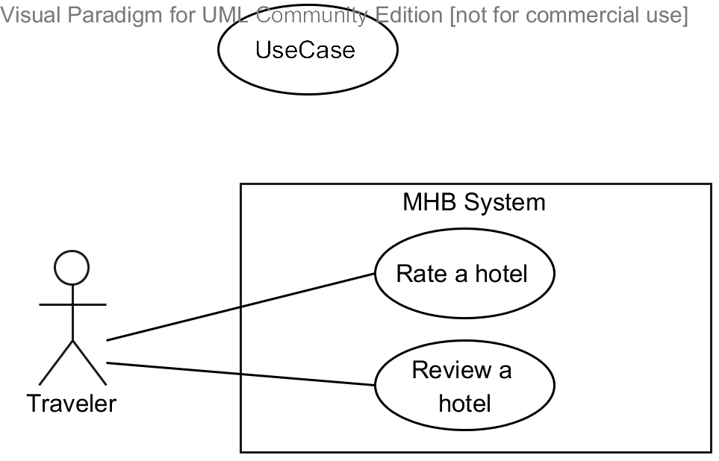

|  |  |  |  |  |
| --- | --- | --- | --- | --- |
| **REVIEW A HOTEL – SPECIFICATION** | | | | |
| **Use-case No.** | UC005 | **Use-case Version** | | 1.0 |
| **Use-case Name** | Review a hotel | | | |
| **Author** | Nguyễn Phú An | | | |
| **Date** | 09/11/2013 | **Priority** | Low | |
| **Actor:**  Traveler  **Summary:**  This use case allows a user to add a review for the hotel he or she is browsing or used to stay in, in order to provide other customers and travelers valuable information and experience related to the hotel.  **Goal:**  To write a review for the hotel.  **Triggers:**  The user fills the content of review box and clicks the button “Gửi bình luận” on the hotel details page.  **Preconditions:**  The user is already logged in with an account which is granted the Traveler role.  A hotel details page is being displayed.  **Post Conditions:**  *On success:* The content of the review for the hotel is added to the top of the list of all reviews for the currently viewed hotel.  *On failure:* An error message is displayed. The content of the error message will be specified in the Exception Scenario section based on the type of failure.  **Main Success Scenario:**   |  |  |  | | --- | --- | --- | | **Step** | **User Action** | **System Response** | | 1. | Fills the text area named “Bình luận của bạn” with his or her own opinion and experience about the hotel. |  | | 2. | Clicks on “Gửi bình luận” button.  [See Exception No. 1, 2] |  | | 2. |  | [See Exception No. 3]  Saves the review, clears the text area named “Bình luận của bạn” and adds the review content to the top of the list named “Bình luận của người dùng”. |   **Alternative Scenarios:**  N/A  **Exceptions:**   |  |  |  | | --- | --- | --- | | **No** | **User Action** | **System Response** | | 1. | Leaves the text area “Bình luận của bạn” empty. | Shows the message “Nội dung comment không được để trống”. | | 2. | Fills the text area “Bình luận của bạn” with a value less than 50 or more than 500 characters in length. | Shows the message “Bình luận phải từ 50 đến 500 ký tự”. | | 3. | Clicks on the button “Gửi bình luận”. | Encounters an exception when inserting the comment into the database. Shows the popup “Không thể thêm bình luận do lỗi hệ thống”. |   **Relationships:**  N/A  **Business Rules:**   |  |  | | --- | --- | | **No** | **Business Rule Description** | | 1. | Reviews can be edited or deleted by the hotel owner who manages the hotel. All reviews only reflect the travelers’ perspectives on the hotels, and by no means reflect the perspective of MHB. | | | | | |

#### « Traveler » Rate a hotel

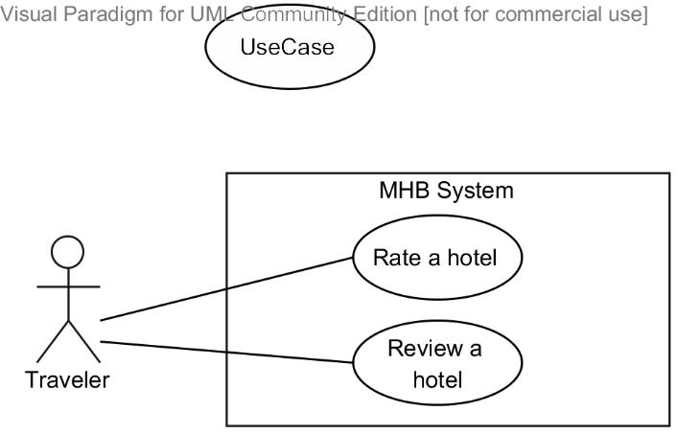

|  |  |  |  |  |
| --- | --- | --- | --- | --- |
| **RATE A HOTEL – SPECIFICATION** | | | | |
| **Use-case No.** | UC006 | **Use-case Version** | | 1.0 |
| **Use-case Name** | Rate a hotel | | | |
| **Author** | Nguyễn Phú An | | | |
| **Date** | 06/11/2013 | **Priority** | Low | |
| **Actor:**  Traveler  **Summary:**  This use case allows a traveler to rate a hotel with one or more rating criteria, so that the hotel owner can have feedback of their services and other users can see an overall assessments of the hotel services that this hotel provides.  **Goal:**  To rate a hotel based on a number of different criteria.  **Triggers:**  The user moves the mouse over the stars corresponding with a rating criterion and clicks on the star numbers corresponding with the rating point.  **Preconditions:**  The user is already logged in with an account which is granted the Traveler role.  A hotel details page is being displayed.  **Post Conditions:**  *On success:* The rating point for the criterion is saved. The overall rating average point and rating average point for the currently rated criterion is immediately updated.  *On failure:* An error message is displayed. The content of the error message will be specified in the Exception Scenario section based on the type of failure.  **Main Success Scenario:**   |  |  |  | | --- | --- | --- | | **Step** | **User Action** | **System Response** | | 1. | Moves the mouse over the stars corresponding the rating criterion to select the value.  Clicks on the star corresponding with the rating point. |  | | 2. |  | [See Exception No. 1]  Saves the rating point for the hotel; Updates the overall rating average point and rating average point for the currently rated criterion. |   **Alternative Scenario:**  N/A  **Exceptions:**   |  |  |  | | --- | --- | --- | | **No** | **User Action** | **System Response** | | 1. | Clicks on a star but the system encounters an exception when saving the rating point for the hotel. | Shows the popup “Không thể lưu đánh giá này do lỗi hệ thống”. |   **Relationships:**  N/A  **Business Rules:**   |  |  | | --- | --- | | **No** | **Business Rule Description** | | 1. | Each hotel can be rated by a number of criteria such as location and traffic, service quality, cleanliness, staff attitude… A traveler can rate each criterion a minimum of 0 point and a maximum of 5 points. | | | | | |

#### « Hotel Owner » Create a hotel

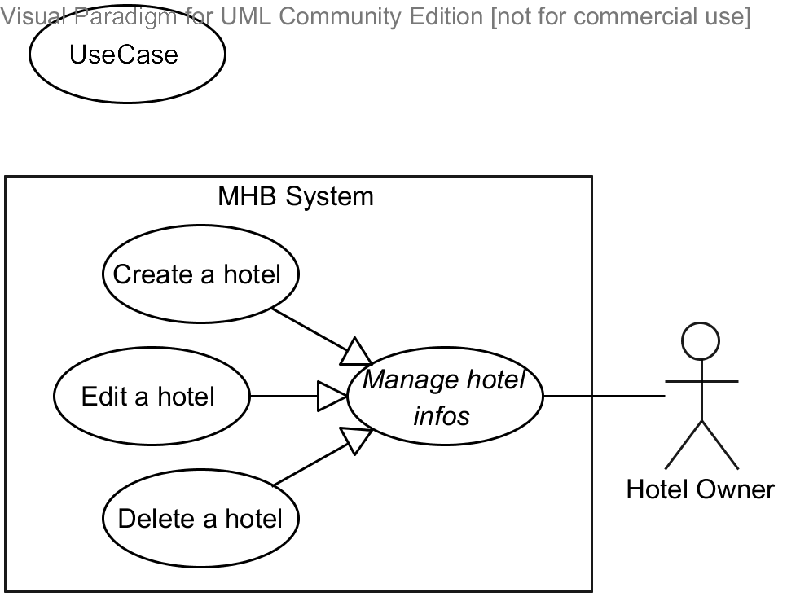

|  |  |  |  |  |
| --- | --- | --- | --- | --- |
| **CREATE A HOTEL – SPECIFICATION** | | | | |
| **Use-case No.** | UC007 | **Use-case Version** | | 1.0 |
| **Use-case Name** | Create a hotel | | | |
| **Author** | Nguyễn Hiếu Triệu Vỹ | | | |
| **Date** | 13/10/2013 | **Priority** | Normal | |
| **Actor:**  Hotel Owner  **Summary:**  This use case allows a hotel owner to create a hotel and specify its basic information. If the hotel is created by a hotel owner, a hotel opening request will be notified to the system admin.  **Goal:**  To manually open a new hotel in the MHB system.  **Triggers:**  The user clicks on the button “Tạo khách sạn mới” on the dashboard page or the link “Tạo khách sạn mới” on the home page.  **Preconditions:**  The user is already logged in with an account which is granted the Traveler, Hotel Owner, or System Admin role.  **Post Conditions:**  *On success:* A new hotel is added to the system. The user is redirected to the hotel list page which is now has a section that describes the currently added hotel.  *On failure:* An error message is displayed. Please refer to the Exception Scenario section the see what the content of the error message is.  **Main Success Scenario:**   |  |  |  | | --- | --- | --- | | **Step** | **User Action** | **System Response** | | 1. | Clicks on the button “Tạo khách sạn mới”. |  | | 2. |  | Displays a form that divided in to two sections. The first section includes the following items:   * “Tên khách sạn” (textbox; required; min length 5; max length 200) * “Tiêu chuẩn” (select list; required; values = 1, 2, 3, 4, 5) * “Tỉnh, thành phố” (dropdown list; required; values retrieved from database) * “Địa chỉ” (textbox with auto complete by Google map; required; min length 5; max length 200); * A google map whose center is the user current location; * “Email” (textbox, max length 254) * “Điện thoại” (textbox, max length 15) * “Trang web” (textbox, max length 200) * “Mô tả ngắn” (text area, required, min length 50, max length 500) * “Hình ảnh chính” (file upload)   The second section contains a list of all hotel features applicable for the hotel being created. Next to each feature, there is a field used to describe the specific information about it.  At the bottom of the page, there should be three buttons, respectively titled “Quay về trang quản lý”, “Lưu và quản về trang quản lý”, “Lưu và tiếp tục”. | | 3. | Fills out the form with relevant values.  [See Exception No. 1, 2, 3, 4, 5, 6, 7, 8, 9, 10, 11, 12, 13] |  | | 4. | Clicks the button “Lưu và quản về trang quản lý”.  [See Alternative No. 1, 2] |  | | 5. |  | Saves the hotels to the database and redirects the user to the hotel list page which now has a new section that describes the newly added hotel.  [See Exception No. 14] |   **Alternative Scenario:**   |  |  |  |  | | --- | --- | --- | --- | | **No** | **Step** | **User Action** | **System Response** | | 1. | 1. | Clicks on the button “Quay về trang quản lý”. |  | |  |  | Shows a popup to ask the user to confirm the action. | | 2. | The user chooses “OK”. |  | | 3. |  | If the user confirms to go back, redirects the user to the list page, otherwise, just hides the popup. | | 2. | 1. | Clicks on the button “Lưu và tiếp tục”. |  | | 2. |  | Saves the hotels to the database and redirects the user to the image gallery page. |   **Exceptions:**   |  |  |  | | --- | --- | --- | | **No** | **User Action** | **System Response** | | 1. | Leaves the field “Tên khách sạn” empty. | Shows the message “Vui lòng nhập tên khách sạn” next to the field. | | 2. | Fills the field “Tên khách sạn” with a value less than 5 or more than 200 characters. | Shows the message “Tên khách sạn phải từ 5 đến 200 ký tự” next to the field. | | 3. | Does not select an item in the select list “Tiêu chuẩn”. | Shows the message “Vui lòng chọn số sao của khách sạn” next to the select list. | | 4. | Does not select an item in the select list “Tỉnh, thành phố”. | Shows the message “Vui lòng chọn tỉnh, thành phố nơi khách sạn tọa lạc” next to the select list. | | 5. | Leaves the field “Địa chỉ” empty. | Shows the message “Vui lòng nhập địa chỉ” next to the field. | | 6. | Fills the field “Địa chỉ” with a value less than 5 or more than 200 characters. | Shows the message “Địa chỉ khách sạn phải từ 5 đến 200 ký tự” next to the field. | | 7. | Fills the field “Email” with a value that cannot be recognized as an email or is more than 254 characters. | Shows the message “Vui lòng nhập địa chỉ email hợp lệ” next to the field. | | 8. | Fills the field “Số điện thoại” with a value that cannot be recognized as a phone number. | Shows the message “Vui lòng nhập số điện thoại hợp lệ” next to the field. | | 9. | Fills the field “Trang web” with a value that cannot be recognized as a web address or is more than 200 characters. | Shows the message “Vui lòng nhập địa chỉ trang web hợp lệ” next to the field. | | 10. | Leaves the text area “Mô tả ngắn” empty. | Shows the message “Vui lòng nhập mô tả ngắn cho khách sạn” next to the text area. | | 11. | Fills the text area “Mô tả ngắn”with a value less than 50 or more than 500 characters. | Shows the message “Mô tả phải từ 50 đến 500 ký tự” next to the text area. | | 12. | Fills the field “Địa chỉ” but an error occurs when accessing to Google Place Service. | Shows the message “Không thể tìm địa chỉ trên Google” next to the field. | | 14. | Clicks the button “Lưu và quản về trang quản lý” or “Lưu và tiếp tục”. | Encounters an exception when inserting the hotel into the database. Shows the popup “Không thể thêm khách sạn mới do lỗi hệ thống”. |   **Relationships:**  “Manage Hotel Infos” abstract use case  **Business Rules:**   |  |  | | --- | --- | | **No** | **Business Rule Description** | | 1. | After inserted into the system, the hotel is still not searchable or filterable on the customer portal and is not accessible to the hotel owner. Only if the system admin approves of the hotel can the hotel owner get access to it and add or change its information. | | | | | |

#### « Hotel Owner » Edit a hotel



|  |  |  |  |  |
| --- | --- | --- | --- | --- |
| **EDIT A HOTEL – SPECIFICATION** | | | | |
| **Use-case No.** | UC008 | **Use-case Version** | | 1.0 |
| **Use-case Name** | Edit a hotel | | | |
| **Author** | Nguyễn Hiếu Triệu Vỹ | | | |
| **Date** | 13/10/2013 | **Priority** | Low | |
| **Actor:**  Hotel Owner  **Summary:**  This use case allows a hotel owner to view and manually change information about an existing hotel in the database. Only activated hotels can be modified by their owners.  **Goal:**  To manually edit information of an existing hotel in the system.  **Triggers:**  The user clicks on the button “Thông tin cơ bản” on a hotel management page. Note that each hotel has its own management page for its hotel owner to monitor information and changes.  **Preconditions:**  The user is already logged in with an account which is granted the Hotel Owner or System Admin role.  The selected hotel must be activated in the system.  The hotel management page is being displayed.  **Post Conditions:**  *On success:* The information of selected hotel is updated in the system. The user is redirected to the hotel management page where information is currently updated.  *On failure:* An error message is displayed. The content of the error message will be specified in the Exception Scenario section based on the type of failure.  **Main Success Scenario:**   |  |  |  | | --- | --- | --- | | **Step** | **User Action** | **System Response** | | 1. | Clicks on the button “Thông tin cơ bản” on the row that contains the hotel to be edited. |  | | 2. |  | [See Exception No. 1]  Displays a form that divided in to two sections. The first section includes the items listed below. All the fields are filled with the corresponding information of the selected hotel.   * “Tên khách sạn” (textbox; disabled) * “Tiêu chuẩn” (select list; required; values = 1, 2, 3, 4, 5) * “Tỉnh, thành phố” (dropdown list; required; values retrieved from database) * “Địa chỉ” (textbox with auto complete by Google map; required; min length 5; max length 200); * A google map whose center is the location of the selected hotel; * “Email” (textbox, max length 254) * “Điện thoại” (textbox, max length 15) * “Trang web” (textbox, max length 200) * “Mô tả ngắn” (text area, required, min length 50, max length 500) * “Hình ảnh chính” (file upload)   The second section contains a list of all hotel features applicable for the hotel being created. Next to each feature, there is a field used to describe the specific information about it. All the features related to the hotel and their descriptions are also displayed. | | 3. | Changes the existing information with relevant values.  [See Exception No. 2, 3, 4, 5, 6, 7, 8, 9, 10, 11] |  | | 4. | Clicks the button “Lưu và quản về trang quản lý”.  [See Alternative No. 1, 2] |  | | 5. |  | Saves the updated information for the hotel and redirects the user to the hotel management page of the selected hotel where the information is currently updated.  [See Exception No. 12] |   **Alternative Scenario:**   |  |  |  |  | | --- | --- | --- | --- | | **No** | **Step** | **User Action** | **System Response** | | 1. | 1. | Clicks on the button “Quay về trang quản lý”. |  | |  |  | Shows a popup to ask the user to confirm the action. | | 2. | The user chooses “OK”. |  | | 3. |  | If the user confirms to go back, redirects the user to the list page, otherwise, just hides the popup. | | 2. | 1. | Clicks on the button “Lưu và tiếp tục”. |  | | 2. |  | Saves the hotels to the database and redirects the user to the image gallery page. |   **Exceptions:**   |  |  |  | | --- | --- | --- | | **No** | **User Action** | **System Response** | | 1. | Clicks on the “Thông tin cơ bản” button but the system could not find the selected hotel because it has been marked deleted while viewing the hotel list page. | Shows the popup “Khách sạn bạn chọn hiện không còn trong hệ thống nữa”. | | 2. | Does not select an item in the select list “Tiêu chuẩn”. | Shows the message “Vui lòng chọn số sao của khách sạn” next to the select list. | | 3. | Does not select an item in the select list “Tỉnh, thành phố”. | Shows the message “Vui lòng chọn tỉnh, thành phố nơi khách sạn tọa lạc” next to the select list. | | 4. | Leaves the field “Địa chỉ” empty. | Shows the message “Vui lòng nhập địa chỉ” next to the field. | | 5. | Fills the field “Địa chỉ” with a value less than 5 or more than 200 characters. | Shows the message “Địa chỉ khách sạn phải từ 5 đến 200 ký tự” next to the field. | | 6. | Fills the field “Email” with a value that cannot be recognized as an email or is more than 254 characters. | Shows the message “Vui lòng nhập địa chỉ email hợp lệ” next to the field. | | 7. | Fills the field “Số điện thoại” with a value that cannot be recognized as a phone number or is more than 15 characters. | Shows the message “Vui lòng nhập số điện thoại hợp lệ” next to the field. | | 8. | Fills the field “Trang web” with a value that cannot be recognized as a web address. | Shows the message “Vui lòng nhập địa chỉ trang web hợp lệ” next to the field. | | 9. | Leaves the text area “Mô tả ngắn” empty. | Shows the message “Vui lòng nhập mô tả ngắn cho khách sạn” next to the text area. | | 10. | Fills the text area “Mô tả ngắn”with a value less than 50 or more than 500 characters. | Shows the message “Mô tả phải từ 50 đến 500 ký tự” next to the text area. | | 11. | Fills the field “Địa chỉ” but an error occurs when accessing to Google Place Service. | Shows the message “Không thể tìm địa chỉ trên Google” next to the field. | | 12. | Clicks the button “Lưu và quản về trang quản lý” or “Lưu và tiếp tục”. | Encounters an exception when inserting the hotel into the database. Shows the popup “Không thể thêm khách sạn mới do lỗi hệ thống”. |   **Relationships:**  “Manage Hotel Infos” abstract use case  **Business Rules:**   |  |  | | --- | --- | | **No** | **Business Rule Description** | | 1. | Only activated hotels can be modified by their respective hotel owners or system admins. If a hotel is not under the management of a hotel owner, he or she cannot modify it. | | 2. | A hotel owner can modify all information about the hotel except for the hotel name. | | | | | |

#### « Hotel Owner » Delete a hotel



|  |  |  |  |  |
| --- | --- | --- | --- | --- |
| **DELETE A HOTEL – SPECIFICATION** | | | | |
| **Use-case No.** | UC009 | **Use-case Version** | | 1.0 |
| **Use-case Name** | Delete a hotel | | | |
| **Author** | Nguyễn Hiếu Triệu Vỹ | | | |
| **Date** | 13/10/2013 | **Priority** | Low | |
| **Actor:**  Hotel Owner  **Summary:**  This use case allows a hotel owner to remove an existing hotel from the system.  **Goal:**  To manually remove an existing hotel from the system.  **Triggers:**  The user clicks on the button “Xóa” on the section that contains the hotel to be deleted in the dashboard page.  **Preconditions:**  The user is already logged in with an account which is granted the Hotel Owner or System Admin role.  The hotel list page is being displayed.  **Post Conditions:**  *On success:* The selected hotel is marked as deleted in the database. The row that contains the selected hotel is removed from the hotel list page.  *On failure:* An error message is displayed. The content of the error message will be specified in the Exception Scenario section based on the type of failure.  **Main Success Scenario:**   |  |  |  | | --- | --- | --- | | **Step** | **User Action** | **System Response** | | 1. | Clicks on the button “Xóa” on the row that contains the hotel to be deleted. |  | | 2. |  | [See Exception No. 1]  Shows a popup to ask the user to confirm the action. | | 3. | Chooses “OK” to continue to delete the hotel.  [See Alternative No. 1] | Marks the selected hotel as deleted in the database.  Removes the row that contains the selected hotel from the hotel list page.  [See Exception No. 2, 3] |   **Alternative Scenario:**   |  |  |  |  | | --- | --- | --- | --- | | **No** | **Step** | **User Action** | **System Response** | | 1. | 1. | Clicks on the button “Hủy bỏ”. |  | | 2. |  | Hides the popup message. |   **Exceptions:**   |  |  |  | | --- | --- | --- | | **No** | **User Action** | **System Response** | | 1. | Clicks on the “Xóa” button but the system could not find the selected hotel because it has been marked as deleted while viewing the hotel list page. | Shows the popup “Khách sạn bạn chọn hiện không còn trong hệ thống nữa”. | | 2. | Clicks on the button “Xóa” but the system encounters an exception when marking the hotel as deleted in the database. | Shows the popup “Không thể xóa khách sạn vào database do lỗi server”. | | 3. | Clicks on the button “Xóa” but the hotel is not under the management of the hotel owner. | Shows the popup “Bạn không có quyền xóa khách sạn này”. |   **Relationships:**  “Manage Hotel Infos” abstract use case  **Business Rules:**   |  |  | | --- | --- | | **No** | **Business Rule Description** | | 1. | A hotel can be deleted by their respective hotel owners or system admins. If a hotel is not under the management of a hotel owner, he or she cannot delete it from the system. | | | | | |

#### « Hotel Owner » Add a room type

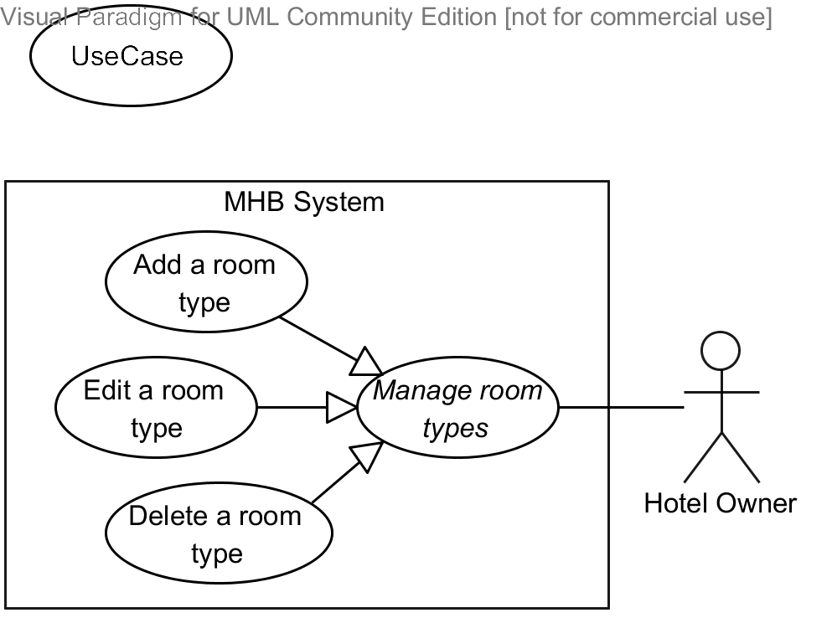

|  |  |  |  |  |
| --- | --- | --- | --- | --- |
| **ADD A ROOM TYPE – SPECIFICATION** | | | | |
| **Use-case No.** | UC010 | **Use-case Version** | | 1.0 |
| **Use-case Name** | Add a room type | | | |
| **Author** | Bùi Minh Đức | | | |
| **Date** | 16/10/2013 | **Priority** | Normal | |
| **Actor:**  Hotel Owner  **Summary:**  This use case allows a hotel owner to manually add information about a new room type of a hotel under his or her management.  **Goal:**  To manually insert a new room type into the database.  **Triggers:**  The user clicks on the button “Tạo loại phòng mới” on the hotel management page.  **Preconditions:**  The user is already logged in with an account which is granted the Hotel Owner role.  The hotel management page of a hotel under the actor’s management is being displayed.  **Post Conditions:**  *On success:* A new room type is added to the database. The user is redirected to the hotel management page which is now has a new section that describes the currently added room type.  *On failure:* An error message is displayed. The content of the error message will be specified in the Exception Scenario section based on the type of failure.  **Main Success Scenario:**   |  |  |  | | --- | --- | --- | | **Step** | **User Action** | **System Response** | | 1. | Clicks on the button “Tạo loại phòng mới”. |  | |  |  | Displays a form that has the following items:   * “Tên loại phòng” (textbox; required; min length 3; max length 100) * “Số lượng phòng mặc định” (dropdown list; required; values from 1 to 100) * “Mô tả ngắn” (textbox; required; min length 5; max length 500) * “Giá mặc định” (textbox; not required; values from 10,000 to 99,999,999) * “Hình ảnh phòng” (file upload; required; image mime type) * “Số người ở được” (dropdown list; required; values from 1 to 10) * “Cho phép ở thêm người” (checkbox) * “Số trẻ em có thể ở thêm tối đa” (dropdown list; values from 1 to 3) * “Số người lớn có thể ở thêm tối đa” (dropdown list; values from 1 to 3) * “Tổng số người có thể ở thêm tối đa” (dropdown list; values from 1 to 6) | | 3. | Fills out the form with relevant values.  [See Exception No. 1, 2, 3, 4, 5, 6, 7]  [See Alternative No. 1] |  | | 4. | Clicks the button “Lưu”.  [See Alternative No. 2] |  | | 5. |  | Saves the room type to the database and redirects the user to the hotel list page which now has a new section that describes the newly added hotel.  [See Exception No. 8] |   **Alternative Scenario:**   |  |  |  |  | | --- | --- | --- | --- | | **No** | **Step** | **User Action** | **System Response** | | 1. | 1. | Checks / unchecks the check box  “Cho phép ở thêm người”. |  | |  | 2. |  | Enables / Disables the dropdown lists named “Số trẻ em có thể ở thêm tối đa”, “Số người lớn có thể ở thêm tối đa”, and “Tổng số người có thể ở thêm tối đa”. | | 2. | 1. | Clicks on the button “Quay về”. |  | |  |  | Shows a popup to ask the user to confirm the action. | | 2. | The user chooses “OK”. |  | | 3. |  | If the user confirms to go back, redirects the user to the list page, otherwise, just hides the popup. |   **Exceptions:**   |  |  |  | | --- | --- | --- | | **No** | **User Action** | **System Response** | | 1. | Leaves the field “Tên loại phòng” empty. | Shows the message “Vui lòng nhập tên loại phòng không kể khoảng trắng ở đầu và cuối.” next to the field. | | 2. | Fills the field “Tên loại phòng” with a value less than 3 or more than 100 characters. | Shows the message “Tên loại phòng phải từ 3 đến 100 ký tự” next to the field. | | 3. | Leaves the field “Số lượng phòng” empty. | Shows the message “Vui lòng nhập số lượng phòng” next to the field. | | 4. | Fills the field “Số lượng phòng” with a value which is less than 0 or not number. | Shows the message “Giá trị số lượng phòng phải là số nguyên dương hoặc bằng 0” next to the select list. | | 5. | Fills the field “Mô tả ngắn” with a value less than 5 or more than 200 characters. | Shows the message “Tên loại phòng phải từ 5 đến 200 ký tự, không kể khoảng trắng ở đầu và cuối.” next to the field. | | 6. | Fills the field “Giá mặc định” with a value out of the range from 10,000 to 99,999,999. | Shows the message “Giá trị giá mặc định phải là số nguyên dương từ 10,000 đồng đến 99,999,999 đồng” next to the select list. | | 7. | Selects the value of max extra people number out of the range from the smaller value of the max extra children number and max extra adults number, to the sum of these two numbers. | Shows the message “Số người ở được tối đa không hợp lệ” next to the select list; Automatically adjusts the max extra people number to the sum of max extra children number and max extra adults number. | | 8. | Clicks on the button “Lưu”. | Encounters an exception when inserting the room type into the database; Shows the popup “Không thể thêm loại phòng này vào database do lỗi server”. |   **Relationships:**  “Manage room types” abstract use case  **Business Rules:**   |  |  | | --- | --- | | **No** | **Business Rule Description** | | 1. | Hotel owners manage their hotels by using room types, groups of rooms that have similar features and prices and do not care about each physical room in the hotel. | | 2. | The price of a room ranges from VND10,000 to VND99,999,999. | | 3. | Vietnam Dong is the official currency for specifying room prices. | | | | | |

#### « Hotel Owner » Edit a room type



|  |  |  |  |  |
| --- | --- | --- | --- | --- |
| **EDIT A ROOM TYPE – SPECIFICATION** | | | | |
| **Use-case No.** | UC011 | **Use-case Version** | | 1.0 |
| **Use-case Name** | Edit a room type | | | |
| **Author** | Bùi Minh Đức | | | |
| **Date** | 19/10/2013 | **Priority** | Low | |
| **Actor:**  Hotel Owner  **Summary:**  This use case allows a hotel owner to view and manually modify information about an existing room type in the database.  **Goal:**  To manually edit information of an existing room type in the database.  **Triggers:**  The user clicks on the button “Chỉnh sửa” on the section that contains the room type to be edited in the hotel management page.  **Preconditions:**  The user is already logged in with an account which is granted the Hotel Owner role.  The hotel management page of the selected hotel is being displayed.  **Post Conditions:**  *On success:* The selected room type is updated in the database. The user is redirected to the room type list page.  *On failure:* An error message is displayed. The content of the error message will be specified in the Exception Scenario section based on the type of failure.  **Main Success Scenario:**   |  |  |  | | --- | --- | --- | | **Step** | **User Action** | **System Response** | | 1. | Clicks on the button “Chỉnh sửa” on the row that contains the room type to be edited. | [See Exception No. 1]  Populates all the information of the selected room type into an editable form that contains the following fields:  Displays a form that has the following items:   * “Tên loại phòng” (textbox; required; min length 3; max length 100) * “Số lượng phòng mặc định” (dropdown list; required; values from 1 to 100) * “Mô tả ngắn” (textbox; required; min length 5; max length 500) * “Giá mặc định” (textbox; not required; values from 10,000 to 99,999,999) * “Hình ảnh phòng” (file upload; required; image mime type) * “Số người ở được” (dropdown list; required; values from 1 to 10) * “Cho phép ở thêm người” (checkbox) * “Số trẻ em có thể ở thêm tối đa” (dropdown list; values from 1 to 3) * “Số người lớn có thể ở thêm tối đa” (dropdown list; values from 1 to 3) * “Tổng số người có thể ở thêm tối đa” (dropdown list; values from 1 to 6) | | 3. | Changes the existing information with relevant values.  [See Exception No. 2, 3, 4, 5, 6, 7, 8]  [See Alternative No. 1] |  | | 4. | Clicks the button “Lưu”.  [See Alternative No. 2] |  | | 5. |  | Saves the room type to the database and redirects the user to the room type list page.  [See Exception No. 9] |   **Alternative Scenario:**   |  |  |  |  | | --- | --- | --- | --- | | **No** | **Step** | **User Action** | **System Response** | | 1. | 1. | Checks / unchecks the check box  “Cho phép ở thêm người”. |  | |  | 2. |  | Enables / Disables the dropdown lists named “Số trẻ em có thể ở thêm tối đa”, “Số người lớn có thể ở thêm tối đa”, and “Tổng số người có thể ở thêm tối đa”. | | 2. | 1. | Clicks on the button “Quay về”. |  | |  |  | Shows a popup to ask the user to confirm the action. | | 2. | The user chooses “OK”. |  | | 3. |  | If the user confirms to go back, redirects the user to the list page, otherwise, just hides the popup. |   **Exceptions:**   |  |  |  | | --- | --- | --- | | **No** | **User Action** | **System Response** | | 1. | Clicks on the “Chỉnh sửa” button but the system could not find the selected room type because it has been marked deleted while viewing the hotel list page. | Shows the popup “Loại phòng bạn chọn hiện không còn trong hệ thống nữa”. | | 2. | Leaves the field “Tên loại phòng” empty. | Shows the message “Vui lòng nhập tên loại phòng.” next to the field. | | 3. | Fills the field “Tên loại phòng” with a value less than 3 or more than 100 characters. | Shows the message “Tên loại phòng phải từ 3 đến 100 ký tự” next to the field. | | 4. | Leaves the field “Số lượng phòng” empty. | Shows the message “Vui lòng nhập số lượng phòng” next to the field. | | 5. | Fills the field “Số lượng phòng” with a value which is less than 0 or not number. | Shows the message “Giá trị số lượng phòng phải là số nguyên dương hoặc bằng 0” next to the select list. | | 6. | Fills the field “Mô tả ngắn” with a value less than 5 or more than 200 characters. | Shows the message “Tên loại phòng phải từ 5 đến 200 ký tự, không kể khoảng trắng ở đầu và cuối.” next to the field. | | 7. | Fills the field “Giá mặc định” with a value out of the range from 10,000 to 99,999,999. | Shows the message “Giá trị giá mặc định phải là số nguyên dương từ 10,000 đồng đến 99,999,999 đồng” next to the select list. | | 8. | Selects the value of max extra people number out of the range from the smaller value of the max extra children number and max extra adults number, to the sum of these two numbers. | Shows the message “Số người ở được tối đa không hợp lệ” next to the select list; Automatically adjusts the max extra people number to the sum of max extra children number and max extra adults number. | | 9. | Clicks on the button “Lưu”. | Encounters an exception when inserting the room type into the database. Shows the popup “Không thể cập nhật loại phòng này vào database do lỗi server”. |   **Relationships:**  “Manage room types” abstract use case  **Business Rules:**  N/A | | | | |

#### « Hotel Owner » Delete a room type



|  |  |  |  |  |
| --- | --- | --- | --- | --- |
| **DELETE A ROOM TYPE – SPECIFICATION** | | | | |
| **Use-case No.** | UC012 | **Use-case Version** | | 1.0 |
| **Use-case Name** | Delete a room type | | | |
| **Author** | Bùi Minh Đức | | | |
| **Date** | 13/10/2013 | **Priority** | Low | |
| **Actor:**  Hotel Owner  **Summary:**  This use case allows a hotel owner to manually remove an existing room type from a hotel under his or her management.  **Goal:**  To manually remove an existing room type from the system.  **Triggers:**  The user clicks on the button “Xóa” on the section that contains the room type to be deleted in the hotel management page.  **Preconditions:**  The user is already logged in with an account which is granted the Hotel Owner role.  The hotel management page of the selected hotel is being displayed.  **Post Conditions:**  *On success:* The selected room type is marked as deleted in the database. The row that contains the selected room type is removed from the room type list page.  *On failure:* An error message is displayed. The content of the error message will be specified in the Exception Scenario section based on the type of failure.  **Main Success Scenario:**   |  |  |  | | --- | --- | --- | | **Step** | **User Action** | **System Response** | | 1. | Clicks on the button “Xóa loại phòng” on the row that contains the room type to be deleted. |  | | 2. |  | Shows a popup to ask the user to confirm the action. | | 3. | Chooses “Đồng ý” to continue to delete the room type.  [See Alternative No. 1] |  | | 4. |  | Marks the selected room type as deleted in the database.  Removes the section that contains the selected room type from the room type list page.  [See Exception No.1, No. 2] |   **Alternative Scenario:**   |  |  |  |  | | --- | --- | --- | --- | | **No** | **Step** | **User Action** | **System Response** | | 1. | 1. | Clicks on the button “Hủy bỏ”. |  | |  | 2. |  | Hides the popup message. |   **Exceptions:**   |  |  |  | | --- | --- | --- | | **No** | **User Action** | **System Response** | | 1. | Clicks on the “Xóa” button but the system could not find the selected room type because it has been marked as deleted while viewing the room type list page. | Shows the popup “Loại phòng bạn chọn hiện không còn trong hệ thống nữa”. | | 2. | Clicks on the button “Lưu” but the system encounters an exception when marking the room type as deleted in the database. | Shows the popup “Không thể xóa loại phòng này trong database do lỗi server”. |   **Relationships:**  “Manage room types” abstract use case  **Business Rules:**  N/A | | | | |

#### « Hotel Owner » View price calendar

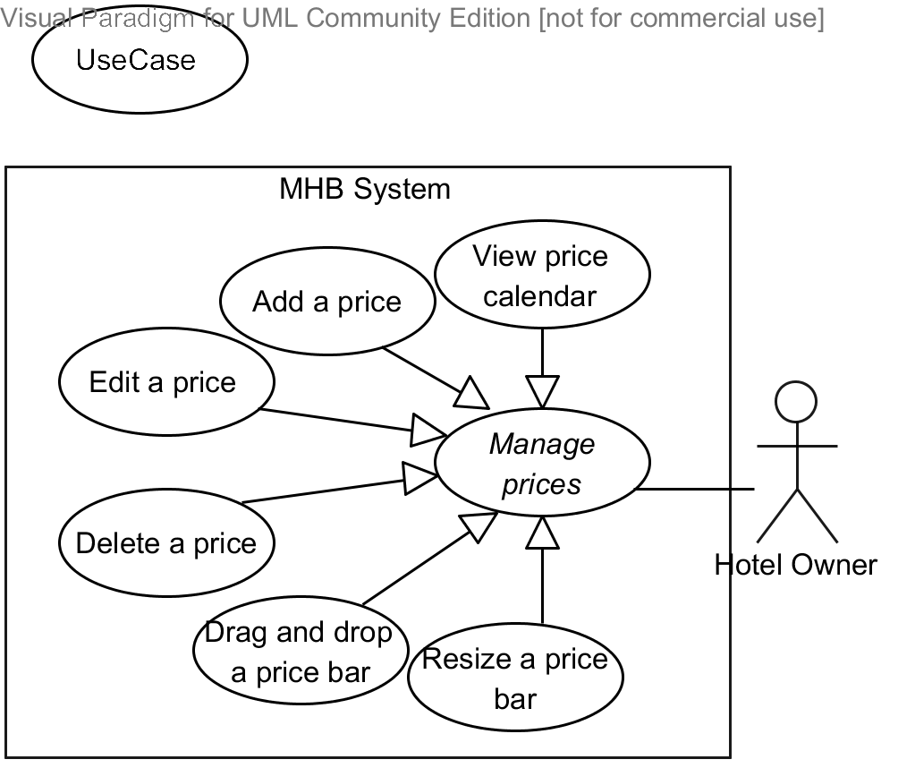

|  |  |  |  |  |
| --- | --- | --- | --- | --- |
| **VIEW PRICE CALENDAR – SPECIFICATION** | | | | |
| **Use-case No.** | UC013 | **Use-case Version** | | 1.0 |
| **Use-case Name** | View price calendar | | | |
| **Author** | Bùi Minh Đức | | | |
| **Date** | 19/10/2013 | **Priority** | High | |
| **Actor:**  Hotel Owner  **Summary:**  This use case allows a hotel owner to view prices of a specific room type displayed in the form of a calendar. Note that the MHB system allows room prices to vary day by day, reflecting the actual prices of the rooms.  **Goal:**  To view all prices that belong to a selected room type of a hotel under the user’s management in a calendar format.  **Triggers:**  The user clicks button “Quản lý giá” in room type list page.  **Preconditions:**  The user is already logged in with an account which is granted the Hotel Owner role.  The hotel management page of the selected hotel is being displayed.  **Post Conditions:**  *On success:* The price calendar is displayed and show all relevant prices.  *On failure:* The price calendar is displayed but show no price or the page redirect to HTTP 404 page.  **Main Success Scenario:**   |  |  |  | | --- | --- | --- | | **Step** | **User Action** | **System Response** | | 1. | Clicks button “Giá phòng” the section that describe a room type in the hotel management page. |  | | 2. |  | Displays the price calendar and displays all prices found in the current month in price calendar.   * The price calendar should be a grid with each cell representing a day in a month. A backward and a forward buttons are used to navigate between months. * A price is represented by a horizontal bar with its label including the price and the number of available rooms. * Prices that remain unchanged during a period are grouped together as a longer horizontal bar for simplicity. If the price bar is in the past, it should be in red; if the price bar is in the future, it should be in blue; and if the price bar contains the current system date, it should be in violet. * For each day, there is a bar that counts the number of bookings that include that day.   [See Exception No. 1, 2] |   **Alternative Scenario:**   |  |  |  |  | | --- | --- | --- | --- | | **No** | **Step** | **User Action** | **System Response** | | 1. | 1. | Clicks on the back or forward button in price calendar. |  | |  | 2. |  | Load prices of the selected month and displays them as specified above.  [See Exception No. 3] | | 2. | 1. | Clicks on a price bar in price calendar. |  | |  | 2. |  | Displays a popup form that show price’s detail information.  [See Exception No. 4, 5] |   **Exceptions:**   |  |  |  | | --- | --- | --- | | **No** | **User Action** | **System Response** | | 1. | Clicks button “Giá phòng” in hotel mangement page but the system can not find any prices for the selected room. | Shows an empty price calendar. | | 2. | Clicks button “Giá phòng” in room type list page but the system can not find the room type in the system. | Redirects to the 404 Page not found page. | | 3. | Clicks on the back or forward button in the price calendar but the system can not load price in the selected month. | Shows an empty price calendar and prompts the message “Không thể tải giá của tháng X”, where X is the selected month. | | 4. | Clicks on a price bar in price calendar but the system checks and finds that price has been marked as deleted. | Shows the message “Không thể xem giá này, giá này đã bị xóa”. | | 5. | Clicks on a price bar in price calendar but the system can’t load the price cause system error. | Show the message “Lỗi, không thể xem giá này”. |   **Relationships:**  “Manage prices” abstract use case  **Business Rules:**   |  |  | | --- | --- | | **No** | **Business Rule Description** | | 1. | Each room type has a number of prices. The prices of the same room type differentiate from each other by the days on which a price takes place. For example, if a room is sold at VND100,000 for the days from Dec 10 to Dec 20 and then at VND120,000 for the days from Dec 21 to Dec 25, it is said to have two prices from Dec 10 to Dec 25. | | 2. | For a room type, the days of a price should not overlap the days of the other prices. | | 3. | For each day on which there is a price that takes place, there is a daily status that stores the actual number of available rooms. | | | | | |

#### « Hotel Owner » Add a price



|  |  |  |  |  |
| --- | --- | --- | --- | --- |
| **ADD A PRICE – SPECIFICATION** | | | | |
| **Use-case No.** | UC014 | **Use-case Version** | | 1.0 |
| **Use-case Name** | Add a price | | | |
| **Author** | Bùi Minh Đức | | | |
| **Date** | 25/10/2013 | **Priority** | Normal | |
| **Actor:**  Hotel Owner  **Summary:**  This use case allows a hotel owner to manually add information about a new price of a selected room type in a hotel under his or her management to the database.  **Goal:**  To insert a new price of the selected room type into the database.  **Triggers:**  The user clicks on the date square in the price calendar in the price management page.  **Preconditions:**  The user is already logged in with an account which is granted the Hotel Owner role.  The price calendar for the selected room type is being displayed.  **Post Conditions:**  *On success:* A new price is added to the database. The price calendar now has a new price bar.  *On failure:* An error message is displayed. The content of the error message will be specified in the Exception Scenario section based on the type of failure.  **Main Success Scenario:**   |  |  |  | | --- | --- | --- | | **Step** | **User Action** | **System Response** | | 1. | Clicks on a date square in price calendar.  [See Alternative No. 1, 2] | Displays a popup form that has the following fields:   * “Giá phòng” (textbox; required; min value: 10,000; max value: 99,999,999) * “Số phòng còn trống” (dropdown list; required; values from 0 to the room quantity of the selected room, the largest value is selected already) * “Từ ngày” (textbox; required; date time format) * “Đến ngày” (textbox; required; date time format) * “Lưu”, “Quay về” (button)   If the selected room type allows extra children, displays the additional field:   * “Phụ thu trẻ em” (textbox; required; min value: 10,000; max value: 99,999,999)   If the selected room type allows extra adults, displays the additional field:   * “Phụ thu người lớn” (textbox; required; min value: 10,000; max value: 99,999,999) | | 2. | Fills out the form with relevant values.  [See Exception No. 1, 2, 3, 4, 5, 6, 7, 8, 9, 10, 11, 12, 13, 14] |  | | 3. | Clicks the button “Lưu”.  [See Alternative No. 3] | Saves the price to the database; Adds the currently added prices as a new price bar in the calendar.  [See Exception No. 15] |   **Alternative Scenario:**   |  |  |  |  | | --- | --- | --- | --- | | **No** | **Step** | **User Action** | **System Response** | | 1. | 1. | Clicks on a date square in price calendar. |  | |  | 2. |  | Checks and finds that there have already been a price on that date. Shows a popup message that notifies “Không thể thêm giá vào ngày này”. | | 2. | 1. | Clicks on a date square in price calendar. |  | |  |  |  | System checked and found that that date is in the past. System show a popup message notify user that “Không thể thêm giá trong qua khứ”. | | 3. | 1. | Clicks on the button “Quay về”. | Shows a popup to ask the user to confirm the action. | |  |  |  | | 2. | The user chooses “OK”. |  | |  |  | Redirects the user to the list page, otherwise, just hides the popup. |   **Exceptions:**   |  |  |  | | --- | --- | --- | | **No** | **User Action** | **System Response** | | 1. | Leaves the field “Giá phòng” empty. | Shows the message “Vui lòng nhập giá phòng” next to the field. | | 2. | Fills the field “Giá phòng” with a value out of the range from 10,000 to 99,999,999. | Shows the message “Giá trị của giá phòng phải là số nguyên dương từ 10,000đ đến 99,999,999đ” next to the field. | | 3. | Leaves the field “Số phòng còn trống” empty. | Shows the message “Vui lòng nhập số phòng còn trống” next to the field. | | 4. | Fills the field “Số phòng còn trống” with a value less than 0 or greater than the default quantity of the selected room type. | Shows the message “Giá trị của số phòng còn trống phải là số nguyên dương lớn hơn hoặc bằng 0” next to the field. | | 5. | Leaves the field “Từ ngày” empty. | Shows the message “Vui lòng nhập thời gian bắt đầu” next to the field. | | 6. | Fills the field “Từ ngày” with a value which is not date time format. | Shows the message “Giá trị phải đúng theo kiểu ngày/tháng/năm” next to the select list. | | 8. | Fills the field “Từ ngày” a date which is in the past. | Shows the message “Giá trị từ ngày không được nằm trong qua khứ” next to the select list. | | 9. | Leaves the field “Đến ngày” empty. | Shows the message “Vui lòng nhập thời gian kết thúc” next to the field. | | 10. | Fills the field “Đến ngày” with a value which is not date time format. | Shows the message “Giá trị phải đúng theo kiểu ngày/tháng/năm” next to the select list. | | 11. | Fills the field “Đến ngày” a date which is in the past | Shows the message “Giá trị đến ngày không được nằm trong qua khứ” next to the select list. | | 12. | Fills the field “Phụ thu trẻ em” with a non-numeric value. | Shows the message “Giá trị phụ thu trẻ em phải là số” next to the select list. | | 13. | Fills the field “Phụ thu trẻ em” with a number out of the range from 10,000 to 99,999,999. | Shows the message “Giá trị phụ thu trẻ em phải nằm trong khoảng từ 10,000đ đến 99,999,999đ” next to the select list. | | 14. | Fills the field “Phụ thu người lớn” with a non-numeric value. | Shows the message “Giá trị phụ thu người lớn phải là số” next to the select list. | | 15. | Fills the field “Phụ thu người lớn” with a value out of the range from 10,000 to 99,999,999. | Shows the message “Giá trị phụ thu người lớn phải là số” next to the select list. | | 16. | Clicks on the button “Lưu”. | Encounters an exception when inserting the price into the database; shows the popup “Không thể thêm giá này vào database do lỗi server”. |   **Relationships:**  “Manage prices” abstract use case  **Business Rules:**   |  |  | | --- | --- | | **No** | **Business Rule Description** | | 1. | For each room type, there is a default number of rooms, which is the actual number of rooms of this type in the hotel. However, for some reasons, the hotel owner may not want to sell all these rooms on the MHB system, therefore the system also allows hotel owners to maintain a different number of an available rooms when they specify prices. | | 2. | The fields “Phụ thu trẻ em” and “Phụ thu người lớn” should be displayed only when the room type allows for extra children or extra adults to stay, in addition to the default number of people who can stay in the room. | | | | | |

#### « Hotel Owner » Edit a price



|  |  |  |  |  |
| --- | --- | --- | --- | --- |
| **EDIT A PRICE – SPECIFICATION** | | | | |
| **Use-case No.** | UC015 | **Use-case Version** | | 1.0 |
| **Use-case Name** | Edit a a price | | | |
| **Author** | Bùi Minh Đức | | | |
| **Date** | 23/10/2013 | **Priority** | Normal | |
| **Actor:**  Hotel Owner  **Summary:**  This use case allows a hotel owner to view and manually edit information about an existing price of a room type in the database.  **Goal:**  To edit information of an existing price of a room type in the database.  **Triggers:**  The user clicks on the price bar that he or she wants to edit in the price calendar.  **Preconditions:**  The user is already logged in with an account which is granted the Hotel Owner role.  The price calendar for the selected room type is being displayed.  **Post Conditions:**  *On success:* The selected price is updated in the database. The modified price is also updated in the price calendar.  *On failure:* An error message is displayed. The content of the error message will be specified in the Exception Scenario section based on the type of failure.  **Main Success Scenario:**   |  |  |  | | --- | --- | --- | | **Step** | **User Action** | **System Response** | | 1. | The user clicks on the price bar that user want to edit in the price calendar. | [See Exception No. 1]  Displays a popup form already filled with information about the selected price that has the following fields:   * “Giá phòng” (textbox; required; min value: 10,000; max value: 99,999,999) * “Số phòng còn trống” (dropdown list; required; values from 0 to the room quantity of the selected room, the largest value is selected already) * “Từ ngày” (textbox; required; date time format) * “Đến ngày” (textbox; required; date time format) * “Lưu”, “Quay về” (button)   If the selected room type allows extra children, displays the additional field:   * “Phụ thu trẻ em” (textbox; required; min value: 10,000; max value: 99,999,999)   If the selected room type allows extra adults, displays the additional field:  “Phụ thu người lớn” (textbox; required; min value: 10,000; max value: 99,999,999) | | 2. | Changes the existing information with relevant values.  [See Exception No. 2, 3, 4, 5, 6, 7, 8, 9, 10, 11, 12, 13, 14, 15] |  | | 3. | Clicks the button “Lưu”.  [See Alternative No. 1, 2] |  | |  |  | Saves the edited price to the database and show message to notify user that save successfully.  [See Exception No. 16] |   **Alternative Scenario:**   |  |  |  |  | | --- | --- | --- | --- | | **No** | **Step** | **User Action** | **System Response** | | 1. | 1. | Clicks on the button “Quay lại”. |  | | 2. |  | Shows a popup to ask the user to confirm the action. | | 3. | The user chooses “OK”. |  | | 4. |  | If the user confirms to go back, redirects the user to the list page, otherwise, just hides the popup. |   **Exceptions:**   |  |  |  | | --- | --- | --- | | **No** | **User Action** | **System Response** | | 1. | Clicks on the price bar that user want to edit in the price calendar but the system could not find the selected price because it has been marked as deleted while viewing the price calendar page. | Shows the message “Giá bạn chọn hiện không còn trong hệ thống nữa”. | | 2. | Leaves the field “Giá phòng” empty. | Shows the message “Vui lòng nhập giá phòng” next to the field. | | 3. | Fills the field “Giá phòng” with a value out of the range from 10,000 to 99,999,999. | Shows the message “Giá trị của giá phòng phải là số nguyên dương từ 10,000đ đến 99,999,999đ” next to the field. | | 4. | Fills the field “Số phòng còn trống” with a value less than 0 or greater than the default quantity of the selected room type. | Shows the message “Giá trị của số phòng còn trống phải là số nguyên dương lớn hơn hoặc bằng 0” next to the field. | | 5. | Leaves the field “Từ ngày” empty. | Shows the message “Vui lòng nhập thời gian bắt đầu” next to the field. | | 6. | Fills the field “Từ ngày” with a value which is not date time format. | Shows the message “Giá trị phải đúng theo kiểu ngày/tháng/năm” next to the select list. | | 8. | Fills the field “Từ ngày” a date which is in the past. | Shows the message “Giá trị từ ngày không được nằm trong qua khứ” next to the select list. | | 9. | Leaves the field “Đến ngày” empty. | Shows the message “Vui lòng nhập thời gian kết thúc” next to the field. | | 10. | Fills the field “Đến ngày” with a value which is not date time format. | Shows the message “Giá trị phải đúng theo kiểu ngày/tháng/năm” next to the select list. | | 11. | Fills the field “Đến ngày” a date which is in the past | Shows the message “Giá trị đến ngày không được nằm trong qua khứ” next to the select list. | | 12. | Fills the field “Phụ thu trẻ em” with a non-numeric value. | Shows the message “Giá trị phụ thu trẻ em phải là số” next to the select list. | | 13. | Fills the field “Phụ thu trẻ em” with a number out of the range from 10,000 to 99,999,999. | Shows the message “Giá trị phụ thu trẻ em phải nằm trong khoảng từ 10,000đ đến 99,999,999đ” next to the select list. | | 14. | Fills the field “Phụ thu người lớn” with a non-numeric value. | Shows the message “Giá trị phụ thu người lớn phải là số” next to the select list. | | 15. | Fills the field “Phụ thu người lớn” with a value out of the range from 10,000 to 99,999,999. | Shows the message “Giá trị phụ thu người lớn phải là số” next to the select list. | | 16. | Clicks on the button “Lưu giá”. | Encounters an exception when inserting the price into the database. Shows the popup “Không cập nhật giá này vào database do lỗi server”. |   **Relationships:**  “Manage prices” abstract use case  **Business Rules:**   |  |  | | --- | --- | | **No** | **Business Rule Description** | | 1. | For each room type, there is a default number of rooms, which is the actual number of rooms of this type in the hotel. However, for some reasons, the hotel owner may not want to sell all these rooms on the MHB system, therefore the system also allows hotel owners to maintain a different number of an available rooms when they specify prices. | | 2. | The fields “Phụ thu trẻ em” and “Phụ thu người lớn” should be displayed only when the room type allows for extra children or extra adults to stay, in addition to the default number of people who can stay in the room. | | | | | |

#### « Hotel Owner » Delete a price



|  |  |  |  |  |
| --- | --- | --- | --- | --- |
| **DELETE A PRICE – SPECIFICATION** | | | | |
| **Use-case No.** | UC016 | **Use-case Version** | | 1.0 |
| **Use-case Name** | Delete a price | | | |
| **Author** | Bùi Minh Đức | | | |
| **Date** | 13/10/2013 | **Priority** | Normal | |
| **Actor:**  Hotel Owner  **Summary:**  This use case allows a hotel owner to manually remove an existing price of a room type from the system.  **Goal:**  To remove an existing price from the system.  **Triggers:**  The user clicks on the button “Xóa giá” in Edit Price popup form.  **Preconditions:**  The user is already logged in with an account which is granted the Hotel Owner role.  The price calendar for the selected room type is being displayed.  A price is selected and the Edit Price popup form appears.  **Post Conditions:**  *On success:* The selected price is marked as deleted in the database. The price bar which represents the selected price is removed from the price calendar.  *On failure:* An error message is displayed. The content of the error message will be specified in the Exception Scenario section based on the type of failure.  **Main Success Scenario:**   |  |  |  | | --- | --- | --- | | **Step** | **User Action** | **System Response** | | 1. | Clicks on the button “Xóa giá” in Edit Price popup form. |  | | 2. |  | Shows a popup to ask the user to confirm the action “Bạn có chắc chắn bạn muốn xóa giá này của loại phòng X”, where X is the name of the room type being viewed. | | 3. | Chooses “OK” to continue to delete the price.  [See Alternative No. 1] |  | | 4. |  | Marks the selected price as deleted in the database;  Removes the price bar that contains the selected price from the price calendar;  Notifies the user “Đã xóa thành công”.  [See Exception No. 1] |   **Alternative Scenario:**   |  |  |  |  | | --- | --- | --- | --- | | **No** | **Step** | **User Action** | **System Response** | | 1. | 1. | Clicks on the button “Hủy bỏ”. |  | |  | 2. |  | Hides the popup message. |   **Exceptions:**   |  |  |  | | --- | --- | --- | | **No** | **User Action** | **System Response** | | 1. | Chooses “OK” to continue to delete the price but the system could not find the selected price because it has been marked as deleted while viewing the price calendar. | Shows the popup “Giá bạn chọn hiện không còn trong hệ thống nữa”. | | 2. | Chooses “OK” to continue to delete the price but the system encounters an exception when marking the price as deleted in the database. | Shows the popup “Không thể xóa giá này trong database do lỗi server”. |   **Relationships:**  “Manage prices” abstract use case  **Business Rules:**  N/A | | | | |

#### « Hotel Owner » Drag and drop a price bar



|  |  |  |  |  |
| --- | --- | --- | --- | --- |
| **DRAG AND DROP A PRICE BAR – SPECIFICATION** | | | | |
| **Use-case No.** | UC017 | **Use-case Version** | | 1.0 |
| **Use-case Name** | Drag and drop a price bar | | | |
| **Author** | Bùi Minh Đức | | | |
| **Date** | 26/10/2013 | **Priority** | Normal | |
| **Actor:**  Hotel Owner  **Summary:**  This use case allows a hotel owner to manually drag a price and drop it onto another position in the price price calendar to update its start date and end date.  **Goal:**  To manually change property “StartDate” and property “EndDate” of a price.  **Triggers:**  The user drops the price bar after clicks, holds, and drags it to another position in price calendar.  **Preconditions:**  The user is already logged in with an account which is granted the Hotel Owner role.  The price calendar for the selected room type is being displayed.  **Post Conditions:**  *On success:* The selected price is updated in the database. The price bar now is placed in new position.  *On failure:* The price bar will bounce back to its original position.An error message is displayed. The content of the error message will be specified in the Exception Scenario section based on the type of failure.  **Main Success Scenario:**   |  |  |  | | --- | --- | --- | | **Step** | **User Action** | **System Response** | | 1. | Clicks, holds, and drags a price bar to another position in price calendar. |  | | 2. |  | Saves the price to the database and show message “Đã cập nhật giá thành công” to notify the user that the price was saved successfully.  [See Exception No. 1, 2, 3, 4] |   **Alternative Scenario:**  N/A  **Exceptions:**   |  |  |  | | --- | --- | --- | | **No** | **User Action** | **System Response** | | 1. | Clicks, holds, and drags a price bar to another position in price calendar but the system could not find the selected price because it has been marked as deleted while viewing the price calendar. | Shows the popup “Giá bạn chọn hiện không còn trong hệ thống nữa”. | | 2. | Clicks, holds, and drags a price bar to another position in price calendar but the system finds the selected price’s start time and end time is not valid. | Shows the popup “Không thể cập nhật giá này”. | | 3. | Clicks, holds, and drags a price bar to another position in price calendar but the system finds that the price bar overlaps another price bar in the same price calendar. | Shows the popup “Ngày của giá này không được trùng ngày với giá khác”. | | 4. | Clicks, holds, and drags a price bar to another position in price calendar but the system finds that the price bar’s new position is in the past. | Shows the popup “Không thể di chuyển giá về quá khứ”. |   **Relationships:**  “Manage prices” abstract use case  **Business Rules:**  N/A | | | | |

#### « Hotel Owner » Resize a price bar



|  |  |  |  |  |
| --- | --- | --- | --- | --- |
| **RESIZE A PRICE BAR – SPECIFICATION** | | | | |
| **Use-case No.** | UC18 | **Use-case Version** | | 1.0 |
| **Use-case Name** | Resize a price bar | | | |
| **Author** | Bùi Minh Đức | | | |
| **Date** | 27/10/2013 | **Priority** | Normal | |
| **Actor:**  Hotel owner  **Summary:**  This use case allows a hotel owner to manually resize a price, (that is, to change its start date and end date) of a specific room type.  **Goal:**  To manually change the property “StartDate” and “EndDate” of a price.  **Triggers:**  The user clicks and hold the right edge of a price bar then drag it to another position in price calendar.  **Preconditions:**  The user is already logged in with an account which is granted the Hotel Owner role.  The price calendar for the selected room type is being displayed.  **Post Conditions:**  *On success:* The selected price is updated in the database. The seleted price bar now is placed in a new position.  *On failure:* The price bar will bouce back to its original position. An error message is displayed. The content of the error message will be specified in the Exception Scenario section based on the type of failure.  **Main Success Scenario:**   |  |  |  | | --- | --- | --- | | **Step** | **User Action** | **System Response** | | 1. | Clicks and hold the right edge of a price bar then drag it to another position in price calendar. | Saves the price to the database and show message “Đã cập nhật giá thành công” to notify the user that the price was saved successfully.  [See Exception No. 1, 2, 3, 4, 5] |   **Exceptions:**   |  |  |  | | --- | --- | --- | | **No** | **User Action** | **System Response** | | 1. | Clicks and holds the right edge of a price bar then drag it to another position in price calendar but the system could not find the selected price because it has been marked as deleted while viewing the price calendar. | Shows the popup “Giá bạn chọn hiện không còn trong hệ thống nữa”. | | 2. | Clicks and hold the right edge of a price bar then drag it to another position in price calendar but the system finds the selected price’s start date exceeds its end date. | Shows the popup “Ngày bắt đầu không được lớn hơn ngày kết thúc”. | | 3. | Clicks and hold the right edge of a price bar then drag it to another position in price calendar but the system finds that the price bar overlaps another price bar in price calendar. | Shows the popup “Ngày của ciá này không được trùng ngày với giá khác”. | | 4. | Clicks and hold the right edge of a price bar then drag it to another position in price calendar but the system finds that the price bar’s new position is in the past. | Shows the popup “Không thể di chuyển giá về quá khứ”. |   **Relationships:**  “Manage prices” abstract use case  **Business Rules:**  N/A | | | | |

#### « Hotel Owner » Approve a booking

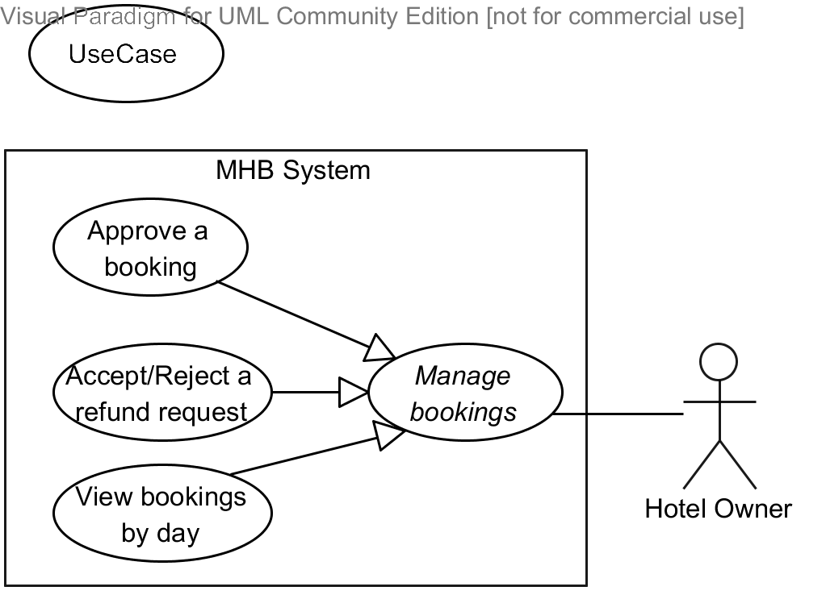

|  |  |  |  |  |
| --- | --- | --- | --- | --- |
| **APPROVE A BOOKING – SPECIFICATION** | | | | |
| **Use-case No.** | UC019 | **Use-case Version** | | 1.0 |
| **Use-case Name** | Approve a booking | | | |
| **Author** | Nguyễn Phú An | | | |
| **Date** | 03/11/2013 | **Priority** | Normal | |
| **Actor:**  Hotel Owner  **Summary:**  This use case allows a hotel owner to view and manually approve a booking request from a customer after he or she paid for one or more rooms in a hotel under the hotel owner’s management.  **Goal:**  To view and approve of a booking request.  **Triggers:**  The user clicks on the link “Quản lý đặt phòng” on the hotel management page; or clicks on the number displayed in the new booking notifications section of a hotel in the dashboard.  **Preconditions:**  The user is already logged in with an account which is granted the Hotel Owner role.  The hotel management page of the selected hotel is being displayed.  **Post Conditions:**  *On success:* The booking status is changed to “Approved” and is updated in the database. The booking cannot change its status again.  *On failure:* An error message is displayed. Please refer to the Exception Scenario section the see what the content of the error message is.  **Main Success Scenario:**   |  |  |  | | --- | --- | --- | | **Step** | **User Action** | **System Response** | | 1. | Clicks on the link “Quản lý đặt phòng” on the hotel management page; or clicks on the number displayed in the new booking notifications section of the hotel. |  | | 2. |  | [See Exception No. 1]  Shows the booking list page with all bookings displayed in a grid and in a descending order of the time the bookings were made. Each booking is a row that contains the following information:   * Created date, customer name; * Booking code, room type, number of rooms booked; * Check-in and check-out dates; * A status box.   If the booking has already been approved previously, the status is “Đã duyệt”. If the booking has not been approved yet but the check-in date already exceeds the current system date, the status is “Quá hạn duyệt”. Otherwise, the status box is a clickable button labeled “Duyệt”. | | 3. | Clicks on the button “Duyệt” on the row that contains a valid unapproved booking. |  | | 4. |  | [See Exception No. 2]  Updates the status of this booking to database; shows the successful message “Đã cập nhật thành công hóa đơn mang mã số X”, where X is the booking code. |   **Alternative Scenario:**  N/A  **Exceptions:**   |  |  |  | | --- | --- | --- | | **No** | **User Action** | **System Response** | | 1. | Open the booking list page. | Show the message “Hiện tại loại phòng này chưa có hóa đơn đặt phòng nào”. | | 2. | Clicks on the button “Duyệt” on the row that contains a valid unapproved booking. | Encounters an exception when updating the status into the database. Shows the popup “Không thể update trạng thái của đơn đặt phòng vào database do lỗi hệ thống”. |   **Relationships:**  “Manage bookings” use case  **Business Rules:**   |  |  | | --- | --- | | **No** | **Business Rule Description** | | 1. | The status for a booking is “Đã duyệt” if the hotel owner has approved of the booking. If the check-in date of the booking exceeds the current system date, the status is “Quá hạn duyệt”. Otherwise, the status is “Chờ duyệt” and is displayed on the page in the form of a button named “Duyệt”. | | 2. | Once the hotel owner approved of a booking, he or she cannot change the status back. | | 3. | Unapproved bookings whose check-in dates exceed the current system date cannot be approved. | | | | | |

#### « Hotel Owner » Accept/Reject a refund request



|  |  |  |  |  |
| --- | --- | --- | --- | --- |
| **ACCEPT/REJECT A REFUND REQUEST – SPECIFICATION** | | | | |
| **Use-case No.** | UC020 | **Use-case Version** | | 1.0 |
| **Use-case Name** | Accept/Reject a refund request | | | |
| **Author** | Nguyễn Phú An | | | |
| **Date** | 03/11/2013 | **Priority** | Normal | |
| **Actor:**  Hotel Owner  **Summary:**  This use case allows a hotel owner to accept or reject a refund request for a booking previously made by a traveler or a guest.  **Goal:**  To accept or reject a refund request send by a traveler or a guest.  **Triggers:**  The user enters to the refund list page by clicking on “Quản lý hủy đặt phòng” link on the hotel management page.  **Preconditions:**  The user is already logged in with an account which is granted the Hotel Owner role.  The booking list page is being displayed.  **Post Conditions:**  *On success:* The refund status is updated into the database. A successful message is displayed that the status is changed. An email is sent to the traveler’s email address to notify about the status of the refund request.  *On failure:* An error message is displayed. The content of the error message will be specified in the Exception Scenario section based on the type of failure.  **Main Success Scenario:**   |  |  |  | | --- | --- | --- | | **Step** | **User Action** | **System Response** | | 1. | Enter to the refund list page by click on “Quản lý hủy đặt phòng” link on the hotel management page. |  | | 2. |  | Shows the refund list page with all refunds displayed in a grid and in order of the dates on which the refund requests were issued. The refunds that the user did not previously seen are highlighted. | | 3. | Chooses a refund request, fills the amount to be refunded in the text box “Số tiền hoàn lại”, and clicks the button “Chấp thuận”.  [See Alternative No. 1]  [See Exception No. 1, 2] |  | | 4. |  | Updates the status of this refund to “Approved” and show the successful message “Bạn đã cập nhật thành công”.  Updates the status of the booking related to this refund requests to “Refunded”.  An email will be sent to customer to notify the status of the refund requests. |   **Alternative Scenario:**   |  |  |  |  | | --- | --- | --- | --- | | **No** | **Step** | **User Action** | **System Response** | | 1. | 1. | Clicks on the button “Không chấp nhận”. |  | |  | 2. |  | Updates the status of this refund to “Approved” and show a successful message “Bạn đã cập nhật thành công”. |   **Exceptions:**   |  |  |  | | --- | --- | --- | | **No** | **User Action** | **System Response** | | 1. | Leaves the textbox “Số tiền hoàn lại” empty and clicks the “Chấp thuận” button. | Shows the message “Số tiền phải hoàn lại không được bỏ trống.” next to the textbox “Số tiền hoàn lại”. | | 2. | Enters a value that cannot be recognized as a number in the textbox “Số tiền hoàn lại” and clicks the “Chấp thuận” button. | Shows the message “Số tiền phải hoàn lại phải là số.” next to the textbox “Số tiền hoàn lại”. | | 3. | Enters a value in the textbox “Số tiền hoàn lại” that is larger than the total amount of the booking related to the refund request and clicks the “Chấp thuận” button. | Show the message “Số tiền hoàn lại không được vượt quá giá trị của hóa đơn đặt phòng” next to the textbox “Số tiền hoàn lại”. |   **Relationships:**  “Manage bookings” use case  **Business Rules:**   |  |  | | --- | --- | | **No** | **Business Rule Description** | | 1. | The status for a refund is “Đang chờ xác nhận” if refund has created recently  Refunds cannot be modified if the status of refund is “S” (refund successful) or “C” (refund is unapproved). A successful refund must be approved by both hotel owner and customer. | | 2. | Status of refund only can be modified by customer if the status is “R” (waiting approve by customer). | | | | | |

#### « Hotel Owner » View bookings by day



|  |  |  |  |  |
| --- | --- | --- | --- | --- |
| **VIEW BOOKINGS BY DAY – SPECIFICATION** | | | | |
| **Use-case No.** | UC021 | **Use-case Version** | | 1.0 |
| **Use-case Name** | View bookings by day | | | |
| **Author** | Bùi Minh Đức | | | |
| **Date** | 17/10/2013 | **Priority** | Normal | |
| **Actor:**  Hotel Owner  **Summary:**  This use case allows a hotel owner to view a list of all bookings made on a specific day when he or she monitors the prices using price calendar.  **Goal:**  To view information of all bookings on a specific day.  **Triggers:**  The user clicks on booking bar (in red) of a specific day in price calendar.  **Preconditions:**  The user is already logged in with an account which is granted the Hotel Owner role.  The price calendar for the selected room type is being displayed.  **Post Conditions:**  *On success:* The booking list popup is displayed and shows a list of bookings made on the selected day.  *On failure:* The booking popup is displayed but shows no bookings. An error message will be shown to the user, depending on what the error is.  **Main Success Scenario:**   |  |  |  | | --- | --- | --- | | **Step** | **User Action** | **System Response** | | 1. | Clicks on booking bar (pink bar) in price calendar.  [See Alternative Scenario No. 1, 2] |  | | 2. |  | Display a popup show booking information.  [See Exception No. 1,2,3]  [See Alternative No. 1, 2] |   **Alternative Scenario:**   |  |  |  |  | | --- | --- | --- | --- | | **No** | **Step** | **User Action** | **System Response** | | 1. | 1. | Clicks button “Xem chi tiết” in booking popup. |  | |  | 2. |  | Displays booking items in a new popup.  [See Exception No. 4] | | 2. | 1. | Clicks button “Quay lại” in booking items popup |  | |  | 2. |  | Closes booking items popup then display booking popup. | | 3. | 1. | Clicks button “Đóng” in booking items popup |  | |  |  |  | Closes booking items popup. |   **Exceptions:**   |  |  |  | | --- | --- | --- | | **No** | **User Action** | **System Response** | | 1. | Clicks on booking bar (in pink) in price calendar but the system can not find any bookings. | Shows an empty booking popup. | | 2. | Clicks button “Xem chi tiết” in booking popup but the system can not load booking items. | Shows an empty booking item popup. | | 3. | Clicks on booking bar (in pink) in price calendar but system the encounters an error when making the request. | Shows the message “Không thể xem các hóa đơn đặt phòng do lỗi từ hệ thống”. |   **Relationships:**  “Manage bookings” use case  **Business Rules:**   |  |  | | --- | --- | | **No** | **Business Rule Description** | | 1. | If there is no bookings on a specific day in the price calendar for a specific room type, the booking bar should not be displayed for that day. | | | | | |

#### « Hotel Owner » Install a Facebook app

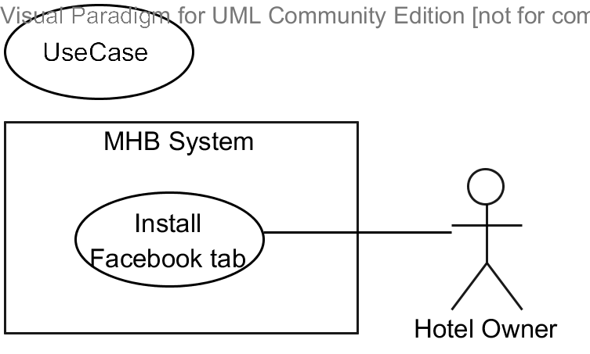

|  |  |  |  |  |
| --- | --- | --- | --- | --- |
| **INSTALL A FACEBOOK APP – SPECIFICATION** | | | | |
| **Use-case No.** | UC022 | **Use-case Version** | | 1.0 |
| **Use-case Name** | Install a Facebook app | | | |
| **Author** | Nguyễn Hiếu Triệu Vỹ | | | |
| **Date** | 18/10/2013 | **Priority** | Normal | |
| **Actor:**  Hotel Owner  **Summary:**  This use case allows a hotel owner to install a Facebook page tab to their fan page on the Facebook network, using all the related information of their hotel in the MHB system, so that the can get a closer touch at their customers.  **Goal:**  To install a Facebook application for a specific hotel under the management of the hotel owner.  **Triggers:**  The user clicks the button “Cài đặt ứng dụng trên Facebook” on the hotel management page.  **Preconditions:**  The user is already logged in with an account which is granted the Hotel Owner role.  The hotel management page of the selected hotel is being displayed.  The hotel itself satisfies the following conditions:   * Required basic information are provided; * At least an image is added to the gallery; * At least a valid room type is added for the hotel; * All room types must have their prices specified for at least the next 10 days.   **Post Conditions:**  *On success:* A customized Facebook application for the selected hotel is installed to the Facebook fan page of this hotel on the Facebook network. A button named “Khách sạn X trên Facebook”, where X is the name of the hotel, is visible on the hotel management page.  *On failure:* An error message is displayed. Please refer to the Exception Scenario section the see what the content of the error message is.  **Main Success Scenario:**   |  |  |  | | --- | --- | --- | | **Step** | **User Action** | **System Response** | | 1. | Clicks the button “Cài đặt ứng dụng trên Facebook” on the hotel management page.  [See Exception No. 1] |  | | 2. |  | Redirects to the Add Tab page on the Facebook network. Facebook automatically redirects you to the log in page. If you are already logged in, go to step 5. | | 3. | Log on to Facebook with your Facebook account. |  | | 4. |  | Facebook redirects the user to the Add Tab page on the Facebook network.  [See Exception No. 2, 3] | | 5. | Selects a page in the list of Facebook fan pages under the management of the user’s Facebook account. |  | | 6. | Selects the “Add Tab” button on the Add Tab page.  [See Alternative No. 1] |  | | 7. |  | Connects the selected page with the hotel and saves all necessary information about the page.  [See Exception No. 4]  Redirects the user to the Facebook fan page with the tab installed. |   **Alternative Scenario:**   |  |  |  |  | | --- | --- | --- | --- | | **No** | **Step** | **User Action** | **System Response** | | 1. | 1. | Does not choose a page on the Add Tab page and go back to MHB. |  | |  | 2. |  | Terminates the installation process. |   **Exceptions:**   |  |  |  | | --- | --- | --- | | **No** | **User Action** | **System Response** | | 1. | Clicks the button “Cài đặt ứng dụng trên Facebook” on the hotel management page but the hotel itself satisfies the following conditions:   * Required basic information are provided; * At least an image is added to the gallery; * At least a valid room type is added for the hotel; * All room types must have their prices specified for at least the next 10 days. | Shows the message “Khách sạn của bạn chưa đủ điều kiện để mở một trang trên Facebook, vui lòng hoàn thành các thông tin cần thiết trước khi tiếp tục.” | | 2. | The user has not logged on to their Facebook account. | Facebook redirects the user to its log in page. | | 3. | The Facebook account of the user is not managing any fan pages or all fan pages he or she manages have this app installed. | Facebook shows the error message “All of the Facebook Pages that you are an admin of have already had this App Tab installed.” to warn the user that they cannot continue to install the app. | | 4. | Selects the “Add Tab” button on the Add Tab page but Facebook fails to send necessary information about the selected page to MHB. | Shows the message “Không thể cài đặt tab cho trang fan page này.” |   **Relationships:**  N/A  **Business Rules:**   |  |  | | --- | --- | | **No** | **Business Rule Description** | | 1. | A hotel must satisfy the following conditions before its owner can install the Facebook app:   * Required basic information are provided; * At least an image is added to the gallery; * At least a valid room type is added for the hotel; * All room types must have their prices specified for at least the next 10 days. | | 2. | A hotel can be installed to at most one Facebook page. | | | | | |

#### « System Admin » Approve hotel opening request

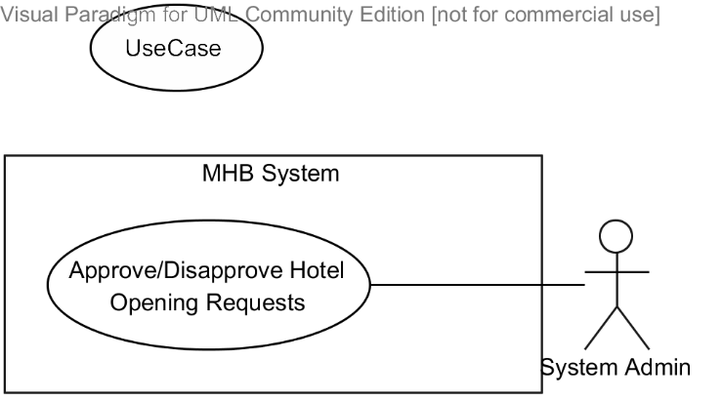

|  |  |  |  |  |
| --- | --- | --- | --- | --- |
| **APPROVE/DISAPPROVE HOTEL OPENING REQUEST – SPECIFICATION** | | | | |
| **Use-case No.** | UC023 | **Use-case Version** | | 1.0 |
| **Use-case Name** | Approve/Disapprove hotel opening request | | | |
| **Author** | Nguyễn Hiếu Triệu Vỹ | | | |
| **Date** | 18/10/2013 | **Priority** | Normal | |
| **Actor:**  System Admin  **Summary:**  This use case allows a system admin to approve of a hotel opening request sent by a hotel owner. Only after a hotel is approved can it be displayed on the hotel information portal, searched, filtered, and booked by the users.  **Goal:**  To approve of a hotel opening request sent by a hotel owner.  **Triggers:**  The user clicks the button “Xác nhận” on the hotel management page.  **Preconditions:**  The user is already logged in with an account which is granted the System Admin role.  The dashboard page is being displayed.  The hotel is not approved on the MHB system.  **Post Conditions:**  *On success:* The selected hotel is approved on the MHB system and can be modified by its hotel owner, displayed on the hotel information portal, and searched, filtered, and booked by the users.  *On failure:* An error message is displayed. Please refer to the Exception Scenario section the see what the content of the error message is.  **Main Success Scenario:**   |  |  |  | | --- | --- | --- | | **Step** | **User Action** | **System Response** | | 1. | Clicks the section that represents the unapproved hotel on the dashboard page.  [See Exception No. 1] |  | | 2. |  | Redirects the user to the hotel management page of the selected hotel. The page should include the basic information of the hotel as usual, plus a button named “Xác nhận” and a button named “Từ chối” at the top of the page. | | 3. | Checks the information of the hotel provided by its owner for validity. |  | | 4. | Selects the button “Xác nhận”.  [See Exception No. 2] |  | | 5. |  | Changes the status of the selected hotel to “Approved” and redirects the user back to the dashboard page.  [See Exception No. 3] |   **Alternative Scenario:**   |  |  |  |  | | --- | --- | --- | --- | | **No** | **Step** | **User Action** | **System Response** | | 1. | 1. | Selects the button “Từ chối”. |  | |  | 2. |  | Changes the status of the selected hotel to “Unapproved” and redirects the user back to the dashboard page. |   **Exceptions:**   |  |  |  | | --- | --- | --- | | **No** | **User Action** | **System Response** | | 1. | Clicks the section that represents the unapproved hotel on the dashboard page but the hotel cannot be found in the system. | Redirects the user to 404 Page not found page. | | 2. | Selects the button “Xác nhận” but the hotel is already approved (by another system admin). | Shows the message “Khách sạn này đã được xác nhận trên MHB rồi.” | | 3. | Selects the button “Xác nhận” but the system encounters an error while changing the hotel status. | Shows the message “Không thể xác nhận khách sạn này do lỗi từ hệ thống.” |   **Relationships:**  N/A  **Business Rules:**   |  |  | | --- | --- | | **No** | **Business Rule Description** | | 1. | After the hotel owner created a hotel on the MHB system, a hotel opening request is sent to the system admin. The hotel can be modified by its hotel owner, displayed on the hotel information portal, and searched, filtered, and booked by the users only when a system admin has reviewed and approved of it. | | 2. | A hotel owner can own a number of different hotels on the MHB system. | | | | | |

#### « System Admin » Get hotel infor from BMT

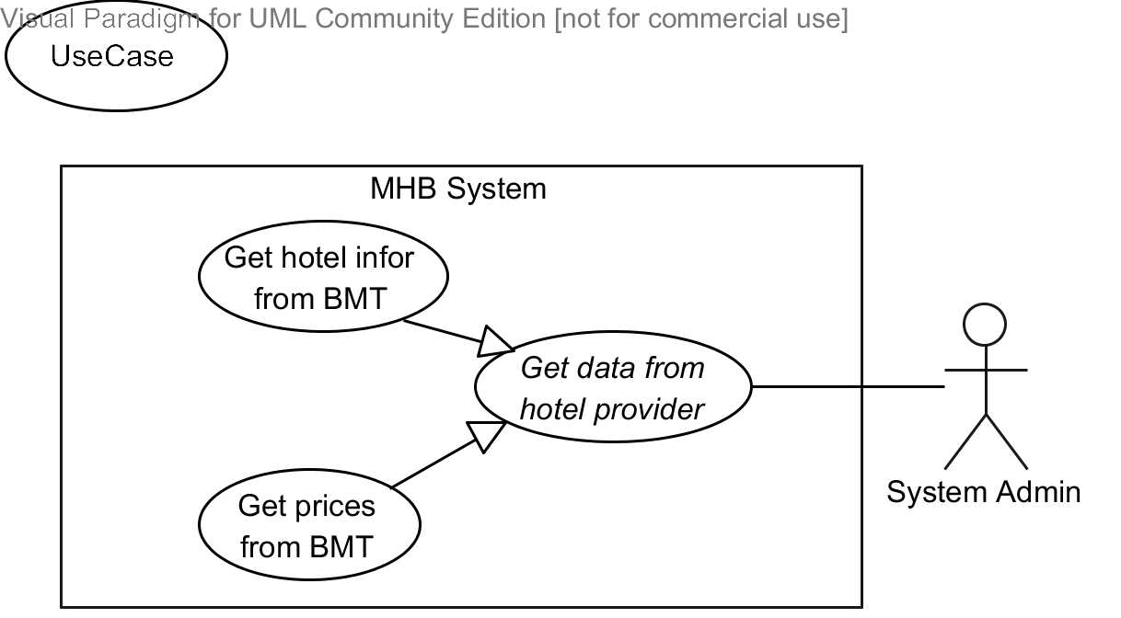

|  |  |  |  |  |
| --- | --- | --- | --- | --- |
| **GET HOTEL INFO FROM BMT – SPECIFICATION** | | | | |
| **Use-case No.** | UC024 | **Use-case Version** | | 1.0 |
| **Use-case Name** | Get hotel infor from BMT | | | |
| **Author** | Bùi Minh Đức | | | |
| **Date** | 15/10/2013 | **Priority** | Normal | |
| **Actor:**  System Admin  **Summary:**  This use case allows a system admin to manually get data of the hotels provided by BMT hotel data provider.  **Goal:**  To manually get data of the hotels provided by BMT hotel data provider.  **Triggers:**  The user clicks the button “Đồng bộ thông tin” on the data synchronization page for BMT.  **Preconditions:**  The user is already logged in with an account which is granted the System Admin role.  The date synchronization page for BMT is being displayed.  The MHB system has successfully agreed upon the connection protocol with the BMT hotel data provider.  **Post Conditions:**  *On success:* The hotels provided by BMT hotel data provider are synchronized. All information, including hotel information, hotel features, images, and room types are up-to-date. A log of all changes are also shown to the user.  *On failure:* A log of all the errors that occurred during the synchronization is shown to the user, depending on what the errors are.  **Main Success Scenario:**   |  |  |  | | --- | --- | --- | | **Step** | **User Action** | **System Response** | | 1. | Clicks the button “Đồng bộ thông tin” on the date synchronization page for BMT. [See Exception No. 1] |  | | 2. |  | Connects to the BMT web services and begins to synchronize information of all the hotels provided by BMT. This information include:   * Hotel information * Hotel features * Images * Room types   Logs all the changes that were made to hotels, room types, and prices.  [See Exception No. 1, 2] | | 3. |  | Once the synchronization process is complete, refreshes page and shows the logs to the user. |   **Alternative Scenario:**  N/A  **Exceptions:**   |  |  |  | | --- | --- | --- | | **No** | **User Action** | **System Response** | | 1. | Cannot connect to BMT web services. | Shows the message “Không thể kết nối đến dịch vụ của BMT”. | | 2. | An error occurs during the synchronization process. | Logs the error and continues the synchronization process. |   **Relationships:**  “Get data from hotel provider” abstract use case  **Business Rules:**   |  |  | | --- | --- | | **No** | **Business Rule Description** | | 1. | In addition to hotels opened directly by their hotel owners, the MHB system also connects with some hotel data providers, one of whom is BMT hotel data provider, to receive information about hotels. | | 2. | If the data provided by a hotel data provider is organized in a different way to the data organized on the MHB system, it is the responsibility of the MHB system to modify, format, and re-organize the data before saving them to the database. | | 3. | Hotel data that needs to exchange between the two systems BMT and MHB include:   * Hotel information * Hotel features * Images * Room types | | 4. | Once the data synchronization starts, it must run until it finishes transferring all the data. You cannot manually stop the process. | | | | | |

#### « System Admin » Get prices from BMT

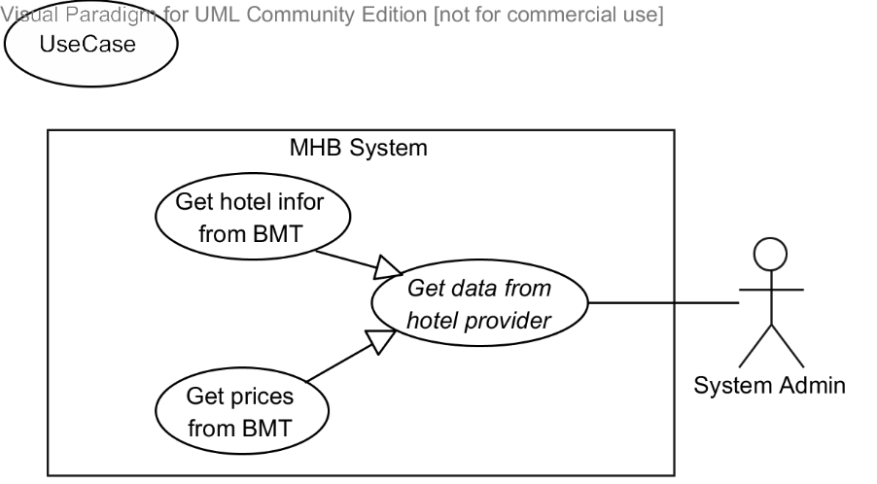

|  |  |  |  |  |
| --- | --- | --- | --- | --- |
| **GET PRICES FROM BMT – SPECIFICATION** | | | | |
| **Use-case No.** | UC024 | **Use-case Version** | | 1.0 |
| **Use-case Name** | Get prices from BMT | | | |
| **Author** | Bùi Minh Đức | | | |
| **Date** | 15/10/2013 | **Priority** | Normal | |
| **Actor:**  System Admin  **Summary:**  This use case allows a system admin to manually get prices and room availabilities of the hotels provided by BMT hotel data provider.  **Goal:**  To manually get prices and availability of the rooms of the hotels provided by BMT hotel data provider.  **Triggers:**  The user clicks the button “Đồng bộ giá” on the data synchronization page for BMT.  **Preconditions:**  The user is already logged in with an account which is granted the System Admin role.  The date synchronization page for BMT is being displayed.  The MHB system has successfully agreed upon the connection protocol with the BMT hotel data provider.  **Post Conditions:**  *On success:* All information related to prices and availability of all the room types that belong to external hotels provided by BMT, are up-to-date. A log of all changes are also shown to the user.  *On failure:* A log of all the errors that occurred during the synchronization is shown to the user, depending on what the errors are.  **Main Success Scenario:**   |  |  |  | | --- | --- | --- | | **Step** | **User Action** | **System Response** | | 1. | Clicks the button “Đồng bộ giá” on the date synchronization page for BMT. [See Exception No. 1] |  | | 2. |  | Connects to the BMT web services and begins to synchronize information of all the hotels provided by BMT. This information include:   * Price changes * Daily available room statuses.   Logs all the changes that were made to hotels, room types, and prices.  [See Exception No. 1, 2] | | 3. |  | Once the synchronization process is completed, refreshes page and shows the logs to the user. |   **Alternative Scenario:**  N/A  **Exceptions:**   |  |  |  | | --- | --- | --- | | **No** | **User Action** | **System Response** | | 1. | Cannot connect to BMT web services. | Shows the message “Không thể kết nối đến dịch vụ của BMT”. | | 2. | An error occurs during the synchronization process. | Logs the error and continues the synchronization process. |   **Relationships:**  “Get data from hotel provider” abstract use case  **Business Rules:**   |  |  | | --- | --- | | **No** | **Business Rule Description** | | 1. | Price data that needs to exchange between the two systems BMT and MHB include:   * Price changes * Daily available rooms. | | 2. | Once the data synchronization starts, it must run until it finishes transferring all the data. You cannot manually stop the process. | | | | | |

### Software System Attributes



#### Reliability

Information about hotels are collected via web services in such a way that preserves the most accurate and up-to-date data. There should be a mechanism that helps prevent violating referential constraints and data integrity when the system synchronizes the data from the web services.

#### Availability

N/A

#### Security

Authentication is required when the user utilizes certain functions in the system. Passwords must be encrypted so the even they are unrecognizable to even system admins and database admins. The system should also require authorization when the user tries to access an unauthorized function.

#### Maintainability

In the architecture design of the system, the responsibilities of all components should be clear and do no overlap each other.

The communications with a web service provider should be packaged in a single module independent from the rest of the system. The module should support plug-and-play, so that, when the web service provider change the structure of the web service results, or when the system must work with another web service provider, minimal changes to the rest of the system are required.

#### Portability

On the client side, the website should be accessible to anyone with a personal computer that connects to the Internet and has a browser.

#### Performance

N/A

## Entity Relationship Diagram

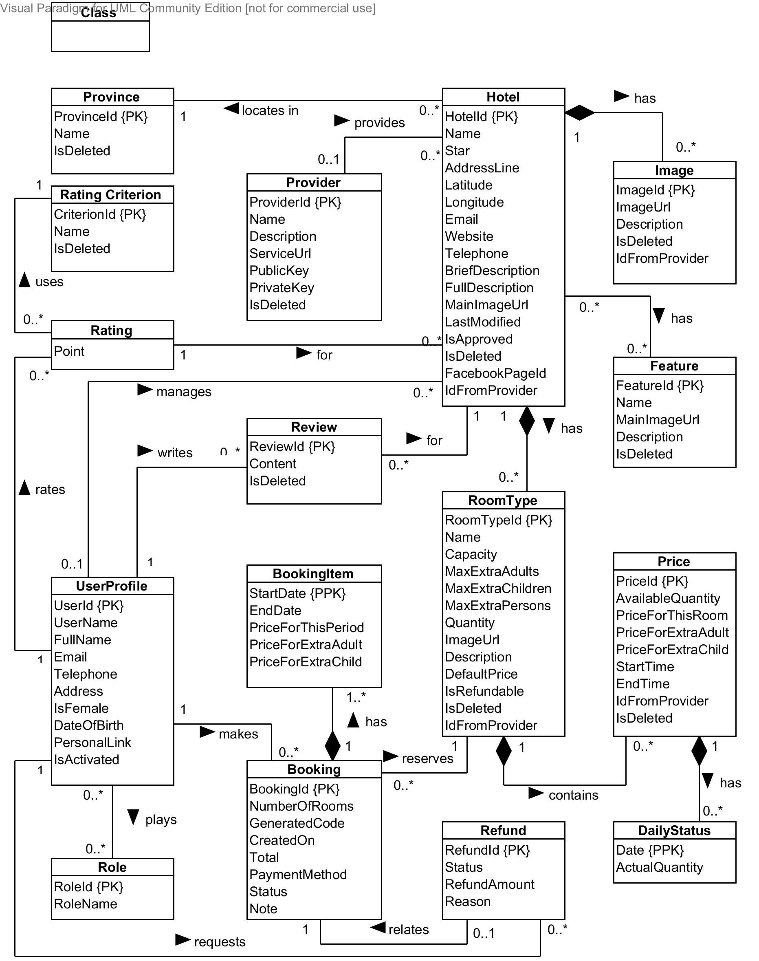

Diagram . Entity relationship diagram

# Software Design Description (SDD)



## Design Overview

The SDD describes the system architectural design and the detailed designs, including the user interfaces, of the system.

The components should communicate through interfaces. The detailed implementation of each component should be transparent to other components. The passive MVC II pattern is the preferable architecture for the website.

The detailed designs of the system should adopt the basic principles of software design, including “high cohesion, low coupling” and “open to extension, closed to modification” principles.

Each of the following sections are summarized below:

* Section 4.2: Gives a specification of the system architecture design, describing the overall architecture of the system and subsystems.
* Section 4.3: Specifies all the components that should be included in the system, and the communications between them.
* Section 4.4: Describes the class and package diagrams, as well as their descriptions in details, to provide a static view of the system.
* Section 4.4: Describes the sequence diagrams for the use cases specified in the SRS, to provide a dynamic view of the system.
* Section 4.5: Describes the user interfaces, to specify what will be seen by the users of the system.
* Section 4.5: Describes the Database Design, including the relations and the relationships between them.

## System Architectural Design

The MVC II (Model – View – Controller) pattern is used as the overall system architecture, because it specifies a clear distinction between the responsibilities of the components and is appropriate for developing web applications.

3. Exchange data

4. Results

**CONTROLLER**

* Intercepts user input;
* Coordinates the view and model;
* Handles communication between the model and data layer.

**VIEW**

* Binds to the model;
* Renders the UIs (HTML, CSS, JavaScript);
* Allows to navigate between controllers.

**MODEL**

* Communicates with data source;
* Exposes functionalities, business logics, and data validation.

Database   
Server

Application Server

1. Request

8. Response

5. Select views

7. Changes made

2. Invoke methods

6. Query states

Method invocations

Change notifications

Figure . Model-View-Controller Architecture

## Component Diagram

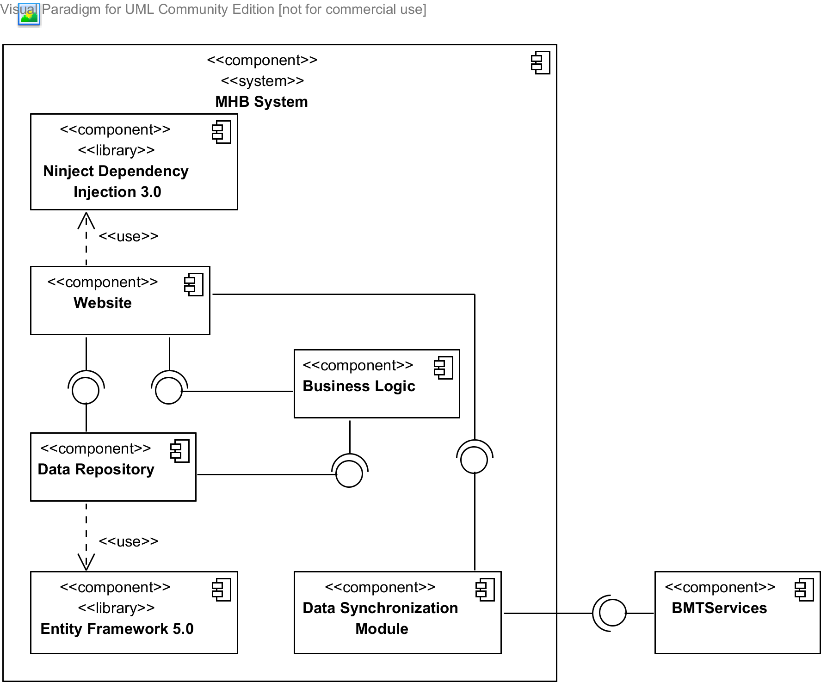

Diagram . Component Diagram

The MHB system include the following major components:

* **Entity Framework 5.0:** An object-relational mapper that enables working with relational data persistence using domain-specific objects;
* **Data Repository:** A data store that provides data access functionality, using the Entity Framework to communicates with the database;
* **Data Synchronization Module:** A module that communicates with the services provided by the BMT hotel data provider and uses interfaces exposed by the Data Repository to persist the data;
* **BMT Services:** A set of web services that provide information about hotels, room types, and price changes for its consumers;
* **Business Logic:** A module that uses interfaces exposed by the Data Repository to encapsulate important businesses of in the MHB system;
* **Ninject Dependency Injection 3.0:** A lightweight dependency injection framework for .NET applications which helps split the application into a collection of loosely-coupled, highly-cohesive pieces, and then glue them back together in a flexible manner.
* **Website:** A web-application that helps expose all the functionalities to end-users.

From the point of view of the MVC-II pattern, the components Entity Framework 5.0, Data Repository, Data Synchronization Module, BMT Services, Business Logic, and Ninject Dependency Injection 3.0 all belong to the Model part. The Controller and the View parts are wrapped in the component Website.

## Detailed Designs



### Entity Classes

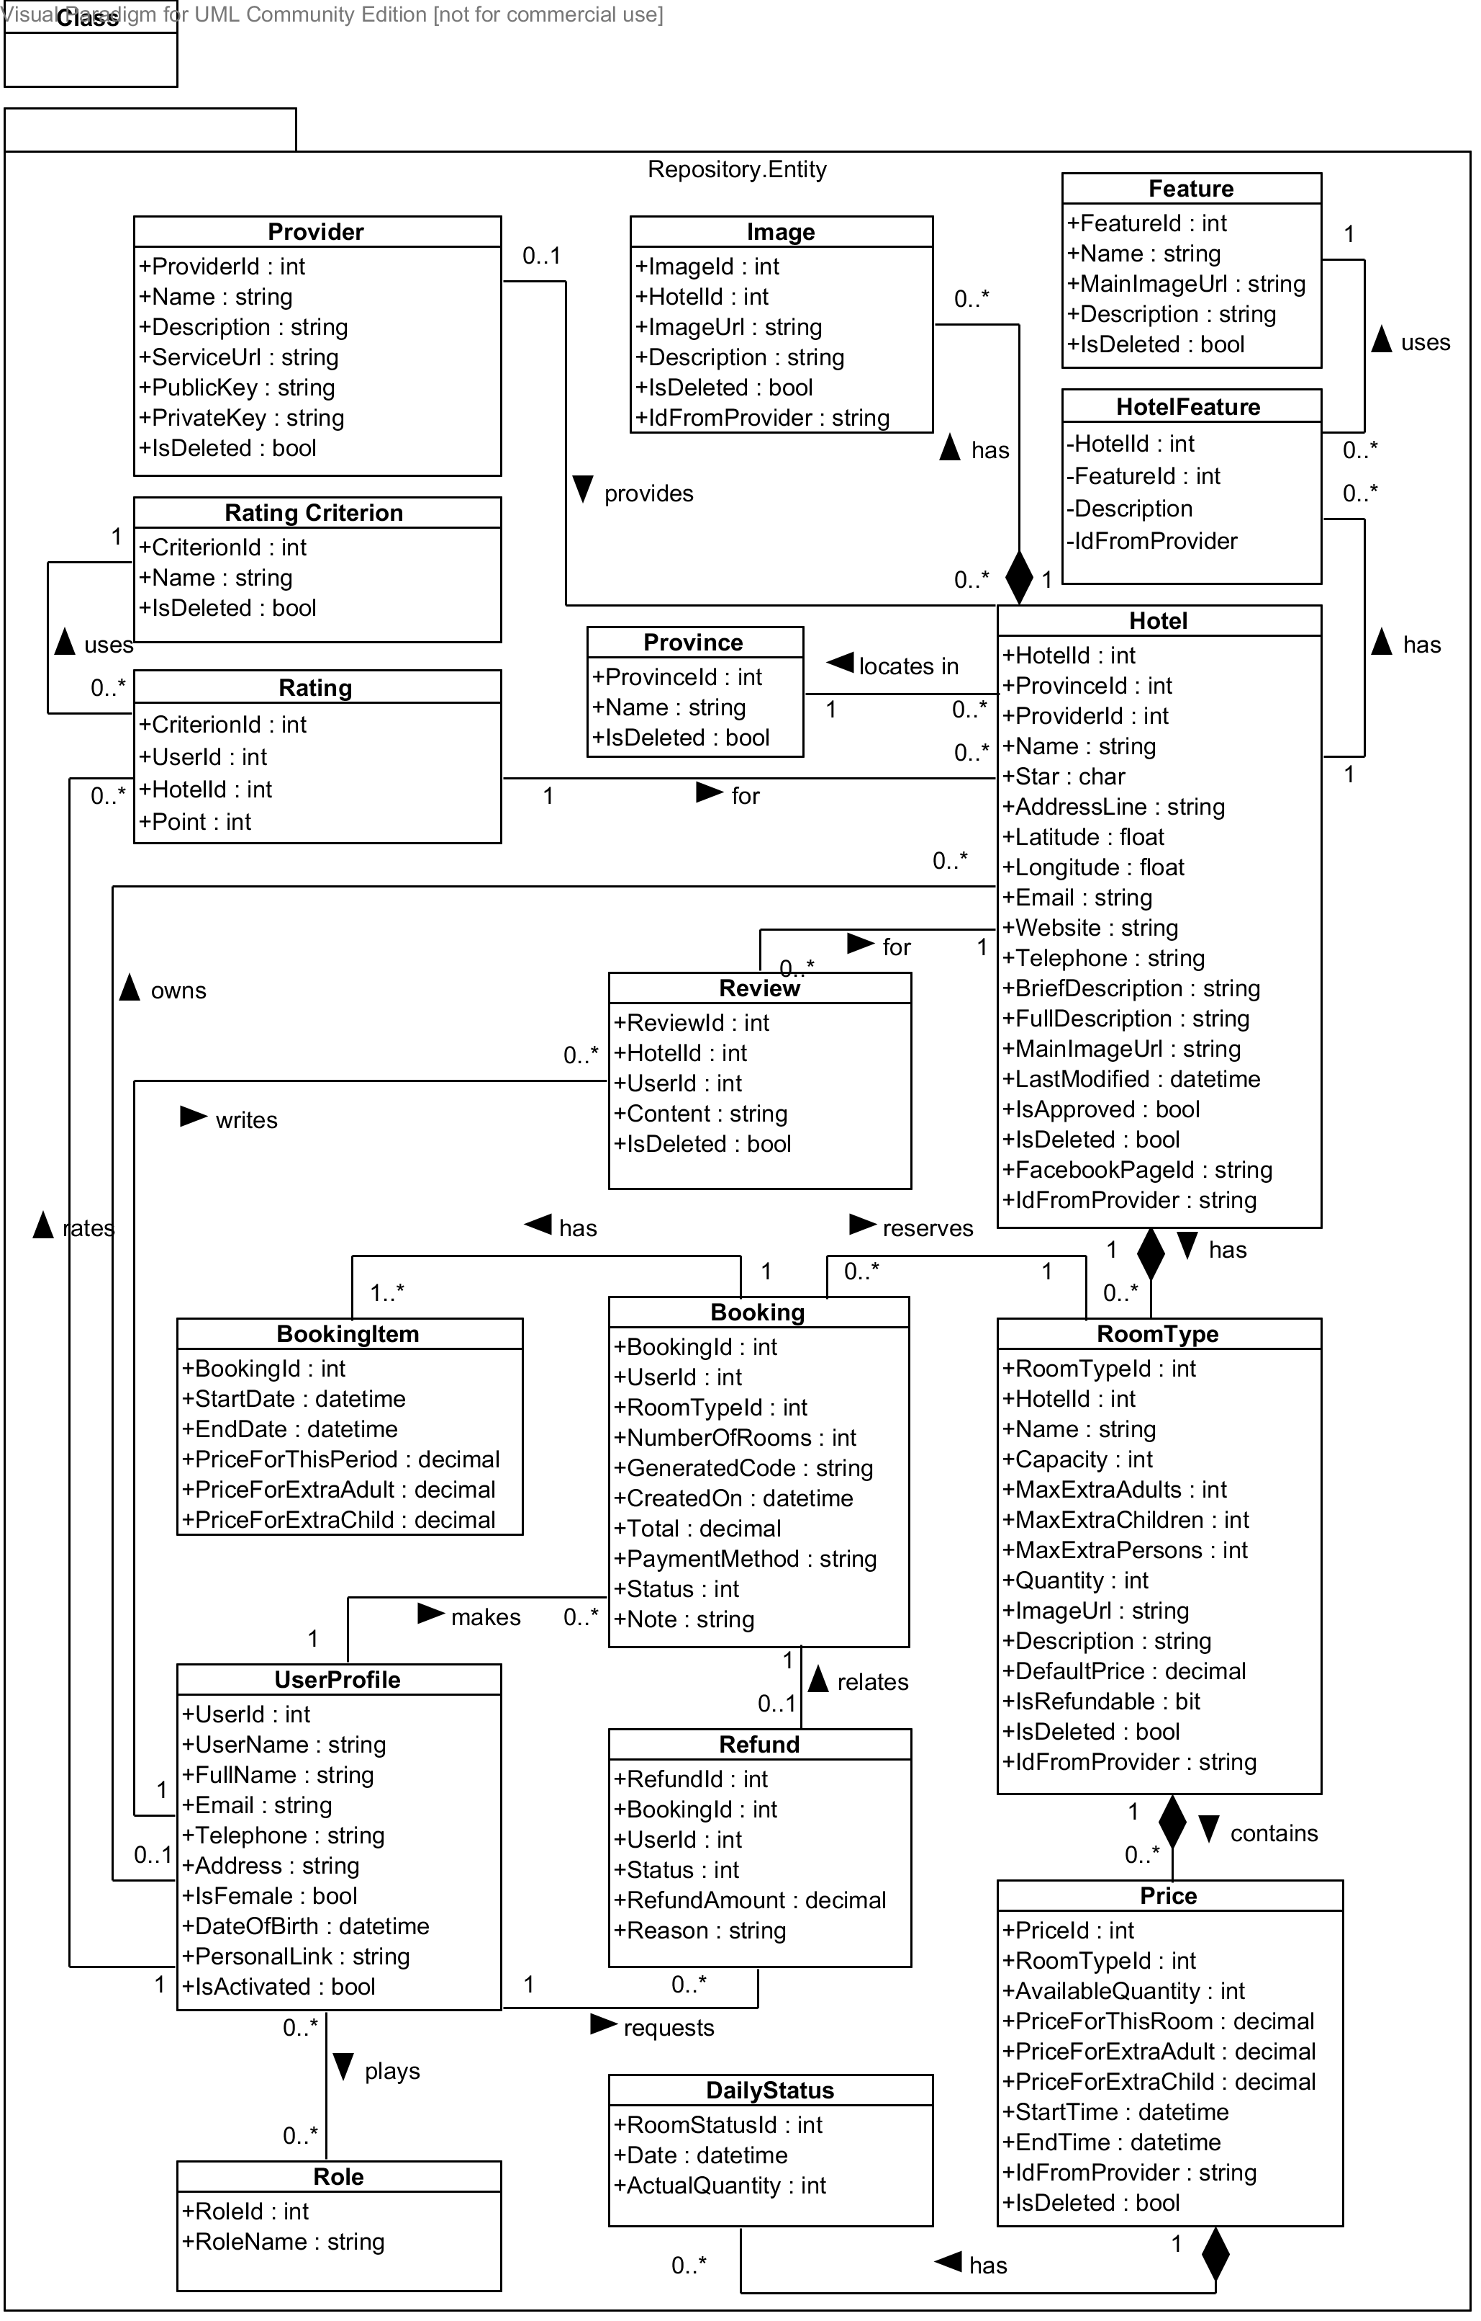

Diagram . Entity class diagram

#### Hotel Class

**Properties**

|  |  |  |  |
| --- | --- | --- | --- |
| Property name | Type | Visibility | Description |
| *HotelId* | int | public | Unique id that differentiates a hotel from the others |
| *ProvinceId* | int | public | Id of the province where the hotel locates in |
| *ProviderId* | int | public | Id of the hotel data provider who provides this hotel |
| *OwnerId* | int | public | Id of the hotel owner who manages this hotel |
| *Name* | string | public | Official name of the hotel |
| *Star* | char | public | International quality of the hotel |
| *AddressLine* | string | public | Address line of the hotel |
| *Latitude* | float | public | Latitude of the hotel’s address line |
| *Longitude* | float | public | Longitude of the hotel’s address line |
| *Email* | string | public | Main email address of the hotel |
| *Website* | string | public | Website address of the hotel |
| *Telephone* | string | public | Main telephone number of the hotel |
| *BriefDescription* | string | public | Short introduction about the hotel |
| *FullDescription* | string | public | Full description of the hotel |
| *MainImageUrl* | string | public | Url of the main image for the hotel |
| *LastModified* | datetime | public | Last time when the hotel’s information was modified |
| *IsApproved* | bool | public | Whether the hotel is approved or not |
| *IsDeleted* | bool | public | Whether the hotel is marked deleted or not |
| *FacebookPageId* | string | public | Id of the Facebook page that has the hotel installed as a tab |
| *IdFromProvider* | string | public | Id of the hotel if it is provided by a hotel data provider |

**Operations:** N/A

#### Feature Class

**Properties**

|  |  |  |  |
| --- | --- | --- | --- |
| Property name | Type | Visibility | Description |
| *FeatureId* | int | public | Unique id that differentiates a feature from the others |
| *Name* | string | public | Name of the hotel feature |
| *MainImageUrl* | string | public | Image url of the hotel feature |
| *Description* | string | public | Short description of the hotel feature |
| *IsDeleted* | bool | public | Whether the hotel feature is deleted or not |

**Operations:** N/A

#### Image Class

**Properties**

|  |  |  |  |
| --- | --- | --- | --- |
| Property name | Type | Visibility | Description |
| *ImageId* | int | public | Unique id that differentiates an image from the others |
| *HotelId* | int | public | Id of the hotel which the image belongs to |
| *ImageUrl* | string | public | Url of the image |
| *Description* | string | public | Description of what the image is about |
| *IdFromProvider* | string | public | Id of the image if it is provided by a hotel data provider |

**Operations:** N/A

#### Provider Class

**Properties**

|  |  |  |  |
| --- | --- | --- | --- |
| Property name | Type | Visibility | Description |
| *ProviderId* | int | public | Unique id that differentiates a provider from the others |
| *Name* | string | public | Official name of the hotel data provider |
| *Description* | string | public | Description of the services of the provider |
| *ServiceUrl* | string | public | Base url of the services provided by the hotel provider |
| *PublicKey* | string | public | Public key used to identify hotel consumer when information exchanges occur |
| *PrivateKey* | string | public | Private key that only the hotel provider and its consumer know |
| *IsDeleted* | bool | public | Where the hotel provider is deleted or not |

**Operations:** N/A

#### Province Class

**Properties**

|  |  |  |  |
| --- | --- | --- | --- |
| Property name | Type | Visibility | Description |
| *ProvinceId* | int | public | Unique id that differentiates a province from the others |
| *Name* | string | public | Name of the province in 64 provinces in Vietnam |
| *IsDeleted* | bool | public | Where the hotel province is deleted or not |

**Operations:** N/A

#### RoomType Class

**Properties**

|  |  |  |  |
| --- | --- | --- | --- |
| Property name | Type | Visibility | Description |
| *RoomTypeId* | int | public | Unique id that differentiates a room type from the others |
| *HotelId* | int | public | Id of the hotel which the room type belongs to |
| *Name* | string | public | Official name of the room type specified by the hotel owner |
| *Capacity* | int | public | Default value of the number of persons who can stay in the room |
| *MaxExtraAdults* | int | public | Number of maximum extra children, if any |
| *MaxExtraChildren* | int | public | Number of maximum extra adults, if any |
| *MaxExtraPersons* | int | public | Number of maximum extra person, if any |
| *Quantity* | int | public | Number of physical rooms of this type in the hotel |
| *ImageUrl* | string | public | Main url of the image for the room type |
| *Description* | string | public | Description of the room type |
| *DefaultPrice* | decimal | public | Default price for the room type |
| *IsRefundable* | bool | public | Whether the rooms of this type can be refunded or not |
| *IsDeleted* | bool | public | Whethere the room type is deleted or not |
| *IdFromProvider* | string | public | Id of the room type if it is provided by a hotel provider |

**Operations:** N/A

#### Price Class

**Properties**

|  |  |  |  |
| --- | --- | --- | --- |
| Property name | Type | Visibility | Description |
| *PriceId* | int | public | Unique id that differentiates a price from the others |
| *RoomTypeId* | int | public | Id of the room type that this price belongs to |
| *AvailableQuantity* | int | public | Number of available rooms for this room type in the period specified |
| *PriceForThisRoom* | decimal | public | Price for this room in the period specified |
| *PriceForExtraAdult* | decimal | public | Price for an extra adult, if any |
| *PriceForExtraChild* | decimal | public | Price for an extra child, if any |
| *StartTime* | datetime | public | Date on which the price becomes active |
| *EndTime* | datetime | public | Date on which the price becomes inactive |
| *IdFromProvider* | string | public | Id of the price if it is provided by a hotel provider |
| *IsDeleted* | bool | public | Whethere the price is deleted or not |

**Operations:** N/A

#### DailyStatus Class

**Properties**

|  |  |  |  |
| --- | --- | --- | --- |
| Property name | Type | Visibility | Description |
| *PriceId* | int | public | Id of the price that this daily status belongs to |
| *Date* | datetime | public | Date on which this daily status takes place |
| *ActualQuantity* | int | public | Actual available number of rooms on the day when the daily status takes place |

**Operations:** N/A

#### UserProfile Class

**Properties**

|  |  |  |  |
| --- | --- | --- | --- |
| Property name | Type | Visibility | Description |
| *UserId* | int | public | Unique id that differentiates a user from the others |
| *Username* | string | public | Unique name that will be use to log in the system |
| *FullName* | string | public | Full name of the user |
| *Email* | string | public | Email address of the user |
| *Telephone* | string | public | Telephone number of the user |
| *Address* | string | public | Address line of the user |
| *IsFemale* | bool | public | Whether the user is female or male |
| *DateOfBirth* | datetime | public | Date of birth of the user |
| *PersonalLink* | string | public | Personal website of the user |
| *IsActivated* | bool | public | Whether the user is activated on the MHB system or not |

**Operations:** N/A

#### Booking Class

**Properties**

|  |  |  |  |
| --- | --- | --- | --- |
| Property name | Type | Visibility | Description |
| *BookingId* | int | public | Unique id that differentiates a hotel from the others |
| *UserId* | int | public | Id of the user who makes the booking |
| *RoomTypeId* | int | public | Id of the room type booked by the user |
| *NumberOfRooms* | int | public | Number of rooms the user booked for this room type |
| *ExtraAdults* | int | public | Number of extra adults, if any |
| *ExtraChildren* | int | public | Number of extra children, if any |
| *GeneratedCode* | string | public | String that whill be used to verify with the hotel when the user checks in |
| *CreatedOn* | datetime | public | Time when the booking is created |
| *Total* | decimal | public | Total amount of the booking order |
| *PaymentMethod* | string | public | Method which the user uses to pay for the booking |
| *Status* | int | public | Status of the booking |
| *Note* | string | public | Additional note the user specifies for the hotel |

**Operations:** N/A

#### Refund Class

**Properties**

|  |  |  |  |
| --- | --- | --- | --- |
| Property name | Type | Visibility | Description |
| *RefundId* | int | public | Unique id that differentiates a refund from the others |
| *BookingId* | int | public | Id of the booking which the refunds relates |
| *UserId* | int | public | Id of the user who requests the refund |
| *Status* | int | public | Status of the refund request |
| *RefundAmount* | decimal | public | Amount that will be refunded to the user |
| *Reason* | string | public | Reason why the user wants the hotel to refund the bookings |

**Operations:** N/A

#### Role Class

**Properties**

|  |  |  |  |
| --- | --- | --- | --- |
| Property name | Type | Visibility | Description |
| *RoleId* | int | public | Unique id that differentiates a role from the others |
| *RoleName* | string | public | Name of the role |

**Operations:** N/A

#### BookingItem Class

**Properties**

|  |  |  |  |
| --- | --- | --- | --- |
| Property name | Type | Visibility | Description |
| *BookingId* | int | public | The id of the booking which this booking item belongs to |
| *StartDate* | datetime | public | Date on which a booking item starts |
| *EndDate* | datetime | public | Date on which a booking item ends |
| *PriceForThisPeriod* | decimal | public | Price for the room in the period specified |
| *PriceForExtraAdult* | decimal | public | Price for an extra adult in the period specified, if any |
| *PriceForExtraChild* | decimal | public | Price for an extra child in the period specified, if any |

**Operations:** N/A

#### Review Class

**Properties**

|  |  |  |  |
| --- | --- | --- | --- |
| Property name | Type | Visibility | Description |
| *ReviewId* | int | public | Unique id that differentiates a review from the others |
| *HotelId* | int | public | Id of the hotel that the review is about |
| *UserId* | int | public | Id of the user who writes the review |
| *Content* | string | public | Content of the review written by the user |
| *IsDeleted* | bool | public | Whether the review is deleted or not |

**Operations:** N/A

#### Rating Class

**Properties**

|  |  |  |  |
| --- | --- | --- | --- |
| Property name | Type | Visibility | Description |
| *CriterionId* | int | public | Id of the criterion being rated by the user |
| *UserId* | int | public | Id of the user who rates the hotel |
| *HotelId* | int | public | Id of the hotel being rated by the user |
| *Point* | int | public | Point that the user gives the hotel for the selected criterion |

**Operations:** N/A

#### RatingCriterion Class

**Properties**

|  |  |  |  |
| --- | --- | --- | --- |
| Property name | Type | Visibility | Description |
| *CriterionId* | int | public | Unique id that differentiates a criterion from the others |
| *Name* | int | public | Name of the criterion used to rate the hotels |
| *IsDeleted* | int | public | Whether the criterion is deleted or not |

**Operations:** N/A



### Repository Classes



#### Class diagram

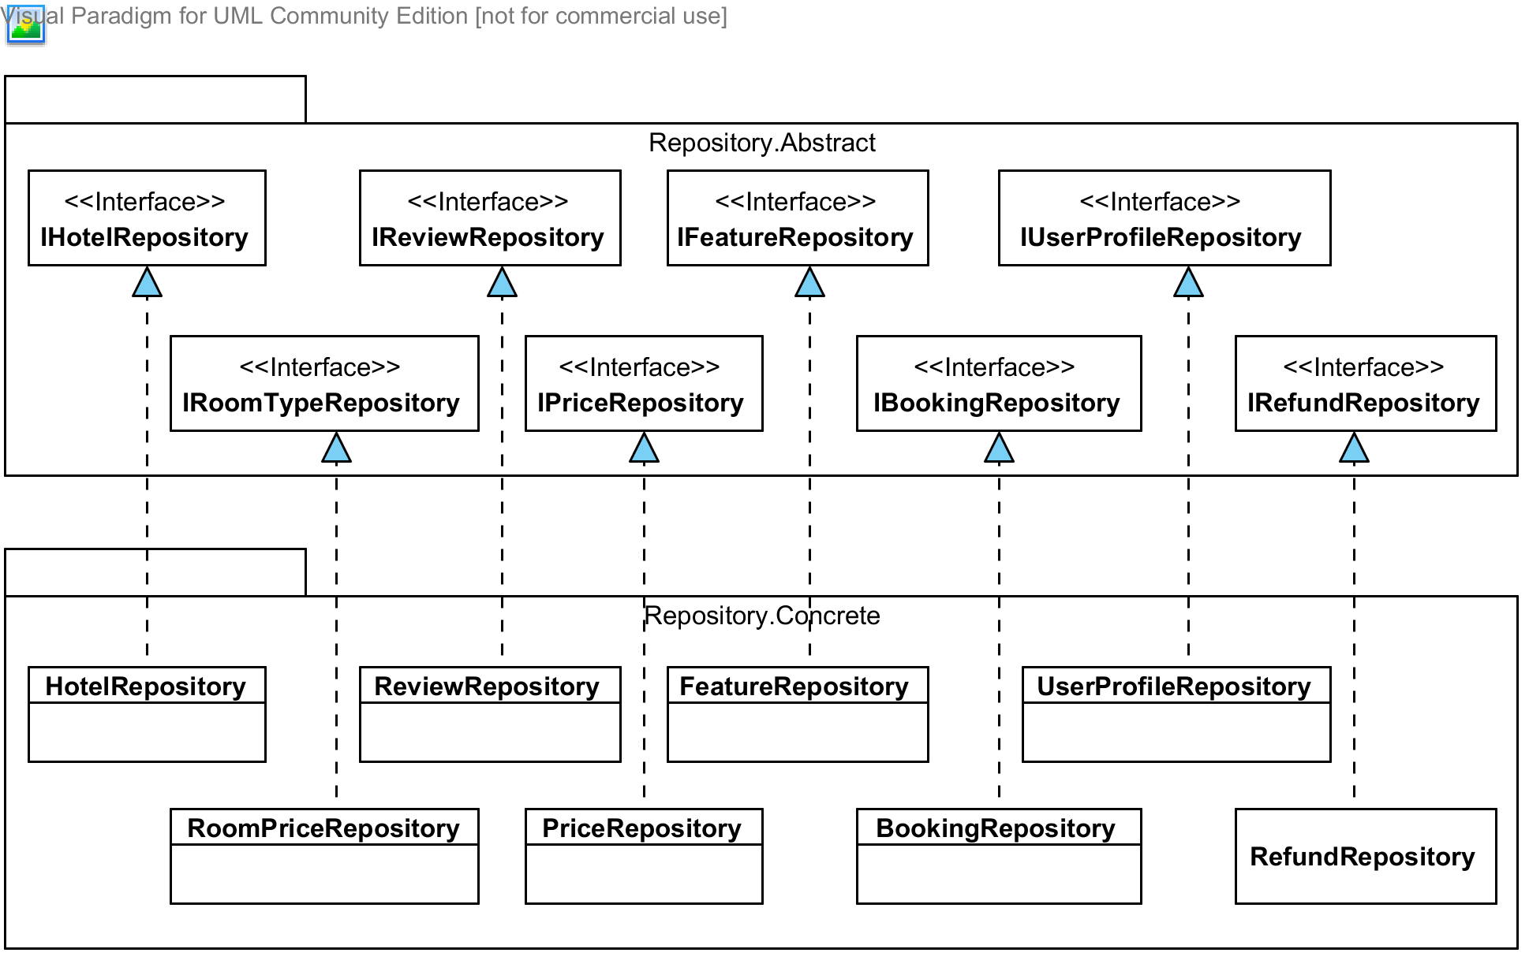

#### IHotelRepository Interface

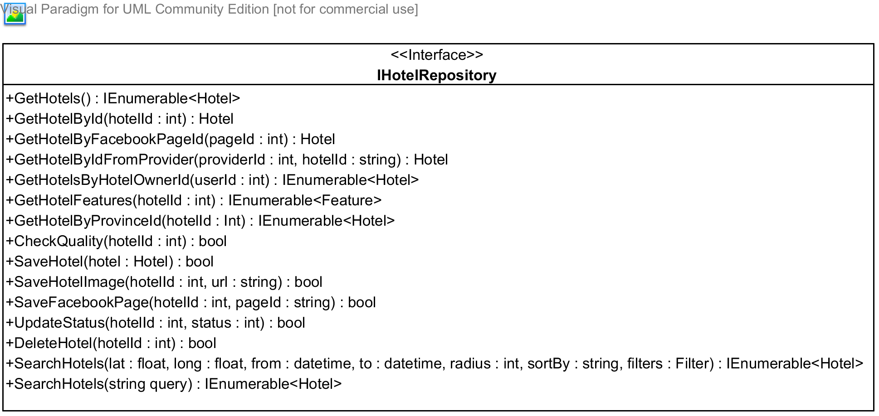

**Properties:** N/A

**Operations**

|  |  |  |
| --- | --- | --- |
| Signature: IEnumerable<Hotel> GetHotels()  Description: Retrieves all the hotels from the database | | |
| N/A | N/A | N/A |

|  |  |  |
| --- | --- | --- |
| Signature: Hotel GetHotelById(int hotelId)  Description: Retrieves a hotel from the database given its id | | |
| Parameter | **Type** | **Description** |
| *hotelId* | int | Id of the hotel to be retrieved |

|  |  |  |
| --- | --- | --- |
| Signature: IEnumerable<Hotel> GetHotelByFacebookPageId(string pageId)  Description: Retrieves a from the database given its Facebook page id | | |
| Parameter | **Type** | **Description** |
| *pageId* | string | Id of the Facebook page of the hotel |
|  |  |  |

|  |  |  |
| --- | --- | --- |
| Signature: Hotel GetHotelByIdFromProvider(int providerId, string hotelId)  Description: Retrieves all the hotels provided by a given provider from the database | | |
| Parameter | **Type** | **Description** |
| *providerId* | int | Id of the provider that provides the hotel |
| *hotelId* | string | Id given by the provider for the hotel |

|  |  |  |
| --- | --- | --- |
| Signature: IEnumerable<Hotel> GetHotelsByOwnerId(int userId)  Description: Retrieves all the hotels under the management of a hotel owner from the database | | |
| Parameter | **Type** | **Description** |
| *userId* | int | Id of the hotel owner |

|  |  |  |
| --- | --- | --- |
| Signature: IEnumerable<Feature> GetHotelFeatures(int hotelId)  Description: Retrieves all features of a given hotel from the database | | |
| Parameter | **Type** | **Description** |
| *hotelId* | int | Id of the hotel to be retrieved |

|  |  |  |
| --- | --- | --- |
| Signature: bool SaveHotel(Hotel hotel)  Description: Saves (insert or update) a hotel to the database | | |
| Parameter | **Type** | **Description** |
| *hotel* | Hotel | Id of the hotel to be saved |

|  |  |  |
| --- | --- | --- |
| Signature: bool CheckQuality(int hotelId)  Description: Check if the hotel with the given id has enough information | | |
| Parameter | **Type** | **Description** |
| *provinceId* | int | Id of the hotel to be checked |

|  |  |  |
| --- | --- | --- |
| Signature: bool SaveImage(int hotelId, string url)  Description: Save an image for the given hotel to the database | | |
| Parameter | **Type** | **Description** |
| *hotelId* | int | Id of the hotel to be saved |
| *url* | string | Url of the image to be saved |

|  |  |  |
| --- | --- | --- |
| Signature: bool SaveFacebookPageId(int hotelId, string facebookPageId)  Description: Save a Facebook page for a given hotel to the database | | |
| Parameter | **Type** | **Description** |
| *hotelId* | int | Id of the hotel to be saved |
| *facebookPageId* | string | Id of the Facebook page provided by Facebook |

|  |  |  |
| --- | --- | --- |
| Signature: bool ApproveHotel(int hotelId)  Description: Approves a hotel to set it active in the system | | |
| Parameter | **Type** | **Description** |
| *hotelId* | int | Id of the hotel to be approved of |

|  |  |  |
| --- | --- | --- |
| Signature: bool DeleteHotel(int hotelId)  Description: Marks a hotel as deleted given its id in the database | | |
| Parameter | **Type** | **Description** |
| *hotelId* | int | Id of the hotel to be deleted |

|  |  |  |
| --- | --- | --- |
| Signature: IEnumerable<Hotel> SearchHotels(float lat, float long, datetime from, datetime to, int radius, string sortBy, Filter filters)  Description: Retrieves all the hotels that satisfy the criteria specified in the parameters from the database | | |
| Parameter | **Type** | **Description** |
| *lat* | float | Latitude of the center of the destination |
| *long* | float | Longitude of the center of the destination |
| *from* | datetime | Date to check prices from |
| *to* | datetime | Date to check prices to |
| *radius* | int | Radius to be search from the center of the destination |
| *sortBy* | string | Order in which the results should be |
| *filters* | Filter | Filters applied to the results |

|  |  |  |
| --- | --- | --- |
| Signature: IEnumerable<Hotel> SearchHotels(string query)  Description: Retrieves all the hotels that contains the query string in its name and address line from the database | | |
| Parameter | **Type** | **Description** |
| *query* | string | Query used to search for hotel name and address line |

|  |  |  |
| --- | --- | --- |
| Signature: IEnumerable<Hotel> GetHotelsByProvinceId(int provinceId)  Description: Retrieves all the hotels from the database | | |
| Parameter | **Type** | **Description** |
| *provinceId* | int | Id of the province that has its hotels to be retrieved |

#### IFeatureRepository Interface

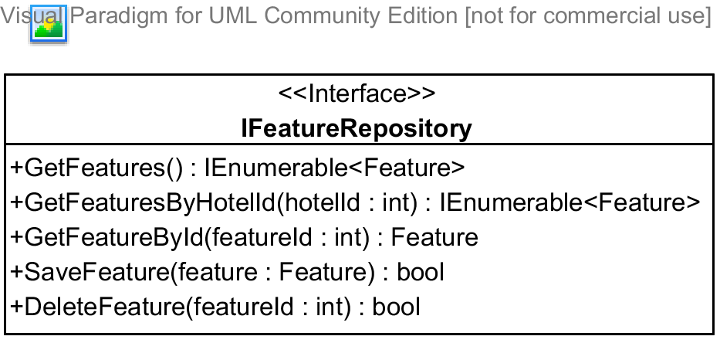

**Properties:** N/A

**Operations**

|  |  |  |
| --- | --- | --- |
| Signature: IEnumerable<Feature> GetFeatures()  Description: Retrieves all the hotel features from the database | | |
| Parameter | **Type** | **Description** |
| N/A | N/A | N/A |

|  |  |  |
| --- | --- | --- |
| Signature: IEnumerable<Feature> GetFeaturesByHotelId(int hotelId)  Description: Retrieves all the hotel features for a given hotel from the database | | |
| Parameter | **Type** | **Description** |
| *hotelId* | int | Id of the hotel that has the features to be retrieved |

|  |  |  |
| --- | --- | --- |
| Signature: Feature GetFeatureById(int featureId)  Description: Retrieves a feature given its id from the database | | |
| Parameter | **Type** | **Description** |
| *featureId* | int | Id of the feature to be retrieved |

|  |  |  |
| --- | --- | --- |
| Signature: bool SaveFeature(Feature feature)  Description: Saves (insert or update) the feature to the database | | |
| Parameter | **Type** | **Description** |
| *feature* | Feature | The feature to be saved |

|  |  |  |
| --- | --- | --- |
| Signature: bool DeletedFeature(int featureId)  Description: Marks the feature as deleted int the database | | |
| Parameter | **Type** | **Description** |
| *featureId* | int | Id of the feature to be deleted |

#### IPriceRepository Interface

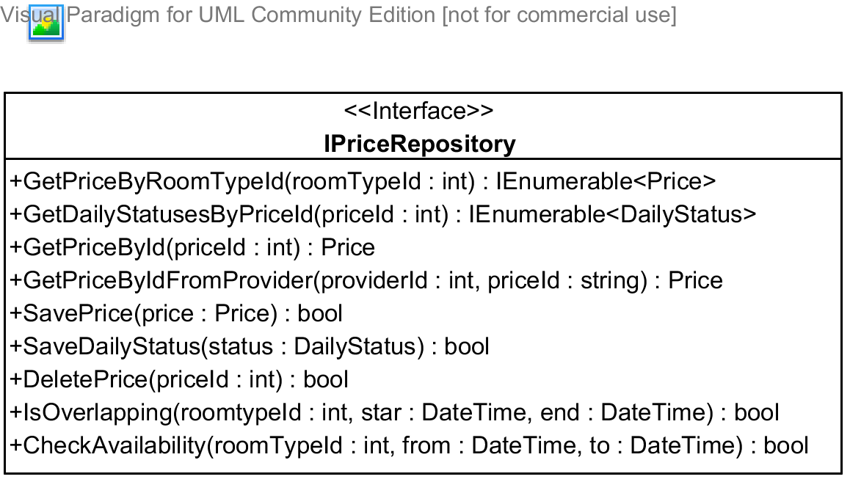

**Properties:** N/A

**Operations**

|  |  |  |
| --- | --- | --- |
| Signature: IEnumerable<Price> GetPriceByRoomTypeId(int roomTypeid)  Description: Retrieves all the prices given its room type from the database | | |
| Parameter | **Type** | **Description** |
| *roomTypeId* | int | Id of the room type that has its prices to be retrieved |

|  |  |  |
| --- | --- | --- |
| Signature: IEnumerable<DailyStatus> GetDailyStatusesByPriceId(int priceId)  Description: Retrieves all the daily status for a given price from the database | | |
| Parameter | **Type** | **Description** |
| *priceId* | int | Id of the price that has the daily statuses to be retrieved |

|  |  |  |
| --- | --- | --- |
| Signature: Price GetPriceById(int priceId)  Description: Retrieves a price given its id from the database | | |
| Parameter | **Type** | **Description** |
| *priceId* | int | Id of price to be retrieved |

|  |  |  |
| --- | --- | --- |
| Signature: bool SavePrice(Price price)  Description: Saves (insert or update) a price to the database | | |
| Parameter | **Type** | **Description** |
| *price* | Price | The price to be saved |

|  |  |  |
| --- | --- | --- |
| Signature: bool SaveDailyStatus(DailyStatus status)  Description: Saves (insert or update) a daily status in the database | | |
| Parameter | **Type** | **Description** |
| *status* | DailyStatus | The daily status to be saved |

|  |  |  |
| --- | --- | --- |
| Signature: bool DeletedPrice(int priceId)  Description: Marks the price as deleted int the database | | |
| Parameter | **Type** | **Description** |
| *priceId* | int | Id of the price to be deleted |

|  |  |  |
| --- | --- | --- |
| Signature: bool IsOverlapping(int roomTypeId, datetime start, datetime end)  Description: Checks if there is a price that overlaps the specified period for the given room type in the database | | |
| Parameter | **Type** | **Description** |
| *roomTypeId* | int | Id of room type to be checked |
| *start* | DateTime | Date on which the price starts |
| *end* | DateTime | Date on which the price ends |

|  |  |  |
| --- | --- | --- |
| Signature: bool GetPriceByIdFromProvider(int providerId, string id)  Description: Retrieves a price given the id provided by the provider from the database | | |
| Parameter | **Type** | **Description** |
| *providerId* | int | Id of the provider who provides the price |
| *id* | string | Id given by the provider |

#### IRoomTypeRepository Interface

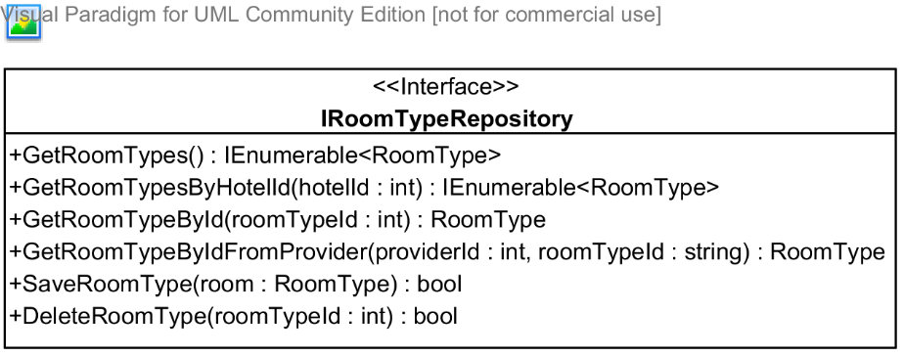

**Properties:** N/A

**Operations**

|  |  |  |
| --- | --- | --- |
| Signature: IEnumerable<RoomType> GetRoomTypes()  Description: Retrieves all the room types from the database | | |
| Parameter | **Type** | **Description** |
| N/A | N/A | N/A |

|  |  |  |
| --- | --- | --- |
| Signature: IEnumerable<RoomType> GetRoomTypeByHotelId(int hotelId)  Description: Retrieves all the room types that belong to a given hotel from the database | | |
| Parameter | **Type** | **Description** |
| *hotelId* | int | Id of the hotel that has the room types to be retrieved |

|  |  |  |
| --- | --- | --- |
| Signature: Feature GetRoomTypeById(int roomTypeId)  Description: Retrieves a room type given its id from the database | | |
| Parameter | **Type** | **Description** |
| *roomTypeId* | int | Id of the room type to be retrieved |

|  |  |  |
| --- | --- | --- |
| Signature: bool SaveRoomType(RoomType room)  Description: Saves (insert or update) the room type to the database | | |
| Parameter | **Type** | **Description** |
| *room* | RoomType | The room type to be saved |

|  |  |  |
| --- | --- | --- |
| Signature: bool DeletedRoomType(int roomTypeId)  Description: Marks a room type as deleted int the database | | |
| Parameter | **Type** | **Description** |
| *roomTypeId* | int | Id of the room type to be deleted |

#### IReviewRepository Interface

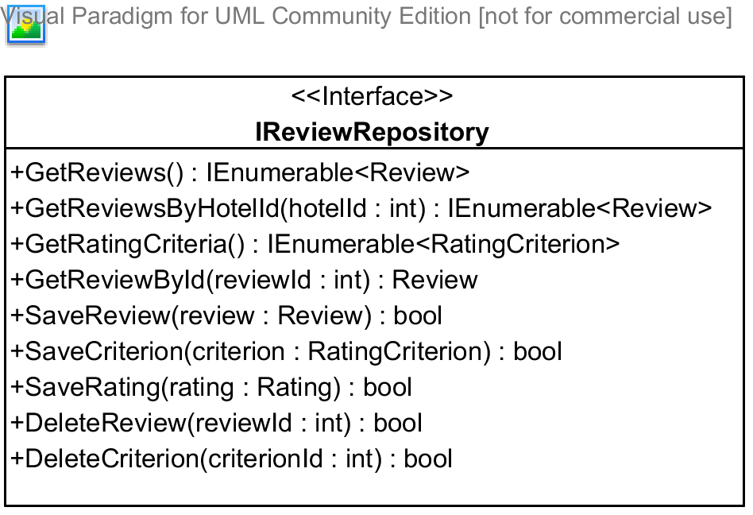

**Properties:** N/A

**Operations**

|  |  |  |
| --- | --- | --- |
| Signature: IEnumerable<Reviews> GetReviews()  Description: Retrieves all the reviews from the database | | |
| Parameter | **Type** | **Description** |
| N/A | N/A | N/A |

|  |  |  |
| --- | --- | --- |
| Signature: IEnumerable<Review> GetReviewByHotelId(int hotelId)  Description: Retrieves all the reviews given its hotel id from the database | | |
| Parameter | **Type** | **Description** |
| *hotelId* | int | Id of the hotel that has its reviews to be retrieved |

|  |  |  |
| --- | --- | --- |
| Signature: Feature GetRatingCriteria()  Description: Retrieves a rating criteria from the database | | |
| Parameter | **Type** | **Description** |

|  |  |  |
| --- | --- | --- |
| Signature: Feature GetReviewById(int reviewId)  Description: Retrieves a review given its id from the database | | |
| Parameter | **Type** | **Description** |
| *reviewId* | int | Id of the review to be retrieved |

|  |  |  |
| --- | --- | --- |
| Signature: bool SaveCriterion(Criterion criterion)  Description: Saves (insert or update) the criterion to the database | | |
| Parameter | **Type** | **Description** |
| *criterion* | Criterion | The criterion to be saved |

|  |  |  |
| --- | --- | --- |
| Signature: bool SaveReview(Review review)  Description: Saves (insert or update) the feature to the database | | |
| Parameter | **Type** | **Description** |
| *review* | Review | The review to be saved |

|  |  |  |
| --- | --- | --- |
| Signature: bool DeletedReview(int reviewId)  Description: Marks the review as deleted int the database | | |
| Parameter | **Type** | **Description** |
| *reviewId* | int | Id of the review to be deleted |

|  |  |  |
| --- | --- | --- |
| Signature: bool DeletedCriterion(int criterionId)  Description: Marks the criterion as deleted int the database | | |
| Parameter | **Type** | **Description** |
| *criterionId* | int | Id of the criterion to be deleted |

|  |  |  |
| --- | --- | --- |
| Signature: bool SaveRating(int userId, int hotelId, int criterionId, int point)  Description: Marks the review as deleted int the database | | |
| Parameter | **Type** | **Description** |
| *userId* | int | Id of user who rated the hotel |
| *hotelId* | int | Id of the hotel being rated |
| *criterionId* | int | Id of the criterion being rated |
| *point* | int | Point the user gives to the hotel for the criterion |

#### IUserProfileRepository Interface

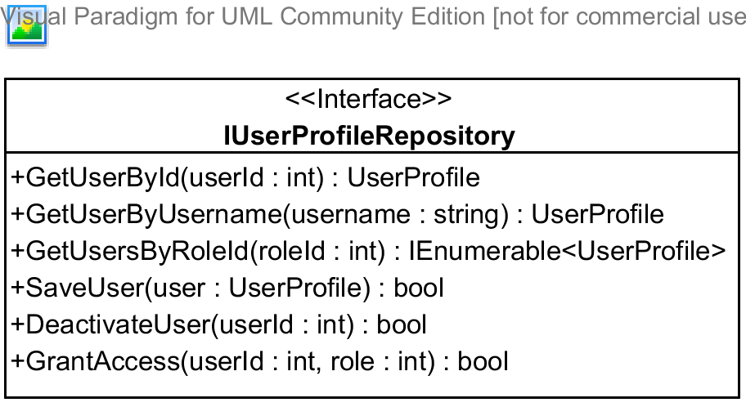

**Properties:** N/A

**Operations**

|  |  |  |
| --- | --- | --- |
| Signature: UserProfile GetUserById(int userId)  Description: Retrieves a user given its id from the database | | |
| Parameter | **Type** | **Description** |
| *userId* | int | Id of user to be retrieved |

|  |  |  |
| --- | --- | --- |
| Signature: UserProfile GetUserByUsername(string username)  Description: Retrieves a user given its username from the database | | |
| Parameter | **Type** | **Description** |
| *username* | int | User of user to be retrieved |

|  |  |  |
| --- | --- | --- |
| Signature: bool SaveUser(UserProfile user)  Description: Saves (insert or update) the feature to the database | | |
| Parameter | **Type** | **Description** |
| *user* | UserProfile | The user to be saved |

|  |  |  |
| --- | --- | --- |
| Signature: bool DeactivateUser(int userId)  Description: Marks the the user as deactivated in the database | | |
| Parameter | **Type** | **Description** |
| *userId* | int | Id of the user to be marked as deactivated |

|  |  |  |
| --- | --- | --- |
| Signature: bool GrantAccess(int userId, int roleId)  Description: Grants the selected role the the user with the user id | | |
| Parameter | **Type** | **Description** |
| *userId* | int | Id of the user to be granted access |
| *roleId* | Role | Role that will be granted to the user |

|  |  |  |
| --- | --- | --- |
| Signature: bool DeactivateUser(int userId)  Description: Marks the the user as deactivated in the database | | |
| Parameter | **Type** | **Description** |
| *userId* | int | Id of the user to be marked as deactivated |

#### IBookingRepository Interface

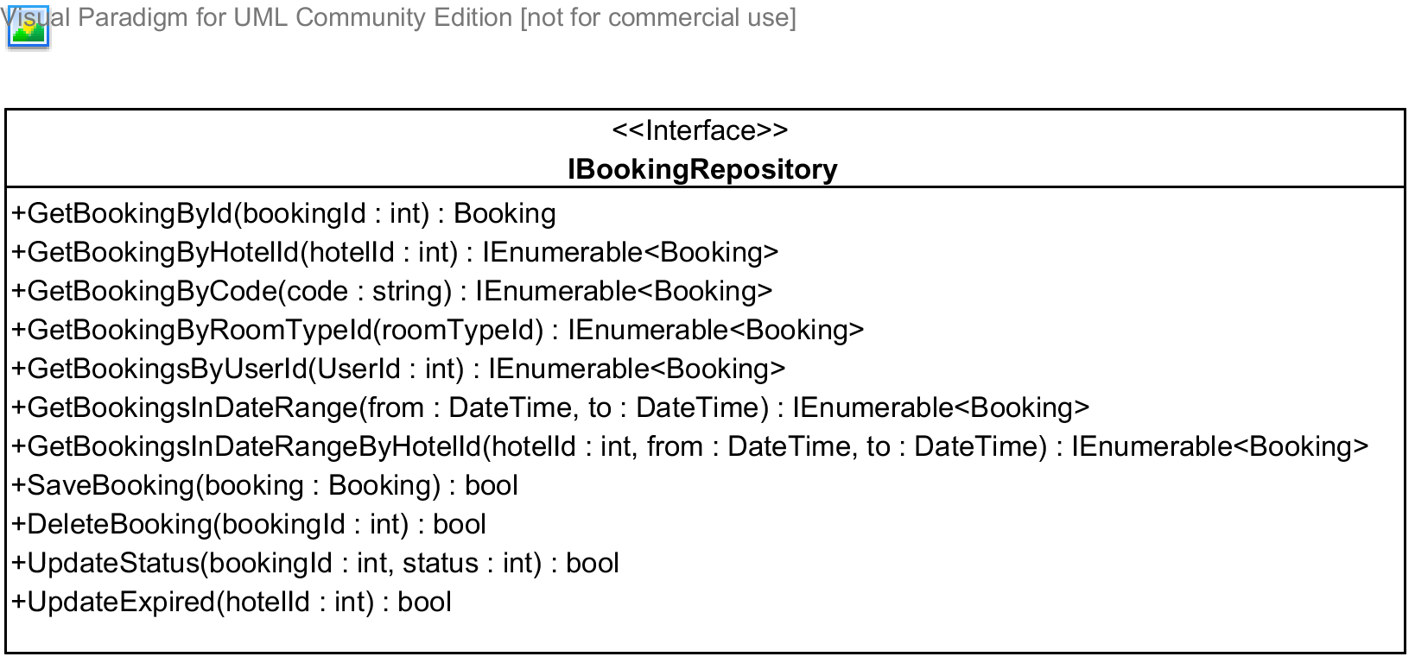

**Properties:** N/A

**Operations**

|  |  |  |
| --- | --- | --- |
| Signature: Booking GetBookingsById(int bookingId)  Description: Retrieves a booking given its id from the database | | |
| Parameter | **Type** | **Description** |
| *bookingId* | int | Id of the booking to be retrieved |

|  |  |  |
| --- | --- | --- |
| Signature: IEnumerable<Booking> GetBookingsByHotelId(int hotelId)  Description: Retrieves all the bookings for a given hotel from the database | | |
| Parameter | **Type** | **Description** |
| *hotelId* | int | Id of the hotel that has the features to be retrieved |

|  |  |  |
| --- | --- | --- |
| Signature: IEnumerable<Booking> GetBookingsByCode(string code)  Description: Retrieves all the hotel features for a given hotel from the database | | |
| Parameter | **Type** | **Description** |
| *code* | int | Code of the booking to be retrieved |

|  |  |  |
| --- | --- | --- |
| Signature: IEnumerable<Booking> GetBookingsByRoomTypeId(int roomTypeId)  Description: Retrieves all the booking for a given type from the database | | |
| Parameter | **Type** | **Description** |
| *roomTypeId* | int | Id of the room type that has its bookings to be retrieved |

|  |  |  |
| --- | --- | --- |
| Signature: IEnumerable<Booking> GetBookingsByUserId(int userId)  Description: Retrieves all the bookings for a given user from the database | | |
| Parameter | **Type** | **Description** |
| *userId* | int | Id of the user that has its bookings to be retrieved |

|  |  |  |
| --- | --- | --- |
| Signature: IEnumerable<Booking> GetBookingsInDateRange(datetime from, datetime to)  Description: Retrieves all the bookings made in a specified date range from the database | | |
| Parameter | **Type** | **Description** |
| *from* | DateTime | Date from which the bookings to be retrieved was made |
| *to* | DateTime | Date until which the bookings to be retrieved was made |

|  |  |  |
| --- | --- | --- |
| Signature: IEnumerable<Booking> GetBookingsInDateRangeByHotelId(int hotelId, datetime from, datetime to)  Description: Retrieves all the bookings made in a specified date range from the database | | |
| Parameter | **Type** | **Description** |
| *hotelId* | int | Id of the hotel that has its bookings to be retrieved |
| *from* | DateTime | Date from which the bookings to be retrieved was made |
| *to* | DateTime | Date until which the bookings to be retrieved was made |

|  |  |  |
| --- | --- | --- |
| Signature: Booking GetBookingsByIdFromProvider(string bookingId)  Description: Retrieves a booking given its id from its hotel provider from the database | | |
| Parameter | **Type** | **Description** |
| *bookingId* | string | Id of booking given by the hotel provider |

|  |  |  |
| --- | --- | --- |
| Signature: bool SaveBooking(Booking booking)  Description: Saves (insert or update) the booking to the database | | |
| Parameter | **Type** | **Description** |
| *booking* | Booking | The booking to be saved |

|  |  |  |
| --- | --- | --- |
| Signature: bool DeletedBooking(int bookingId)  Description: Marks the booking as deleted int the database | | |
| Parameter | **Type** | **Description** |
| *bookingId* | int | Id of the booking to be deleted |

|  |  |  |
| --- | --- | --- |
| Signature: bool UpdateExpired(int hotelId)  Description: Updates all the bookings that are expired to “Expired” status | | |
| Parameter | **Type** | **Description** |
| *hotelId* | Refund | Id of the hotel to update |

#### IRefundRepository Interface

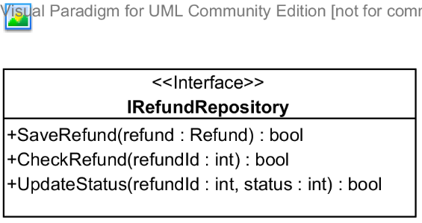

**Properties:** N/A

**Operations**

|  |  |  |
| --- | --- | --- |
| Signature: bool SaveRefund(Refund refund)  Description: Saves (insert or update) the refund to the database | | |
| Parameter | **Type** | **Description** |
| *refund* | Refund | The refund to be saved |

|  |  |  |
| --- | --- | --- |
| Signature: bool UpdateStatus(int refundId, int status)  Description: Update the status a refund given its id to the database | | |
| Parameter | **Type** | **Description** |
| *refundId* | int | Id of the refund to be updated |
| *status* | int | Status that will be updated for the refund |

|  |  |  |
| --- | --- | --- |
| Signature: bool ChecRefund(int refundId)  Description: Checks if the refund with the given Id can be approved or not | | |
| Parameter | **Type** | **Description** |
| *refundId* | int | Id of the refund to be checked |

|  |  |  |
| --- | --- | --- |
| Signature: bool UpdateExpired(int hotelId)  Description: Updates all the refunds that are expired to “Expired” status | | |
| Parameter | **Type** | **Description** |
| *hotelId* | Refund | Id of the hotel to update |

### Data Synchronization Classes



#### Class diagram

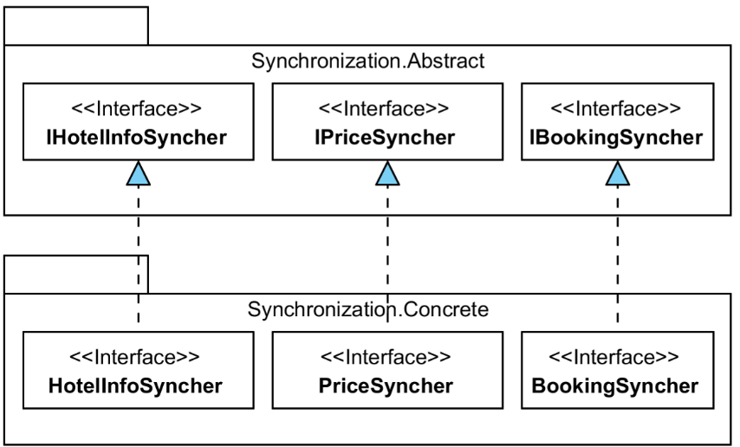

#### IHotelSyncher Interface

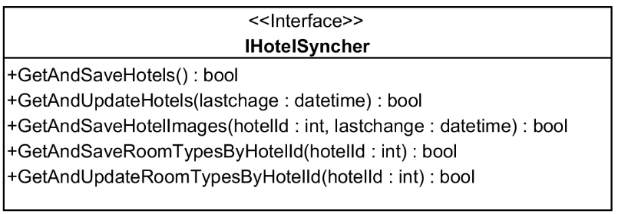

**Properties:** N/A

**Operations**

|  |  |  |
| --- | --- | --- |
| Signature: bool GetAndSaveHotels()  Description: Retrieves all the hotels provided by the BMT provider and save them the the database | | |
| Parameter | **Type** | **Description** |
| N/A | N/A | N/A |

|  |  |  |
| --- | --- | --- |
| Signature: bool GetAndUpdateHotels(datetime lastChange)  Description: Updates all the hotels provided by the BMT provider by calling its services and then saving the updated information to the database. | | |
| Parameter | **Type** | **Description** |
| *lastChange* | DateTime | Time on which the last change was made on the data |

|  |  |  |
| --- | --- | --- |
| Signature: bool GetAndSaveHotelImages(int hotelId, datetime lastChange)  Description: Retrieves all the images of the given hotel provided by the BMT provider and save them the the database. | | |
| Parameter | **Type** | **Description** |
| *lastChange* | datetime | Time on which the last change was made on the data |
| *hotelId* | int | Id of the hotel to be updated |

|  |  |  |
| --- | --- | --- |
| Signature: bool GetAndSaveHotelImages(int hotelId)  Description: Retrieves all the room types of the given hotel provided by the BMT provider and save them the the database. | | |
| Parameter | **Type** | **Description** |
| *hotelId* | int | Id of the hotel to be updated |

|  |  |  |
| --- | --- | --- |
| Signature: bool GetAndUpdatesHotelImages(int hotelId)  Description: Updates all the room types of the selected hotel provided by the BMT provider by calling its services and then saving the updated information to the database. | | |
| Parameter | **Type** | **Description** |
| *hotelId* | int | Id of the hotel to be updated |

#### IPriceSyncher

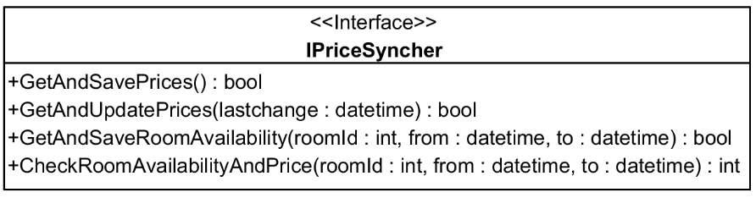

**Properties:** N/A

**Operations**

|  |  |  |
| --- | --- | --- |
| Signature: bool GetAndSavePrices(int hotelId)  Description: Retrieves all the prices of all the hotels provided by the BMT provider and save them the the database. | | |
| Parameter | **Type** | **Description** |
| N/A | N/A | N/A |

|  |  |  |
| --- | --- | --- |
| Signature: bool GetAndUpdatePrices(lastchange: datetime)  Description: Updates all prices of the the hotels provided by the BMT provider by calling its services and then saving the updated information to the database. | | |
| Parameter | **Type** | **Description** |
| *lastChange* | datetime | Time on which the last change was made on the data |

|  |  |  |
| --- | --- | --- |
| Signature: bool GetAndSaveRoomAvailability(int hotelId)  Description: Retrieves all the room availability statuses of the selected room type provided by the BMT provider and save them the the database. | | |
| Parameter | **Type** | **Description** |
| *roomId* | int | Id of the room to be updated |
| *from* | datetime | Date on which the checking starts |
| *to* | datetime | Date on which the checking ends |

|  |  |  |
| --- | --- | --- |
| Signature: int CheckRoomAvailabilityAndPrice(int roomId, int quantity, datetime from, datetime to)  Description: Checks if the room type is avaible on the specified period and retrieves its price if it is available. | | |
| Parameter | **Type** | **Description** |
| *roomId* | int | Id of the room to be checked |
| *quantity* | int | Number of rooms to check |
| *from* | datetime | Date on which the checking starts |
| *to* | datetime | Date on which the checking ends |

#### IBookingSyncher Interface

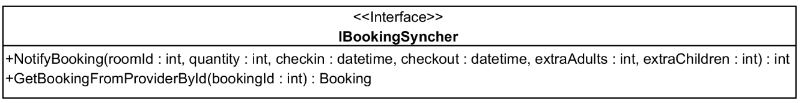

**Properties:** N/A

**Operations**

|  |  |  |
| --- | --- | --- |
| Signature: int NotifyBooking((int roomId, int quantity, datetime checkin, datetime checkout, int extraChildren, int extraAdults)  Description: Sends the booking to the BMT hotel provider | | |
| Parameter | **Type** | **Description** |
| *roomId* | int | Id of room type being booked |
| *quantity* | int | Numbers of rooms needed |
| *checkin* | datetime | Check-in date |
| *checkout* | datetime | Check-out date |
| *extraChildren* | int | Number of extra children, if allowed by the hotel owner |
| *extraAdults* | int | Number of extra adults, if allowed by the hotel owner |

|  |  |  |
| --- | --- | --- |
| Signature: GetBookingFromProviderById(int bookingId)  Description: Retrieves the booking from the BMT provider given its id | | |
| Parameter | **Type** | **Description** |
| *bookingId* | id | Id of the booking to be retrieved |

### Business Logic Classes



#### Class diagram

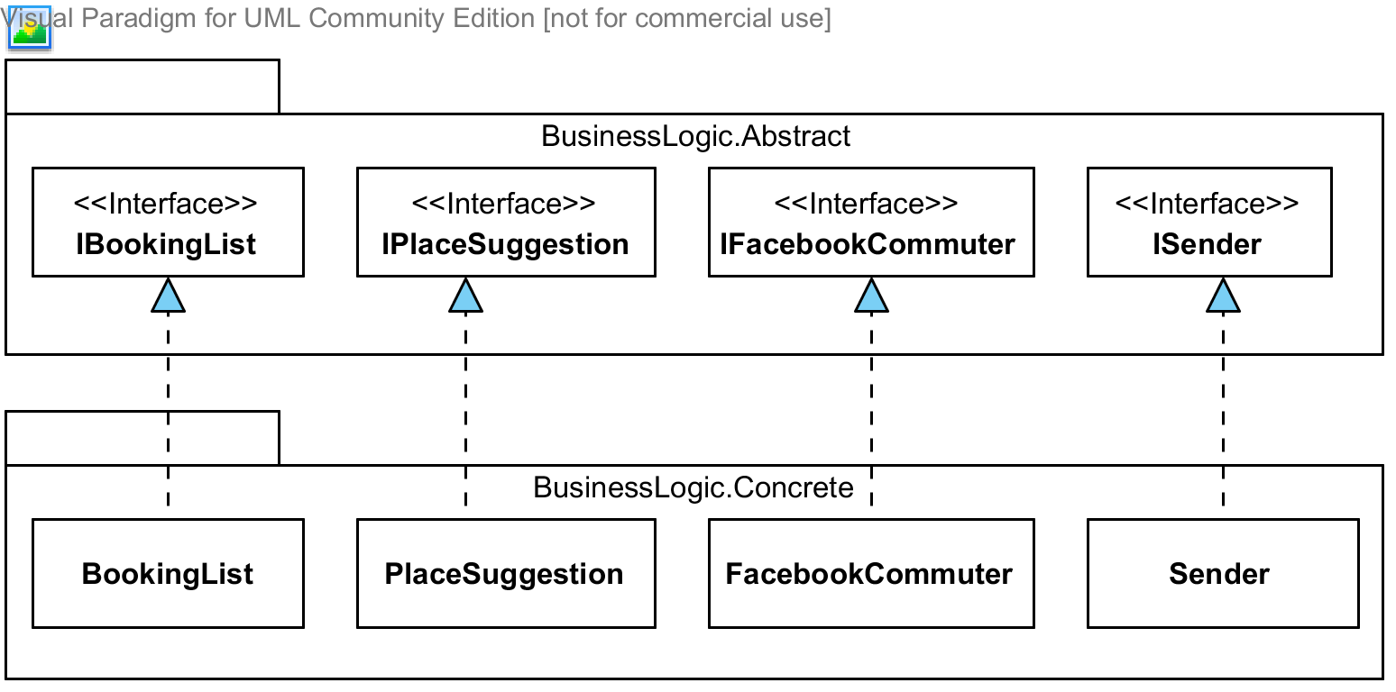

#### ISender Interface

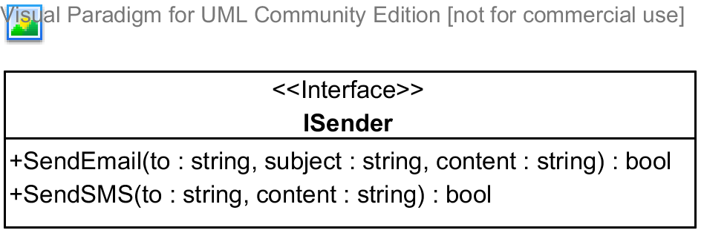

**Properties:** N/A

**Operations**

|  |  |  |
| --- | --- | --- |
| Signature: bool SendEmail(string to, string subject, string content)  Description: Sends an email to the address specified | | |
| Parameter | **Type** | **Description** |
| *to* | string | The email address to send to |
| *subject* | string | The subject of the email |
| *content* | string | The content of the email |

|  |  |  |
| --- | --- | --- |
| Signature: bool SendSMS(string to, string content)  Description: Sends an SMS message to the address specified | | |
| Parameter | **Type** | **Description** |
| *to* | string | The telephone number to send to |
| *content* | string | The content of the message |

#### IBookingList Interface

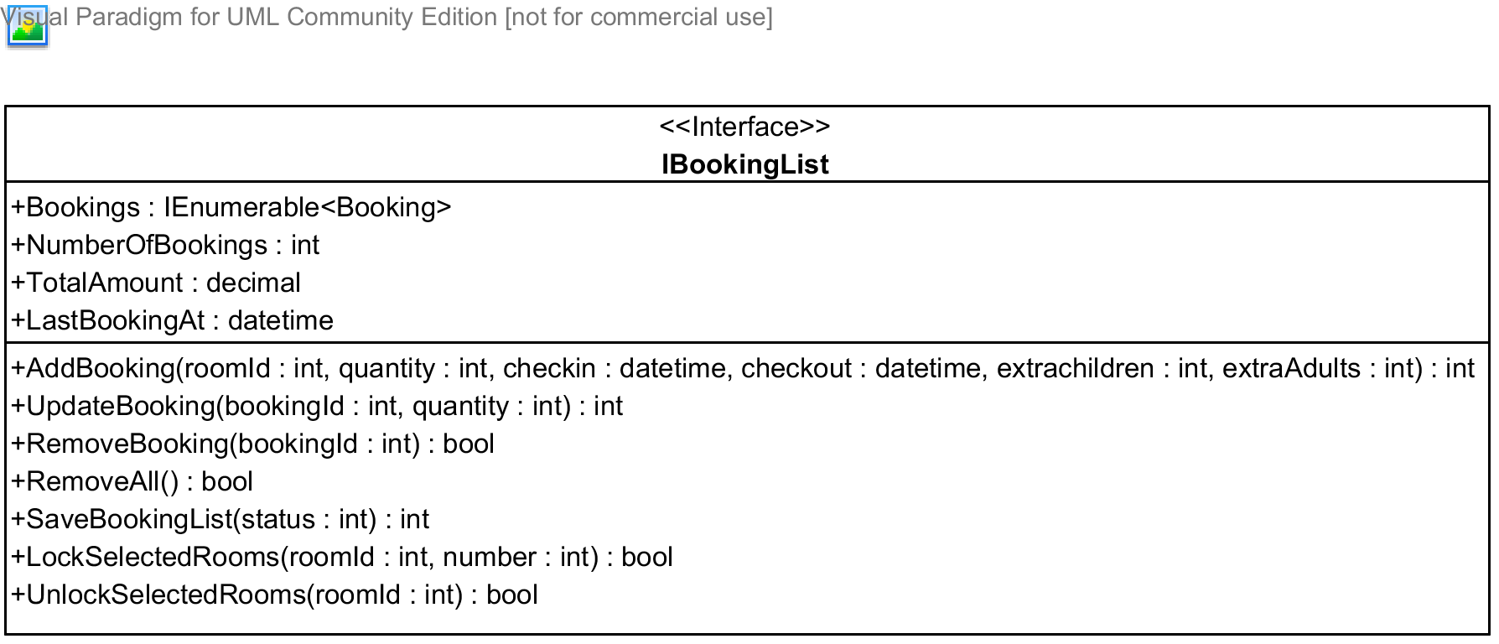

**Properties**

|  |  |  |  |
| --- | --- | --- | --- |
| Property name | Type | Visibility | Description |
| *Bookings* | IEnumerable<Booking> | public | A list of all bookings in the booking list for the current user |
| *NumberOfBooking* | int | public | Number of bookings in the booking list |
| *TotalAmount* | decimal | public | Total amount of all the booking |
| *LastBookingAt* | datetime | public | Time when the last booking was added to the booking list |

**Operations**

|  |  |  |
| --- | --- | --- |
| Signature: int AddBooking(int roomId, int quantity, datetime checkin, datetime checkout, int extraChildren, int extraAdults)  Description: Adds a bookings made by the current user to the booking list | | |
| Parameter | **Type** | **Description** |
| *roomId* | int | Id of room type being booked |
| *quantity* | int | Numbers of rooms needed |
| *checkin* | datetime | Check-in date |
| *checkout* | datetime | Check-out date |
| *extraChildren* | int | Number of extra children, if allowed by the hotel owner |
| *extraAdults* | int | Number of extra adults, if allowed by the hotel owner |

|  |  |  |
| --- | --- | --- |
| Signature: int UpdateBooking(int bookingId, int quantity)  Description: Update a booking in the booking list given its id | | |
| Parameter | **Type** | **Description** |
| *bookingId* | int | Id of the booking to be updated |
| *quantity* | int | Number of rooms to be updated |

|  |  |  |
| --- | --- | --- |
| Signature: bool RemoveBooking(int bookingId)  Description: Removed a booking in the booking list given its id | | |
| Parameter | **Type** | **Description** |
| *bookingId* | int | Id of the booking to be removed |

|  |  |  |
| --- | --- | --- |
| Signature: bool RemoveAll(int bookingId)  Description: Removed all the bookings int the booking list | | |
| Parameter | **Type** | **Description** |

|  |  |  |
| --- | --- | --- |
| Signature: bool SaveBookingList(int status)  Description: Saves the booking list to the database | | |
| Parameter | **Type** | **Description** |
| *status* | int | Status of the bookings to be saved |

|  |  |  |
| --- | --- | --- |
| Signature: bool LockSelectedRooms(int roomId, int number)  Description: Locks the rooms selected so that other user cannot book these rooms | | |
| Parameter | **Type** | **Description** |
| *roomId* | int | Id of the room type to be locked |
| *number* | int | Number of rooms to be locked for this type |

|  |  |  |
| --- | --- | --- |
| Signature: bool UnlockSelectedRooms(int roomId)  Description: Unlocks the rooms selected so that other user can book these rooms | | |
| Parameter | **Type** | **Description** |
| *roomId* | int | Id of the room type to be unlocked |

#### IPlaceSuggestion Interface

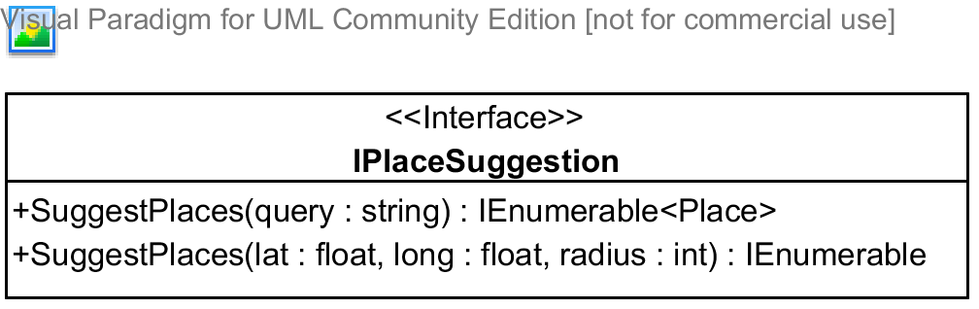

**Properties:** N/A

**Operations**

|  |  |  |
| --- | --- | --- |
| Signature: IEnumerable<Place> SuggestPlaces(string query)  Description: Suggests places(hotel address, provinces, and other type of places,...) given a query string | | |
| Parameter | **Type** | **Description** |
| *query* | string | A string that will be used to search and suggest places |

|  |  |  |
| --- | --- | --- |
| Signature: IEnumerable<Place> SuggestPlaces(float lat, float long, int radius)  Description: Suggests places(hotel address, provinces, and other type of places,...) given the center of the destination and the radius to be searched | | |
| Parameter | **Type** | **Description** |
| *lat* | float | Latitude of the destination center |
| *long* | float | Longitude of the destination center |
| *radius* | int | Radius to limit the searching |

#### IFacebookCommuter Interface

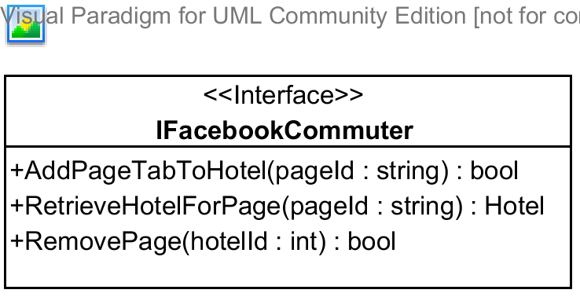

**Properties:** N/A

**Operations**

|  |  |  |
| --- | --- | --- |
| Signature: bool AddPageTabToHotel(string pageId, int hotelId)  Description: Adds a page tab to the hotel | | |
| Parameter | **Type** | **Description** |
| *pageId* | string | Id of the Facebook page to be added to the hotel |
| *hotelId* | int | Id of the hotel to be added |

|  |  |  |
| --- | --- | --- |
| Signature: Hotel RetrieveHotelForPage(string pageId)  Description: Retrieves a hotel given its pageId | | |
| Parameter | **Type** | **Description** |
| *pageId* | string | Facebook page id of the hotel to be retrieved |

|  |  |  |
| --- | --- | --- |
| Signature: bool RemovePage(int hotelId)  Description: Removes the Facebook page from the hotel given its id | | |
| Parameter | **Type** | **Description** |
| *hotelId* | int | Id of the hotel to remove the Facebook page |

## Behavioral Diagrams



### State Machine Diagram: Booking Status Transition

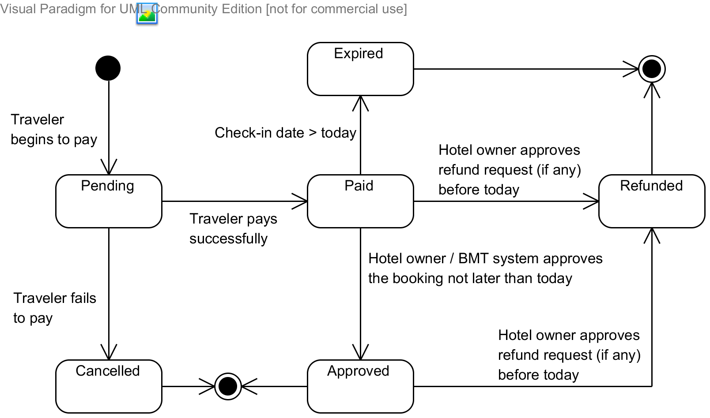

Diagram . State machine diagram: Booking status transition

### State Machine Diagram: Refund Request Status Transition

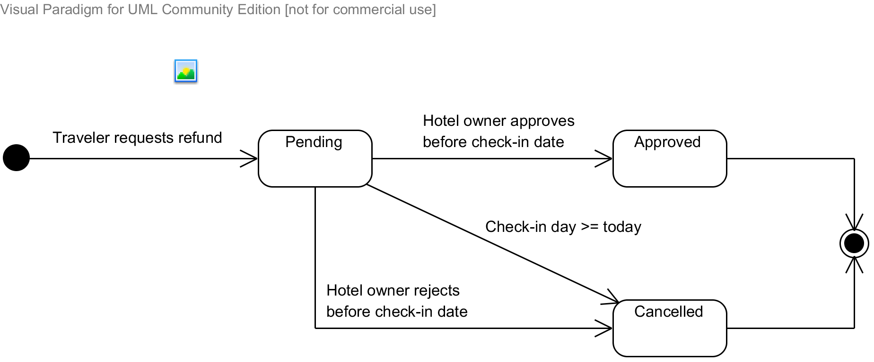

Diagram . State machine diagram: Refund request status transition

### Sequence Diagram: Search Hotels

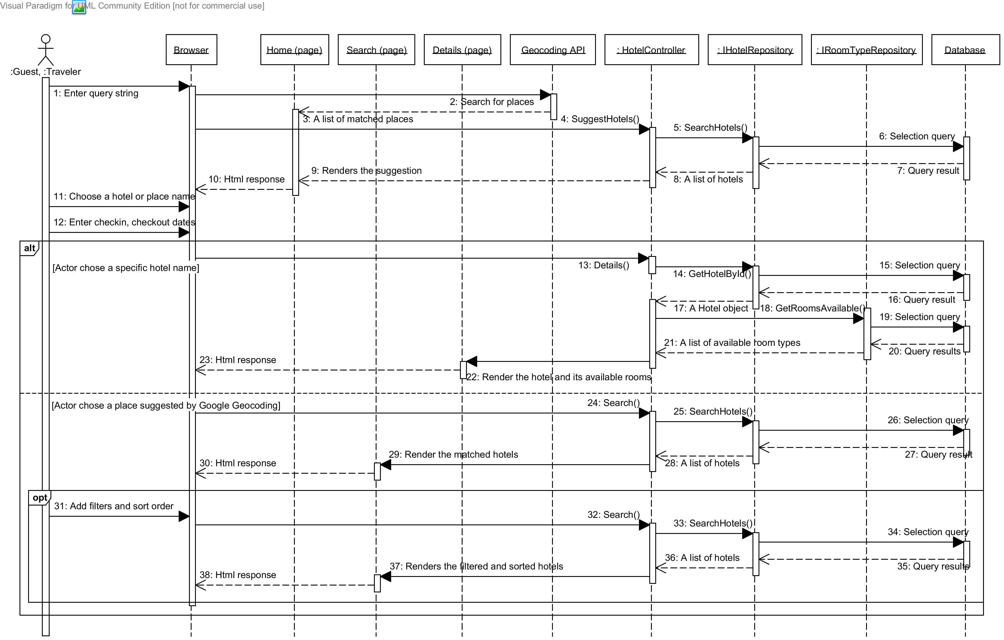

Diagram . Sequence diagram: Search Hotels

### Sequence Diagram: Add Rooms to Booking List

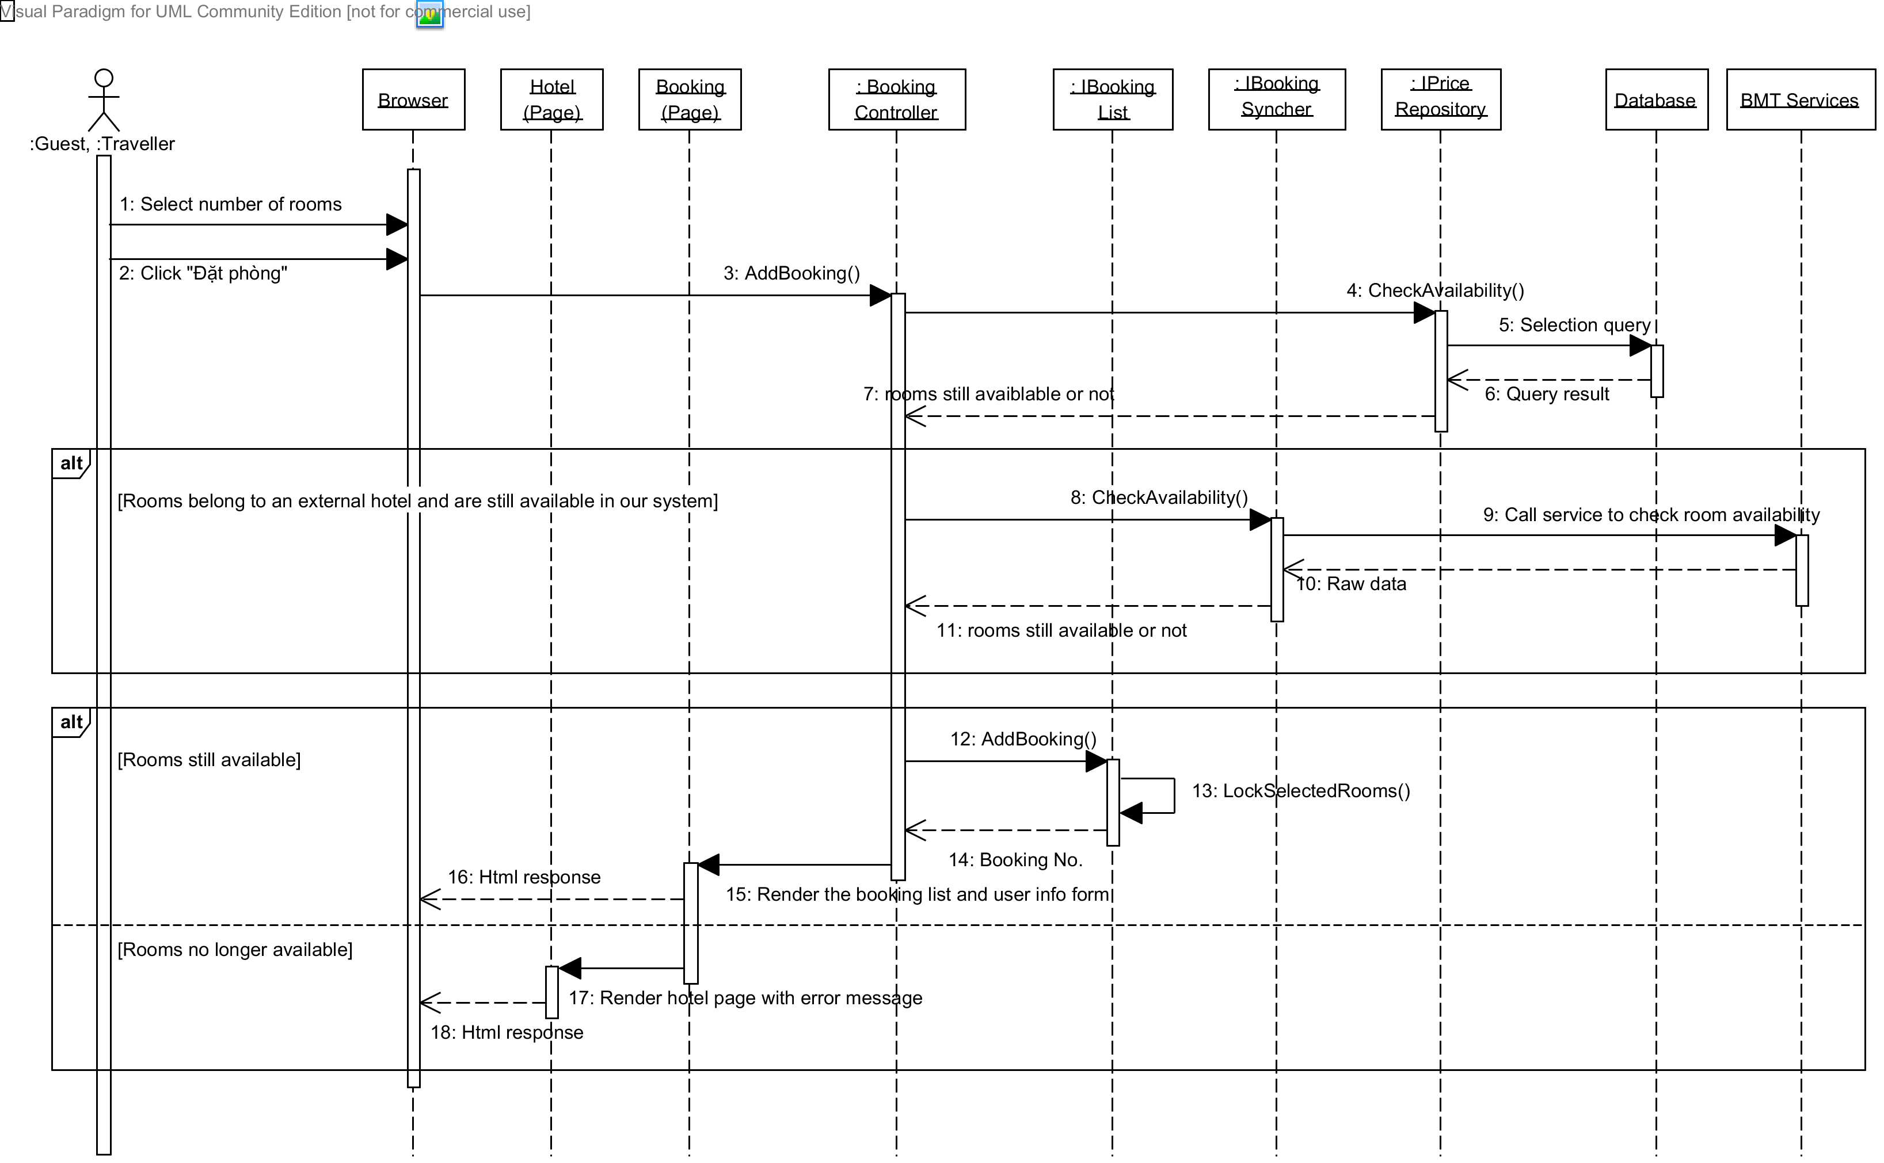

Diagram . Sequence diagram: Add rooms to booking list

### Sequence Diagram: Book Rooms and Pay

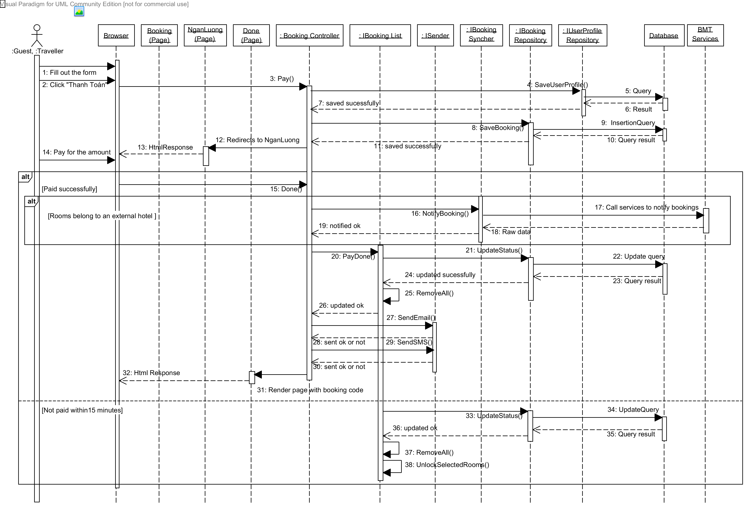

Diagram . Sequence diagram: Book rooms and pay

### Sequence Diagram: Request a Refund

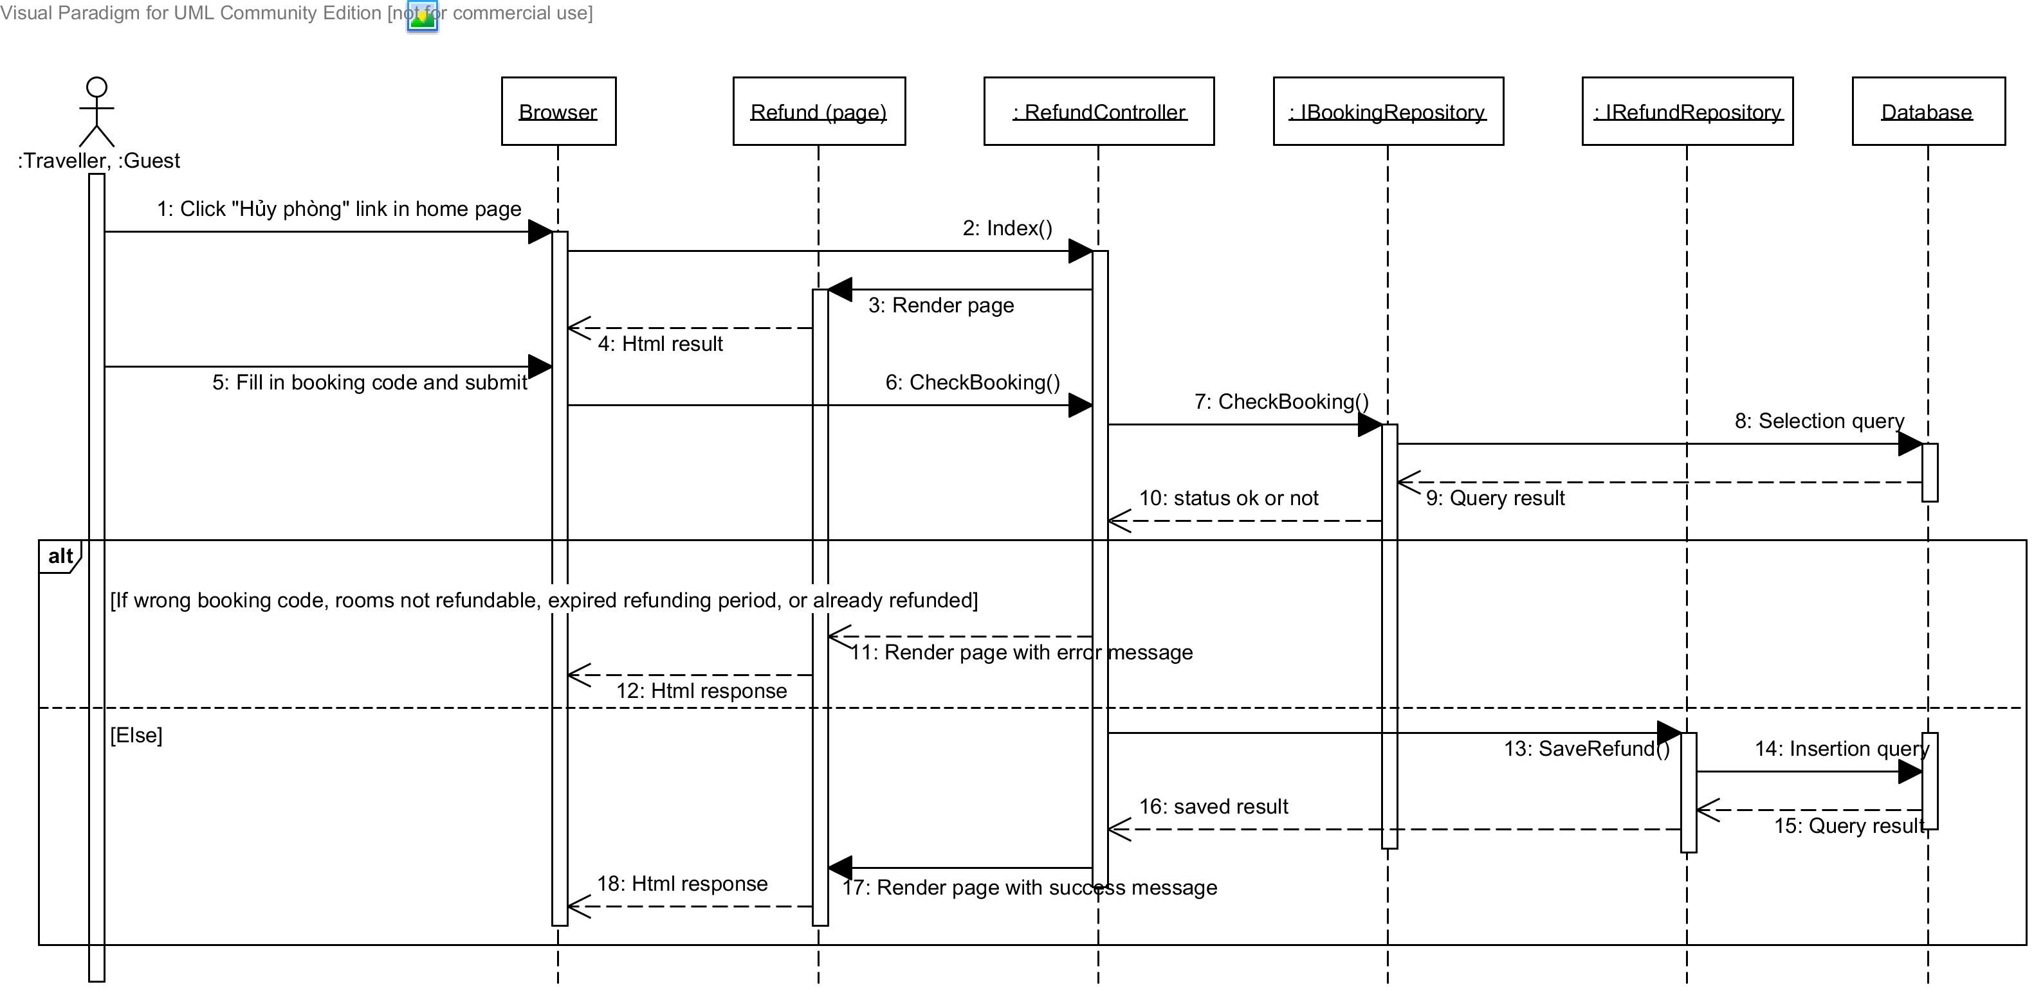

Diagram . Sequence diagram: Request a refund

### Sequence Diagram: Create a Hotel

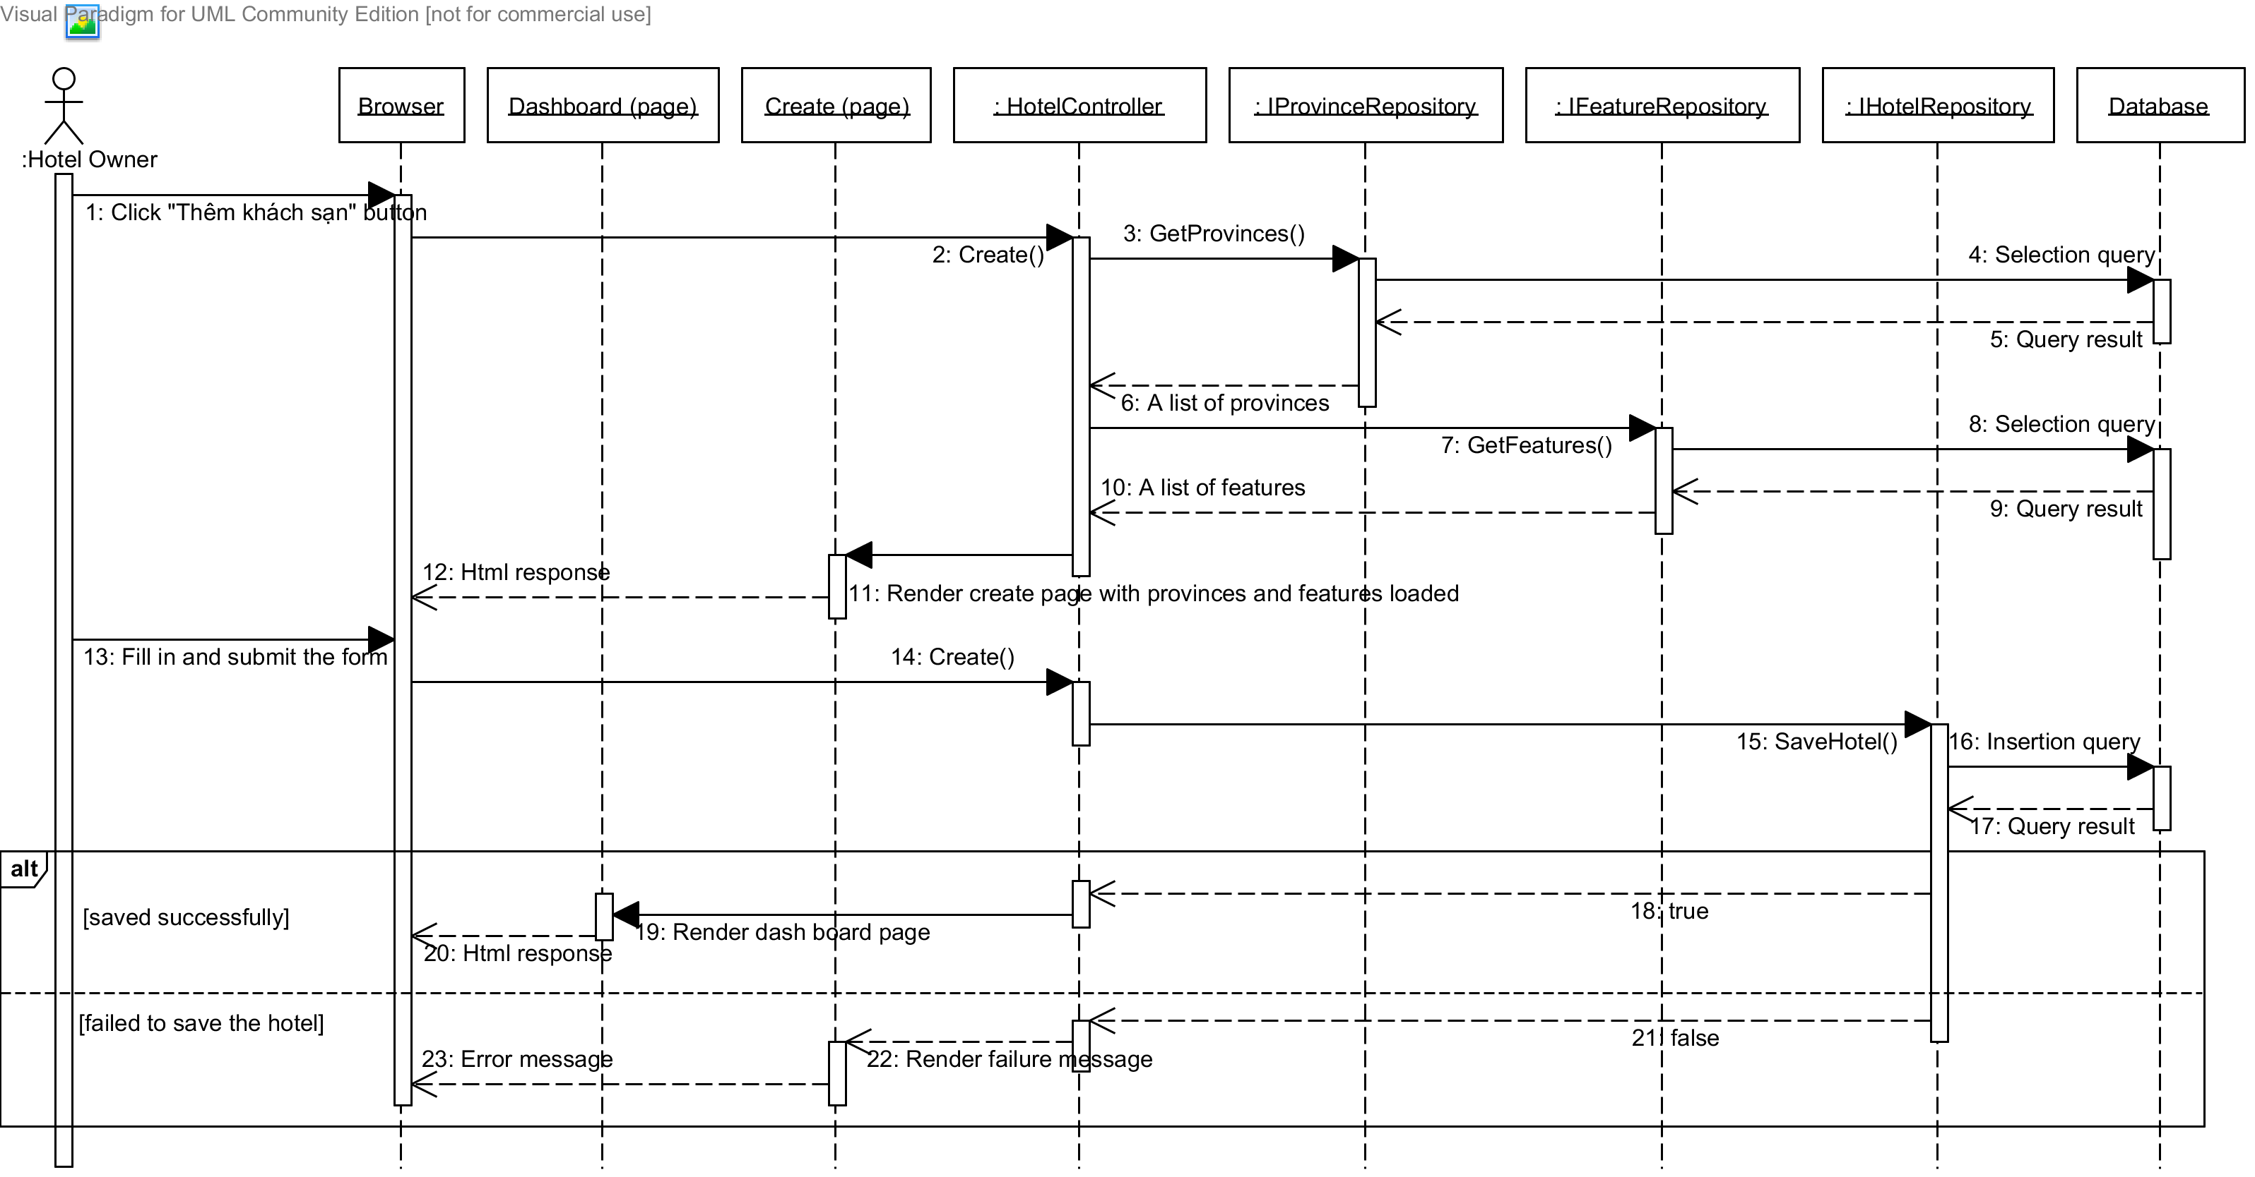

Diagram . Sequence diagram: Create a hotel

### Sequence Diagram: Edit a Hotel

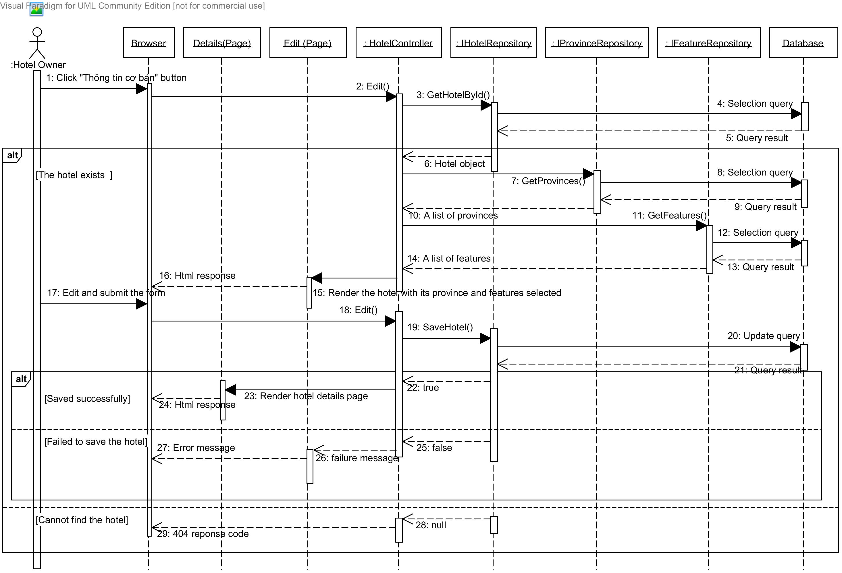

Diagram . Sequence diagram: Edit a hotel

### Sequence Diagram: Add a Price

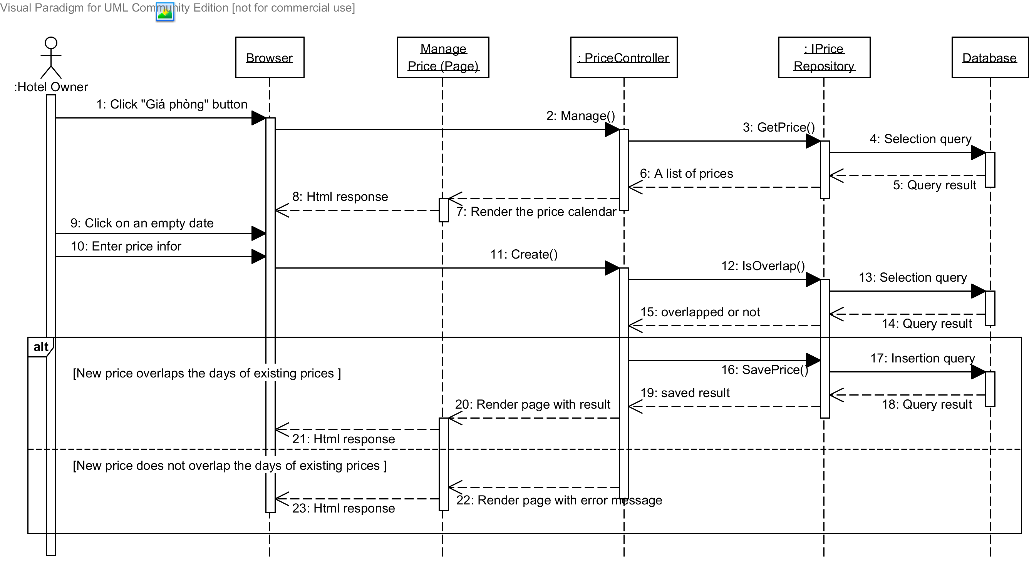

Diagram . Sequence diagram: Add a price

### Sequence Diagram: Approve a Booking

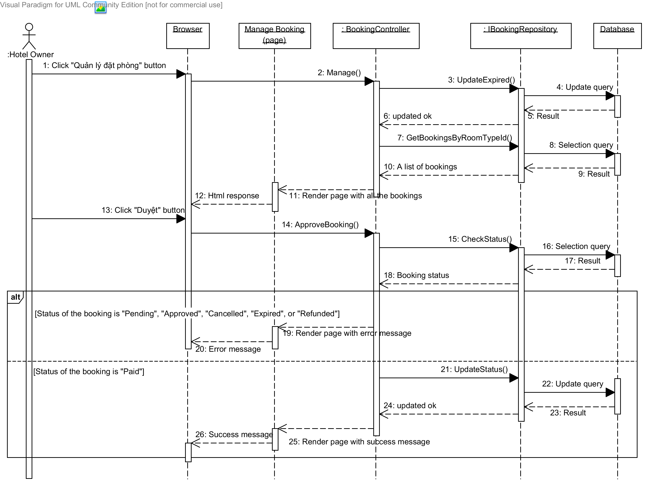

Diagram . Sequence diagram: Approve a booking

### Sequence Diagram: Approve a Refund Request

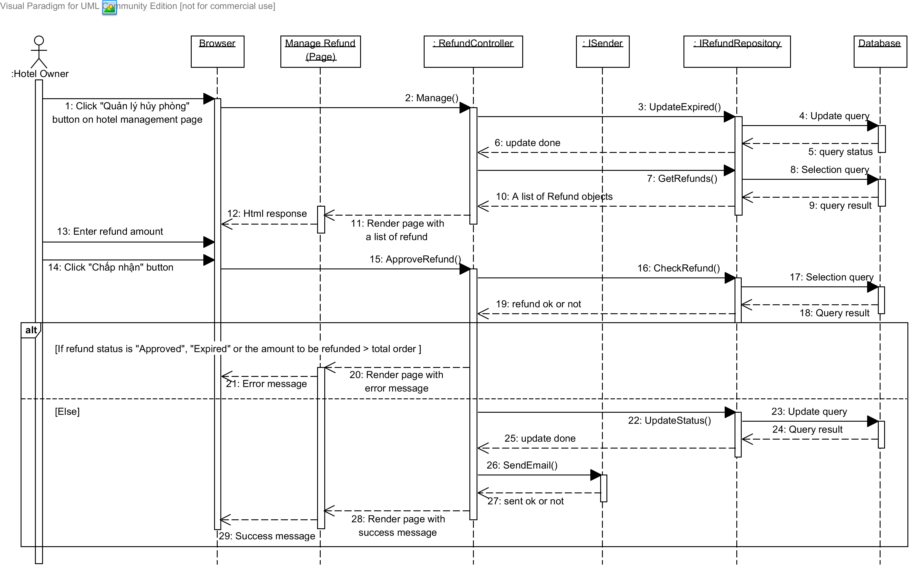

Diagram . Sequence diagram: Approve a refund request

### Sequence Diagram: Get Hotel Information from BMT

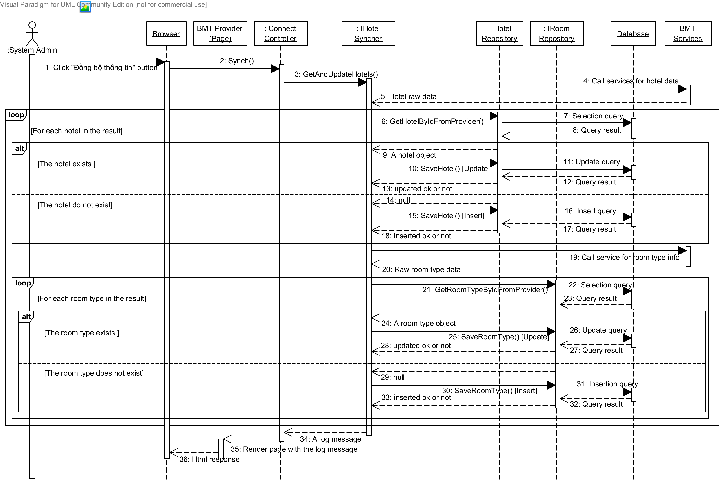

Diagram . Sequence diagram: Get hotel information from BMT

### Sequence Diagram: Get Prices from BMT

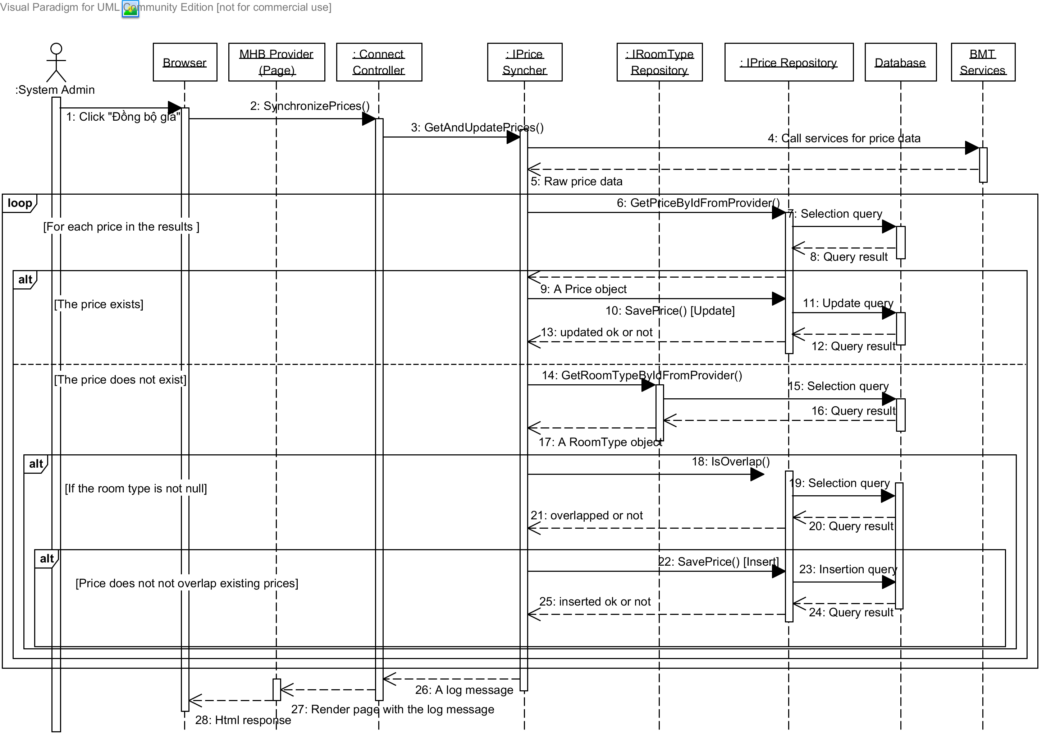

Diagram . Sequence diagram: Get prices from BMT

### Sequence Diagram: Install Facebook tab

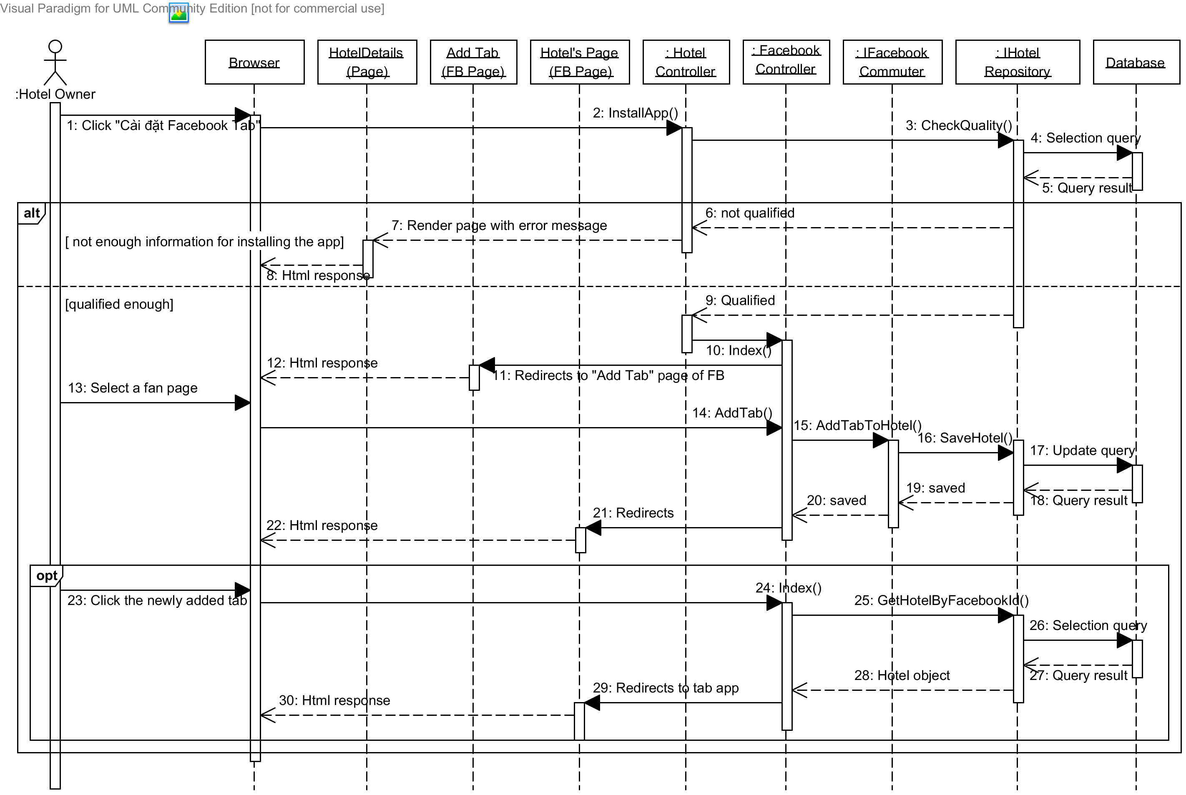

Diagram . Sequence diagram: Install Facebook tab

## User Interface Design

Below are some important screen designs for the MHB systems.



### Home Page

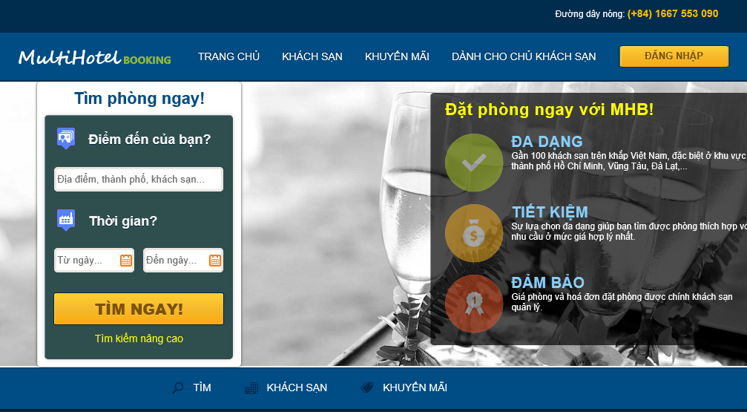

10

9

8

7

6

3

5

2

4

1

Figure . Home page

|  |  |  |  |  |  |  |
| --- | --- | --- | --- | --- | --- | --- |
| No. | Element | Description | Read Only | Mandatory | Control Type | Data type |
| 1. | “Trang chủ” link | A link to the home page of the hotel information portal | N/A | N/A | Link | N/A |
| 2. | “Khách sạn” link | A link to the hotel list page | N/A | N/A | Link | N/A |
| 3. | “Khuyến mãi” | A link to the promotion page for all hotels | N/A | N/A | Link | N/A |
| 4. | “Dành cho chủ khách sạn”link | A link to the page for hotel owners | N/A | N/A | Link | N/A |
| 5. | “Đăng nhập” button | A button that displays the log in popup | N/A | N/A | Button | N/A |
| 6. | “Điểm đến” textbox | The place where the traveler wish to go to | No | Yes | Textbox | Text |
| 7. | “Từ ngày” texbox | The date when the traveler wants to check in | No | Yes | Textbox | Text |
| 8. | “Đến ngày” textbox | The date when the traveler wants to check out | No | Yes | Textbox | Text |
| 9. | “Tìm ngay” textbox | A button that leads to the search results page | N/A | N/A | Button | N/A |
| 10. | “Tìm kiếm nâng cao” button | A link to the advanced search page | N/A | N/A | Link | N/A |

### Search Hotels Page

|  |  |  |  |  |  |  |
| --- | --- | --- | --- | --- | --- | --- |
| No. | Element | Description | Read Only | Mandatory | Control Type | Data type |
| 1. | “Điểm đến” textbox | The place where the traveler wishes to go to | No | Yes | Textbox | Text |
| 2. | “Từ ngày” textbox | The date when the traveler wants to check in | No | Yes | Textbox | Text |
| 3. | “Đến ngày” textbox | The date when the traveler wants to check out | No | Yes | Textbox | Text |
| 4. | “Chọn thứ tự” dropdown list | The order of the results | No | No | Dropdown list | N/A |
| 5. | “Bán kính” dropdown list | The radius from the center of the destination | No | No | Button | N/A |
| 6. | “Tìm kiếm” button | A button that searches and displays hotels | N/A | N/A | Button | N/A |
| 7. | “Tỉnh, thành phố” checkboxes | A groups of provinces to filter the results | No | No | Check-boxes | Text |
| 8. | “Tiêu chuẩn khách sạn” checkboxes | A groups of star qualities to filter the results | No | No | Check-boxes | Text |
| 9. | “Đánh giá” checkboxes | A group of user rating averages to filter the results | No | No | Check-boxes | Text |
| 10. | “Lọc kết quả” button | A button that filters the results found | N/A | N/A | Link | N/A |
| 11. | Details of a hotel section | Detailed information of a hotel | N/A | N/A | Div | N/A |
| 12. | Price of a hotel section | Lowest price for a hotel. | N/A | N/A | Div | N/A |
| 13. | Google map section | A Google map that displays all the hotels found | N/A | N/A | Map | N/A |
| 14. | Marker for a destination | A Google marker for the destination the user searches | N/A | N/A | Marker | N/A |
| 15. | Marker for a hotel | A Google marker for a hotel in the result | N/A | N/A | Marker | N/A |

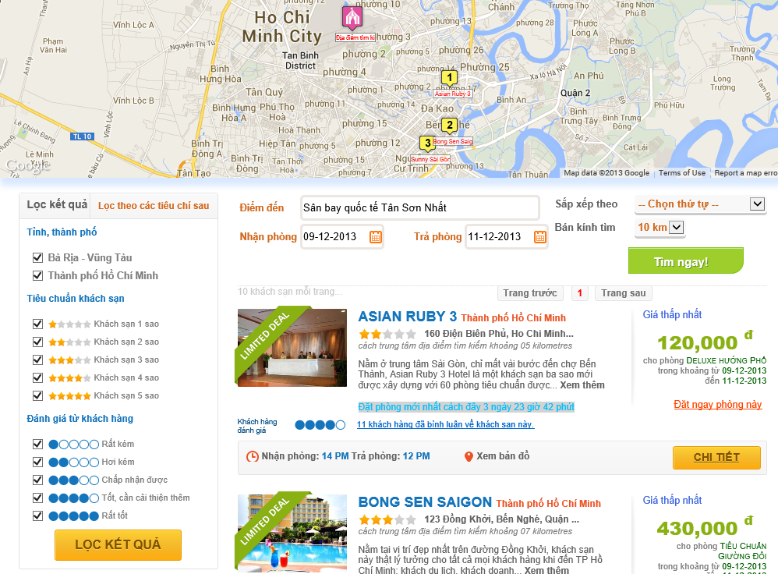

15

14

13

12

11

10

1

4

5

6

9

8

7

3

2

Figure . Search Hotel page

### Hotel Details Page

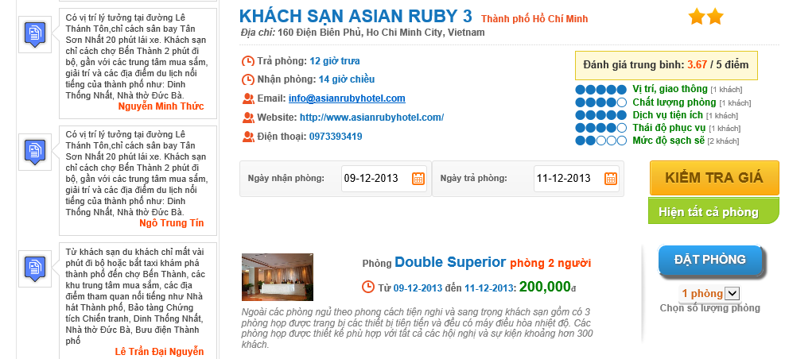

2

11

10

6

5

9

71

8

4

3

1

Figure . Hotel Details page

|  |  |  |  |  |  |  |
| --- | --- | --- | --- | --- | --- | --- |
| No. | Element | Description | Read Only | Mandatory | Control Type | Data type |
| 1. | Details of a hotel section | Detailed information of a hotel | N/A | N/A | Div | N/A |
| 2. | Rating average points section | Rating average points rated by traveler. | N/A | N/A | Div | N/A |
| 3. | “Ngày nhận phòng” textbox | The date when the traveler wants to check in | No | Yes | Textbox | Text |
| 4. | “Ngày trả phòng” textbox | The date when the traveler wants to check out | No | Yes | Textbox | Text |
| 5. | “Kiểm tra giá” button | A button that searches and displays room types available | N/A | N/A | Button | N/A |
| 6. | “Hiện tất cả phòng” button | A button that displays all room types of a hotel | N/A | N/A | Button | N/A |
| 7. | Details of a room type section | Detailed information of a room type | N/A | N/A | Div | N/A |
| 8. | Price section | Price for a room in the searching period. If there are many prices for this period, all of them are displayed. | N/A | N/A | Div | N/A |
| 9. | “Đặt phòng” button | A button that leads to the Booking Details page | N/A | N/A | Button | N/A |
| 10. | “Số lượng phòng” dropdown list | The number of rooms the traveler wants to book | No | No | Dropdown list | Text |
| 11. | Review section | A review for the hotel | N/A | N/A | Div | N/A |

### Booking Details Page

|  |  |  |  |  |  |  |
| --- | --- | --- | --- | --- | --- | --- |
| No. | Element | Description | Read Only | Mandatory | Control Type | Data type |
| 1. | “Giới tính” dropdown list | Gender of the traveler | No | Yes | Textbox | Text |
| 2. | “Họ và tên” textbox | Full name of the traveler | No | Yes | Textbox | Text |
| 3. | “Địa chỉ” textbox | Address line of the traveler | No | Yes | Textbox | Text |
| 4. | “Ngày tháng năm sinh” textbox | Date of birth of the traveler |  | Yes | Textbox | Text |
| 5. | “Email” textbox | Email address of the traveler | No | Yes | Textbox | Text |
| 6. | “Số điện thoại” textbox | Telephone number of the traveler | No | Yes | Textbox | Text |
| 7. | “Yêu cầu” text area | Any custom request the traveler want to send to the hotel | No | No | Text area | Text |
| 8. | “Đặt thêm phòng” link | A link to go back to the hotel to book more rooms | N/A | N/A | Link | N/A |
| 9. | “Chi tiết đặt phòng” section | The booking detail of the rooms booked | N/A | N/A | Div | N/A |
| 10. | Details button | A button that displays the price details of a booking when it is hovered | N/A | N/A | Button | N/A |
| 11. | Edit booking button | A button to edit the current booking | N/A | N/A | Button | N/A |
| 12. | Delete booking button | A button to remove the current booking | N/A | N/A | Button | N/A |
| 13. | “Thanh toán” section | The detail of total amount | N/A | N/A | Div | N/A |
| 14. | “Thanh toán” button | A button that leads to the payment page | N/A | N/A | Button | N/A |

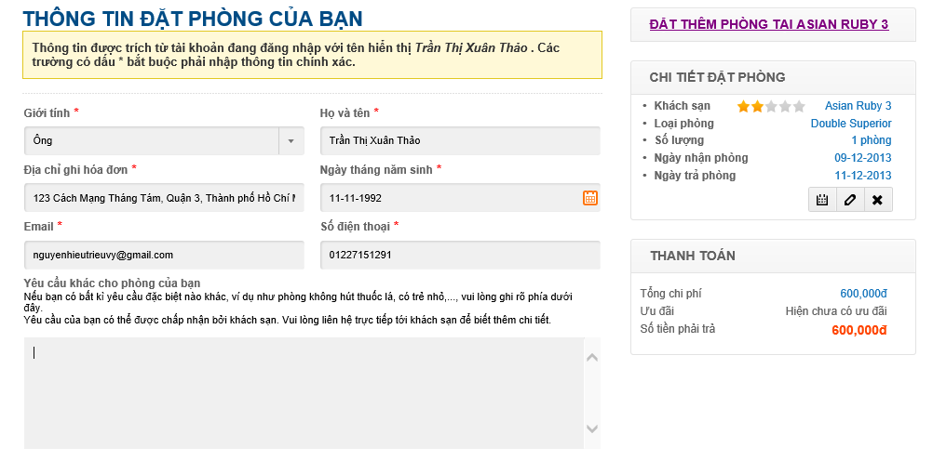

8

14

13

12

11

10

9

7

6

5

4

3

1

2

Figure . Booking Details page

### Booking Success Page

|  |  |  |  |  |  |  |
| --- | --- | --- | --- | --- | --- | --- |
| No. | Element | Description | Read Only | Mandatory | Control Type | Data type |
| 1. | Payment information section | The details of the payment made by the customer | N/A | N/A | Div | N/A |
| 2. | Booking code | The booking code generated for the booking made | N/A | N/A | Div | N/A |
| 3. | Customer information | The detailed information of the customer who made the booking | N/A | N/A | Div | N/A |
| 4. | Details of bookings | The details of the booking made by the customer | N/A | N/A | Div | N/A |

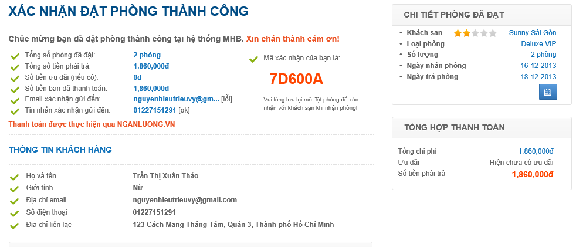

4

3

2

1

### Dashboard Page

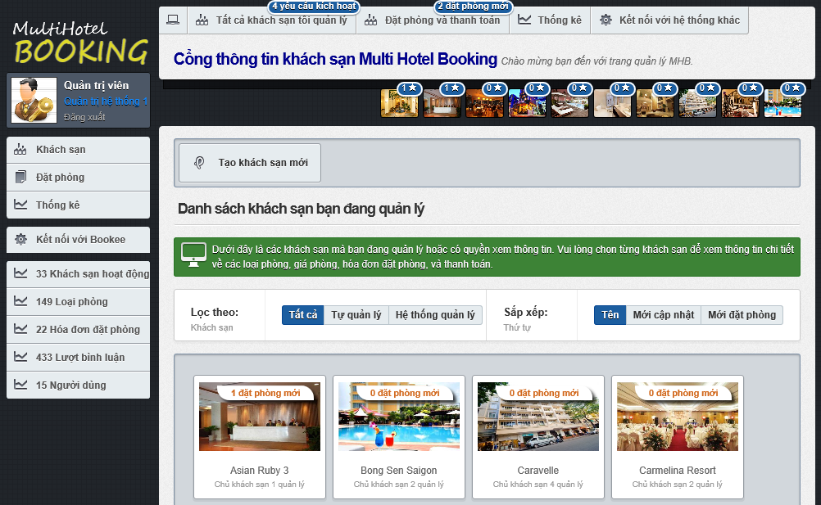

17

16

15

14

13

12

11

10

9

8

7

6

5

4

3

2

1

Figure . Dashboard page

|  |  |  |  |  |  |  |
| --- | --- | --- | --- | --- | --- | --- |
| No. | Element | Description | Read Only | Mandatory | Control Type | Data type |
| 1. | User information section | Information of the logged user | N/A | N/A | Div | N/A |
| 2. | “Khách sạn” link | A link to the dashboard page | N/A | N/A | Link | N/A |
| 3. | “Đặt phòng” link | A link to the booking manangement page | N/A | N/A | Link | N/A |
| 4. | “Thống kê” link | A link to the statistics page | N/A | N/A | Link | N/A |
| 5. | “Kết nối tới Bookee” link | A link to the data synchronization page | N/A | N/A | Link | N/A |
| 6. | New hotel opening requests notification | A notification for new hotel opening request issued by hotel owner | N/A | N/A | Div | N/A |
| 7. | New bookings notification | A notification for new bookings in all the hotels | N/A | N/A | Div | N/A |
| 8. | New bookings notification for a hotel | A notification for new bookings in a specific hotel | N/A | N/A | Div | N/A |
| 9. | “Tất cả” button | A button to list all the hotels | N/A | N/A | Button | N/A |
| 10. | “Tự quản lý” button | A button to filter on local hotels | N/A | N/A | Button | N/A |
| 11. | “MHB quản lý” button | A button to filter on external hotels | N/A | N/A | Button | N/A |
| 12. | “Tên” button | A button to sort the hotels by their names | N/A | N/A | Button | N/A |
| 13. | “Mới cập nhật” button | A button to sort the hotels by their last modified time | N/A | N/A | Button | N/A |
| 14. | “Mới đặt phòng” button | A button to sort the hotels by their last booked time | N/A | N/A | Button | N/A |
| 15. | Hotel list section | A list of all the hotels | N/A | N/A | Div | N/A |
| 16. | “Tạo khách sạn mới” button | A button that redirects to the hotel creating page | N/A | N/A | Button | N/A |
| 17. | Newly booked hotels section | A list of 10 hotel that have the most new bookings. | N/A | N/A | Div | N/A |

### Hotel Management Page

|  |  |  |  |  |  |  |
| --- | --- | --- | --- | --- | --- | --- |
| No. | Element | Description | Read Only | Mandatory | Control Type | Data type |
| 1. | “Kích hoạt khách sạn” button | A button used to activate a hotel opening request | N/A | N/A | Button | N/A |
| 2. | “Quay về trang quản lý khách sạn chung” button | A link to the dashboard page | N/A | N/A | Button | N/A |
| 3. | Name of the hotel | Name of the hotel you are viewing | N/A | N/A | Label | N/A |
| 4. | Information section | Detailed information of the hotel being viewed | N/A | N/A | Div | N/A |
| 5. | Completeness measure | Percent of information completeness for the hotel | N/A | N/A | Div | N/A |
| 6. | “Thông tin cơ bản” button | A link to the hotel editing page | N/A | N/A | Button | N/A |
| 7. | “Hình ảnh và thông tin nâng cao” button | A link to the hotel resouces page | N/A | N/A | Button | N/A |
| 8. | “Quản lý đặt phòng” button | A link to the booking management page | N/A | N/A | Button | N/A |
| 9. | “Đánh giá của người dùng” button | A link to the review management page | N/A | N/A | Button | N/A |

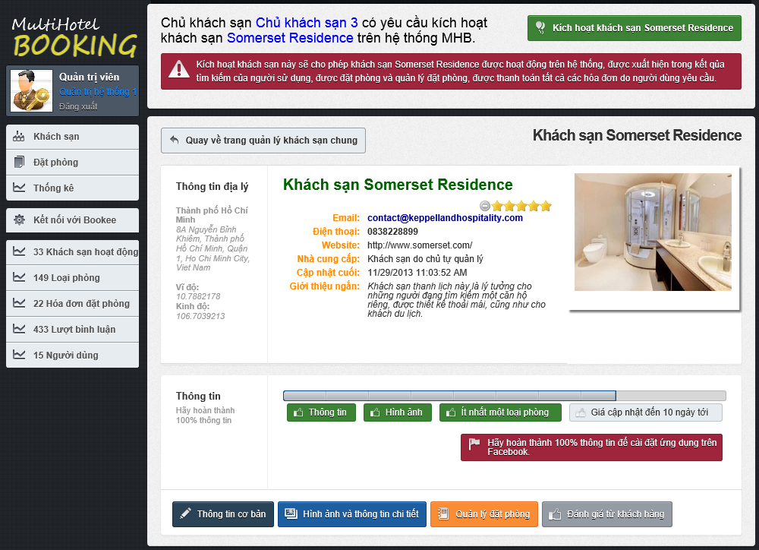

9

8

7

6

5

4

3

2

1

### Approve Booking Page

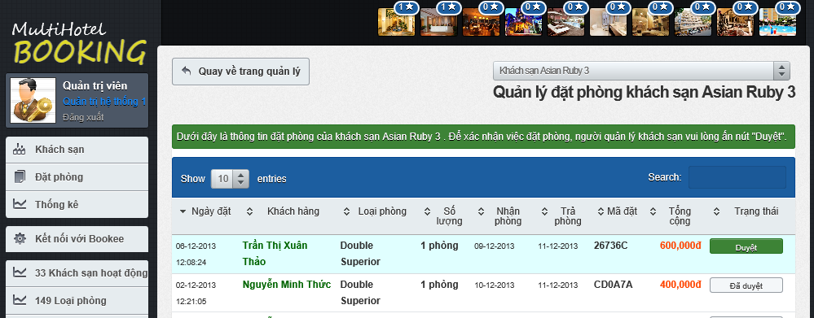

3

2

1

Figure . Approve Booking page

|  |  |  |  |  |  |  |
| --- | --- | --- | --- | --- | --- | --- |
| No. | Element | Description | Read Only | Mandatory | Control Type | Data type |
| 1. | Booking detail row | Details of a booking | N/A | N/A | Row | N/A |
| 2. | “Duyệt” link | A button to approve of a booking made by a traveler | N/A | N/A | Button | N/A |
| 3. | “Đã duyệt” link | A disabled button that indicates that the booking was approved sucessfully | Yes | N/A | Button | N/A |

### Prices Monitor Page

|  |  |  |  |  |  |  |
| --- | --- | --- | --- | --- | --- | --- |
| No. | Element | Description | Read Only | Mandatory | Control Type | Data type |
| 1. | Gray price bar | A price bar (in gray) that represents a price in the past. | N/A | N/A | Div | N/A |
| 2. | Violet price bar | A price bar (in violet) that represents a price crossing from the past to the future (including the current system date). | N/A | N/A | Div | N/A |
| 3. | Blue price bar | A price bar (in blue) that represents a price in the future. | N/A | N/A | Div | N/A |
| 4. | Red bar | The number of bookings made on a specific day for the selected room type. | N/A | N/A | Div | N/A |

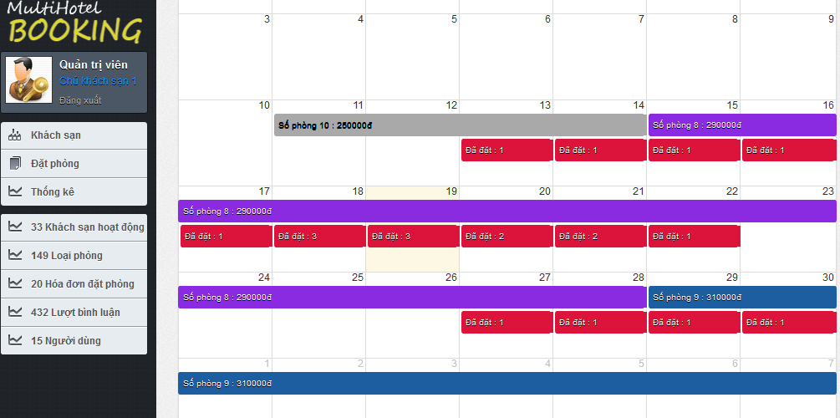

1

3

2

4

## Database Design



### Logical database design

From the ERD specified in the SRS section, logical database design includes the following relations:

|  |  |  |
| --- | --- | --- |
| No. | Relation | Description |
| 1. | Province | Stores all the provinces in Vietnam. |
| 2. | Provider | Stores information of hotel data providers. |
| 3. | Hotel | Stores information of local and external hotels in the MHB system. |
| 4. | Feature | Stores features that can be can be used to describe hotels. |
| 5. | HotelFeature | Stores the specific features associated with the hotels. |
| 6. | Image | Stores all hotel images. |
| 7. | RoomType | Stores all room types of all the hotels in the MHB system. |
| 8. | Price | Stores prices for all the room types of all the hotels. |
| 9. | DailyStatus | Stores the daily available statuses of all the prices. |
| 10. | Booking | Stores all the bookings made by the users of the system. |
| 11. | BookingItem | Stores details of all the bookings. |
| 12. | Refund | Stores all the refunds requested by the users who have booked rooms. |
| 13. | Review | Stores all the review written by the users of the system. |
| 14. | Rating | Stores all the ratings for hotels made by the users of the system. |
| 15 | RatingCriterion | Stores all the criteria which the users of the system can rate. |
| 16. | UserProfile | Stores information of all the users in the system. |
| 17. | Role | Stores all the roles used to grant access rights to users. |
| 18. | AdminHotel | Stores all the hotels under the management of the users. |
| 19. | UserRole | Stores the roles that users are granted |



The details of each relation are specified below

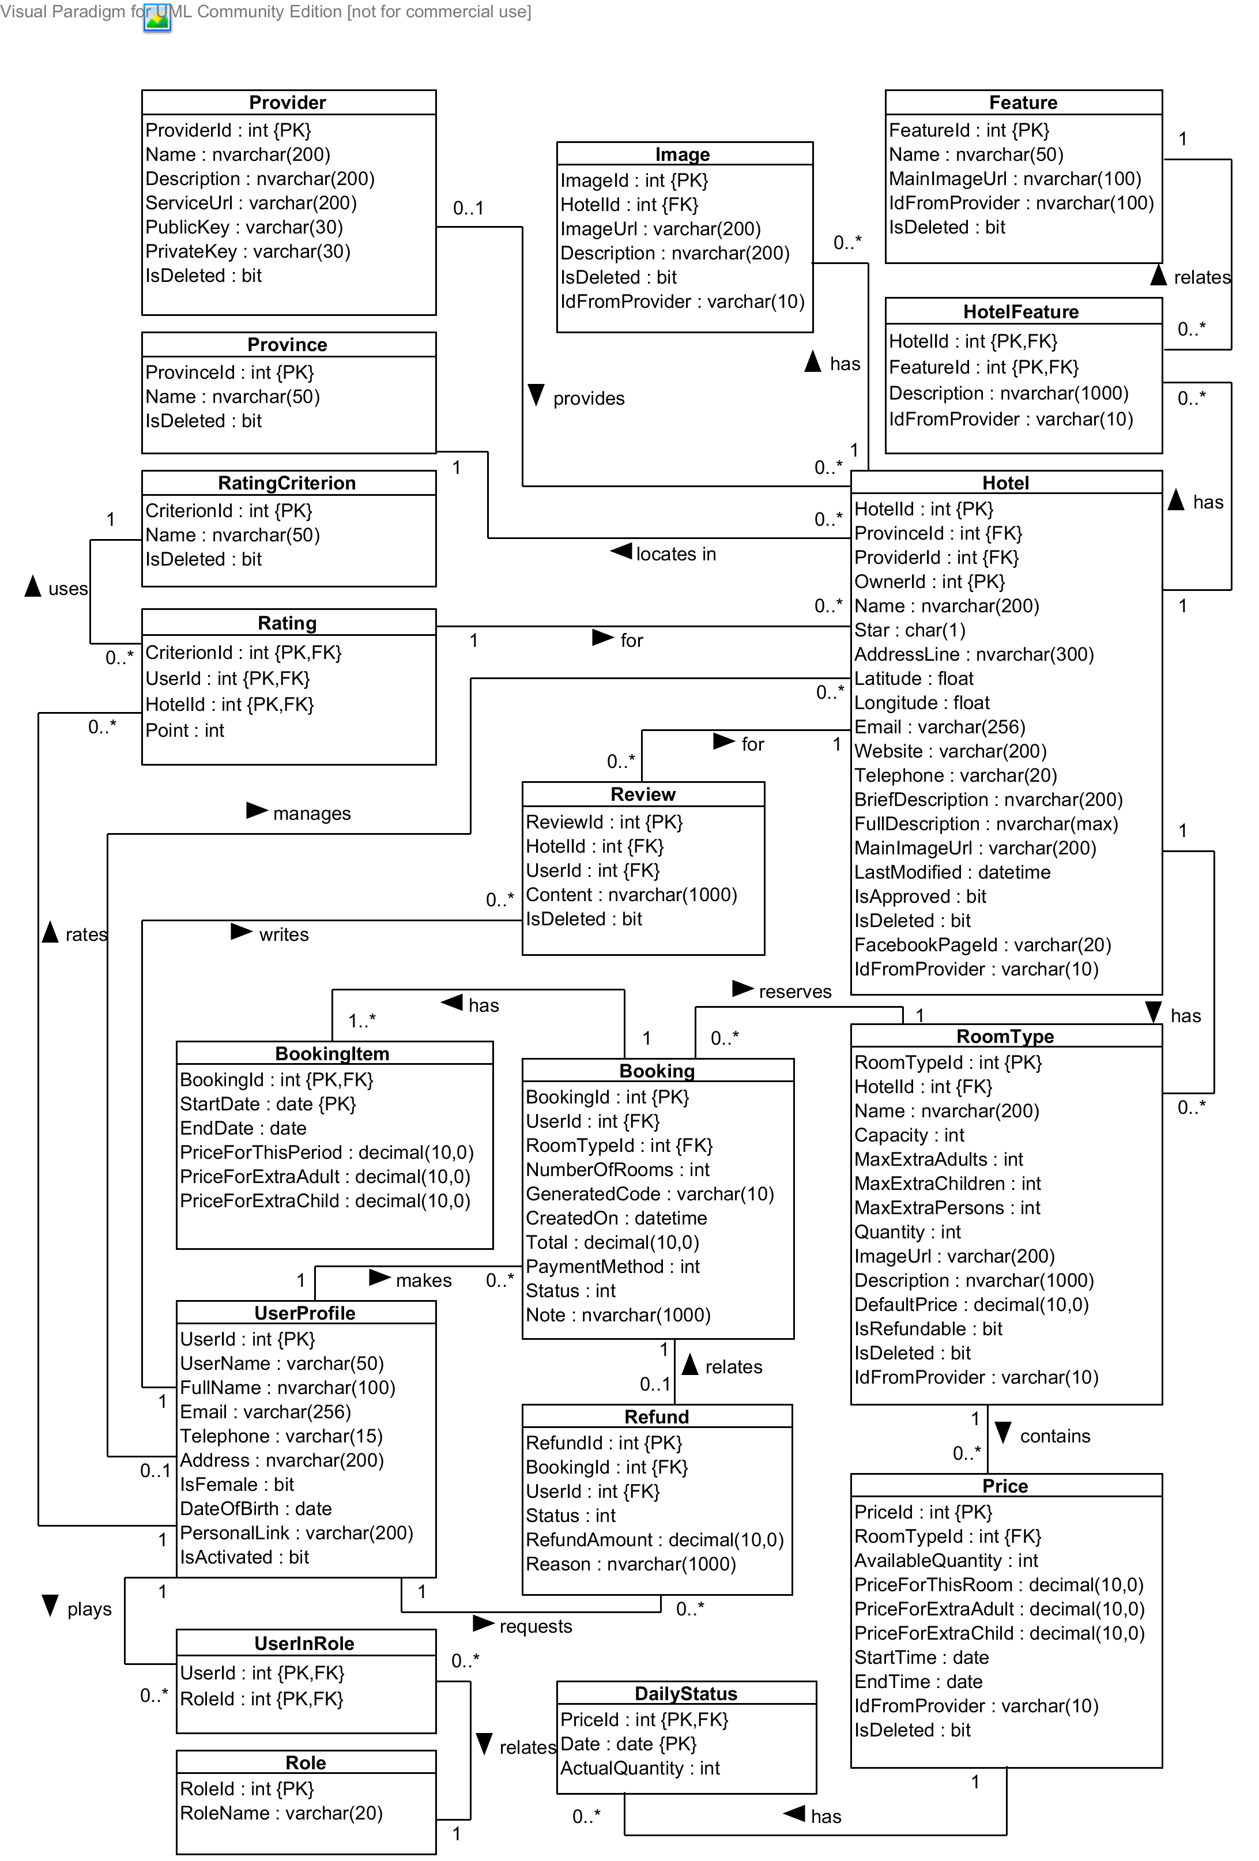

Diagram . Logical database design

#### Booking Relation

|  |  |  |  |  |  |  |
| --- | --- | --- | --- | --- | --- | --- |
| Field Name | Type | Nullable | Unique | Key | Default | Description |
| *BookingId* | int |  | 🗹 | PK |  | Unique id that differentiates a hotel from the others |
| *UserId* | int |  |  | FK |  | Id of the user who makes the booking |
| *RoomTypeId* | int |  |  | FK |  | Id of the room type booked by the user |
| *RoomQuantity* | int |  |  |  |  | Number of rooms the user booked for this room type |
| *ExtraAdults* | int |  |  |  |  | Number of extra adults, if any |
| *ExtraChildren* | int |  |  |  |  | Number of extra children, if any |
| *GeneratedCode* | varchar(10) |  | 🗹 |  |  | String that whill be used to verify with the hotel when the user checks in |
| *CreatedOn* | datetime |  |  |  |  | Time when the booking is created |
| *Total* | decimal(10, 0) |  |  |  |  | Total amount of the booking order |
| *PaymentMethod* | int |  |  |  | 1 | Method which the user uses to pay for the booking |
| *Status* | int |  |  |  | 1 | Status of the booking |
| *Note* | nvarchar(1000) | 🗹 |  |  |  | Additional note the user specifies for the hotel |

#### BookingItem Relation

|  |  |  |  |  |  |  |
| --- | --- | --- | --- | --- | --- | --- |
| Field Name | Type | Nullable | Unique | Key | Default | Description |
| *BookingId* | int |  |  | PK, FK |  | The id of the booking which this booking item belongs to |
| *StartDate* | date |  |  | PK |  | Date on which a booking item starts |
| *EndDate* | int |  |  |  |  | Date on which a booking item ends |
| *PriceForThisPeriod* | decimal |  |  |  |  | Price for the room in the period specified |
| *PriceForExtraAdult* | decimal |  |  |  |  | Price for an extra adult in the period specified, if any |
| *PriceForExtraChild* | decimal |  |  |  |  | Price for an extra child in the period specified, if any |

#### DailyStatus Relation

|  |  |  |  |  |  |  |
| --- | --- | --- | --- | --- | --- | --- |
| Field Name | Type | Nullable | Unique | Key | Default | Description |
| *PriceId* | int |  | 🗹 | PK, FK |  | Id of the price that this daily status belongs to |
| *Date* | date |  |  | PK |  | Date on which this daily status takes place |
| *ActualQuantity* | int |  |  |  |  | Actual available number of rooms on the day when the daily status takes place |

#### Feature Relation

|  |  |  |  |  |  |  |
| --- | --- | --- | --- | --- | --- | --- |
| Field Name | Type | Nullable | Unique | Key | Default | Description |
| *FeatureId* | int |  | 🗹 | PK |  | Unique id that differentiates a feature from the others |
| *Name* | nvarchar(50) |  |  |  |  | Name of the hotel feature |
| *MainImageUrl* | nvarchar(100) | 🗹 |  |  |  | Image url of the hotel feature |
| *IdFromProvider* | nvarchar(50) | 🗹 |  |  |  | Short description of the hotel feature |
| *IsDeleted* | bit |  |  |  | 0 | Whether the hotel feature is deleted or not |

#### Hotel Relation

|  |  |  |  |  |  |  |
| --- | --- | --- | --- | --- | --- | --- |
| Field Name | Type | Nullable | Unique | Key | Default | Description |
| *HotelId* | int |  | 🗹 | PK |  | Unique id that differentiates a hotel from the others |
| *ProvinceId* | int |  |  | FK |  | Id of the province where the hotel locates in |
| *ProviderId* | int | 🗹 |  | FK |  | Id of the provider who provides this hotel |
| *OwnerId* | int | 🗹 |  |  |  | Id of the owner who manages this hotel |
| *Name* | nvarchar(200) |  |  |  |  | Official name of the hotel |
| *Star* | char(1) |  |  |  |  | International quality of the hotel |
| *AddressLine* | nvarchar(300) |  |  |  |  | Address line of the hotel |
| *Telephone* | varchar(15) |  |  |  |  | Main telephone number of the hotel |
| *Email* | varchar(254) |  |  |  |  | Main email address of the hotel |
| *Latitude* | float | 🗹 |  |  |  | Latitude of the hotel’s address line |
| *Longitude* | float | 🗹 |  |  |  | Longitude of the hotel’s address line |
| *Website* | varchar(200) |  |  |  |  | Website address of the hotel |
| *BriefDescription* | nvarchar(500) |  |  |  |  | Short introduction about the hotel |
| *FullDescription* | nvarchar(max) | 🗹 |  |  |  | Full description of the hotel |
| *MainImageUrl* | varchar(200) | 🗹 |  |  |  | Url of the main image for the hotel |
| *LastModified* | datetime |  |  |  |  | Last time when the hotel’s information was modified |
| *IsApproved* | bit |  |  |  |  | Whether the hotel is approved or not |
| *FacebookId* | varchar(20) |  | 🗹 |  |  | Id of the Facebook page that has the hotel installed as a tab |
| *IdFromProvider* | varchar(10) | 🗹 |  |  |  | Id of the hotel if it is provided by a hotel data provider |
| *IsDeleted* | bit |  |  |  | 0 | Whether the hotel is marked deleted or not |

#### HotelFeature Relation

|  |  |  |  |  |  |  |
| --- | --- | --- | --- | --- | --- | --- |
| Field Name | Type | Nullable | Unique | Key | Default | Description |
| *HotelId* | int |  |  | PK |  | Id of the hotel that has the feature |
| *FeatureId* | int |  |  | FK |  | Id of the feature |
| *Description* | nvarchar(1000) | 🗹 |  |  |  | Custom description of hotel feature |
| *IdFromProvider* | varchar(50) | 🗹 |  |  |  | Id provided by hotel provider |

#### Image Relation

|  |  |  |  |  |  |  |
| --- | --- | --- | --- | --- | --- | --- |
| Field Name | Type | Nullable | Unique | Key | Default | Description |
| *ImageId* | int |  | 🗹 | PK |  | Unique id that differentiates an image from the others |
| *HotelId* | int |  |  | FK |  | Id of the hotel which the image belongs to |
| *ImageUrl* | varchar(200) |  |  |  |  | Url of the image |
| *Description* | nvarchar(200) | 🗹 |  |  |  | Description of what the image is about |
| *IdFromProvider* | varchar(10) | 🗹 |  |  |  | Id of the image if it is provided by a hotel data provider |
| *IsDeleted* | bit |  |  |  | 0 | Unique id that differentiates an image from the others |

#### Price Relation

|  |  |  |  |  |  |  |
| --- | --- | --- | --- | --- | --- | --- |
| Field Name | Type | Nullable | Unique | Key | Default | Description |
| *PriceId* | int |  | 🗹 | PK |  | Unique id that differentiates a price from the others |
| *RoomTypeId* | int |  |  | FK |  | Id of the room type that this price belongs to |
| *AvailableQuantity* | int |  |  |  | 1 | Number of available rooms for this room type in the period specified |
| *PriceForThisRoom* | decimal(10, 0) |  |  |  | 0 | Price for this room in the period specified |
| *PriceForExtraChild* | decimal(10, 0) |  |  |  | 0 | Price for an extra adult, if any |
| *PriceForExtraAdult* | decimal(10, 0) |  |  |  | 0 | Price for an extra child, if any |
| *StartTime* | date |  |  |  |  | Date on which the price becomes active |
| *EndTime* | date |  |  |  |  | Date on which the price becomes inactive |
| *IdFromProvider* | varchar(10) | 🗹 |  |  |  | Id of the price if it is provided by a hotel provider |
| *IsDeleted* | bit |  |  |  | 0 | Whethere the price is deleted or not |

#### Provider Relation

|  |  |  |  |  |  |  |
| --- | --- | --- | --- | --- | --- | --- |
| Field Name | Type | Nullable | Unique | Key | Default | Description |
| *ProviderId* | int |  | 🗹 | PK |  | Unique id that differentiates a provider from the others |
| *Name* | nvarchar(200) |  |  |  |  | Official name of the hotel data provider |
| *Description* | nvarchar(200) | 🗹 |  |  |  | Description of the services of the provider |
| *ServiceUrl* | varchar(200) |  |  |  |  | Base url of the services provided by the hotel provider |
| *PublicKey* | varchar(30) | 🗹 |  |  |  | Public key used to identify hotel consumer when information exchanges occur |
| *PrivateKey* | varchar(30) | 🗹 |  |  |  | Private key that only the hotel provider and its consumer know and keep it a secret |
| *IsDeleted* | bit |  |  |  | 0 | Where the hotel provider is deleted or not |

#### Province Relation

|  |  |  |  |  |  |  |
| --- | --- | --- | --- | --- | --- | --- |
| Field Name | Type | Nullable | Unique | Key | Default | Description |
| *ProvinceId* | int |  | 🗹 | PK |  | Unique id that differentiates a province from the others |
| *Name* | nvarchar(50) |  |  |  |  | Name of the province in 64 provinces in Vietnam |
| *IsDeleted* | bit |  |  |  |  | Where the hotel province is deleted or not |

#### Rating Relation

|  |  |  |  |  |  |  |
| --- | --- | --- | --- | --- | --- | --- |
| Field Name | Type | Nullable | Unique | Key | Default | Description |
| *CriterionId* | int |  |  | PK, FK |  | Id of the criterion being rated by the user |
| *UserId* | int |  |  | PK, FK |  | Id of the user who rates the hotel |
| *HotelId* | int |  |  | PK, FK |  | Id of the hotel being rated by the user |
| *Point* | int |  |  |  |  | Point that the user gives the hotel for the selected criterion |

#### RatingCriterion Relation

|  |  |  |  |  |  |  |
| --- | --- | --- | --- | --- | --- | --- |
| Field Name | Type | Nullable | Unique | Key | Default | Description |
| *CriterionId* | int |  | 🗹 | PK |  | Unique id that differentiates a criterion from the others |
| *Name* | nvarchar(50) |  |  |  |  | Name of the criterion used to rate the hotels |
| *IsDeleted* | bit |  |  |  | 0 | Whether the criterion is deleted or not |

#### Refund Relation

|  |  |  |  |  |  |  |
| --- | --- | --- | --- | --- | --- | --- |
| Field Name | Type | Nullable | Unique | Key | Default | Description |
| *RefundId* | int |  |  | PK |  | Unique id that differentiates a refund from the others |
| *BookingId* | int |  |  |  |  | Id of the booking which the refunds relates |
| *Status* | int |  |  |  |  | Status of the refund request |
| *RefundedAmount* | decimal(10, 0) | 🗹 |  |  |  | Amount that will be refunded to the user |
| *Reason* | nvarchar(1000) | 🗹 |  |  |  | Reason why the user wants the hotel to refund the bookings |
| *UserId* | int |  |  |  |  | Id of the user who requests the refund |

#### Review Relation

|  |  |  |  |  |  |  |
| --- | --- | --- | --- | --- | --- | --- |
| Field Name | Type | Nullable | Unique | Key | Default | Description |
| *ReviewId* | int |  | 🗹 | PK |  | Unique id that differentiates a review from the others |
| *HotelId* | int |  |  | FK |  | Id of the hotel that the review is about |
| *UserId* | int |  |  | FK |  | Id of the user who writes the review |
| *Content* | nvarchar(1000) |  |  |  |  | Content of the review written by the user |
| *IsDeleted* | bit |  |  |  | 0 | Whether the review is deleted or not |

#### RoomType Relation

|  |  |  |  |  |  |  |
| --- | --- | --- | --- | --- | --- | --- |
| Field Name | Type | Nullable | Unique | Key | Default | Description |
| *RoomTypeId* | int |  | 🗹 | PK |  | Unique id that differentiates a room type from the others |
| *HotelId* | int |  |  | FK |  | Id of the hotel which the room type belongs to |
| *Name* | nvarchar(200) |  |  |  |  | Official name of the room type specified by the hotel owner |
| *Capacity* | int |  |  |  |  | Default value of the number of persons who can stay in the room |
| *MaxExtraAdults* | int |  |  |  | 0 | Number of maximum extra children, if any |
| *MaxExtraChildren* | int |  |  |  | 0 | Number of maximum extra adults, if any |
| *MaxExtraPersons* | int |  |  |  | 0 | Number of maximum extra person, if any |
| *Quantity* | int |  |  |  | 1 | Number of physical rooms of this type in the hotel |
| *Description* | nvarchar(1000) | 🗹 |  |  |  | Main url of the image for the room type |
| *ImageUrl* | varchar(200) | 🗹 |  |  |  | Description of the room type |
| *DefaultPrice* | decimal(10, 0) | 🗹 |  |  |  | Default price for the room type |
| *IdFromProvider* | varchar(10) | 🗹 |  |  |  | Id of the room type if it is provided by a hotel provider |
| *IsRefundable* | bit |  |  |  |  | Whether bookings made for this room type can be refunded or not |
| *IsDeleted* | bit |  |  |  | 0 | Whethere the room type is deleted or not |

#### UserProfile Relation

|  |  |  |  |  |  |  |
| --- | --- | --- | --- | --- | --- | --- |
| Field Name | Type | Nullable | Unique | Key | Default | Description |
| *UserId* | int |  | 🗹 | PK |  | Unique id that differentiates a user from the others |
| *UserName* | varchar(50) |  |  |  |  | Unique name that will be use to log in the system |
| *FullName* | nvarchar(100) |  |  |  |  | Full name of the user |
| *Email* | nvarchar(256) |  |  |  |  | Email address of the user |
| *Telephone* | varchar(15) |  |  |  |  | Telephone number of the user |
| *Address* | nvarchar(200) |  |  |  |  | Address line of the user |
| *IsFemale* | bit | 🗹 |  |  |  | Whether the user is female or male |
| *DateOfBirth* | date |  |  |  |  | Date of birth of the user |
| *PersonalLink* | varchar(200) | 🗹 |  |  |  | Personal website of the user |
| *IsActivated* | bit |  |  |  | 1 | Whether the user is activated on the MHB system or not |

#### Role Relation

|  |  |  |  |  |  |  |
| --- | --- | --- | --- | --- | --- | --- |
| Field Name | Type | Nullable | Unique | Key | Default | Description |
| *RoleId* | int |  | 🗹 | PK |  | Unique id that differentiates a role from the others |
| *RoleName* | nvarchar(20) |  |  | PK |  | Name of the role |

#### UserRole Relation

|  |  |  |  |  |  |  |
| --- | --- | --- | --- | --- | --- | --- |
| Field Name | Type | Nullable | Unique | Key | Default | Description |
| *UserId* | int |  |  | PK, FK |  | Id of the role |
| *RoleId* | int |  |  | PK, FK |  | Id of the user in that role |

### Physical database design

Please note that in the physical database implemented using SQL Server 2008 R2, the tables wrapped in the dashed line, (namely *webpages_Roles*, *webpages_UserInRoles*, *webpage_OAuthMembership*, and *webpage_Membership*) are generated and supported by the MVC .NET 4.0 framework to help simplify the authentication and authorization processes.



Diagram . Physical database design

# Software Test Document



## Introduction



### System Overview

From the perspective of a user, the MHB system operates in the following order

### Test Approach

The system will be tested following the normal testing approach for a software project, including for major stages: Unit testing, Integration testing, System testing, and Acceptance testing.

Firstly, each member will be responsible for *unit testing* all the modules he or she developed. The other team members will later approve of the modules developed by verifying that they comply with the detailed designs.

Secondly, the team leader will perform *integration testing* for the whole application with the assistance of the other team members.

Next, all of the team members will conduct *system testing* to make sure that the system is consistent with the requirements initially specified.

Finally, the supervisor of the project will be accountable for a*cceptance testing*, with the assistance of all team members.

## Test Plan



### Features to be tested

The following features will be system-tested and the results are specified in this test document. The order of the tested features are listed in the system main flow.

|  |  |  |  |
| --- | --- | --- | --- |
| No. | Feature | Description | Assigned |
| 1. | Log in | Test if the user is authenticated before he or she access authorized resources. | DucBM |
| 2. | View dashboard | Test if the dashboard page for admins and hotel owners is displayed correctly | DucBM |
| 3. | Create a hotel | Test if the hotel owners can create a hotel and send a hotel opening request to the system admins | DucBM |
| 4. | Approve hotel opening request | Test if the system admins can approve of hotel an hotel opening request issued by a hotel owner | DucBM |
| 5. | Monitor prices | Test if the prices for a room type can be easily and accurately monitored | VyNHT |
| 6. | Synchronize with external provider | Test if the system admins can connect to and exchange hotel information. | AnNP |
| 7. | Search hotels | Test if the hotel searching function results in appropriate hotel information. | AnNP |
| 8. | Search rooms available | Test if the system can search for rooms available and their prices in a specific period | AnNP |
| 9. | Book rooms and pay | Test if the travelers can book rooms and purchase for them via online payment services | DucBM |
| 10. | Review a hotel | Test if the travelers can write reviews for hotels | DucBM |
| 11. | Rate a hotel | Test if the hotels can be rated by various criteria | VyNHT |
| 12. | Request a refund | Test if a booking can be refunded if it satisfies the refund conditions | VyNHT |
| 13. | Approve booking | Test if a booking can switch between statuses correctly | VyNHT |
| 14. | Install Facebook tab | Test if the hotel owners can install a tab on for the Facebook page of the hotel | DucBM |

### Features not to be tested

The following features will not be tested.

* For guests and travelers: Change password, Update account information, View past bookings, Request a refund;
* For hotel owners and system admins: Grant access rights, Edit a hotel, Delete a hotel, Add a room type, Edit a room type, Delete a room type, Add a price, Edit a price, Delete a price, Update a review, Delete a review, Delete Facebook tab, Approve a refund, View statistics.

## System Test Cases



### Log in

|  |  |  |  |  |  |  |  |
| --- | --- | --- | --- | --- | --- | --- | --- |
| Test case ID | Test Case Description | Test Case Procedure | Expected Output | Inter-Test Case Dependence | Result | Test Date | Note |
|  | **Main Steps: 1.** Click on the button “Đăng nhập” at the top of the home page.  **2.** Enter the username in the “Tên đăng nhập” textbox, and the password in the “Mật khẩu” textbox.  **3.** Click the “Đăng nhập” button. | | | | | | |
| [LG-1] | Loginwith an activated account | * Fill an authentic username in the “Tên đăng nhập” textbox; * Fill the correct password in the “Mật khẩu” textbox; * Click the “Đăng nhập” button. | The user is logged in with the account and redirected to the page he or she is browsing if the user is a traveler, or to the admin dashboard page if the user is a hotel owner or a system admin. |  | Passed | 15/11/2013 |  |
| [LG-2] | Loginwith empty username and password | * Leaves the username and password box empty; * Click the “Đăng nhập” button. | The message “Tên đăng nhập không được bỏ trống” will be shown next to the “Tên đăng nhập” textbox;  The message “Mật khẩu không được bỏ trống” will be shown next to the “Mật khẩu” textbox. |  | Passed | 15/11/2013 |  |
| [LG-3] | Loginwith a wrong account | * Fill in the “Tên đăng nhập” textbox with an the existing username; * Fill a wrong password in the “Mật khẩu” textbox; * Click the “Đăng nhập” button. | The user will be redirected back to the log in page, with the message “Tên đăng nhập hoặc mật khẩu không chính xác” displayed at the top part. |  | Passed | 15/11/2013 |  |
| [LG-4] | Loginwith a wrong account | * Fill in the “Tên đăng nhập” textbox with an the non-existing username; * Fill a ramdom password in the “Mật khẩu” textbox; * Click the “Đăng nhập” button. | The user will be redirected back to the log in page, with the message “Tên đăng nhập hoặc mật khẩu không chính xác” displayed at the top part. |  | Passed | 15/11/2013 |  |
| [LG-5] | Loginwith a deactivated account | * Fill in the “Tên đăng nhập” textbox with the username of a deactivated account; * Fill the correct password in the “Mật khẩu” textbox; * Click the “Đăng nhập” button. | The user will be redirected back to the log in page, with the message “Tài khoản này đã bị khóa, vui lòng thử đăng nhập với một tài khoản khác” displayed at the top part. |  | Passed | 15/11/2013 |  |

### View Dashboard

|  |  |  |  |  |  |  |  |
| --- | --- | --- | --- | --- | --- | --- | --- |
| Test case ID | Test Case Description | Test Case Procedure | Expected Output | Inter-Test Case Dependence | Result | Test Date | Note |
|  | **Main Steps: 1.** Log in with Hotel Owner or System Admin role.  **2.** Click on the “Khách sạn” link in the menu bar if the log in form does not redirect you to this page.  All the hotels under your management is on the dashboard. | | | | | | |
| [VD-1] | View hotels under your management | * Click on the “Khách sạn” link in the menu bar | The dashboard display a list of hotels you are managing. Each item in the list includes the following information:   * Name and address of the hotel; * Number of new bookings; * Which hotel owner manages it. |  | Passed | 17/11/2013 |  |
| [VD-2] | View hotels with filters | * Click on the “Khách sạn” link in the menu bar * Click the “Tự quản lý” or “MHB quản lý” button on the section “Lọc theo” | The list of hotels is filtered limited to hotels owned by a local hotel owner or hotels provided by an external hotel data provider. |  | Passed | 17/11/2013 |  |
| [VD-3] | View hotels with sorting order | * Click on the “Khách sạn” link in the menu bar * Click “Mới cập nhật” or “Mới đặt phòng” button on the section “Sắp xếp theo” | The list of hotel is ordered by the last time it was updated or the last booking it has |  | Passed | 17/11/2013 |  |

### Create a hotel

|  |  |  |  |  |  |  |  |
| --- | --- | --- | --- | --- | --- | --- | --- |
| Test case ID | Test Case Description | Test Case Procedure | Expected Output | Inter-Test Case Dependence | Result | Test Date | Note |
|  | **Main Steps: 1.** Log in the system with Hotel Owner role  **2.** Click on the “Khách sạn” link in the menu bar  **3.** Click on “Tạo khách sạn mới” button  **4.** Provide the necessary information about the hotel  **5.** Click the “Lưu và tiếp tục” button. | | | | | | |
| [CH-1] | Try to save a hotel with errorneous input | * Make one or more validation errors when entering the information for the hotel. Because there too many validation error types, please refer to the use case “Create a hotel” for more information. | The corresponding message will be shown next to the fields that have errorneous input. |  | Passed | 15/11/2013 |  |
| [CH-2] | Save a hotel with validated input | * Fill in all fields with validated input; * Select some features for the hotel in the “Các dịch vụ của khách sạn” tab * Click the “Lưu và tiếp tục” button. | The hotel is saved into the database. A hotel opening request is issued waiting for a System Admin to approve of it. The user is redirected to the dashboard page. |  | Passed | 15/11/2013 |  |

### Approve hotel opening request

|  |  |  |  |  |  |  |  |
| --- | --- | --- | --- | --- | --- | --- | --- |
| Test case ID | Test Case Description | Test Case Procedure | Expected Output | Inter-Test Case Dependence | Result | Test Date | Note |
|  | **Main Steps: 1.** Log in the system with System Admin role.  **2.** Click on a hotel marked “Chưa xác nhận”  **3.** Press the “Xác nhận khách sạn” button | | | | | | |
| [AH-1] | Approve a hotel successfully | * In the dash board page, click on a hotel that was marked “Chưa xác nhận”. The user will be redirected to the hotel management page of that hotel. * Verify the information provided by the hotel owner. * Press the “Xác nhận khách sạn” button to approve of and allow the hotel to operate on the MHB system. | The hotel will be marked as “Activated” on the MHB system. In the hotel dashboard page the hotel will be displayed as an activated hotel. The system now allows its hotel owner to provide additional information. |  |  |  |  |

### Monitor prices

|  |  |  |  |  |  |  |  |
| --- | --- | --- | --- | --- | --- | --- | --- |
| Test case ID | Test Case Description | Test Case Procedure | Expected Output | Inter-Test Case Dependence | Result | Test Date | Note |
|  | **Main Steps: 1.** Click on the “Giá phòng” link on room type you want to monitor prices to see the price calendar.  **2.** Drag, drop, resize, and click on the price bars to updates it information. | | | | | | |
| [MP-1] | View the price bar successfully | * Click on the “Giá phòng” link on room type you want to monitor prices to see the price calendar | A price calendar for the selected room type will be display. In the calendar there are three types of price bars:   * Gray price bars represent the prices in the past; * Blue price bars represent the prices in the future; * Violet price bars represent the prices crossing from the past to the future (including system current date);   In each price bar contains the price itself and the number of rooms available for the period it spans on |  | Passed | 24/11/2013 |  |
| [MP-2] | Try to drag a price bar in the past | * Drag a gray price bar and drop it somewhere. | The notification “Không thể cập nhật giá trong quá khứ” is shown. |  | Passed | 24/11/2013 |  |
| [MP-3] | Try to drag a price bar in the future to the past | * Drag a blue price bar and drop it on to a date in the past. | The notification “Không thể cập nhật giá trong quá khứ” is shown. |  | Passed | 24/11/2013 |  |
| [MP-4] | Try to drag a price bar crossing from the past to the future | * Drag a violet price bar and drop somewhere. * Choose “OK” to confirm the action of splitting the price bar * Drag the second price bar and drag it somewhere in the future. | A message box asks the user to confirm the action “Một phần của giá này nằm trong quá khứ nên bạn không thể cập nhật được. Bạn có muốn cập nhật phần còn lại không?”  The price bar is split into two smaller bars: one in the past and one in the future (including the system current date)  The corresponding price is updated and the price calendar is refreshed. |  | Passed | 24/11/2013 |  |
| [MP-5] | Try to resize a price bar in the past | * Holds the edge of a gray price bar and drags it to another position | The notification “Không thể cập nhật giá trong quá khứ” is shown. |  | Passed | 24/11/2013 |  |
| [MP-6] | Try to resize a price bar with start date exceeding end date | * Holds the edge of a blue price bar and drags it to another position so that start date exceeds end date | The notification “Ngày bắt đầu của giá không được lớn hơn ngày kết thúc” is shown. |  | Passed | 24/11/2013 |  |
| [MP-6] | Try to edit the number of available rooms less than the number of rooms booked | * Click on a blue price bar. A popup will be display to edit the price * Reduce the number of rooms to less than the number of rooms booked on the date which the price bar covers. | The notification “Vào ngày X đã có Y đặt phòng, bạn không thể giảm số lượng phòng trống xuống thấp hơn mức đó”, where X is the date and Y is the number of rooms booked, is shown. |  | Passed | 24/11/2013 |  |

### Synchronize with external data provider

|  |  |  |  |  |  |  |  |
| --- | --- | --- | --- | --- | --- | --- | --- |
| Test case ID | Test Case Description | Test Case Procedure | Expected Output | Inter-Test Case Dependence | Result | Test Date | Note |
|  | **Main Steps: 1.** Log in to the system with System Admin role.  **2.** Click the link “Kết nối với Bookee” on the menu pane.  **3.** Click the button “Đồng bộ dữ liệu” | | | | | | |
| [SW-1] | Successfully connects and synchronize the hotel data. | * Click the link “Kết nối với Bookee” on the menu pane. * Click the button “Đồng bộ dữ liệu”. | The two system begins to synchronize data about hotels, features, room types, and prices together. Once the synchronization process is complete, a log of all the events that occurred during the process will be shown to the user. |  | Passed | 28/11/2013 |  |
| [SW-2] | Cannot connect and synchronize data | * Your internet connection is lost to prevent access to the internet. * Click the link “Kết nối với Bookee” on the menu pane. * Click the button “Đồng bộ dữ liệu”. | The notification “Không thể kết nối đến hện thống Bookee. Vui lòng liên hệ kỹ thuật để được hỗ trợ” is shown. |  | Passed | 28/11/2013 |  |

### Search hotels

|  |  |  |  |  |  |  |  |
| --- | --- | --- | --- | --- | --- | --- | --- |
| Test case ID | Test Case Description | Test Case Procedure | Expected Output | Inter-Test Case Dependence | Result | Test Date | Note |
|  | **Main Steps: 1.** Go to the “Khách sạn” tab on the home page.  **2.** Provide the destination, check-in and check-out dates, searching radius, and sorting order of the results.  **3.** Click the “Tìm ngay” button.  **4.** (Optional) Apply filters on the results. | | | | | | |
| [SH-1] | Search for hotels by criteria such as user’s destination, check-in and check-out dates, searching radius, and sorting order of the results | * Fill in the “Điểm đến của bạn” textbox with the place name or the hotel name you want to search. A list of suggestions, inluding hotels and places is displayed. * Choose a place name in the suggestion list; * Specify a valid check-in date and check-out date; * Choose the searching radius in the “Bán kính tìm kiếm” dropdown list; * Choose the order of the results in the “Sắp xếp theo” dropdown list; * Click the “Tìm ngay” button. | A list of all hotels that sastisfy the searching criteria is shown without refeshing the page. Each item in the list represents a hotel found and should include the following information:   * Basic information: name, star, address, email, phone, website, check-in time, check-out time, features, images, and introduction article; * Distance from the hotel to the center of the searched place; * Average rating points by user; * Last time a booking was made; * Cheapest room for the period specified.   The google map section will automatically update the locations of all the hotels found. |  | Passed | 17/11/2013 |  |
| [SH-2] | Search hotels without filling any information | * Leaves all the fields empty; * Click the “Tìm ngay” button. | The notification “Vui lòng chọn địa điểm, ngày nhận phòng, ngày trả phòng trước khi tiếp tục” is shown. |  | Passed | 17/11/2013 |  |
| [SH-3] | Search hotels with only place name | * Fill in the “Điểm đến của bạn” textbox with the place name or the hotel name you want to search. A list of suggestions, inluding hotels and places is displayed. * Click the “Tìm ngay” button. | The notification “Vui lòng chọn ngày nhận phòng, ngày trả phòng trước khi tiếp tục” is shown. |  | Passed | 17/11/2013 |  |
| [SH-4] | Search hotels with check-in date exceeding checkout date | * Fill in the “Ngày đặt phòng” textbox with a date that exceeds the date in the “Ngày trả phòng” textbox. * Click the “Tìm ngay” button. | The notification “Ngày nhận phòng không được vượt quá ngày trả phòng” is shown. |  | Passed | 17/11/2013 |  |
| [SH-5] | Search hotels with the period between the check-in and checkout date exceeding 30 days | * Fill in the “Ngày đặt phòng” textbox and “Ngày trả phòng” textbox with two dates that span more than 30 days. * Click the “Tìm ngay” button. | The notification “Vui lòng giới hạn số ngày ở khách sạn dưới 30 ngày trước khi tiếp tục” is shown. |  | Passed | 17/11/2013 |  |
| [SH-6] | Filter the results by star quality and user rating average point | * Perform test procedure [SH-1] again to get the results; * Check / uncheck some star qualities (from 1 to 5 stars) in the “Lọc kết quả” pane; * Check / uncheck some user rating average points (from 1 to 5 points) in the “Lọc kết quả” pane; * Click the “Lọc kết quả” button. | The list of found hotels is filtered by the criteria you specified and shown immediately without refreshing the page.  The google map section will automatically update the locations of all the hotels filtered. |  | Passed | 17/11/2013 |  |
| [SH-7] | Filter the results by with no criteria | * Perform test procedure [SH-1] again to get the results; * Uncheck all star qualities in the “Lọc kết quả” pane; * Uncheck all user rating average points in the “Lọc kết quả” pane; * Click the “Lọc kết quả” button. | The notification “Vui lòng chọn ít nhất một tiêu chuẩn để lọc kết quả tìm kiếm” is shown. |  | Passed | 17/11/2013 |  |

### Search available rooms in a hotel

|  |  |  |  |  |  |  |  |
| --- | --- | --- | --- | --- | --- | --- | --- |
| Test case ID | Test Case Description | Test Case Procedure | Expected Output | Inter-Test Case Dependence | Result | Test Date | Note |
|  | **Main Steps: 1.** Go to the “Khách sạn” page and select one hotel to view its details.  **2.** Fill in the “Ngày nhận phòng” textbox with the check-in date and the “Ngày trả phòng” textbox with the check-out date.  **3.** Click the “Kiểm tra giá” button. | | | | | | |
| [SR-1] | Search available rooms in a specific period | * Fill in the “Ngày nhận phòng” textbox with the check-in date; * Fill in the “Ngày trả phòng” textbox with the check-out date; * Click the “Kiểm tra giá” button. | A list of all room types that are avaible in the specified period is shown without refeshing the page. Each item in the list represents a room types found and should include the following information:   * Basic information: name, description, number of persons who can stay, extra persons allowed or not, refundable or not; * A grid that displays all the prices in that period. Each price include the date it becomes active, the date it becomes inactive, the price itself, the price for an extra child or adult, if any; * A dropdown list named “Số phòng bạn cần đặt” and a button named “Đặt phòng”. |  | Passed | 15/11/2013 |  |
| [SR-2] | Search available rooms in a specific period but no available rooms are found. | * Fill in the “Ngày nhận phòng” textbox with the check-in date; * Fill in the “Ngày trả phòng” textbox with the check-out date; * Click the “Kiểm tra giá” button. | The notification “Không tìm thấy phòng trống nào trong thời gian bạn đưa ra. Vui lòng thay đổi hoặc giới hạn ngày nhận và trả phòng để tìm được nhiều kết quả hơn” is shown. |  | Passed | 15/11/2013 |  |
| [SR-3] | Search available rooms with empty check-in and check-out dates. | * Leave one of the “Ngày nhận phòng” and “Ngày trả phòng” textboxes empty; * Click the “Kiểm tra giá” button. | The notification “Vui lòng chọn ngày nhận phòng, ngày trả phòng trước khi tiếp tục” is shown. |  | Passed | 15/11/2013 |  |

### Book rooms

|  |  |  |  |  |  |  |  |
| --- | --- | --- | --- | --- | --- | --- | --- |
| Test case ID | Test Case Description | Test Case Procedure | Expected Output | Inter-Test Case Dependence | Result | Test Date | Note |
|  | **Main Steps: 1.** Perform Test Procedure [SR-1] to check available rooms of a hotel in a specific period.  **2.** Choose number of rooms you need and click the “Đặt phòng” button.  **3.** Fill in the information form with your personal information.  **4.** Pay for the rooms booked. | | | | | | |
| [BR-1] | Book a room type in a specific period | * Navigate to a room type that is available in the searching period; * Choose number of rooms you need in the dropdown list named “Số phòng bạn cần đặt”; * Click the “Đặt phòng” button. | The booking is added to the booking list. The user is redirected to the booking detail page. |  | Passed | 15/11/2013 |  |
| [BR-2] | Fail book a room type in a specific period | * Choose number of rooms you need in the dropdown list named “Số phòng bạn cần đặt”; * In the mean time, another user performs Test Procedure [BR-1] to book a number of rooms of this time so that the number of rooms left is less than the selected number; * Click the “Đặt phòng” button. | The notification “Hiện tại khách sạn không còn đủ số lượng phòng bạn muốn đặt, vui lòng tải lại trang hoặc giảm số lượng phòng xuống” is shown. |  | Passed | 15/11/2013 |  |
| [BR-3] | Fail add a booking to the booking list | * Perform Test Procedure [BR-1] 5 times to add 5 bookings into the booking list; * Perform Test Procedure [BR-1] again. | The notification “Vui lòng thanh toán hóa đơn hoặc bỏ bớt phòng trong danh sách đặt phòng trước khi tiếp tục” is shown. |  | Passed | 15/11/2013 |  |
| [BR-4] | Fail add a booking to the booking list | * Perform Test Procedure [BR-1] to book a room type in a specific period. * Perform Test Procedure [BR-1] again to book the same room type in the same period so that the total number of rooms is greater than 10. | The notification “Bạn chỉ có thể đặt tối đa 10 phòng của cùng một loại phòng trong một khoảng thời gian” is shown. |  | Passed | 15/11/2013 |  |
| [BR-5] | Fail add a booking to the booking list | * Perform Test Procedure [BR-1] to book a room type in a specific period. * Perform Test Procedure [BR-1] to book a room type in a different hotel. | The notification “Bạn có thể đặt nhiều phòng nhưng các phòng phải ở cùng một khách sạn” is shown. |  | Passed | 15/11/2013 |  |
| [BR-6] | Successfully book rooms | * Perform Test Procedure [BR-1] to book a room type in a specific period. * Fill in the information form with your personal information. * Click the “Thanh toán” button. * Pay for the room on Ngân Lượng. | An email of the booking details is sent to the user’s email.  An SMS message containing the booking code is sent to the user’s number.  A booking success page is shown to the user. Basic information includes:   * The booking code; * Personal information of the user; * Details of the booking. |  | Passed | 15/11/2013 |  |
| [BR-7] | Fail to validate the user’s information | * Perform Test Procedure [BR-1] to book a room type in a specific period.   Make at least one of the following errors:   * Leave the textbox “Họ và tên” empty. * Fill the textbox “Họ và tên” with a value less than 5 or more than 100 characters in length * Leave the textbox “Địa chỉ” empty. * Fill the textbox “Địa chỉ” with a value less than 5 or more than 200 characters in length. * Leave the textbox “Ngày sinh” empty. * Leave the textbox “Email” empty. * Fill the textbox “Email” with an invalid email format. * Leave the textbox “Số điện thoại” empty. * Fill the textbox “Số điện thoại” with an invalid telephone number format. | The corresponding message will be shown next to the fields that have errorneous input.   * The message “Họ và tên không được để trống, tối thiểu là 5 kí tự, tối đa là 100 kí tự” is shown; * The message “Họ và tên tối thiểu là 5 kí tự, tối đa là 100 kí tự.” is shown; * The message “Địa chỉ không được để trống, tối thiểu là 5 kí tự, tối đa là 200 kí tự.” is shown; * The message “Địa chỉ tối thiểu là 5 kí tự, tối đa là 200 kí tự.” is shown; * The message “Ngày sinh không được để trống” is shown * The message “Email không được để trống” is shown * The message “Email không hợp lệ.” is shown; * The message “Số điện thoại không được để trống” is shown; * The message “Số điện thoại không hợp lệ.” is shown. |  | Passed | 15/11/2013 |  |
| [BR-8] | Fail to pay for a booking list | * Perform Test Procedure [BR-1] to book a room type in a specific period. * Enter valid personal information. * Open the booking detail page in a new tab and remove all the bookings by clicking the “X” button. * Return to the original booking detail page. * Click the “Thanh toán” button. | The notification “Bạn chưa đặt phòng nào. Vui lòng đặt ít nhất một phòng để tiếp tục” is shown. |  | Passed | 15/11/2013 |  |
| [BR-9] | The booking list is emptied after 15 minutes | * Perform Test Procedure [BR-1] to book a room type in a specific period. * Waits for more than 15 minutes | The booking detail is refreshed with no bookings waiting to be paid in the booking list. |  | Passed | 15/11/2013 |  |

### Request a refund

|  |  |  |  |  |  |  |  |
| --- | --- | --- | --- | --- | --- | --- | --- |
| Test case ID | Test Case Description | Test Case Procedure | Expected Output | Inter-Test Case Dependence | Result | Test Date | Note |
|  | **Main Steps: 1.** Go the the “Hủy đặt phòng” link.  **2.** Choose a booking you have made or enter your booking code in the “Mã xác nhận” box.  **3.** Click the “Gửi yêu cầu hủy phòng” button. | | | | | | |
| [RR-1] | Successfully request for a refund | * Fill the generated code of booking that has been approved, not expired and not refunded before in the “Mã xác nhận” box. * Click the “Gửi yêu cầu hủy phòng” button. | The message “Bạn đã gởi yêu cầu thành công, chúng tôi sẽ xử lí và thông báo trong email cho bạn trong thời gian sớm nhất. Vui lòng kiểm tra e-mail để xác nhận.” is displayed. |  | Passed | 19/11/2013 |  |
| [RR-2] | Fail to request for a refund | * Fill the generated code of a booking that has been refunded before or expired in the “Mã xác nhận” box. * Click the “Gửi yêu cầu hủy phòng” button. | The message “Thông tin bạn nhập không chính xác, đã tồn tại hoặc đã quá hạn. Vui lòng thử lại.” is displayed. |  | Passed | 19/11/2013 |  |
| [RR-3] | Fail to request for a refund | * Leave the “Mã xác nhận” textbox empty. * Click the “Gửi yêu cầu hủy phòng” button. | The message box “Mã xác nhận phải là kí tự chữ hoặc số có 6 kí tự” is displayed. |  | Passed | 19/11/2013 |  |

### Rate a hotel

|  |  |  |  |  |  |  |  |
| --- | --- | --- | --- | --- | --- | --- | --- |
| Test case ID | Test Case Description | Test Case Procedure | Expected Output | Inter-Test Case Dependence | Result | Test Date | Note |
|  | **Main Steps: 1.** Log in to the system with Traveler role  **2.** Go to the hotel details page  **3.** Click to choose the point for each rating criterion | | | | | | |
| [RH-1] | Rate a hotel successfully | * Go to the hotel details page. * Click on the stars (from 0 to 5) to choose the point for a rating criterion. | The rating is saved and the average rating section is reloaded. |  | Passed | 17/11/2013 |  |
| [RH-2] | Fail to rate a hotel | * Go to the hotel details page. * Open the page in a new tab and log out of the system. * Click on the stars (from 0 to 5) to choose the point for a rating criterion. | The user is redirected to the login page. |  | Passed | 17/11/2013 |  |

### Write a review

|  |  |  |  |  |  |  |  |
| --- | --- | --- | --- | --- | --- | --- | --- |
| Test case ID | Test Case Description | Test Case Procedure | Expected Output | Inter-Test Case Dependence | Result | Test Date | Note |
|  | **Main Steps: 1.** Log in to the system with Traveler role  **2.** Go to the hotel details page  **3.** Write a review and click the “Gửi nhận xét” button. | | | | | | |
| [WR-1] | Write a review successfully | * Fill the content of of the review (more than 50 characters in length) in the “Nhận xét của bạn” box. * Click the “Gửi nhận xét” button. | The review is saved and is added at the top of the review list. |  | Passed | 17/11/2013 |  |
| [WR-2] | Fail to validate the review content | * Leave the box “Nhận xét của bạn” empty. * Click the “Gửi nhận xét” button. | The message “Bình luận phải có độ dài ít nhất 50 kí tự” is displayed |  | Passed | 17/11/2013 |  |

### Approve booking

|  |  |  |  |  |  |  |  |
| --- | --- | --- | --- | --- | --- | --- | --- |
| Test case ID | Test Case Description | Test Case Procedure | Expected Output | Inter-Test Case Dependence | Result | Test Date | Note |
|  | **Main Steps: 1.** Click on the “Quản lý đặt phòng” button on the hotel management page of the hotel you want to view its booking.  **2.** Click on the button “Duyệt” for a new booking. | | | | | | |
| [AB-1] | Approve a booking successfully | * Click on the button “Duyệt” to approve of a new booking. | The booking is marked as “Approved” and the message “Đã duyệt thành công đặt phòng mang mã số X”, where X is the booking code, is shown.  Once the booking is approved, you cannot restore it back. |  | Passed | 19/11/2013 |  |
| [AB-2] | Try to approve a booking that was refunded | * Click on the “Quản lý đặt phòng” button on the hotel management page * In the mean time, manually change the booking status to “Đã hoàn tiền” (This status appears when the hotel owner approves of a refund request). * Click on the button “Duyệt” to approve of a new booking. | The message “Không thể duyệt đặt phòng mang mã số X. Vui lòng tải lại trang”, where X is the booking code, is shown. |  | Passed | 19/11/2013 |  |
| [AB-3] | Try to approve a booking that was expired | * Click on the “Quản lý đặt phòng” button on the hotel management page * In the mean time, manually change the server time to after the check-in date of a new booking; * Click on the button “Duyệt” to approve of that new booking. | The message “Không thể duyệt đặt phòng mang mã số X. Vui lòng tải lại trang”, where X is the booking code, is shown. |  | Passed | 19/11/2013 |  |

### Install Facebook tab

|  |  |  |  |  |  |  |  |
| --- | --- | --- | --- | --- | --- | --- | --- |
| Test case ID | Test Case Description | Test Case Procedure | Expected Output | Inter-Test Case Dependence | Result | Test Date | Note |
|  | **Main Steps: 1.** Log in to the system with Hotel Owner role.  **2.** Go to the hotel management page of the hotel you want to install the Facebook tab.  **3.** Click “Cài đặt khách sạn trên Facebook”. | | | | | | |
| [IF-1] | Successfully install the Facebook tab for the hotel | * Go to the hotel management page of the hotel you want to install the Facebook tab. Make sure that the hotel information is 100% complete by providing basic information, images, at least one room type, and prices for the next 10 days. * Click the button “Cài đặt khách sạn trên Facebook”. You will be redirected to the “Add Tab App” page of Facebook. * Select a page which your Facebook account is managing. * Select the button “Add Tab” | The tab will be install and customized for the hotel selected and the user will be redirected to the tab on their Facebook page. |  | Passed | 15/11/2013 |  |
| [IF-2] | Try to install the tab to an incomplete hotel | * Go to the hotel management page of a hotel. Make sure that this hotel is 100% complete and does not have any Facebook tab installed. * Open the page in a new tab and delete all of its images. * Return to the original page and click the button “Cài đặt khách sạn trên Facebook”. | The notification “Khách sạn của bạn chưa đủ thông tin để cài đặt trên Facebook” is shown. |  | Passed | 15/11/2013 |  |
| [IF-3] | Try to install the tab but no pages are available. | * Go to the hotel management page of a hotel 100% complete. * Click the button “Cài đặt khách sạn trên Facebook”. You will be redirected to the “Add Tab App” page of Facebook but you do not manage any Facebook pages all of them have this tab installed. | The notification “This application is already installed for all applicable pages” is shown by Facebook. |  | Passed | 15/11/2013 |  |

## Checklists



### Checklist of Validation

|  |  |  |  |  |
| --- | --- | --- | --- | --- |
| Question | | Yes | No | N/A |
| 1 | Does a failure of validation on every field cause a sensible user error message? | 🗹 |  |  |
| 2 | Is the user required to fix entries which have failed validation tests? | 🗹 |  |  |
| 3 | Have any fields got multiple validation rules and if so are all rules being applied? | 🗹 |  |  |
| 4 | If the user enters an invalid value and clicks on the OK button (i.e. does not TAB off the field) is the invalid entry identified and highlighted correctly with an error message? |  | 🗹 |  |
| 5 | Is validation consistently applied at screen level unless specifically required at field level? |  | 🗹 |  |
| 6 | For all numeric fields check whether negative numbers can and should be able to be entered. | 🗹 |  |  |
| 7 | For all numeric fields check the minimum and maximum values and also some mid-range values allowable? | 🗹 |  |  |
| 8 | For all character/alphanumeric fields check the field to ensure that there is a character limit specified and that this limit is exactly correct for the specified database size? |  | 🗹 |  |
| 9 | Do all mandatory fields require user input? | 🗹 |  |  |
| 10 | If any of the database columns don’t allow null values then the corresponding screen fields must be mandatory. (If any field which initially was mandatory has become optional then check whether null values are allowed in this field.) | 🗹 |  |  |

### Submission Checklist

|  |  |  |  |  |
| --- | --- | --- | --- | --- |
| Question | | Yes | No | N/A |
| TABLES AND FIGURES | | | | |
| 1 | Does every table column, including the stub column, have a heading? | 🗹 |  |  |
| 2 | Are all tables referred to in text? |  | 🗹 |  |
| 3 | Are the elements in the figures large enough to remain legible after the figure has been reduced to the width of a journal column or page? |  | 🗹 |  |
| 4 | Is lettering in a figure no smaller than 8 points and no larger than 14 points? |  | 🗹 |  |
| 5 | Are the figures being submitted in a file format acceptable to the publisher? |  | 🗹 |  |
| 6 | Has the figure been prepared at a resolution sufficient to produce a high-quality image? |  | 🗹 |  |
| 7 | Are all figures numbered consecutively with Arabic numerals? | 🗹 |  |  |
| 8 | Are all figures and tables mentioned in the text and numbered in the order in which they are mentioned? | 🗹 |  |  |
| REFERENCES | | | | |
| 1 | Are references cited both in text and in the reference list? |  | 🗹 |  |
| 2 | Do the text citations and reference list entries agree both in spelling and in date? |  | 🗹 |  |
| 3 | Are journal titles in the reference list spelled out fully? | 🗹 |  |  |
| 4 | Are the references (both in the parenthetical text citations and in the reference list) ordered alphabetically by the authors’ surnames? |  | 🗹 |  |
| 5 | Are inclusive page numbers for all articles or chapters in books provided in the reference list? |  | 🗹 |  |
| 6 | Are references to studies included in your meta-analysis preceded by an asterisk? |  | 🗹 |  |
| FORMAT | | | | |
| 1 | Have you checked the journal’s website for instructions to authors regarding specific formatting requirements for submission? | 🗹 |  |  |
| 2 | Is the entire manuscript—including quotations, references, author note, content footnotes, and figure captions—double-spaced? Is the manuscript neatly prepared? |  | 🗹 |  |
| 3 | Are the margins at least 1 in. (2.54 cm)? |  | 🗹 |  |
| 4 | Are the title pages, abstracts, references, appendices, content footnotes, tables, and figures on separate pages (with only one table or figure per page)? Are the figure captions on the same page as the figures? Are manuscript elements ordered in sequence, with the text pages between the abstract and the references? | 🗹 |  |  |
| 5 | Are all pages numbered in sequence, starting with the title page? | 🗹 |  |  |
| PARAGRAPHS AND HEADINGS | | | | |
| 1 | Is each paragraph longer than a single sentence but not longer than one manuscript page? | 🗹 |  |  |
| 2 | Do the levels of headings accurately reflect the organization of the paper? | 🗹 |  |  |
| 3 | Do all headings of the same level appear in the same format? | 🗹 |  |  |

# Software User’s Manual



## Installation Guide

### Prerequisites

Before we install the application and throw it into operation, the preconditions about the environment and tools specified below must be satisfied.

Firstly, system requirements for the MHB application to run on top of are specified below:

* Personal computers for the minimum configuration: 2 Gb of RAM, 50Gb of hard disk, Core 2 Duo 2.0 Ghz;
* Microsoft Windows 7 or higher.
* At least 100MB for the application resources, and another 100MB for data storage.

Secondly, these tools must be installed in advance and run without errors:

* IIS Express 7.0 or higher
* SQL Server 2008 or higher,
* .NET Framework 4.5,
* WebDeploy 3.5

### Installation procedures

The following installation guides are composed using IIS Express 8.0, SQL Server 2012, .NET Framework 4.5 and WebDeploy 3.5. If you are using another version of these tools, the installation procedures might be a little bit different.

**Step** 1. Prepare the deployment package

Extract the deployment package to a folder on the server, for example, D:\Capstone Project\MHB.

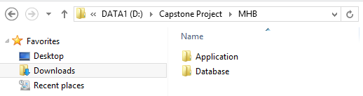

**Step 2. Create the database**

Open the file “DB1.0.sql” in the folder “Database” of the deployment package by Microsoft SQL Server Management Studio (MSSQL).

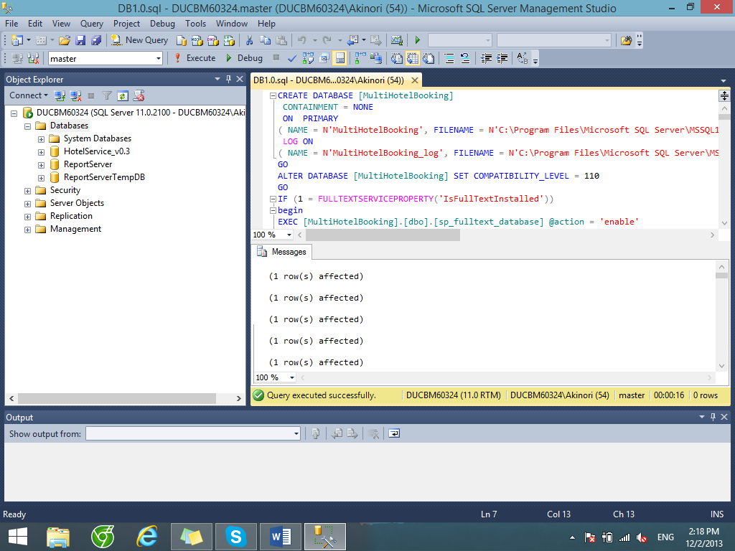

Change the paths of the SQL server where the databases are stored. Usually this file path has the form “C:\Program Files\Microsoft SQL Server\***<SQLServerInstanceName>***\MSSQL\DATA”.

Next, press F5 or the Execute button to run the database script. If the database is created successfully, continue to the next step.

**Step 3. Install the application**

Open the IIS Manager by typing its name into the search box in the start menu in Windows 7 or the charm bar in Windows 8.

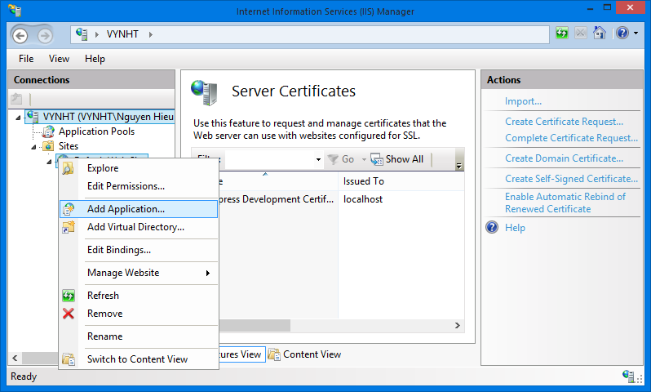

Expand the Sites folder and then right click on Default Web Site. Select “Add Application…” to open Add Application window. In the “Add application” window, fill the field “Alias” with the name of the website.

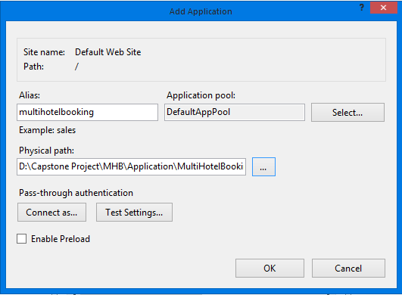

Click the “…” button to browse to the folder that contains the deployment package. Select the “Website” folder in the “MultiHotelBooking” folder, in the “Application” folder and click OK.

Verify that the MultiHotelBooking Website has been added to “Default Web Site” of IIS Express by right-clicking the website’s name, choosing “Manage Application” and then “Browse”.

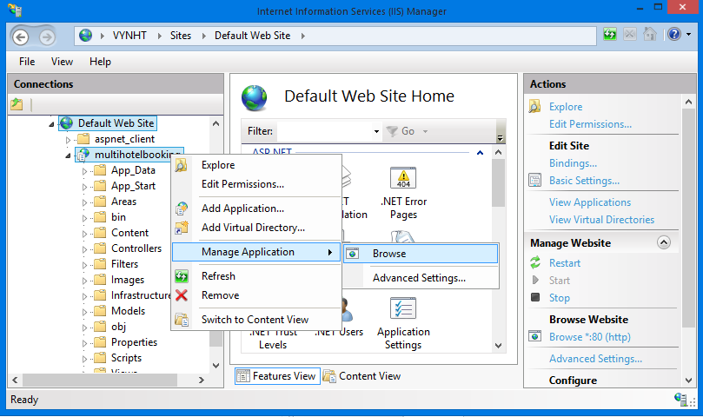

Note that at this step, you will see an error connecting to the database, because you didn’t change the database connection configuration. We will solve it shorly.

**[Optional] Step 4**. **Create a new Self Signed Certificate**

This step is to enable SSL browsing to your application when it is installed on Facebook.

Certificates are managed in IIS by clicking the root machine node in the left-hand tree-view explorer, and then selecting the "Server Certificates" icon in the feature pane on the right:

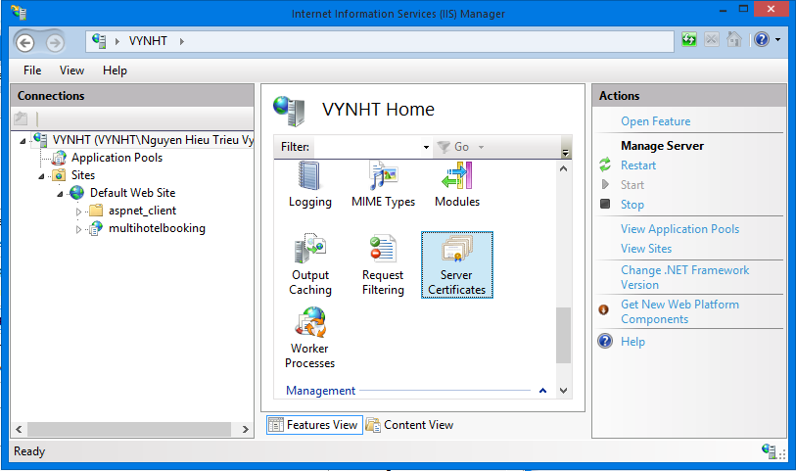

This will then list all certificates registered on the machine, and allow you to optionally import and/or create new ones.

You could optionally go to a certificate authority like Verisign and purchase a certificate to import using this admin UI. Alternatively, you can create a “self-signed certificate” which is a test certificate that I can use during the development and testing of my site. To do this, click the “Create Self-Signed Certificate” link on the right-hand side of the admin tool:

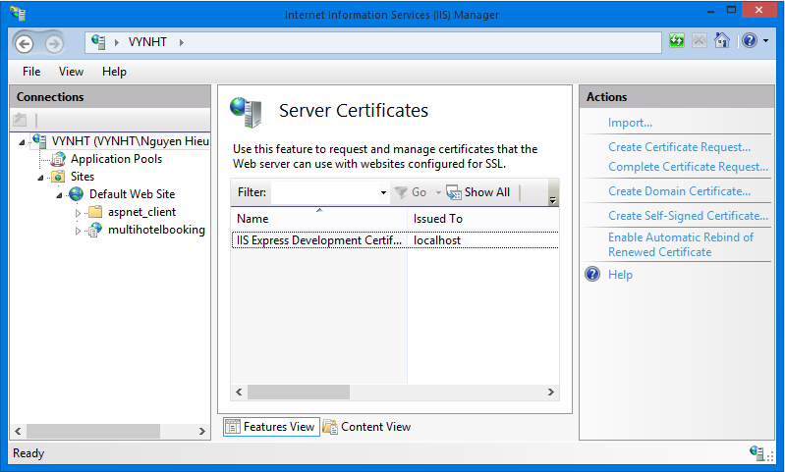

Enter a name to use for the certificate (for example: "test") and hit ok. IIS will then automatically create a new self-signed crypto certificate for you and register it on the machine:

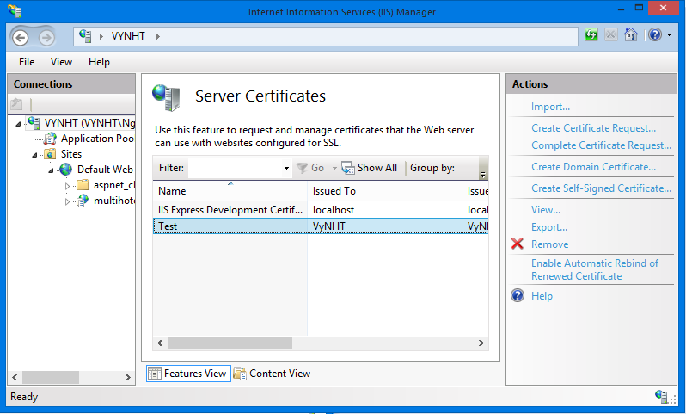

To SSL enable the web-site we created earlier, select the web-site node in the left-hand tree-view, and the click the “Bindings” link in its “actions” pane on the right-hand side of the screen:

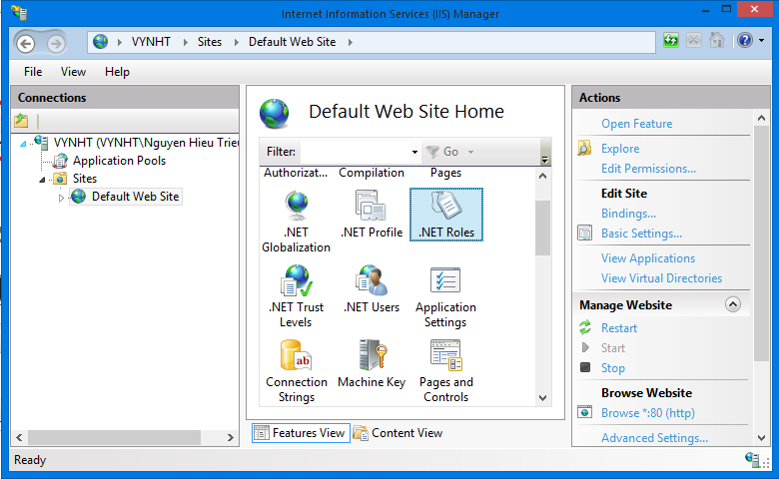

This will then bring up a dialog that lists all of the binding rules that direct traffic to this site (meaning the host-header/IP address/port combinations for the site):

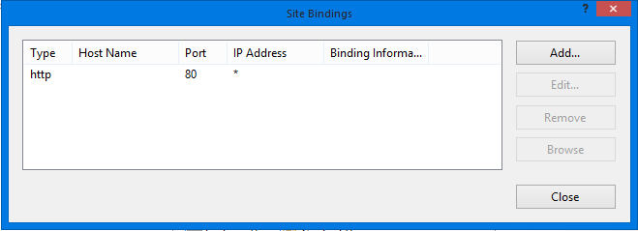

To enable SSL for the site, we'll want to click the “Add” button. This will bring up an “add binding” dialog that we can use to add HTTPS protocol support. We can select the self-signed certificate we created earlier from the SSL certificate dropdownlist in the dialog, and in doing so indicate that we want to use that certificate when encrypting content over SSL:

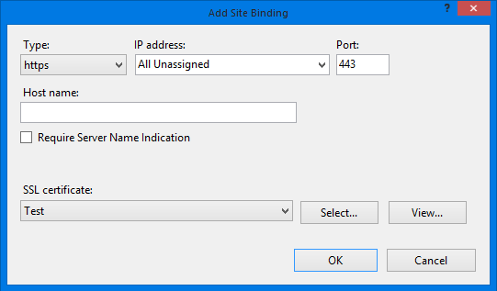

Click “OK”, and we now have SSL enabled for our site.

**Step 5. Configure database connection string**

In the “Application\MultiHotelBooking\Website” folder of the deployment package, find and open the file Web.config using Notepad or any other text editor.

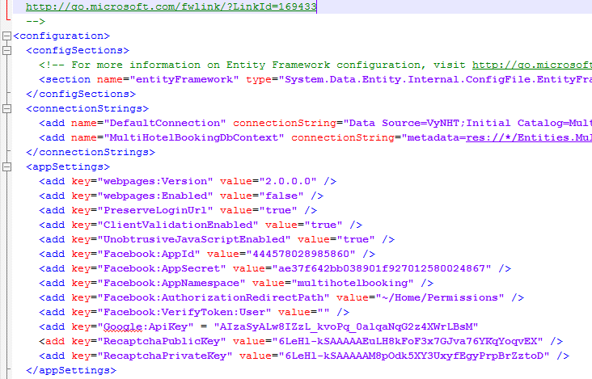

In the connectionStrings tag, change the Data Source of the connection strings to the SQLServer instance where you installed the database. Also, update the password to access the SQLServer instance in the connection strings.

**Step 6. Configure Facebook app**

Go to your Facebook app at <https://developers.facebook.com/apps/> (if you don’t have one, here is how to create one <https://developers.facebook.com/docs/opengraph/getting-started/>).

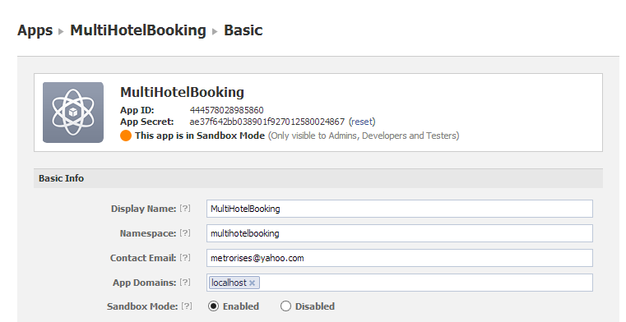

Update the App Id, App Secret, and Namespace for the app in the web.config file.

**Step 6**. **Configure the Facebook app as follows.**

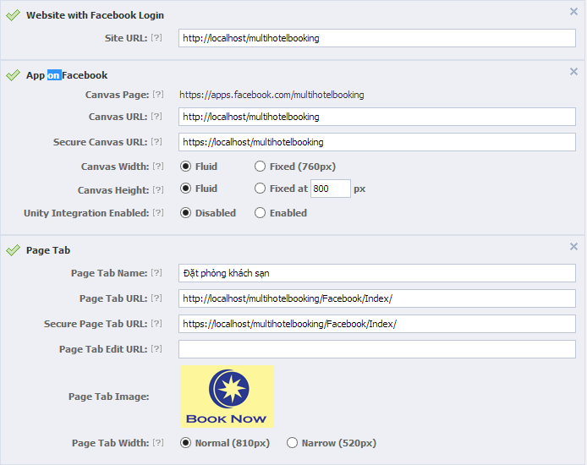

In the configuration below, “multihotelbooking” is the name of the website (Alias) you’ve just installed on IIS.

|  |  |
| --- | --- |
| Field Name | Value |
| *Site Url* | <http://localhost/multihotelbooking> |
| *Canvas Url* | <http://localhost/multihotelbooking> |
| *Secure Canvas Url* | <https://localhost/multihotelbooking> |
| *Page Tab Name* | The name of the app displayed on the fan pages |
| *Page Tab Url* | <http://localhost/multihotelbooking/Facebook/Index> |
| *Secure Page Ta Url* | <https://localhost/multihotelbooking/Facebook/Index> |
| *Page Tab Image* | An image for the app |

You can also update your own Google API Key and Recaptcha public and private keys if you would like to. Now go to [**http://localhost/multihotelbooking**](http://localhost/multihotelbooking) and [**https://localhost/multihotelbooking**](https://localhost/multihotelbooking) and enjoy the website**.**

## User’s Guide



### Guides for Guests and Travelers



#### Log in to the system

This function allows a user with a registered account to log in to the MHB system.

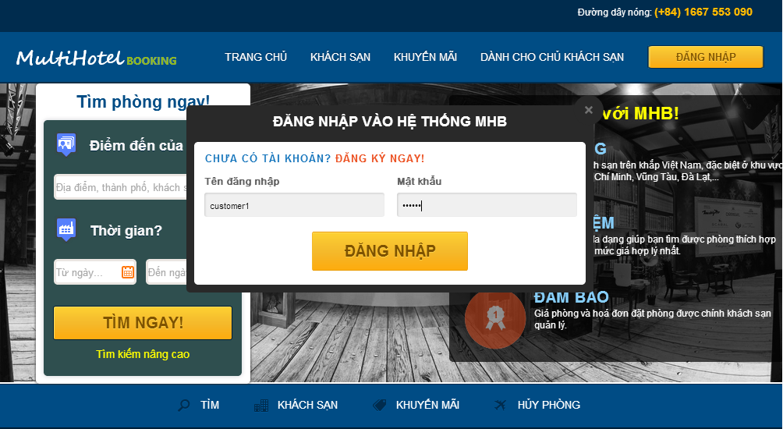

1

3

2

4

4

Screen . Login screen

|  |  |
| --- | --- |
| Step | Instruction |
| 1. | Click the “Đăng nhập” button on the menu bar of the “Trang chủ” page. |
| 2. | Fill the registered account in the “Tên đăng nhập” field |
| 3. | Fill the password in the “Mật khẩu” field |
| 4. | Click the “Đăng nhập” button to log in to the system. You will be redirected to the page you are viewing |

#### Log out of the system

This function allows the user to log out of the system after he or she finishes browsing the website.

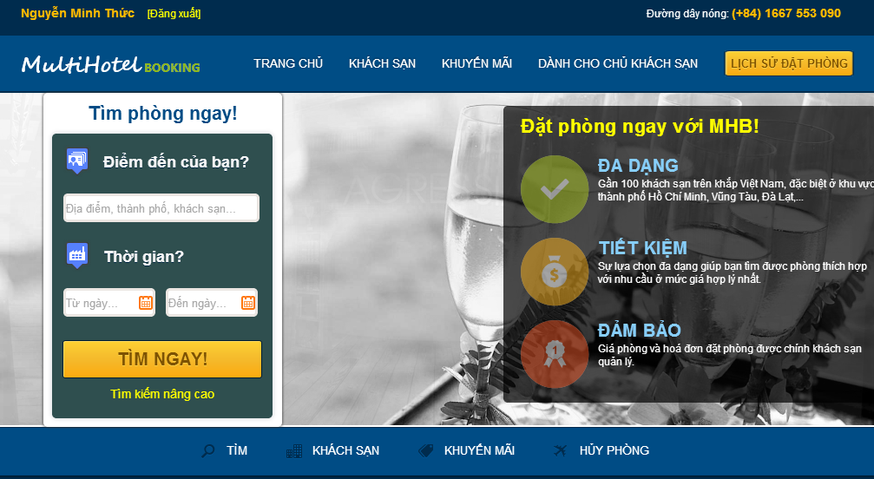

1

Screen . Logout screen

|  |  |
| --- | --- |
| Step | Instruction |
| 1. | Click the “Đăng nhập” button on the menu bar of the “Trang chủ” page. You will be redirected to the page you are viewing if this page allows guests to access, or the “Trang chủ” page otherwise. |

#### Register an account with Traveler role

This function allows the user to register a new account with Traveler role in the MHB system.

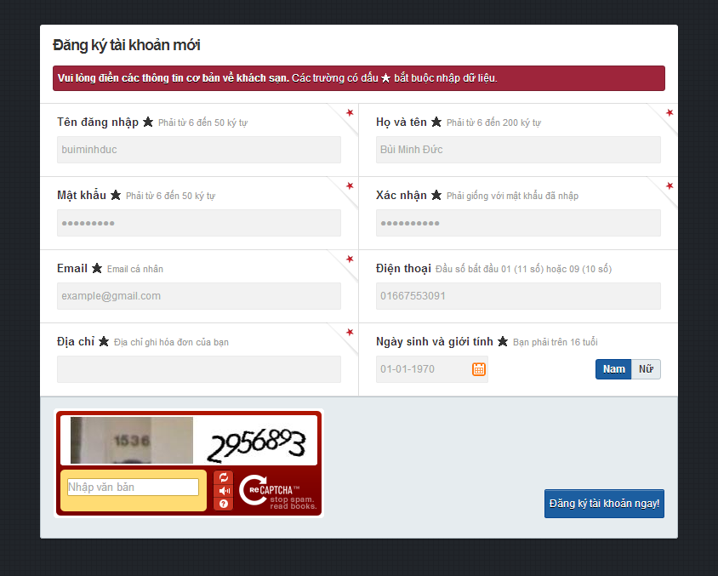

3

4

5

Screen . Register screen

|  |  |
| --- | --- |
| Step | Instruction |
| 1. | Click the “Đăng nhập” button on the menu bar of the “Trang chủ” page. |
| 2. | Click “Đăng ký ngay” on the “Đăng nhập” popup (Screen 2). The system will redirect you to “Đăng ký” page. |
| 3. | Fill in the fields “Tên đăng nhập”, “Họ và tên”, “Mật khẩu”, “Xác nhận”, “Email” “Điện thoại”, “Địa chỉ”, “Ngày sinh”, and “Giới tính” with your username, full name, password, password, email address, phone number, address line, date of birth, and gender.  Your input will be validated as you type. Please make sure that all the values that you provide are validated. |
| 4. | Fill in the “Nhập văn bản” field with the numbers or characters in the captcha image. |
| 5. | Click the button “Đăng ký tài khoản ngay” to proceed to register your account with Traveler role.  If registered successfully, you will be redirected to the “Đăng nhập” page to login with the newly created account. |

#### Search for hotels

This function allows the user to search for hotels by various criteria to find the hotel that bests suit his or her needs.

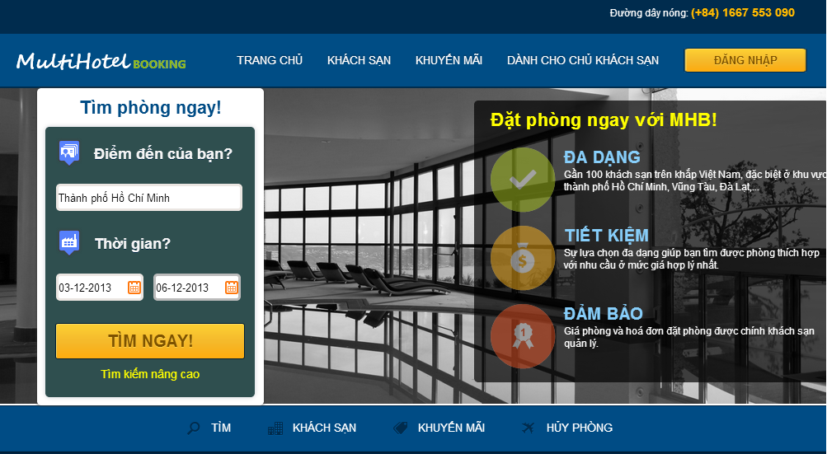

2

3

1

Screen . Home page screen

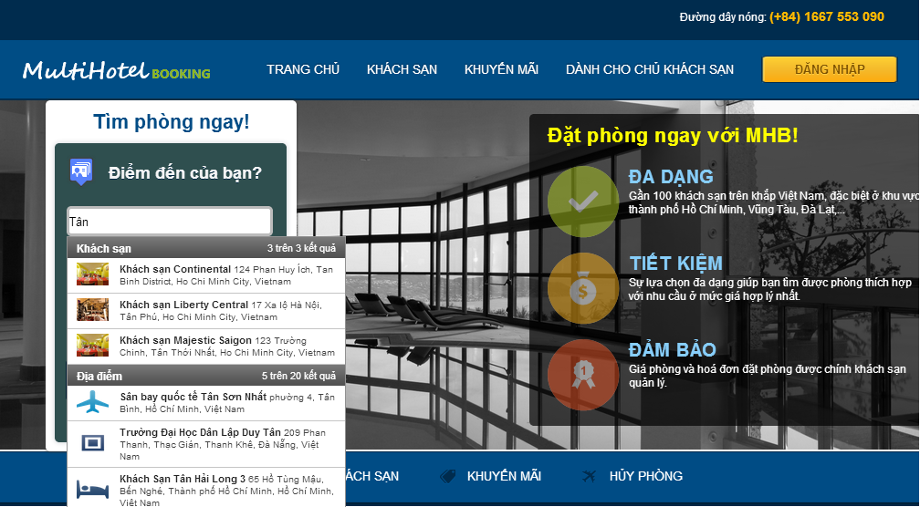

Screen . Places suggestion screen

|  |  |
| --- | --- |
| Step | Instruction |
| 1. | Fill in the textbox “Điểm đến của bạn?” with a place, city, or hotel name.  A list of suggestions will appear as you type. Select one item of the suggestions to specify the place of your destination. |
| 2. | Pick a date for checking in and a date for checking out. Your input will be validated as you picked a date. |
| 3. | Click the button “Tìm ngay”. You will be redirected to the hotel search page. |

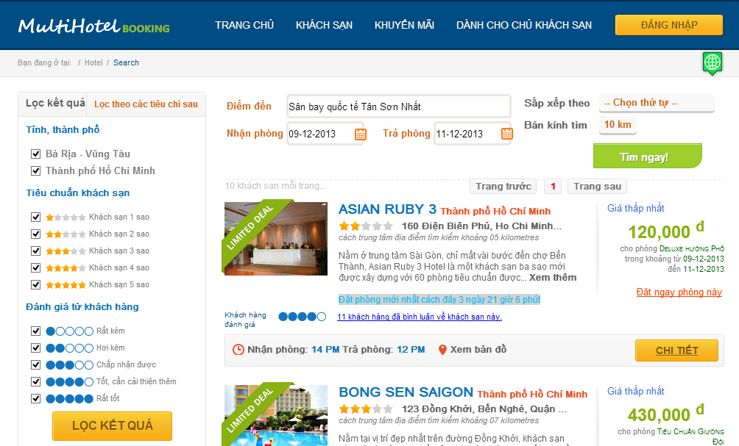

7

4

6

5

Screen . Search hotel screen

|  |  |
| --- | --- |
| Step | Instruction |
| 4. | You can change your searching criteria to limit or expand the results. The website will behave as when you search in the home page. |
| 5. | Specify some filters on the results by   * Checking or unchecking cities in “Tỉnh, thành phố” section; * Checking or unchecking hotel’s stars in “Tiêu chuẩn khách sạn” section; * Checking or unchecking average rating point of customers in “Đánh giá từ khách hàng” section. |
| 6. | Click the “Lọc kết quả” button. The system will filter the results without refreshing the page. |
| 7. | You can view all the searched and filtered hotels on the Google map by clicking the button marked 7 in the search hotel screen. The hotels are numbered as in the result list. |

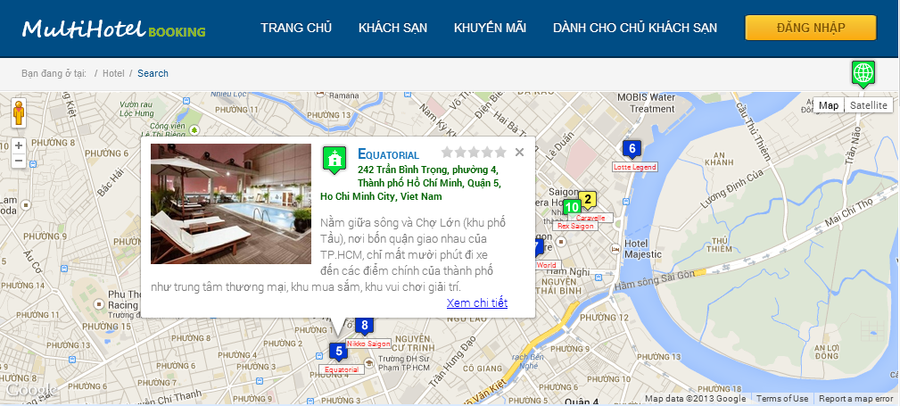

Screen . Hotels on google map screen

#### View hotel details, rate, and comment

This function allows the user to view details of a hotel other information, review, and rate the hotel after he or she searches for the appropriate hotels.



1

Screen . Search results screen

2

3

4

|  |  |
| --- | --- |
| Step | Instruction |
| 1. | Click the “Chi tiết” button in the result list of the hotel search page. You will be redirected to the hotel details page of the selected hotel. |

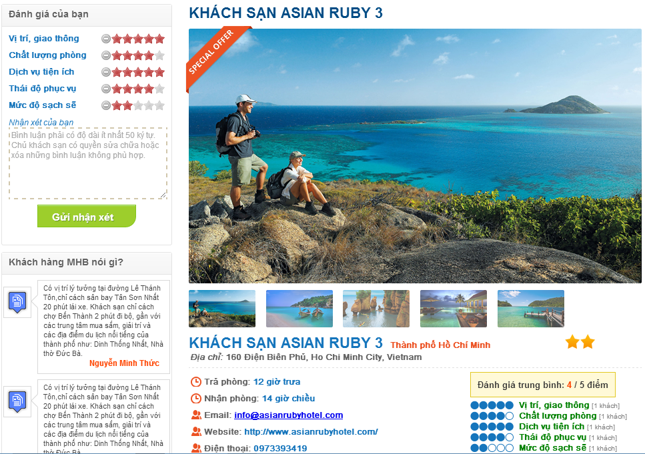

Screen . Hotel details screen

|  |  |
| --- | --- |
| Step | Instruction |
| 2. | (Optional) Rate the hotel by different critiaria like location and traffic, room quality, hotel services, staff attitude, cleanliness by checking the number of stars for each criterion in “Đánh giá của bạn” |
| 3. | (Optional) Fill your review about the hotel in the box “Nhận xét của bạn”. The content of the review can be your opinion on the hotel services, your personal experience, and what needs to be improved. |
| 4. | (Optional) Press the button “Gửi nhận xét” in order to submit a review for the hotel. |

#### Book rooms and pay

This function allows the user to select a number of available rooms to book and pay for.

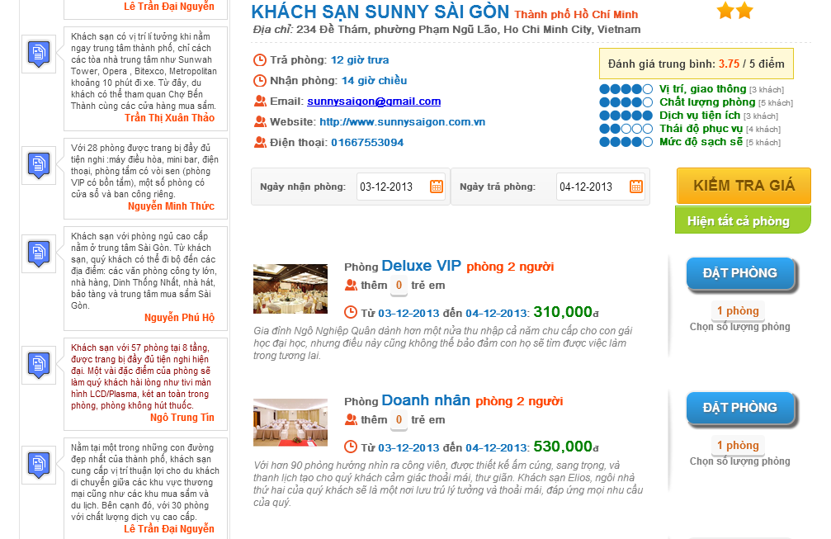

**1**

**2**

**4**

**3**

**5**

Screen . Room details screen

|  |  |
| --- | --- |
| Step | Instruction |
| 1. | Pick a date for checking in to fill the textbox “Ngày nhận phòng” and a date for checking out to fill the textbox “Ngày trả phòng”. Your dates will be validated before you continue. |
| 2. | Click the “Kiểm tra giá” button to check for room availability and prices. If there are available rooms in the specified period, the system will list their information and prices in the list below. |
| 3. | (Optional) Choose number of rooms in the rectangular under “Đặt phòng” button. The default value for number of rooms is 1. |
| 4. | (Optional) Choose number of extra children or adults, if allowed by the hotel. |
| 5. | Click the “Đặt phòng” button. The system will drive you to Booking Details Page. |

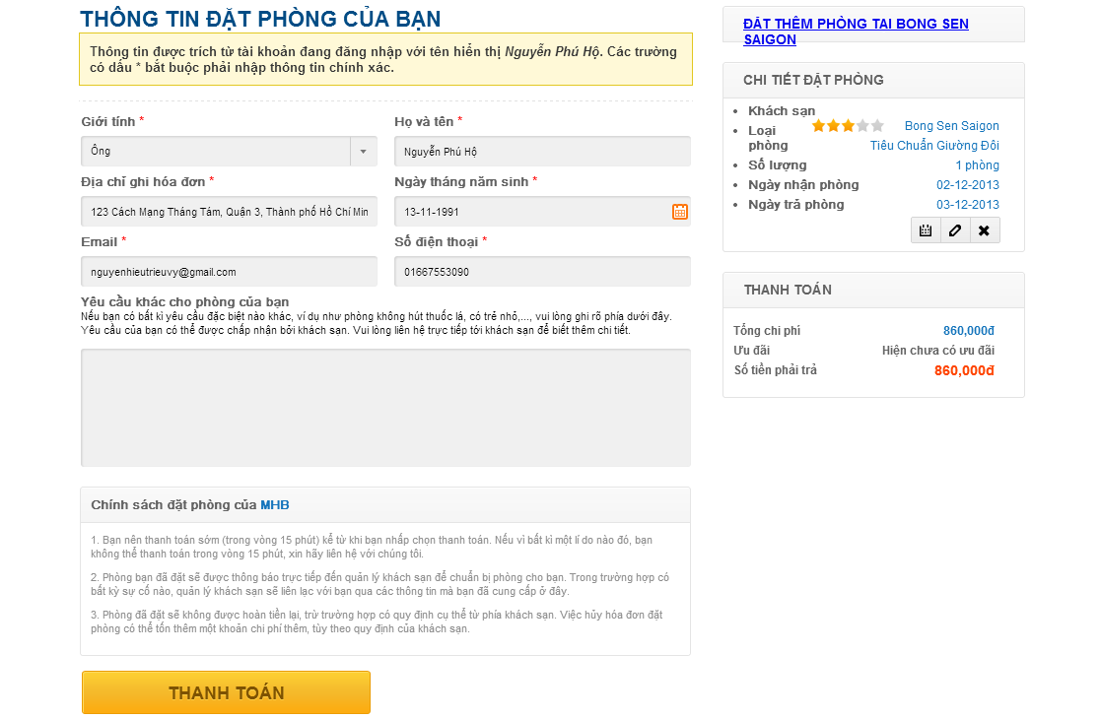

**8**

**6**

**7**

Screen . Booking details screen

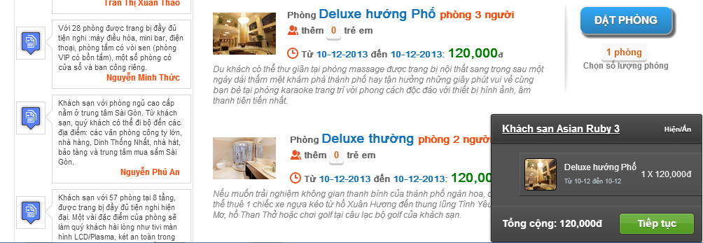

Screen . Book more rooms screen

|  |  |
| --- | --- |
| Step | Instruction |
| 6. | (Optional) Click on the link “Đặt thêm phòng tại khách sạn X”, where X is the name of the selected hotel to book more rooms of this hotel. Repeat the steps from 1 to 5 to add more rooms to the booking list. |
| 7. | Fill in the customer information form. If you are already logged in the website, the details of your account will be automatically filled in the form.  Provide us your real gender, full name, address, date of birth, email, phone number and specify any request you want to send to the hotel owner. Your input will be validated as you type and will be used for the hotel owner to verify your booking when you check in the hotel, so please make sure you enter accurate information. |
| 8. | Click the button “Thanh toán”. You will be redirected to “Ngân Lượng” payment service. |

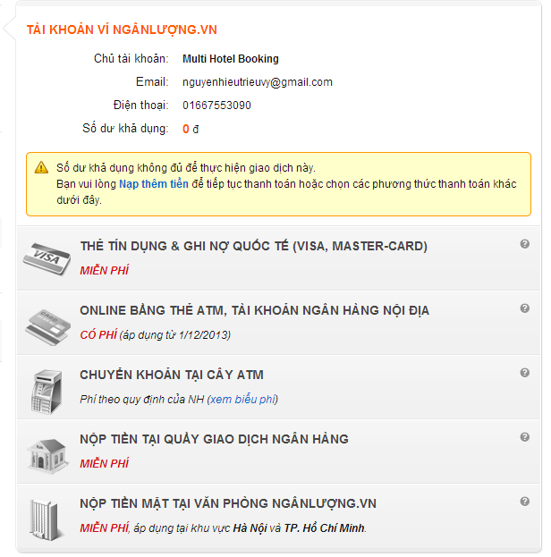

**9**

Screen . Ngân Lượng payment screen

|  |  |
| --- | --- |
| Step | Instruction |
| 9. | Pay for the rooms using your “Ngân Lượng” account. If the payment was made successfully, you will be redirected to the booking success page. |
| 10. | An email of the booking details will be sent to your email address. An SMS message containing your booking code will be sent to your phone number. Use this booking code and your personal information to verify with the hotel when you check in. |
| 11. | The booking success page shows your booking details and your booking code. Record this code to use to verify with the hotel when you check in. |

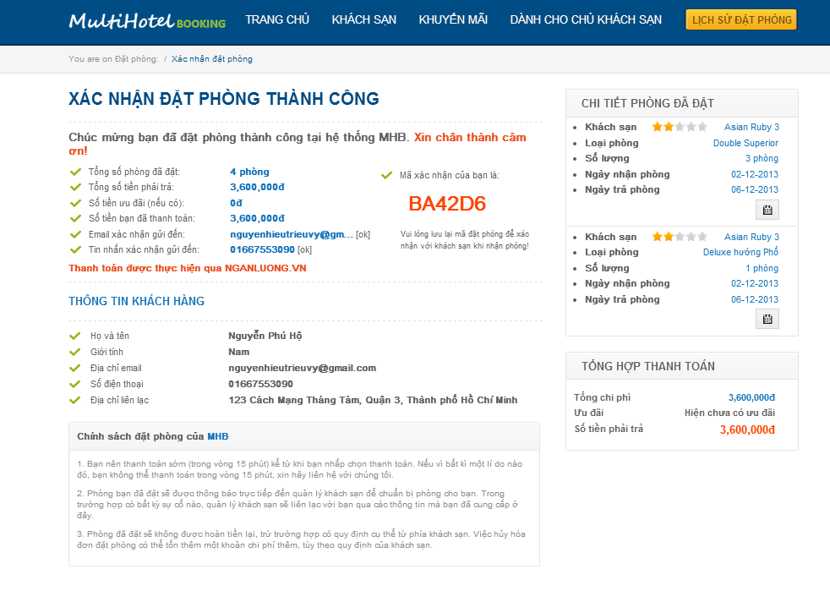

**11**

Screen . Booking success screen

### Guides for Hotel Owners and System Admins



#### View the dashboard page

This function allows the user to view the dashboard page where all hotels under your management and their related information are displayed.

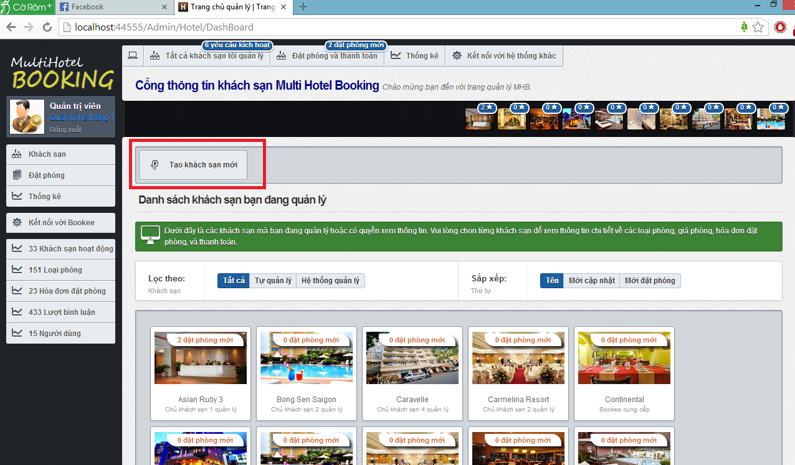

**7**

**6**

Screen . Admin dashboard screen

**5**

**4**

**3**

**2**

**1**

|  |  |
| --- | --- |
| Section | Description |
| 1. | The number of hotel opening request by hotel owner. This section is only available to System Admins. |
| 2. | The number of new bookings that need to be approved. |
| 3. | Ten hotels under your management that have the most new bookings. |
| 4. | Filters on local and external hotel. |
| 5. | Orders in which the hotels under your management should be displayed |
| 6. | All the hotels under your management |
| 7. | The menu bar that contains links to other pages. |

#### Create a hotel

This function allows the user to insert a new hotel to the system and send a hotel opening request to System Admin.

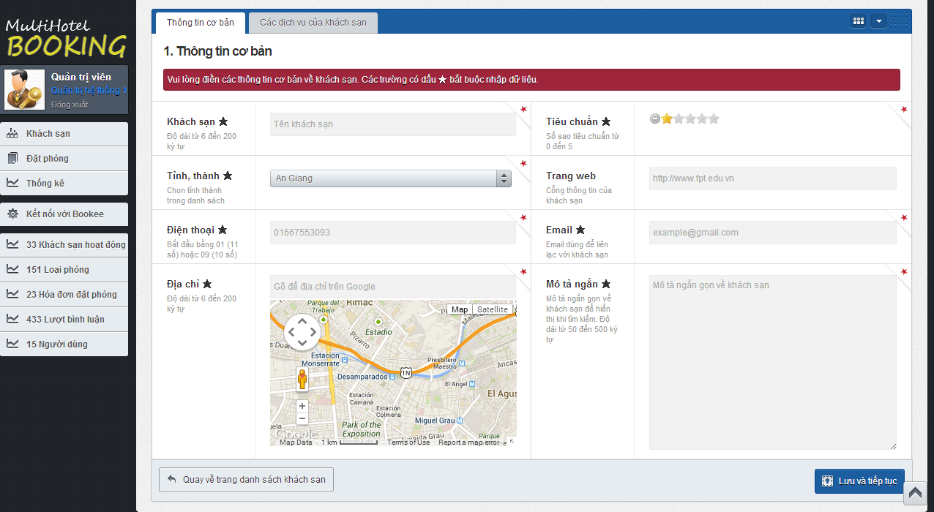

**3**

**2**

Screen . Create a hotel screen

|  |  |
| --- | --- |
| Step | Instruction |
| 1. | Click the “Tạo khách sạn mới” button on the hotel dashboard. |
| 2. | Provide necessary information for the hotel.   * Fill the hotel name in the “Khách sạn” textbox; * Choose the province where the hotel is located in in “Tỉnh, thành” dropdown list; * Fill the address line of the hotel in “Địa chỉ”. * Check the hotel’s star quality, ranging from 0 to 5. * Fill the hotel’s website in the “Website” textbox. * Fill the hotel’s email in the “Email” textbox. * Fill a short introduction about the hotel in the box “Mô tả ngắn”.   In the “Các dịch vụ của khách sạn” tab, tick the services that the hotel has and provide some custom description for them.  Your input will be validated as you type. Because the hotel you create will have to be approved by System Admin before it is set as activated, the information you provide must be accurate. |
| 3. | Click the “Lưu và tiếp tục” button. The system saves the hotel and continues to the Resource page of the hotel. |

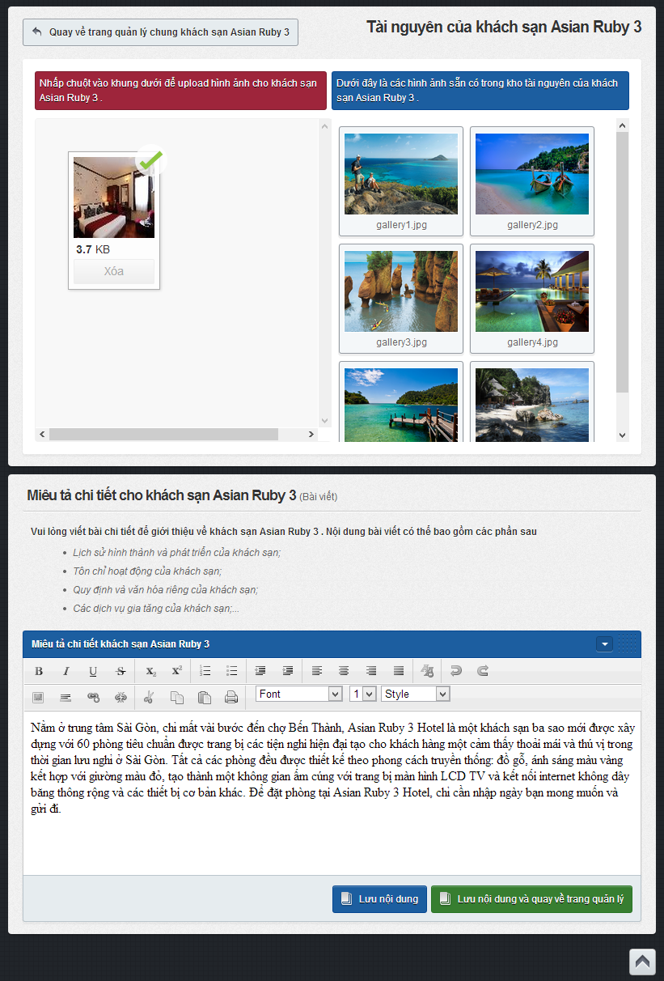

**6**

**5**

**4**

|  |  |
| --- | --- |
| Step | Instruction |
| 4. | Click the big plus button to add images to the hotel. A popup will appear to let you choose the hotel’s images. Choose the images you want to add and click Open.  The website will automatically upload all the images you selected. |
| 5. | Fill the detailed description for the hotel in the text editor “Miêu tả chi tiết khách sạn”. This description will be used as an article to introduce about your hotel on the MHB system. |
| 6. | Click the “Lưu nội dung” button or “Lưu nội dung rồi quay về trang quản lý” button. |

#### Delete a hotel under your management

This function allows the user to delete a hotel under your management from the system. All the information related to this hotel (room types, prices, features, images…) will be deleted too.

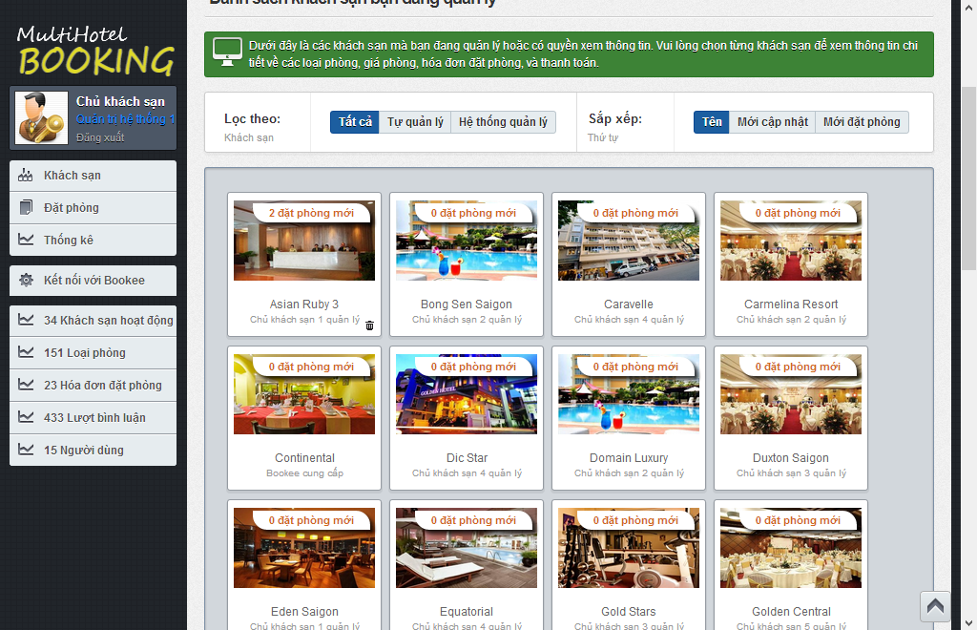

**1**

Screen . Delete a hotel screen

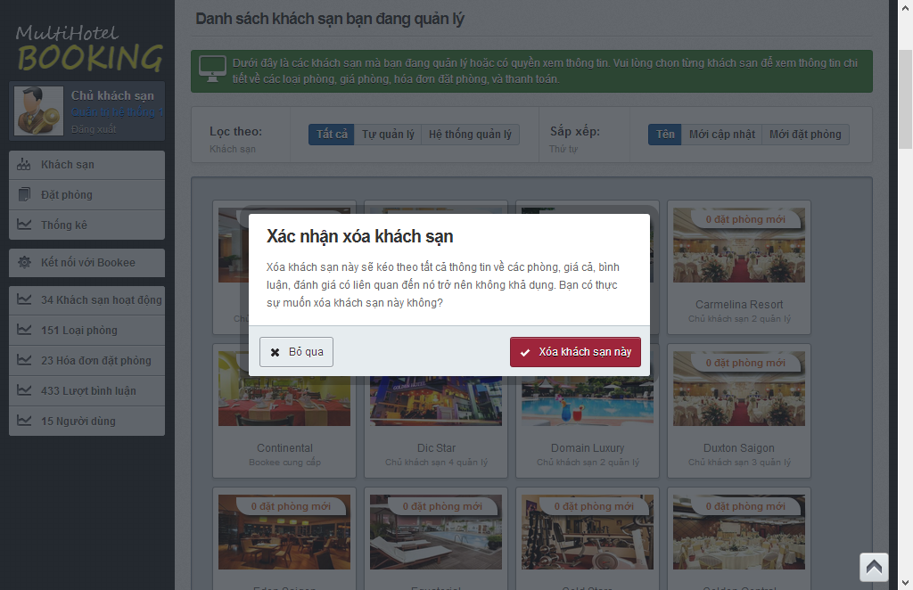

**2**

|  |  |
| --- | --- |
| Step | Instruction |
| 1. | Hover your mouse over a hotel and click  button. A pop up will be displayed to ask you to confirm if you really want to delete the hotel. |
| 2. | Click “Bỏ qua” button if you don’t to delete this hotel; or  Click “Xóa khách sạn này” button if you want to delete this hotel. |

#### Add a room type

This function allows the user to add a new room type for an existing hotel.

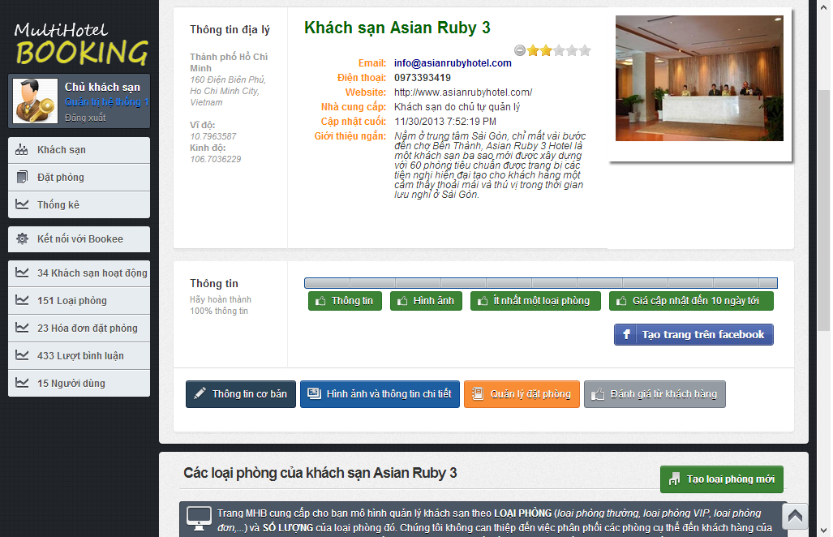

**1**

Screen . Hotel Details screen

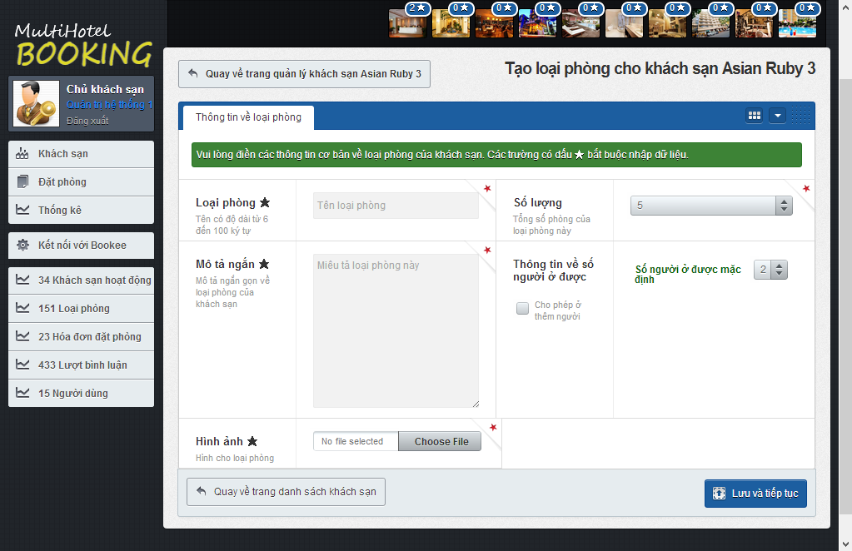

**3**

**2**

Screen . Add a room type screen

|  |  |
| --- | --- |
| Step | Instruction |
| 1. | Click the button “Tạo loại phòng mới” button in Hotel details page of the hotel you want to create a new room type. |
| 2. | Provide necessary information for the room type.   * Fill the name of the room type in the “Loại phòng” textbox; * Choose the number of rooms of this type in the “Số lượng” dropdownlist; * Fill a short description about this room type in the box “Mô tả ngắn” * Choose default number of persons who can stay in this room in the “Số người ở được mặc định” dropdown list and check/uncheck “Cho phép ở thêm người” to allow or not allow extra persons. * Choose room’s picture in “Hình ảnh” textbox by click “Choose file” button then choose a picture file and click Open. |
| 4. | Click the “Lưu và tiếp tục” button. The system will save the room type and redirect you back to the hotel management page of the room type newly added. |

#### Delete a room type

This function allows the user to delete a room type of a hotel under your management from the system. All the information related to this room type will be deleted too.

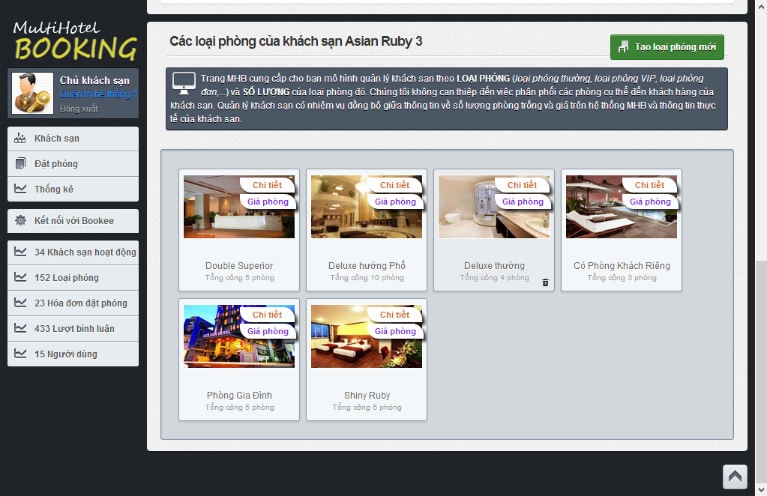

1

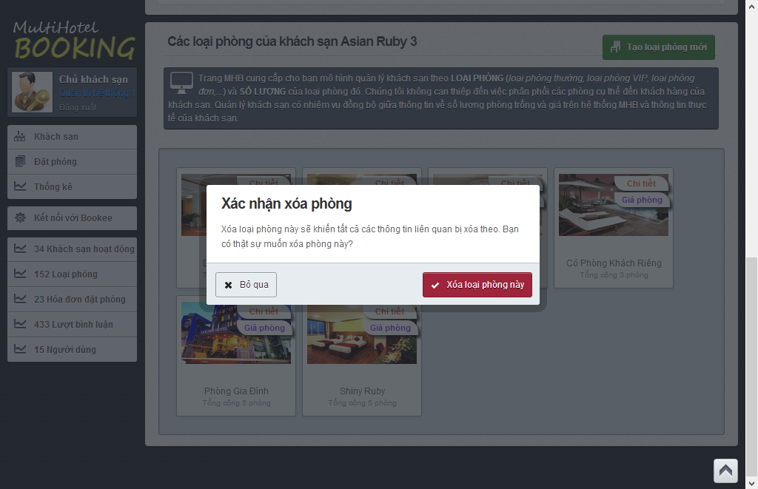

2

Screen . Delete a room type screen

|  |  |
| --- | --- |
| Step | Instruction |
| 1. | Hover your mouse over a room type and click  button. A pop up will be displayed to ask you to confirm if you really want to delete the room type. |
| 2. | Click “Bỏ qua” button if you don’t to delete this room type; or  Click “Xóa khách sạn này” button if you want to room type this hotel. |

#### Monitor prices

This function allow a hotel owner to monitor the prices of a room type in a hotel under his or her management. In addition, the screen also allows to see the bookings made on a specific day for a room type.



4

3

2

1

Screen . Price calendar screen

|  |  |
| --- | --- |
| Section | Description |
| 1. | A price bar (in gray) that represents a price in the past. You cannot drag, drop, or resize the price bar because the price is no longer active for the room type. |
| 2. | A price bar (in violet) that represents a price crossing from the past to the future (including the current system date). You can drag, drop, and resize the future part of the price bar to update the price in the future. |
| 3. | A price bar (in blue) that represents a price in the future. You can drag, drop, and resize this price bar to update the price in the future. |
| 4. | The number of bookings made on a specific day for the selected room type. |

#### Add a price

This function allows a hotel owner to add a new price for the selected room type.

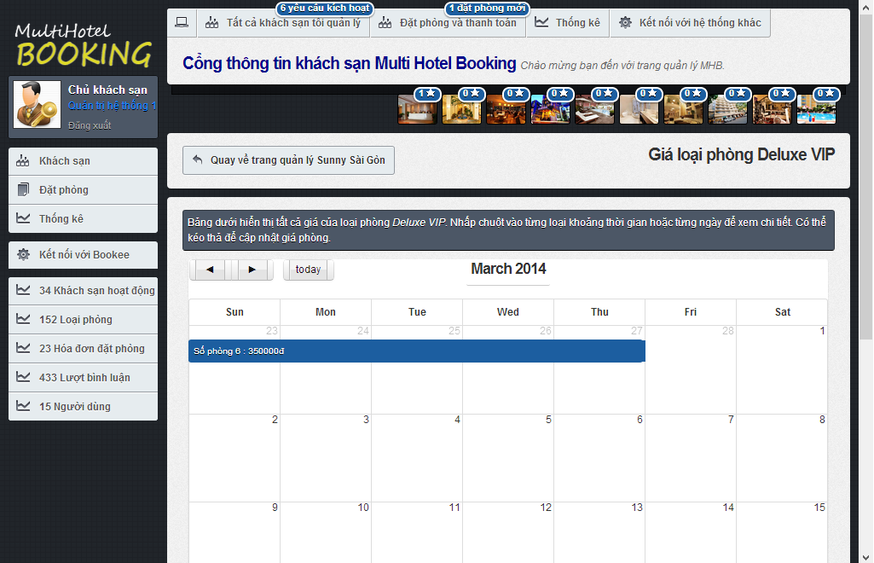

1

Screen . Price calendar screen

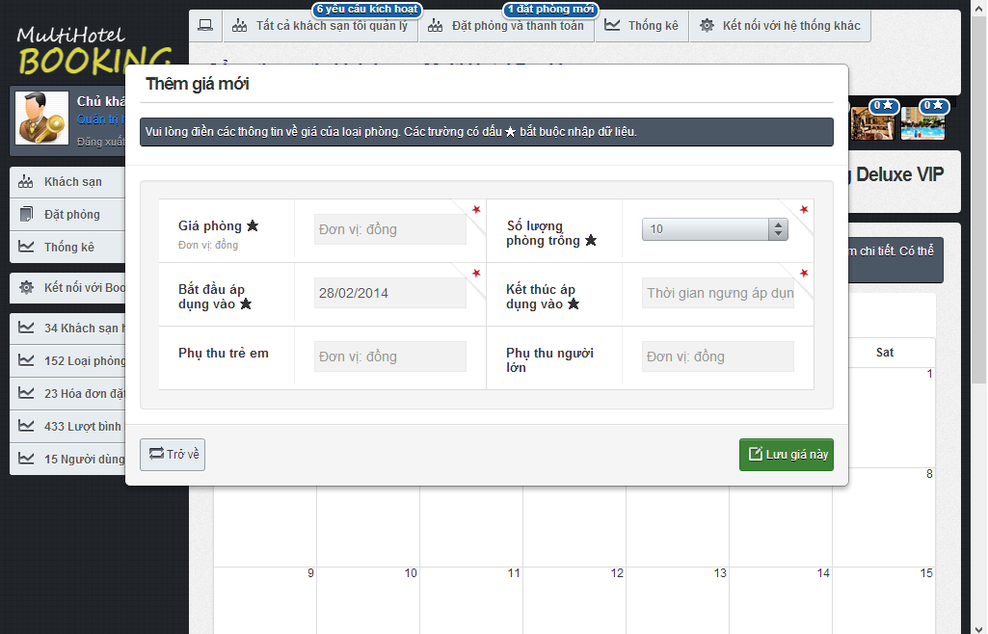

3

2

Screen . Add a price screen

|  |  |
| --- | --- |
| Step | Instruction |
| 1. | Click on an empty date you want to add new price in the price calendar for the selected room. A popup window will be displayed to add a new price for the date. |
| 2. | Provide necessary information about the new price:   * Fill the price in Vietnam Dong in the “Giá phòng” textbox; * Choose the number of rooms available for the period in the “Số lượng phòng trống” dropdown list; * Choose the start date and end date of the price; * Fill the price for extra children in “Phụ thu trẻ em”, if any; * Fill the price for extra adults in “Phụ thu người lớn”, if any.   Your input will be validated as you type. |
| 3. | Click the “Lưu giá này” button. The price will be saved and added to the calendar. |

#### Resize, drap and drop a price

This function allows a hotel owner to easily update the start date and end date of a price.

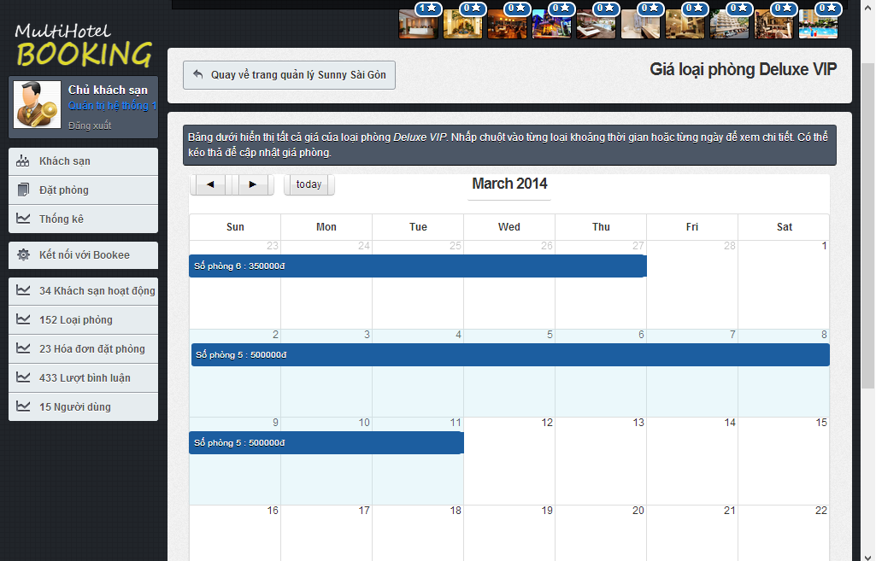

2

1

Screen . Resize a price screen

|  |  |
| --- | --- |
| Step | Instruction |
| 1. | **(**Optional) Click and hold the edge of a price bar you want to resize and drag it to your desired position in the price calendar. Release the mouse to update the price to the new position in calendar. |
| 2. | (Optional) Click and hold a price bar in the price calendar, then drag it to new position in the calendar. Release the mouse to drop the price to the new position in calendar. |

#### Approve a booking

This function allows the user to verify that he or she has approved of a booking made by a customer.

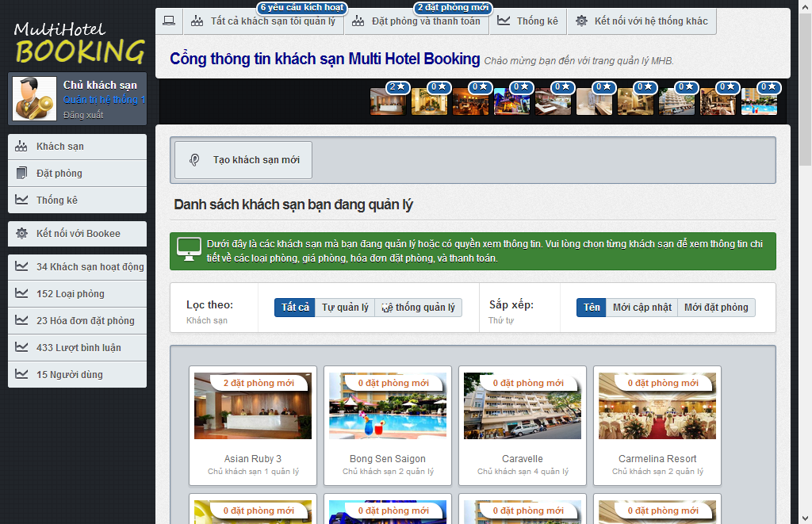

1

1

Screen . Dashboard screen

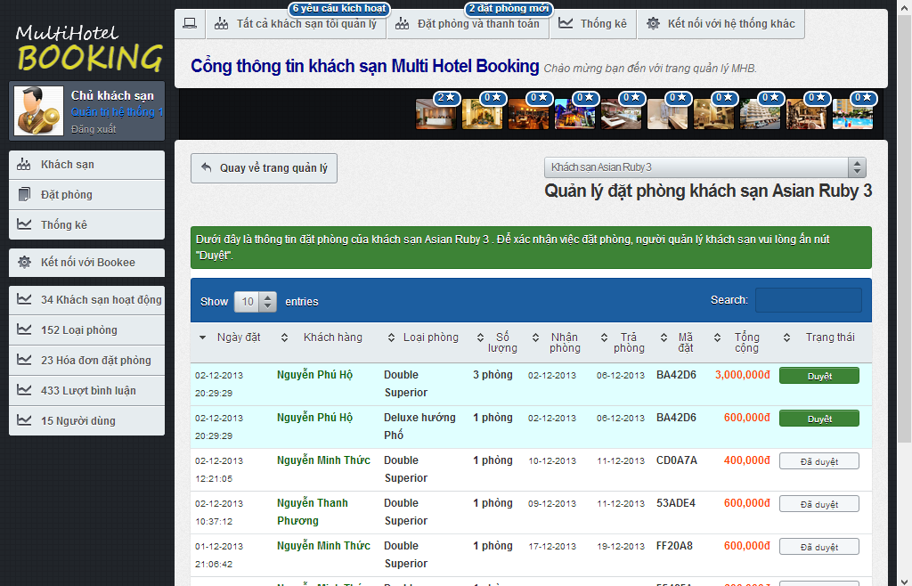

2

Figure . Booking list screen

|  |  |
| --- | --- |
| Step | Instruction |
| 1. | In hotel dashboard page, click the notification bar of a hotel that has new bookings ade by customers; or click on the list of ten hotels that have the most new bookings at the top of the dashboard page. |
| 2. | Check the new booking, allocate the necessary rooms and services in your hotel, and click the button “Duyệt” to verify that you have approved of a booking. A notification is shown to you to notify that the booking was approved successfully.  Note that once you have “approved” of a booking, you cannot restore it back. |

#### Approve hotel opening request

This function allows a system admin to approve of a hotel opening request made by a hotel owner.

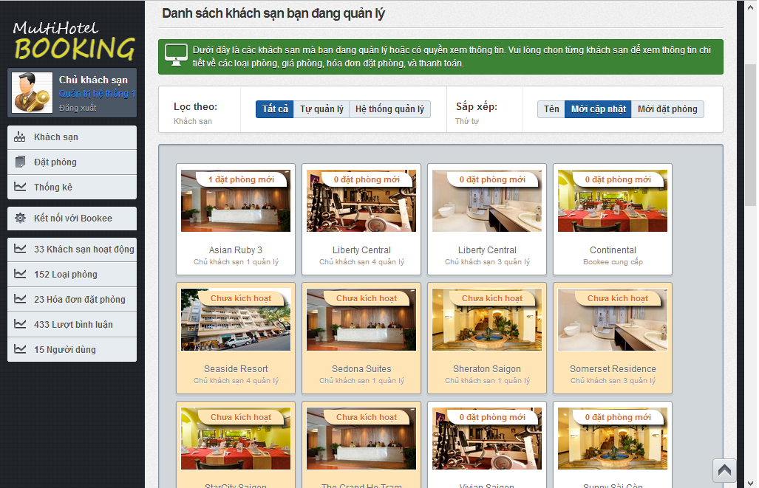

1

Screen . Hotel opening request screen

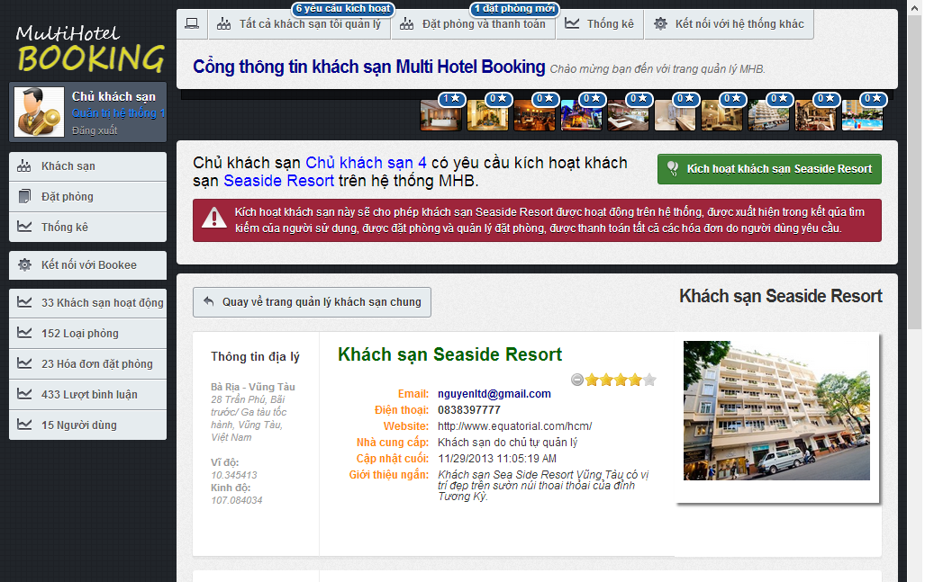

2

Screen . Approve hotel opening request screen

|  |  |
| --- | --- |
| Step | Instruction |
| 1. | Click on a hotel which is not approved by System Admin yet. You will be redirected to the hotel details page. At the top of this page is the content of the request. |
| 2. | Check the hotel information, make necessary contact with the hotel owner to verify the information. If the hotel is valid and can be put into operation on the MHB system, click the “Kích hoạt Khách sạn X” button, where X is the name of the hotel, to approve this hotel.  After the hotel is approved, you will be redirected back to the dashboard page. |

#### Install a Facebook Tab

This function allows the user to add a new tab on the Facebook page of the hotel.

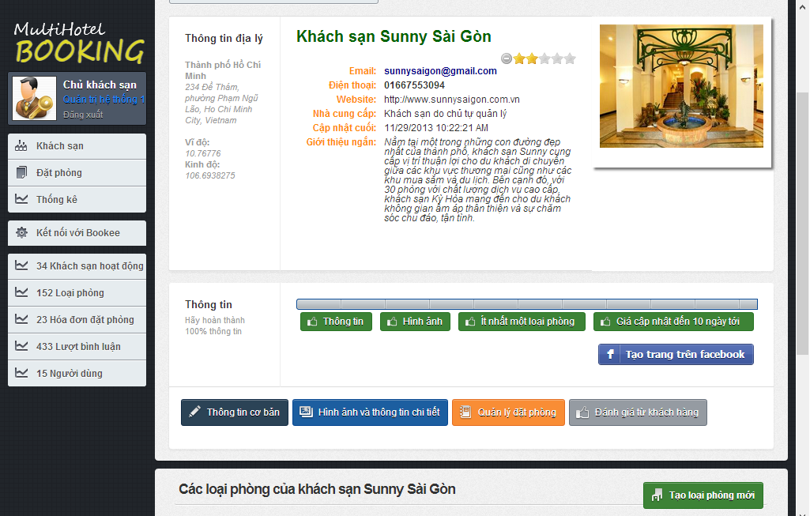

1

Screen . Add Facebook Tab screen

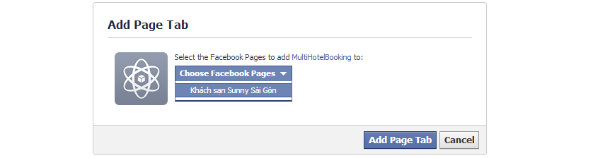

3

2

Screen . Add page tab screen

|  |  |
| --- | --- |
| Step | Instruction |
| 1. | Click the “Tạo trang trên facebook” button. Note that in order to see this button you must complete 100% information of your hotel, including basic information, images, at least a room type, and prices for at least the next 10 days. The system will redirect you to the Add page tab on the Facebook network. |
| 2. | Choose the Facebook fan page of the hotel in the Facebook pages list. If your hotel does not have a Facebook page, go to <https://www.facebook.com/business/build> to see how to create one. |
| 3. | Click the “Add Page Tab” button. The tab will be automatically created and you will be redirected to the page tab to see your hotel installed on Facebook. |

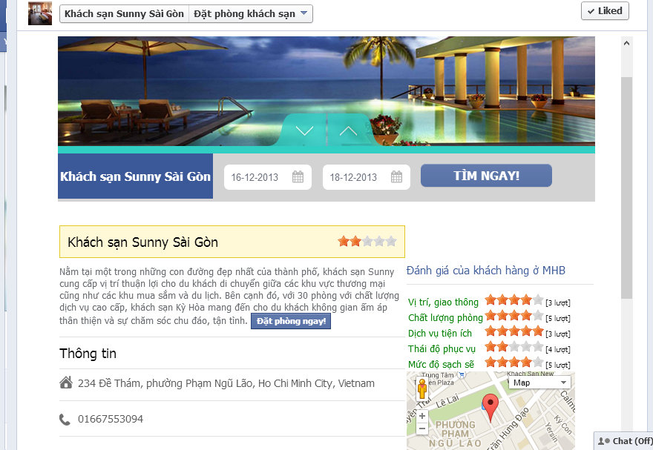

Screen . Facebook tab app screen

#### Synchronize the external provider (BMT)

This function allows a system admin to manually synchronize information about hotels provided by an external hotel provider (BMT in this case).

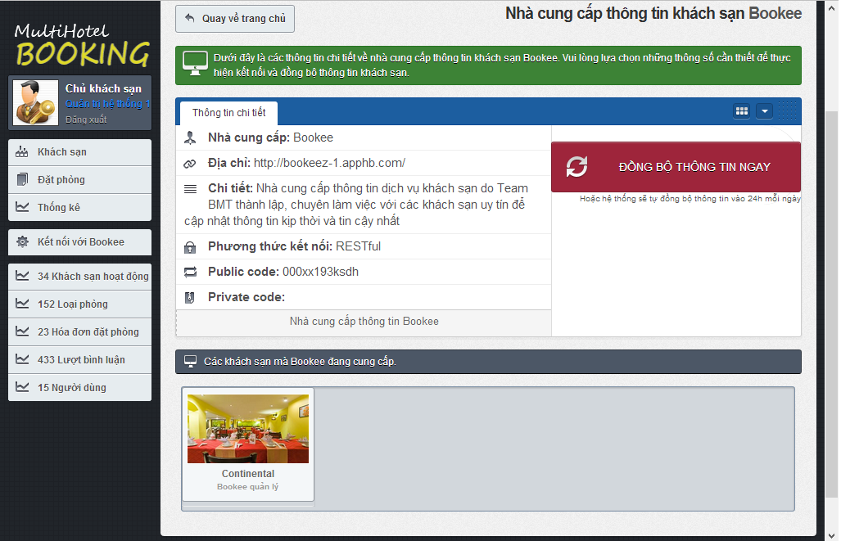

3

2

ĐỒNG BỘ GIÁ

ĐỒNG BỘ THÔNG TIN

1

|  |  |
| --- | --- |
| Step | Instruction |
| 1. | Click the “Kết nối với Bookee” link in the menu bar. You will be redirected to the data synchronization page for this provider. |
| 2., 3. | Click the button “Đồng bộ thông tin” or “Đồng bộ giá” to synchronize data with provider. After you clicked this button, it will takes a while to synchronize the data between the two systems. If you don’t want to wait, you can go to another page, because the synchronization will still continue.  Once the data is completely synchronized, the page will refresh and show a log of the synchronization process. |

# Appendix

## Reference

<http://www.ivivu.com/ho-tro-43-vi.html>

<http://www.agoda.com/info/about-agoda.html>

<http://service.hotels.com/app/home/locale/en_US>

<http://www.booking.com/faq.en-us.html>

<https://developer.ean.com/docs/>

<http://en.wikipedia.org/wiki/Model-view-controller>

<http://www.visual-paradigm.com/product/vpuml/tutorials/>

<http://www.packtpub.com/mastering-ninject-for-dependency-injection/book>

<http://en.wikipedia.org/wiki/Waterfall_model>

<http://www.asp.net/mvc/tutorials/mvc-4>

<http://msdn.microsoft.com/en-us/library/vstudio/ff926074.aspx>

<http://www.csharpfriends.com/articles/getarticle.aspx?articleid=336>

<http://www.uml-diagrams.org/>

<http://en.wikipedia.org/wiki/Database_design>